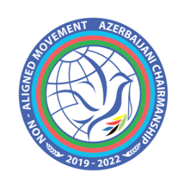
CHAIR
NON-ALIGNED MOVEMENT
GENEVA CHAPTER

UN Human Rights Council

Intergovernmental Working Group on the Right to Development

24th session

Consideration and intergovernmental negotiation of the second revised draft convention on the right to development

Statement

delivered by Azerbaijan on behalf of the Non-Aligned Movement

Geneva, 15 May 2023

Thank you, Mr. Chair,

- I have the honor to deliver this statement on behalf of the Non-Aligned Movement (NAM) Member States.

- NAM underlines the need of promoting and protecting all universally recognized human rights and fundamental freedoms, in particular the right to development, and to provide an effective framework thereof including remedies to redress grievances on or violations of human rights and fundamental freedoms in accordance with the relevant Founding Principles of the Movement, the UN Charter and international human rights instruments, consistent with the obligations of States regardless of their political, economic and cultural systems.

- In this sense, the Movement have strived for greater acceptance, operationalization and realization of the right to development at the international level, and have urged all States to undertake at the national level necessary policy formulation and institute measures required for the implementation of the right to development as a fundamental human right, and have further urged all States to expand and deepen mutually beneficial cooperation with each other in ensuring development and eliminating obstacles to development, in the context of promoting an effective international cooperation for the realization of the right to development, bearing in mind that lasting progress towards the implementation of the right to development requires effective development policies at the national level as well as equitable economic relations and a favorable economic environment at the international level.

- NAM attaches special importance to Article 10 of the Vienna Declaration and Program of Action, which establishes that States must cooperate with each other to ensure development and eliminate obstacles to its realization.

- NAM reiterates its appreciation for the submission of the second revised draft convention on the right to development with commentaries by the Chair-Rapporteur and thanks him and the experts for their presentations.

- In this regard, the Non-Aligned Movement Members States would like to assure their full constructive participation, and look forward to work constructively within the intergovernmental negotiations.

Thank you.

