Check against delivery

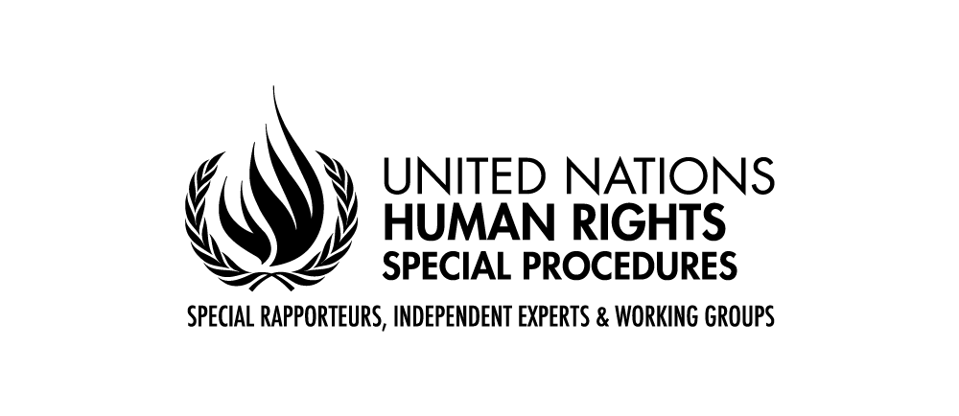

Statement by Mr Surya Deva
United Nations Special Rapporteur on the right to development

24th Session of the Working Group on the Right to Development

Interactive Dialogue, Geneva

15 May 2023

Dear Chair-Rapporteur of the Working Group, Excellencies, distinguished delegates, ladies and gentlemen,

It is my great pleasure and honour to address you today as the UN Special Rapporteur on the right to development.

At the outset, I would like to congratulate the Chair-Rapporteur as well as all members of the Drafting Group for adopting an inclusive, consultative and evidence-based approach in the drafting process of the proposed Convention on the Right to Development.

I would also like to thank my predecessor, Mr Saad Alfarargi, for his efforts during the last six years to promote the implementation of the right to development. I will build on his work and collaborate with the Working Group, the Expert Mechanism, the OHCHR’s right to development team and all other relevant stakeholders to mainstream the right to development.

Mr Chair

In my remarks today, I would like to focus on three aspects: share initial thoughts about my vision about the right to development, highlight the focus of my two reports this year, and offer some suggestions regarding the second revised text of the Draft Convention on the Right to Development.

Although economic development is needed to realise all human rights, the right to development should not be equated or confused with a mere focus on economic growth. Rather, a holistic understanding of development, which includes securing all fundamental freedoms, should be pursued. The right to development should contribute to building a human rights economy.

Moreover, this right is not relevant merely for people of the Global South. Like any other human right, the right to development is relevant to each and every human being all over the world. The Covid-19 pandemic has clearly shown that even the Global North States and their people are vulnerable to disruptive developments. Therefore, creating an inclusive, equitable and sustainable “shared future” would require all States and other stakeholders to work together to realise fully the right to development.

I believe that the following seven “Ps” are critical to the realisation of the right to development at the local, national, regional and international levels:
- People – all development policies and programmes should be people-centred and leave no one behind. A special attention should be given to the development aspirations of vulnerable or marginalised individuals and groups.
- Participation – all individuals and communities should be able to participate, in an active, informed, free and meaningful way, in all decision-making processes concerning the right to development. Moreover, there should be adequate civic space to facilitate such participation.
- Peace – as we are witnessing in many parts of the world, internal conflicts and wars disrupt prospects of realising the right to development. More collective efforts are needed to address the root causes of such conflicts and in turn secure lasting peace and security.
- Planet – the right to development is not a license to destroy the planetary ecosystem. Without a clean environment and rich biodiversity, there will be no future for people. At the same time, a reasonable differentiation should be made in development pathways adopted by developed and developing States.
- Private sector – businesses are indispensable to realising the right to development. At the same time, unregulated business activities could seriously undermine this right. Therefore, States and market actors should create incentives for responsible business conduct.
- Policy coherence – Sates and other actors should act cohesively. That would mean integrating the right to development in other agendas such as the Sustainable Development Goals, business and human rights, trade and investment, environmental pollution, climate change, new technologies, and migration.
- Past – the historical context of colonisation is especially relevant in the context of the right to development. Both States and peoples benefitting from past wrongs have a moral responsibility to contribute to the realisation of the right to development of those left behind.

In performing all my mandate activities, I will adopt a consultative, constructive and contextual approach in pushing for the full realisation of the right to development globally. I will also be integrating an intersectional perspective in discharging my mandate, because different experiences and aspirations of children, women, migrant workers, ethnic or racial minorities, elderly people, persons with disability and Indigenous Peoples do matter.

Ladies and gentlemen,

In my first report to the Human Rights Council in September 2023, I aim to outline a vision for the future in “reinvigorating the right to development”. I have already shared today some initial thinking on this issue. My second report of 2023, which I will present to the UN General Assembly in October 2023, will focus on “the role of business in realising the right to development”, in the context of the 2030 Agenda for Sustainable Development and other relevant international human rights instruments.

I will strongly encourage States, international organisations, national human rights institutions, businesses, civil society organisations, trade unions and academia to provide relevant information (including good practices) regarding these two thematic reports and possible priorities for the mandate during the next three years.

Mr Chair

Let me now offer some suggestions to improve further the current text of the Draft Convention. These suggestions build on the written input that I have recently provided to the Working Group.

In my view, at least four aspects of the Draft Convention can be strengthened. First, the Convention should take cognisance of both potentials and perils of business activities for realising the right to development. It should acknowledge the independent duty of businesses to respect all human rights, including the right to development, and require them to conduct human rights due diligence to ensure that their operations do not undermine the right to development. The Convention should also obligate States to regulate effectively, both individually and collectively, unsustainable or irresponsible business activities.

Second, the Draft Convention should pay greater attention to the wider normative context and encourage policy coherence. It should create entry points to harness the potential of other human rights processes and related agendas to realise the right to development. For example, regional and international frameworks related to the Sustainable Development Goals, business and human rights, trade and investment, development finance, environmental pollution, climate change, migration, and regulation of technology will be relevant to realise fully the right to development.

Third, considering that the beneficiaries of the right to development are not a homogenous group, an intersectional approach should be embedded throughout the Draft Convention. The goal of leaving no one behind could only be achieved by overcoming multi-layered and intersectional discrimination faced by many marginalised or vulnerable individuals and groups.

Fourth, the Draft Convention should integrate better the critical importance of the right of active, free, informed and meaningful participation of individuals and communities in all decision-making processes, including the formulation of policies, laws, programmes and initiatives concerning the right to development. In the absence of such bottom-up participation of the intended beneficiaries of the right to development, the resultant development is unlikely to be inclusive, equitable and sustainable.

Mr Chair

I look forward to engaging constructively in discussion about the content of the Draft Convention during this session and in future. I will also encourage all States and other stakeholders to do the same.

Thank you for your kind attention.

