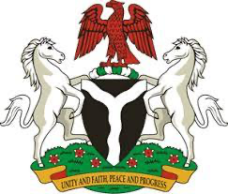

Please check against delivery
24TH SESSION OF THE WORKING GROUP
ON THE RIGHT TO DEVELOPMENT

15TH MAY, 2023
STATEMENT BY NIGERIA
Chairperson,
Nigeria aligns with the statements by African Group and NAM. We congratulate you, Chair-Rapporteur, on your re-election to steer the work of this important Working Group during this session, and reiterate Nigeria’s unflinching support for the work of the Working Group. We commend the Working Group for the continued constructive engagement with all stakeholders in the onerous efforts to midwife a legally binding instrument that speaks to the pertinence and strengthening of the implementation and realization of the right to development.
2. Right to development is an inalienable right of fundamental significance to the accelerated implementation of the Sustainable Development Goals. We reiterate that the lack of development opportunities has negatively impacted the well-being of numerous citizens of developing economies, and contributes to layers of instability and series of conflicts, as well constituting credible threats to international peace and security.
3. We call for a sincere international cooperation and collaboration efforts to work assiduously towards ensure the realization of the right to development as envisaged in the Sustainable Development Goals. We emphasize that the responsibility to promote the right to development does not rest on individual States, given its universality and applicability, and therefore underscores the importance of international solidarity in this regard.
4. In conclusion, we underline the need for all stakeholders to renew their commitment to the continued collective international efforts towards the realization of the right to development, and the attainment of the full enjoyment of human rights by all, and in ensuring global peace and security.
I thank you.
******

