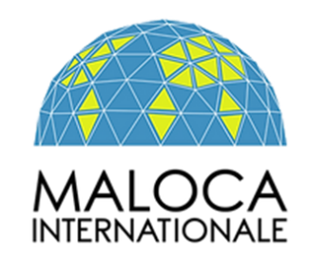

Intergovernmental Working Group on the Right to Development, Human Rights Council, May 2023, Geneva.

Dear Ambassador Akram,

This is the first time that our organization has spoken in point 4.1 of the Agenda which summons us on the rightto development.

The Pijao People, in Colombia, have listened to the debates on indigenous peoples and gender that occupy States in this room.

We understand that Colombia, Chile, Argentina, Mexico, on the other hand, find that the word "gender" and the "peoples", colonially called indigenous, such as the Pijao people and the Quechua-Aymara peoples are important, and therefore the word people is important in this debate.

The Quechua-Aymara peoples, wrongly called indigenous or peasant, benefit from the protection of ILO Convention 169 of 1989, since the sovereign States within whose borders these peoples live, have ratified this Convention. We thank the Colombian State for advocating for ILO Convention 169 of 1989, interpreted with the minimum standards of the Declaration of Rights of Indigenous Peoples of 2007.

Development, expressed in mining projects, causes the influx of Aymara Quechua women, peasants and girls in mining operations, which is why we think it is important for Argentina's proposal to return to the language that recognized the gender approach in the third part of the draft text that concerns us.

ILO Convention 169 is equally important, since it recognizes the territorial rights of peoples, who, like the Tancualla Quechua people, suffer the expropriation of their lands awarded in 1969, under the current administration of Dina Boluarte in Peru.

Thanks a lot

