Check against delivery

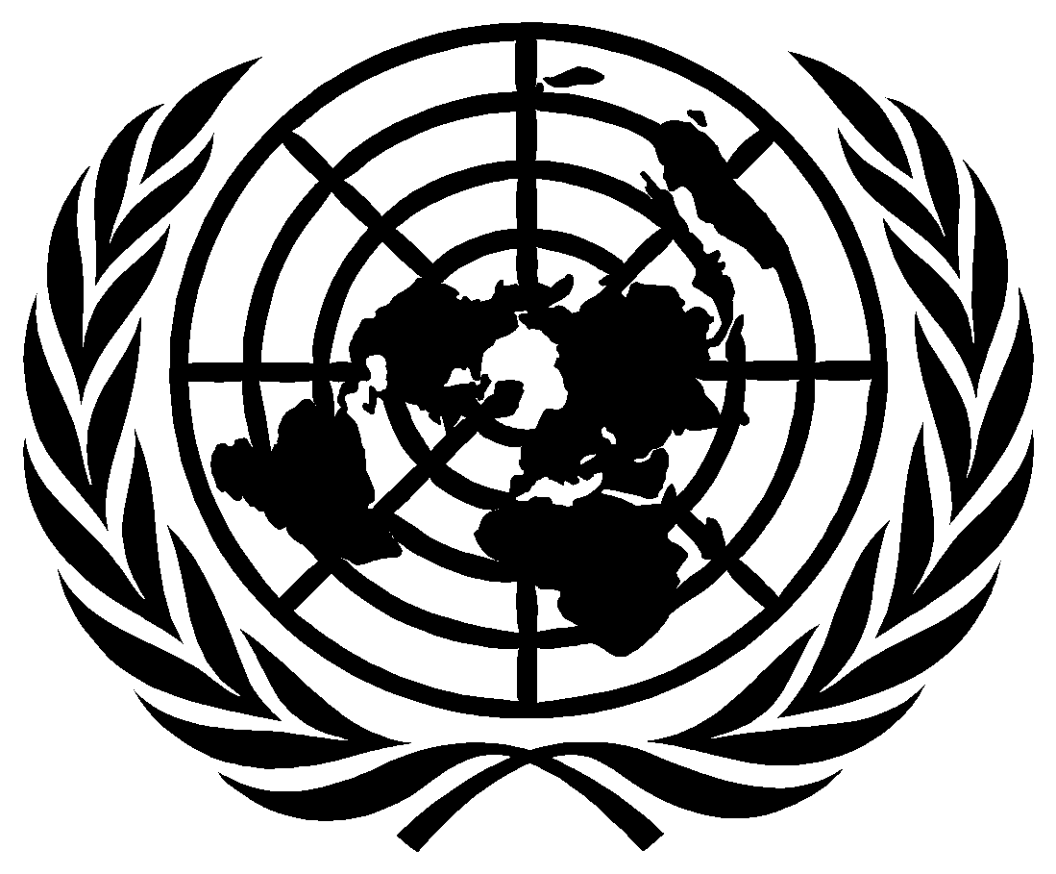

United Nations Human Rights Council

THE TWENTY-FOURTH SESSION OF THE INTERGOVERNMENTAL WORKING GROUP ON THE RIGHT TO DEVELOPMENT

OPENING STATEMENT

BY

AMBASSADOR ZAMIR AKRAM

Chair-Rapporteur of the Intergovernmental Working Group on the Right to Development

15 May 2023

Madame Deputy High Commissioner,
Excellencies,
Distinguished delegates,
Dear Ladies and Gentlemen,

I welcome you to the 24th session of the Working Group on the Right to Development, and as the re-elected Chair-Rapporteur, I am deeply grateful for the honour you have bestowed upon me.
Our annual sessions provide us with an opportunity and space to reaffirm our shared commitment to promoting and realizing the right to development, a right, which is crucial for achieving sustainable and inclusive growth for all, notably in a world still grappling with the challenges of the post COVID-19 pandemic, the climate crisis, and ongoing conflicts around the world.
As the High Commissioner for Human Rights underlined in his opening remarks at the high-level meeting of the Human Rights Council commemorating the 35th anniversary of the United Nations Declaration on the Right to Development earlier this year, “genuine development is not about enriching a few individuals or businesses. It is not based on exploitation of the many by few. Genuine development benefits everyone, across society, by advancing equity and justice. It is rooted in equality of opportunity, full enjoyment of human rights, and a fair share of resources for all.”
Since its establishment, the Working Group has played an important role in monitoring and reviewing progress made in implementing the right to development. It was and remains an important forum to bring States together and to make a solid contribution towards removing the obstacles in the way of development.
Since I assumed the Chair in 2015, I have made every effort to ensure an open, participatory, and consensus-oriented process; to enable each and everyone of us to engage actively in the work of the Working Group, to bring positions closer together by building on agreed language.
This was done in support of the Human Rights Council mandate that was to elevate the right to development to the same level and on a par with all other human rights and fundamental freedoms.
The programme of work at the time, provided that criteria for the periodic evaluation of global partnerships should be prepared. These criteria were to be used, as appropriate, in the elaboration of a comprehensive and coherent set of standards for the implementation of the right to development.
The Working Group would then take appropriate steps for ensuring respect for and practical application of these standards, which could take various forms, including guidelines on the implementation of the right to development, and evolve into a basis for consideration of an international legal standard of a binding nature, through a collaborative process of engagement.
The Working Group considered the draft right to development criteria and operational sub-criteria from 2011-2018, without making any progress in efforts to reaching agreement on a text.
Accordingly, to break the deadlock, I presented a set of standards to the Working Group in 2016. The aim of the four standards was to identify common ground and agreed language. The standards were intended as a road map or framework for action for achieving the Sustainable Development Goals. They employed agreed language so as to ensure that they were non-controversial and enjoyed the broadest possible endorsement. These were considered, together with a NAM proposal of standards, again without any progress on the issue.
Given the lack of progress, in 2018, the Human Rights Council decided, in resolution 39/9, that the Working Group, at its 20th session, commence the discussion to elaborate a draft legally binding instrument on the right to development. In the same resolution, the Council requested me to prepare a draft legally binding instrument on the right to development.
This draft was prepared in 2019 with the help of a group of legal experts whom I advised to base the language of the draft text on existing international legal instruments, including human rights treaties and relevant declarations and resolutions adopted by consensus as much as possible. The purpose was to ensure the broadest possible acceptance of the text, if not consensus.
At the request of the Council in its resolution 51/7, I have now submitted the second revised text of the draft convention to this session for intergovernmental negotiations. I am deeply grateful to the support of the expert drafting group, but also for the many comments and textual proposals, which we have received from Member States and other stakeholders.
The Human Rights Council has also requested me to submit the final draft text after these intergovernmental negotiations to the Council later this year, most likely in September this year. In my view as well, I feel that the process in this Working Group has reached a level of maturity beyond which the draft text requires consideration by all UN members for eventual adoption. Accordingly, the Council may decide to transmit the draft text to the General Assembly.
While presenting the report on the 23rd session of the Working Group to the General Assembly in October last year, I met several officials from the Office of Legal Affairs in New York and consulted them on the way forward. They shared United Nations practice with other intergovernmental negotiations where texts were transmitted to the General Assembly with the recommendation to convene an intergovernmental conference, under the auspices of the United Nations. They also suggested that in the case of a legally binding instrument on the right to development, such a procedure might be the best way to proceed, in light of the universal membership of the General Assembly.
In my meeting with the UN Secretary-General, he encouraged me to move forward, and endorsed the advice of the legal department.
It is also worth recalling the process by which the Declaration on the Right to Development was adopted which offers a potential precedent. A Working Group of 15 governmental experts drafted the Declaration during nine sessions between 1981 and 1985, at the end of which it transmitted several drafts and proposals to the Commission on Human Rights as it was not able to complete its work. The Commission then transmitted all relevant documents including the summary record of the discussions to the General Assembly in order for the Assembly to continue the discussion. A new draft was submitted to the Third Committee, laying the groundwork for the final text of the declaration, which was adopted by vote in 1986.
As we work towards the adoption of the draft convention on the right to development, we must also emphasize the need for international cooperation and solidarity. In an increasingly globalized world, the realization of the right to development depends on our collective efforts to address global challenges such as poverty, inequality, and climate change. We must forge new partnerships, both North-South and South-South cooperation, as well as triangular cooperation, to facilitate the sharing of resources, technology, and knowledge, and to strengthen our collective capacity to overcome these challenges.
We must pay special attention to the most vulnerable and marginalized groups, including women, children, persons with disabilities, indigenous peoples, migrants, and refugees. Their voices and concerns must be at the centre of our discussions and actions. It is only by ensuring the full and effective participation of these groups in the development process that we can achieve truly inclusive and sustainable development.
We must acknowledge the importance of good governance, the rule of law, and strong, accountable institutions in the realization of the right to development. Corruption, lack of transparency, and weak institutions not only undermine development efforts but also erode trust in public institutions and jeopardize the enjoyment of human rights. We must therefore work together to promote good governance, combat corruption, and ensure the full participation of civil society in the decision-making processes that affect their lives.
In conclusion, I encourage you all to approach our discussions with an open mind, a spirit of collaboration, and a commitment to finding common ground. Together, let us strive for a future where the right to development is fully realized for all, and where no one is left behind.
Thank you.

