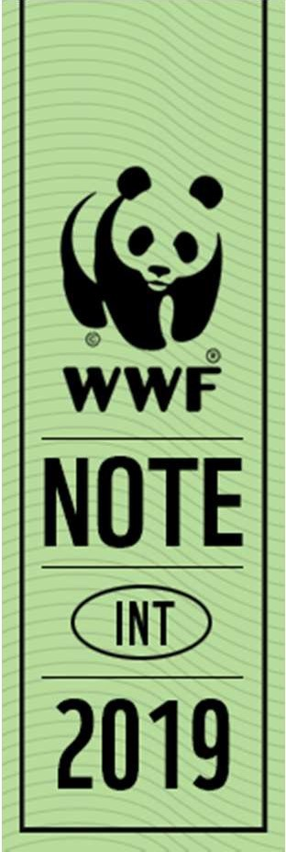
CONSULTATION ON A DRAFT LEGALLY BINDING INSTRUMENT ON THE RIGHT TO DEVELOPMENT

WWF INPUT

Global Policy and Advocacy, July 2019

WWF International (NGO in consultative status with ECOSOC) welcomes the opportunity to provide its input on the consultation on a draft legally binding instrument on the right to development.

At this stage of the process, we will focus our inputs on few elements related with the content of the instrument. The type of instrument as well as institutional arrangements, compliance, monitoring and enforcement mechanisms would probably be easier to define once the scope, objectives, key elements and provisions are clearly defined.

WWF recommends that an instrument on the right to development:

- Fully integrate and build on key environmental obligations, commitments and principles, with a special attention of those that were agreed since the 1986 Declaration on the Right to Development. The following critical instrument should be the basis of any instrument on the right to development:
  - 1972 Stockholm Declaration, 1992 Rio Declaration, Rio+20 Declaration
  - The 3 Rio Conventions: UNCBD, UNCCD and UNFCCC
  - The 2030 Agenda for Sustainable Development
  - Other relevant Multilateral Environmental Agreements depending on the specific issues addressed in the instrument.

- Clearly and explicitly recognizes that a safe, clean, healthy and sustainable environment is the basis of life on earth and it is a necessary condition for the fulfilment of a wide range of human rights, including the right to life, food, health, water and sanitation.

- Explicitly recognizes that, in order to realize the right to development and eradicate poverty and hunger, governments and all other relevant actors should reverse the current dramatic and rapid loss of Nature and Nature’s contributions to people (see IPBES latest assessment and the Global Sustainable Development Report). In fact, without the current free contributions of Nature to people, including clean air and water, food security and nutrition, that are particularly important for the most vulnerable and the poorest, it will be impossible to achieve the right to development.

- Fully recognize the rights of Indigenous Peoples. The instrument should be built on UNDRIP and give particular attention on Indigenous Peoples and local communities collective tenure rights and their rights to withhold their Free Prior and Informed Consent.

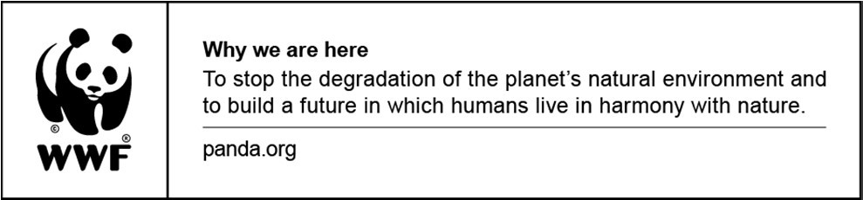

Page 1 of 1

