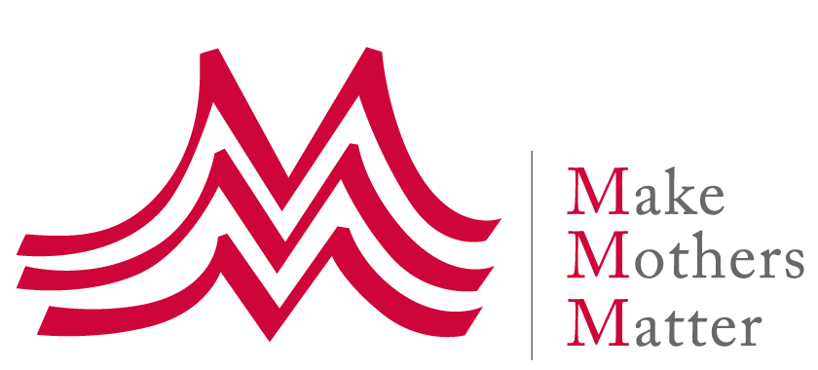
Working Group on the Right to Development
24th session - 15-19 Mai 2023
Input to the 2nd revised text of the draft of the convention on the right to development

We would like to commend and thank the working group for its work on the 2nd draft of the convention, and for the opportunity to provide input.

We suggest 3 changes to the draft text, which all relate to unpaid care work.

The rationale for these edit suggestions

The Covid-19 pandemic has shed light on the issue of the inequitable distribution of unpaid care and domestic work and how it can be a major barrier for women and girls to access education and work, and participate in public life. Addressing this issue is key for the realisation of women’s and girls’ rights, including their right to development, but also for the realisation of the rights of care receivers, in particular children’s and older persons’ rights.

The pandemic has also shown the magnitude of unpaid care work and how essential and foundational this work is for the wellbeing of all, and for the good functioning and future of our society and our economy: it is at the core of the right to development. This work must therefore be recognized, more equitably shared and adequately supported – something that we think should be recognized in the convention.

Unpaid care work was already framed as a human right issue by the UN Special Rapporteur on Poverty Magdalena Sepulveda in her 2013 Report to the UN Geneva Assembly on Unpaid care work and women's human rights.

The importance of this issue is also recognized in the 2030 agenda as it is reflected as one of the 5 targets of Goal 5 on Gender Equality, Target 5.4: ‘Recognize and value unpaid care and domestic work through the provision of public services, infrastructure and social protection policies and the promotion of shared responsibility within the household and the family as nationally appropriate’.

Care as not (yet?) been recognized as a Human Right – Right to care, right to be cared for – but an increasing number of States, in particular in Latin America have now recognized - or have committed to recognize - Care as a Right, and are set to transform to ‘caring society’.

The time has come to take a more holistic view of work, where both paid and unpaid care work are considered, their interrelation and interdependence recognized, and their relevance to the right to development affirmed through the inclusion of this issue on the convention.

Suggested changes

Article 12 – Paragraph 2. To this end, each State Party shall take all necessary measures at the national level, and shall ensure, inter alia, equality of opportunity[, including through digital inclusion where applicable,] for all human persons [individuals] and peoples in their access to basic resources, education, health services, food, housing, and employment, [Care,] [and social security and protection,] and in the fair distribution of income, and shall carry out appropriate economic and social reforms with a view to eradicating all social injustices[, in particular those linked to Gender].

We suggest adding ‘Care’ as a service & infrastructure that States must provide as it is an essential part of a redistributive policy, essential for gender equality.

Article 15 – Paragraph 1. States Parties recognize that certain human persons [individuals], groups and peoples, owing to their marginalization or vulnerability because of race, colour, sex, language, religion, political or other opinion, nationality, statelessness, national, ethnic or social origin, property, [care responsibilities,] disability, birth, age or other status, including as human rights defenders, may need specific and remedial measures to accelerate or achieve de facto equality in their enjoyment of the right to development. Specific and remedial measures can [may] include[, among others,] enabling the full, effective, appropriate and dignified participation of such human persons [individuals], groups and peoples in decision-making processes, programmes and policymaking that affect their full and equal enjoyment of the right to development, without subjecting them to structural, environmental or institutional constraints or barriers.

As stated above, the inequitable distribution of unpaid care work between men and women is one of the main barriers to Gender Equality and the realisation of women’s and girls’ rights. Globally women do 3.2 time more unpaid care work than men, up to 10 times in some countries.

Care responsibilities is therefore an important cause of economic and social vulnerability for women, especially when they are mothers. These responsibilities can be multiple when a women must care for children and an older or dependent relative.

Article 16 – Paragraph 2. To that end, States Parties shall adopt appropriate measures, individually and jointly, inter alia:
(a) To prevent and eliminate all forms of violence and harmful practices against all women and girls in the public and private spheres online and offline, including trafficking [in persons] and [all forms of] sexual and other types of exploitation;
(b) To ensure women’s full, equal, effective and meaningful participation and equal opportunities for leadership at all levels in the conceptualization, decision-making, implementation, monitoring and evaluation of policies and programmes in political, economic, [social,] cultural and public life, and within legal persons[, inter alia by addressing their disproportionate share of unpaid care and domestic work as one of the main structural barrier];
(c) To adopt and strengthen policies and enforceable legislation for the promotion of equality of opportunities and the empowerment of all women and girls at all levels;
(d) To incorporate and mainstream [a] gender perspectives into the formulation, adoption, and implementation of all national laws, policies and practices and international legal instruments, policies, and practices;
(e) To ensure equal and equitable access to, and control over, the resources necessary for the full realization of the right to development by women and girls everywhere;
(f) To ensure equal and equitable access to quality education and services necessary for the full realization of the right to development by women and girls everywhere;
(g) To realize the women, [and] peace and security agenda and ensure the full, effective and meaningful participation of women in the prevention and resolution of armed conflicts and in peacebuilding for the maintenance and promotion of peace and security at all levels.

Further to the above, this addition can be justified in different negotiated texts adopted recently, notably the Agreed conclusions of the 2023 UN Commission on the Status of Women - In particular:
18. The Commission expresses concern about the unequal pace of digital transformation and access to technology within and among countries and the structural and systemic barriers inter alia, gender stereotypes and negative social norms and the disproportionate share of unpaid care and domestic work, undermining the ability of women and girls from securely accessing information and communications technologies and the internet and from being equipped with the knowledge, awareness and skills for their social empowerment and women’s economic empowerment, and connected at a level that allows for a safe online experience at affordable cost especially in developing countries, including the least developed countries and small island developing States and African countries.
76. The Commission recognizes that women and girls undertake a disproportionate share of unpaid care and domestic work, which limits women’s ability to participate in decision-making processes and occupy leadership positions, and poses significant constraints on women’s and girls’ education and training, and on women’s economic opportunities and entrepreneurial activities including in the context of innovation and technological change, and education in the digital age.

Given the importance of this issue for equality between men and women, we could also have an additional paragraph based on existing language (from the CSW agreed conclusion and the 2030 development agenda):
Address structural barriers to equality between men and women, in particular the disproportionate share of unpaid care and domestic work undertaken by women and girls, by recognizing, valuing and redistributing unpaid care and domestic work through the provision of public services, infrastructure and social protection policies and the promotion of shared responsibility

Report of the Special Rapporteur on extreme poverty and human rights, Ms. Maria Magdalena Sepúlveda Carmona on unpaid care work and women's human rights – A/68/293 – Accessible on https://undocs.org/Home/Mobile?FinalSymbol=A%2F68%2F293&Language=E&DeviceType=Desktop&LangRequested=False
See the Buenos Aires Commitment, which was adopted at the XV Regional Conference on Women in Latin America and the Caribbean in November 2022 – Accessible on https://conferenciamujer.cepal.org/15/en/documents/buenos-aires-commitment
See also above the 2013 report of the UN Special Rapporteur on Poverty Magdalena Sepulveda to the UN General Assembly on Unpaid care work and women's human rights – A/68/293
The 2023 CSW67 Agreed Conclusions (E/CN.6/2023/L.3) are available on https://www.unwomen.org/en/csw/csw67-2023/session-outcomes

