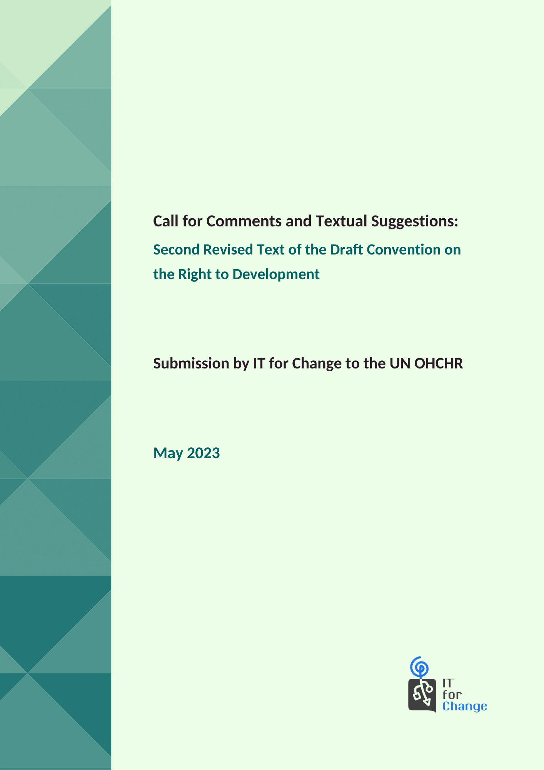

Office of the United Nations High Commissioner for Human Rights

Call for Comments and Textual Suggestions: Second Revised Text of the

Draft Convention on the Right to Development

Submission by IT for Change to the UN OHCHR

Note to the reader:
Recommended additions in the text of the draft convention are in red.
Recommended deletions are in strikethrough.

Introduction
Against the backdrop of rising digital inequalities and human rights violations by digital transnational corporations, the call for comments and textual suggestions to the second revised text of the draft convention on the right to development (Draft Convention) is welcome. We note that the following specific suggestions made by us to the original text of the Draft Convention have been incorporated/adequately clarified:
- IT for Change’s (ITfC) suggestion to incorporate the reference to the Declaration of Principles and Plan of Action adopted at the World Summit on the Information Society (WSIS), including the Tunis Agenda for the Information Society, in the Preamble, has been accepted. We recommended the inclusion of these instruments as they reiterate the indispensable role of digital capacities and infrastructures in promoting the right to development for all. In light of the proposed Global Digital Compact (September 2024) and WSIS+20 Review (2025), the connections between the WSIS principles and development in the digital epoch become crucial.
- In Article 5(3), which pertains to the right to self-determination, we suggested the addition of the data and knowledge commons, including the right to access, control, and benefit from this societal wealth. In response to our suggestion, the Expert Drafting Group has noted that the provision stands modified now, and that it does not restrict itself to “natural” wealth. We welcome the clarification by the Expert Drafting Group in this regard. The data commons are a unique societal wealth, and sovereignty and collective data rights over these are indispensable components of the right to self-determination.
- Under Article 13 (duty to cooperate), sub-clause (1), our suggestion to add the word “technological” to ensure States Parties reaffirm and implement their duty to cooperate in order to solve international problems of, amongst others, technological nature, has been accepted. Further, in the same Article, our recommendation for the inclusion of the phrase, “decent work”, has also been taken. These are vital additions, given the changing world of work, the emergence of the gig economy, and the erosion of worker rights, especially in the Global South.
- With regard to sub-clause (4)(e) of Article 13 (duty to cooperate), we had suggested the incorporation of the “productive capacity and public digital infrastructure creation” in relation to Official Development Assistance (ODA) and financial flows. We note that the Expert Drafting Group has clarified that the text is accommodative of all forms of needs, including this.
Our detailed submissions with regard to the second revised text of the Draft Convention are given below. Broadly, our submission makes inputs to the text with respect to:
- Emphasizing that meaningful enjoyment of the right to development necessitates reducing the technological gap between the developed and developing countries.
- Acknowledging the concerns of the Global South regarding extractive data practices of transnational corporations.
- Ensuring sustainable development includes within its ambit sustainable technological development to counter the increasing carbon footprint of digitization, including frontier technology like blockchain and artificial intelligence (AI).
- Preserving the sovereignty of developing and least developed countries (LDCs) to regulate their policy space.
- Enshrining the commitment that the right to development must be realized in conformity with the full range of digital rights.
- Addressing the concerns of developing and least developed countries regarding rights violations and tax evasion on account of the virtualized nature of the business activities of transnational digital corporations.
- Imposing responsibility upon States Parties to conduct prior assessment of risks and potential extraterritorial impacts of their laws, policies, and practices on the enjoyment of a spectrum of rights.
- Ensuring capacity-building support is carried out in a manner that safeguards developing countries’ sovereignty over the data resources of their citizens.
- Enabling adequate benefit-sharing mechanisms in international data regimes, akin to the Convention on Biodiversity and the Nagoya Protocol.
- Underscoring that barriers to development include technological barriers.
- Foregrounding the prerequisite for the right to development to recognize intersectional forms of discrimination as an impediment to achieving substantive gender equality.

Article Number and Proposed Text | Revised/Recommended by ITfC
Preamble:  Concerned at the existence of serious obstacles to the realization of the right to development comprising, inter alia, poverty in all its forms and dimensions, including extreme poverty, hunger, inequality in all forms and manifestations within and among countries, climate change, health emergencies and health crises, colonization, neo-colonization, forced displacement, racism, discrimination, conflicts, foreign domination and occupation, aggression, threats against national sovereignty, national unity and territorial integrity, terrorism, crime, corruption, all forms of deprivation affecting the subsistence of peoples, and the denial of other human rights, | Preamble:  Concerned at the existence of serious obstacles to the realization of the right to development comprising, inter alia, poverty in all its forms and dimensions, including extreme poverty, hunger, inequality in all forms and manifestations within and among countries, climate change, health emergencies and health crises, technological inequality and data extractivism, colonization, neo-colonization, forced displacement, racism, discrimination, conflicts, foreign domination and occupation, aggression, threats against national sovereignty, national unity and territorial integrity, terrorism, crime, corruption, all forms of deprivation affecting the subsistence of peoples, and the denial of other human rights,  Rationale:  The United Nations Department of Economic and Social Affairs conducted the ‘World Economic and Social Survey 2018’ on frontier technologies for sustainable development. In the Survey, it was observed that “A great technological gap persists, largely explaining the ‘development divide’ between developed and developing countries.” While frontier technologies provide leapfrogging opportunities to developing countries, most developing countries still need to catch up with the previous technological paradigms raising concerns that the development divide will widen with the deployment of Industry 4.0. This requires a concerted effort at the multilateral level to narrow the technological gap through, amongst others, ODA and international public finance.  Digital colonialism, led by Big Tech’s extraction of data from Global South/developing countries limits the latter’s ability to exercise sovereignty over the data of their peoples and territories. The acknowledgment of the concerns of the Global South in the text of the Draft Convention will provide a much-needed fillip to their attempts to preserve their policy space and assert their right to the economic value of data.
Article 3 - General principles:  (g) Sustainable development: development must be achieved in all its dimensions, including, economic, social and environmental, in a balanced and integrated manner and in harmony with nature. The right to development must be fulfilled so as to equitably meet developmental and environmental needs of present and future generations; and the right to development cannot be realized if development is unsustainable; | Article 3 - General principles:  (g) Sustainable development: development must be achieved in all its dimensions, including, economic, social, technological and environmental, in a balanced and integrated manner and in harmony with nature. The right to development must be fulfilled so as to equitably meet developmental and environmental needs of present and future generations; and the right to development cannot be realized if development is unsustainable;  Rationale:  Technology can be an enabler for inclusive and sustainable development. However, the advent of frontier technologies such as blockchain and AI brings to the fore concerns regarding the carbon footprint of digitization. An increase in energy demand, e-waste, and mineral extraction poses a serious threat to sustainable development. As developing countries bear the repercussions of climate change, the developmental gains achieved by them are under threat. It is disconcerting that Big Tech is not committed to reducing its full value chain emissions. The inclusion of the term “technological” in the provision pertaining to sustainable development will provide the necessary impetus to States Parties to hold Big Tech and frontier technology to a higher standard of accountability.
Article 5 - Relationship with the right of peoples to self-determination:  6. Nothing contained in the present Convention shall be construed as authorizing or encouraging any action which would dismember or impair, totally or in part, the territorial integrity or political unity of sovereign and independent States conducting themselves in compliance with the principle of equal rights and self-determination of peoples and thus possessed of a government representing the whole people belonging to the territory, without distinction of any kind. Each State Party shall refrain from any action aimed at the partial or total disruption of the national unity and territorial integrity of any other State. | Article 5 - Relationship with the right of peoples to self-determination:  6. Nothing contained in the present Convention shall be construed as authorizing or encouraging any action which would dismember or impair, totally or in part, the territorial integrity or political unity of sovereign and independent States conducting themselves in compliance with the principle of equal rights and self-determination of peoples and thus possessed of a government representing the whole people belonging to the territory, without distinction of any kind. Each State Party shall refrain from any action aimed at the partial or total disruption of the national unity, development sovereignty and territorial integrity of any other State.  Rationale:  Trade agreements are often used as instruments by developing countries to restrict the policy/regulatory space of developing countries through provisions entailing the prohibition of data localization requirements and transfer of source code. Linked to the national unity and territorial integrity of nation states is their development sovereignty. The inclusion of the suggested addition will ensure the preservation of the right to development of developing countries and LDCs.
Article 6 - Relationship with other human rights:  2. States Parties agree that the right to development is an integral part of human rights and must be realized in conformity with the full range of civil, cultural, economic, environmental, political and social rights. | Article 6 - Relationship with other human rights:  2. States Parties agree that the right to development is an integral part of human rights and must be realized in conformity with the full range of civil, cultural, economic, environmental, political, and social and digital rights.  Rationale:  Technological ubiquity has given rise to a focus on digital rights such as privacy, freedom of speech and expression online, protection from harmful content, demands for algorithmic transparency, freedom from workplace surveillance, etc. Right to development, in the digital epoch, must respect and be realized in conformity with digital rights as these are an extension of the equal and inalienable rights in the United Nation’s Universal Declaration of Human Rights.
Article 11 - Obligation to protect:  States Parties shall adopt and enforce all necessary, appropriate and reasonable measures, including administrative, legislative, investigative, judicial, diplomatic and others, to ensure that natural or legal persons, peoples, groups or any other State or agents that the State is in a position to regulate do not nullify or impair the enjoyment and exercise of the right to development within or outside their territories when:  (a) Such conduct occurs, partially or fully, on the territory of the State Party;  (b) The natural or legal person has the nationality of the State Party;  (c) The State Party has the requisite legal duty under either domestic or international law to supervise, regulate or otherwise exercise oversight of the conduct of the legal person engaging in business activities, including those of a transnational character. | Article 11 - Obligation to protect:  States Parties shall adopt and enforce all necessary, appropriate and reasonable measures, including administrative, legislative, investigative, judicial, diplomatic and others, to ensure that natural or legal persons, peoples, groups or any other State or agents that the State is in a position to regulate do not nullify or impair the enjoyment and exercise of the right to development within or outside their territories when:  (a) Such conduct occurs, partially or fully, on the territory of the State Party;  (b) The natural or legal person has the nationality of the State Party;  (c) The State Party has the requisite legal duty under either domestic or international law to supervise, regulate or otherwise exercise oversight of the conduct of the legal person engaging in business activities, including those of a transnational character, and of a virtualized nature.  Rationale:  Big Tech’s hegemony in the global economy calls for urgent regulatory measures to enforce corporate accountability for human rights obligations, taxation, and cross-border conduct, including in virtualized business operations. The incorporation of the term “and of a virtualized nature” would include concerns that developing countries express in respect of rights violations as well as tax evasion by transnational digital corporations.
Article 11 - Obligation to protect:  States Parties shall adopt and enforce all necessary, appropriate and reasonable measures, including administrative, legislative, investigative, judicial, diplomatic and others, to ensure that natural or legal persons, peoples, groups or any other State or agents that the State is in a position to regulate do not nullify or impair the enjoyment and exercise of the right to development within or outside their territories when:  (a) Such conduct occurs, partially or fully, on the territory of the State Party;  (b) The natural or legal person has the nationality of the State Party;  (c) The State Party has the requisite legal duty under either domestic or international law to supervise, regulate or otherwise exercise oversight of the conduct of the legal person engaging in business activities, including those of a transnational character. | Article 11 - Obligation to protect:  [Renumber existing provision under Article 11 as Article 11(1) and add the following suggested text as sub-clause (2)]  (2) States Parties shall conduct prior assessment, with public participation and public disclosure, of the risks and potential extraterritorial impacts of their laws, policies and practices on the enjoyment of civil, cultural, economic, environmental, political, social and digital rights within or outside their territories, and adopt measures to prevent violations and ensure effective remedies.  Rationale:  With the increasingly transnational and digital nature of global value chains, it is essential to consider the extraterritorial impact of domestic laws. The commentary to the second revised text reveals that Article 11 is derived from the Maastricht Principles on Extraterritorial Obligations of States in the Area of Economic, Social and Cultural Rights. Here we think it apt to add another provision from the Maastricht Principles pertaining to impact assessment and prevention – to enable States Parties to abstain from conduct infringing the rights of other States Parties and their citizens. This is extremely important in an age when AI regulation is seen as key for democracy and rule of law, and ex-ante assessments and the “precautionary principle” are gaining ground as necessary measures before AI models are adopted. Further, the liability for remedies in the event of societal and individual harms needs to be pinned down on entities that do not perform their duty of care with regard to algorithms and AI.
Article 13 - Duty to cooperate:  4. States Parties recognize their duty to cooperate to create a social and international order conducive to the realization of the right to development by, inter alia:  (e) Enhancing capacity-building support to developing countries, including for least developed countries and small island developing States, to increase significantly the availability of high-quality, relevant, timely and reliable disaggregated data;  (g) Enhancing North-South, South-South, triangular and other forms of regional and international cooperation in all spheres, particularly on access to science, technology and innovation, and also enhancing knowledge-sharing on mutually agreed terms, including through improved coordination among existing mechanisms, in particular at the United Nations level and through existing and new mechanisms for global technology facilitation; | Article 13 - Duty to cooperate:  4. States Parties recognize their duty to cooperate to create a social and international order conducive to the realization of the right to development by, inter alia:  (e) Enhancing capacity-building support to developing countries, including for least developed countries and small island developing States, to increase significantly the availability of high-quality, relevant, timely and reliable disaggregated data, while safeguarding the individual and collective data sovereignty of their citizens in such data;  (g) Enhancing North-South, South-South, triangular and other forms of regional and international cooperation in all spheres, particularly on access to science, technology and innovation, and also enhancing knowledge-sharing on mutually agreed terms, while also recognizing adequate benefit-sharing mechanisms, including through improved coordination among existing mechanisms, in particular at the United Nations level and through existing and new mechanisms for global technology facilitation;  Rationale:  The availability of data under Article 13(4)(e) must ensure that the sovereignty of citizens in developing countries is protected, and capacity-building support does not become a way for more powerful countries to enclose/capture valuable data resources from these territories for the business advancement of their corporations.  Similarly, in Article 13(4)(g), knowledge sharing on mutually agreed terms must recognize the inherent difference in political and technological power between Global North and South countries, and enable benefit-sharing mechanisms, as under the Convention on Biodiversity and the Nagoya Protocol, to take precedence.
Article 15 - Specific and remedial measures:  1. States Parties recognize that certain individuals, groups and peoples, owing to their marginalization or vulnerability because of race, colour, sex, language, religion, political or other opinion, national, ethnic or social origin, property, disability, birth, age or other status, may need specific and remedial measures to accelerate or achieve de facto equality in their enjoyment of the right to development. Specific and remedial measures may include enabling the full, effective, appropriate and dignified participation of such individuals, groups and peoples in decision-making processes, programmes and policymaking that affect their full and equal enjoyment of the right to development, without subjecting them to structural, environmental or institutional constraints or barriers. | Article 15 - Specific and remedial measures:  1. States Parties recognize that certain individuals, groups and peoples, owing to their marginalization or vulnerability because of race, colour, sex, language, religion, political or other opinion, national, ethnic or social origin, property, disability, birth, age or other status, may need specific and remedial measures to accelerate or achieve de facto equality in their enjoyment of the right to development. Specific and remedial measures may include enabling the full, effective, appropriate and dignified participation of such individuals, groups and peoples in decision-making processes, programmes and policymaking that affect their full and equal enjoyment of the right to development, without subjecting them to structural, environmental, technological or institutional constraints or barriers.  Rationale:  The inclusion of technological barriers is in keeping with the current draft of the Convention which has already recognized the immense importance of the digital on development-related concerns. This addition brings overall coherence to this aspect.
Article 16 - Equality between men and women:  1. States Parties, in accordance with their obligations under international law, shall ensure substantive equality between women and men, and shall adopt measures, including through legislation and temporary special measures as and when appropriate, to end all forms of discrimination against women and girls so as to ensure their full and equal enjoyment of the right to development. | Article 16 - Equality between men and women:  1. States Parties, in accordance with their obligations under international law, shall ensure substantive equality between women and men, and shall adopt measures, including through legislation and temporary special measures as and when appropriate, to recognize and end all forms of intersectional discrimination against women and girls so as to ensure their full and equal enjoyment of the right to development.  Rationale:  Recognizing and addressing intersectional discrimination is necessary to achieving meaningful substantive equality for all., moving beyond a single-axis discrimination law.

This submission is written by Anita Gurumurthy, Nandini Chami, Amoha Sharma, and Shreeja Sen of IT for Change. For clarifications, please reach out to anita@itforchange.net.
Article 5(3), second revised text of the draft convention on the right to development: All peoples may, in pursuing the realization of their right to development, freely dispose of their wealth and sustainably use their natural resources based upon the principle of mutual benefit and international law. In no case may a people be deprived of its own means of subsistence. Nothing in the present Convention shall be interpreted as impairing the inherent right of all peoples to enjoy and utilize fully and freely their wealth and natural resources in a manner consistent with international law and the provisions of the present Convention.
World Economic and Social Survey 2018 - Frontier technologies for sustainable development. (2018). United Nations. Retrieved April 21, 2023, from https://www.un.org/development/desa/dpad/wp-content/uploads/sites/45/publication/WESS2018_full_web.pdf
UNCTAD. (2022). Industry 4.0 for Inclusive Development. Retrieved April 21, 2023, from https://unctad.org/system/files/official-document/dtlstict2022d4_en.pdf
Goel, D. (2021, May 06). The global digital divide is reminiscent of colonialism. LSE. Retrieved April 21, 2023, from https://blogs.lse.ac.uk/brexit/2021/05/06/the-global-digital-divide-is-reminiscent-of-colonialism/
Cross-border ‘Data flow with data rights’: Going beyond the ‘Data Free Flow With Trust’ (DFFT) framework to include economic rights to data. (2022, September). IT for Change. Retrieved February 21, 2023, from https://itforchange.net/sites/default/files/2208/Cross-Border%20%E2%80%98Data%20Flow%20With%20Data%20Rights%E2%80%99.pdf
Utoikamanu, F. (2018, December). Closing the technology gap in least developed countries. UN Chronicle. Nos. 3 & 4 Vol. LV, "New Technologies: Where To?". Retrieved April 21, 2023, from https://www.un.org/en/chronicle/article/closing-technology-gap-least-developed-countries
UNEP. (2021, November). The Growing Footprint of Digitalisation - Foresight Brief No. 027 November 2021. Retrieved April 21, 2023, from https://wedocs.unep.org/handle/20.500.11822/37439
Dervis, K. (2007). Devastating For The World's Poor: Climate Change Threatens The Development Gains Already Achieved. Vol. XLIV, No. 2, "Green Our World!", 2007. UN. Retrieved April 21, 2023, from https://www.un.org/en/chronicle/article/devastating-worlds-poor-climate-change-threatens-development-gains-already-achieved
Kwet, M. (2022, May 31). Digital ecosocialism - Breaking the power of big tech. Longreads. Retrieved March 03, 2023, from https://longreads.tni.org/digital-ecosocialism
Sengupta, R. Development opportunities or challenges: Looking at the proposed Free Trade Agreement between India and the European Union. Rosa-Luxemburg-Stiftung. Retrieved April 21, 2023, from https://www.rosalux.eu/kontext/controllers/document.php/1002.a/1/17af0e.pdf
Focus on rights in the digital age. (n.d.). OECD. Retrieved April 21, 2023, from https://www.oecd.org/digital/rights/
Hutt, R. (2015, November 13). What are your digital rights?. World Economic Forum. Retrieved April 21, 2023, from https://www.weforum.org/agenda/2015/11/what-are-your-digital-rights-explainer/
Maastricht Principles on Extraterritorial Obligations of States in the area of Economic, Social and Cultural Rights. (n.d.). CIEL. Retrieved April 21, 2023, from https://www.ciel.org/wp-content/uploads/2015/05/Maastricht_ETO_Principles_21Oct11.pdf
Smith, B. (2016). Intersectional Discrimination and Substantive Equality: A Comparative and Theoretical Perspective. The Equal Rights Review, Vol. Sixteen (2016). Retrieved May 11, 2023, from https://www.equalrightstrust.org/ertdocumentbank/Intersectional%20Discrimination%20and%20Substantive%20Equality%20A%20Comparative%20and%20Theorectical%20Perspective.pdf

