ECOSOC Special Consultative Status (2010)

Response to the Call for Comments and Textual Suggestions on the Second Revised Draft Convention on the Right to Development

May 2023, Geneva, Switzerland

Submission by:

ADF International
Rue Pré-de-la-Bichette 1
1202 Geneva, Switzerland

Web: www.ADFinternational.org
Email: UN@ADFinternational.org

Introduction
- ADF International is a faith-based legal advocacy organisation that protects fundamental freedoms and promotes the inherent dignity of all people before national and international institutions. As well as having ECOSOC consultative status with the United Nations (registered name ‘Alliance Defending Freedom’), ADF International has accreditation with the European Commission and Parliament, and the Organisation of American States. ADF International is also a participant in the FRA Fundamental Rights Platform.

- ADF International welcomes the opportunity to submit additional comments and suggestions on the second revised text of the draft convention on the right to development (hereinafter, the ‘Draft Convention’) in view of the resumption of negotiations during the 24th session of the Working Group on the Right to Development.

- The present submission serves to reiterate and expand upon a number of proposals put forth in our earlier written contributions, with a primary focus on the institutional setup of, and interlinkages between, the Conference of States Parties (CSP) and the Implementation Mechanism (IM) in Articles 25 and 27, respectively. Moreover, it offers additional, alternative textual suggestions informed by the feedback received by the Expert Drafting Group (EDG).

- In light of the EDG's response to our proposal concerning Article 27, paragraph 3, subparagraph (a) of the Draft Convention, this written contribution also aims to further elucidate our position and concerns regarding the matter of general comments, notably with respect to the conferral upon the IM of an express competence to ‘[A]dopt general comments or recommendations to assist with the interpretation or implementation of the provisions of the present Convention [emphasis added].’

- Conference of States Parties

- ADF International regrets that its proposal on Article 24, paragraph 2, subparagraph (a) of the first revised text of the Draft Convention, submitted in response to the call for inputs issued by the Working Group on the Right to Development after its 22nd session, namely to transfer the competence to periodically examine reports by States Parties on the implementation of their obligations under the Convention from the CSP to the IM, was neither included in the compilation of comments and textual suggestions, nor addressed in the commentary to the second revised text of the Draft Convention. An accurate representation of our proposals would have facilitated a comprehensive understanding of our position regarding both the relations between the CSP and the IM and the scope of the IM’s general comments or recommendations.
- ADF International takes note of the EDG’s retention of the abovementioned provision in the new revised text of the Draft Convention under Article 25. While maintaining our principled position regarding the independence and impartiality of treaty monitoring bodies, we acknowledge the additional commentary made by the EDG regarding the sui generis nature of both the CSP and IM established under this convention, meant to provide flexibility for States Parties, account for the voluminous reporting burden already imposed on states, and avoid duplication with existing mechanisms. However, we wish to reiterate our concerns about the accountability gap that would be created without some necessary adjustments.

- It remains a subject of concern whether entrusting the competence to periodically examine States Parties’ reports to an intergovernmental body would ensure the requisite levels of impartiality and objectivity needed for a human rights treaty body. Moreover, as also noted by the EDG in its commentary to the second revised text of the Draft Convention, there is no express requirement for States Parties to submit periodic reports, nor is there any timeframe indicating the periodicity at which States Parties should undertake such submissions.

- While we acknowledge the intention of EDG for the convention’s monitoring mechanism to operate on a non-adversarial, non-punitive, facilitative, co-ordinational and assistive basis, vesting the IM with the competence to examine States Parties’ reports would not hinder the realization of this objective. Instead, it would provide a measure of third-party oversight and accountability, while also lending greater authority to the diverse range of activities to be undertaken by the IM in accordance with Article 27.

- Accordingly, ADF International reiterates its proposal to delete Article 25, paragraph 2, subparagraph (a) of the Draft Convention. It is emphasised that this textual suggestion should be read in conjunction with the proposed addition of a new subparagraph (a) to Article 27, paragraph 3 to endow the IM with the competence to receive and examine States Parties’ reports (see below).

- Should the competence to receive such reports ultimately remain with the CSP, ADF International respectfully submits that the provision that ‘the Conference of States Parties may refer such reports to the implementation mechanism contemplated under Article 27 of the present Convention [emphasis added]’ should be amended to allow for the IM’s systematic involvement in this process, rather than leaving it at the discretion of the CSP. This would bridge the gap in expertise and knowledge that the IM may otherwise face, while also mitigating the risk of selectivity in the referral of such reports. Moreover, enabling the IM to engage with States Parties in this context would contribute to other aspects of its mandate, including but not limited to the adoption of general comments or recommendations.

- Based on the aforementioned, ADF International recommends to, in Article 25, paragraph 2, subparagraph (a), replace “may” with “shall”.
(b) Implementation Mechanism

- ADF International notes with disappointment that its proposal on Article 26 (now Article 27), paragraph 2 of the first revised text of the Draft Convention, aimed at ensuring that the independent experts composing the IM be elected by States Parties from among their nationals, was also neither included in the compilation of comments and textual suggestions, nor addressed in the commentary to the second revised text of the Draft Convention.
- In relation to Article 27, paragraph 3 of the new revised text of the Draft Convention, and as a corollary to the proposed deletion of Article 25, paragraph 2, letter (a), ADF International reiterates its proposal to add a new subparagraph (a) entrusting the IM with the competence to periodically examine reports by States Parties on the implementation of their obligations under the Convention, and in this regard to make such suggestions and general recommendations on these reports as it may consider appropriate.

- Second, we reaffirm the need to require the general comments or recommendations adopted by the IM to be based strictly on, and related to, the information contained in the periodic reports submitted by States Parties. In fact, the stated goal of a non-punitive, non-adversarial, facilitative, and co-operational mechanism enshrined in paragraph 1 of Article 27 would be better served if such comments and recommendations reflected and built upon evidence of state practice, instead of endeavoring to interpret treaty provisions as currently mandated by the Draft Convention under paragraph 3, letter (a) of the same Article. Anchoring the inputs of the IM to the information obtained from States Parties' reports would also guard against any potential overreach, and thus enhance the authority and credibility of its work.
- Lastly, irrespective of whether the competence to receive States Parties’ reports is transferred to the IM, ADF International wishes to renew its proposal to explicitly acknowledge the prerogative of States Parties to submit written observations in response to the inputs provided by the IM. This proposition aims to foster increased collaboration and promote synergies between the States Parties and the IM, in alignment with the guiding principles enshrined in Article 27, paragraph 1.

- Based on the aforementioned, and consistent with the letter and the spirit of the various ‘core’ international human rights instruments, ADF International calls for the reformulation of Article 27 as follows:

Article 27 Establishment of an implementation mechanism
1. At its first session, the Conference of States Parties shall establish an implementation mechanism to facilitate, coordinate and assist, in a non-adversarial and non-punitive manner, the implementation and promotion of compliance with the provisions of the present Convention.
2. The implementation mechanism shall consist of independent experts elected by States Parties from among their nationals, consideration being given to, inter alia, gender balance and equitable geographical representation, as well as to an appropriate representation of different legal systems. Experts shall serve in their personal capacity and shall be of high moral standing and recognized competence and experience in the field covered by the present Convention.
3. The implementation mechanism shall:
(a) Periodically examine reports by States Parties on the implementation of their obligations under the Convention, and in this regard to make such suggestions and general recommendations on these reports as it may consider appropriate;
(a) (b) Adopt general comments or recommendations to assist in the interpretation or implementation of the provisions of the present Convention In order to foster the effective implementation of the Convention and to encourage international cooperation in the field covered by the Convention, make suggestions and general recommendations based on information received pursuant to subparagraph (a);
(c) Transmit to any State Party concerned and report to the General Assembly its suggestions and general recommendations under subparagraphs (a) and (b), together with comments, if any, from States;
(b) (d) Review obstacles to the implementation of the Convention at the request of the Conference of States Parties;
(c) (e) Review requests by rights holders to comment on situations in which their right to development has been adversely affected by the failure of States to comply with their duty to cooperate, as reaffirmed and recognized under the Convention;
(d) (f) Undertake any other functions within the scope of the Convention that may be vested by the Conference of States Parties.
4. The Conference of States Parties shall adopt rules of procedure for the operation of the implementation mechanism.
- In the event that the competence to examine States Parties’ reports is not transferred to the IM, ADF International urges that careful consideration be given to all other textual suggestion contained in paragraph 2 and 3 above.
(c) Scope of General Comments or Recommendations

- Finally, ADF International wishes to address the response provided by the EDG in its commentary to the second revised text of the Draft Convention regarding our perspective on the conferral upon the IM of the power to adopt general comments to ‘assist with the interpretation or implementation of the provisions of the present Convention [emphasis added].’

- At the outset, ADF International firmly acknowledges the valuable role performed by treaty monitoring bodies in making suggestions and general recommendations based on the scrutiny of reports and other information submitted by States Parties as part of their reporting obligations. As mentioned in our prior submission, however, it is evident from an ordinary reading of the relevant provisions of the core international human rights treaties that general comments or recommendations are not designed to engender evolutionary interpretations of treaty obligations, but rather to assist States Parties with their implementation in a supportive and non-prescriptive manner.

- In this regard, while it is not necessary to reproduce its comments in their entirety at this juncture, our prior submission argued that treaty monitoring bodies have in some instances accorded themselves the “self-regulatory prerogative” to deliver dynamic interpretations of their constitutive instruments, and that indeed in a number of cases such interpretations stand in flagrant contradiction with the established rules of interpretation of treaties. We also argued that without an express conferral of the competence to consider the periodic reports submitted by States Parties, and in the absence of an explicit requirement that the content of general comments or recommendations be based on the information contained in such reports, the IM would not possess the requisite experience and legitimacy to issue general comments or recommendations of any nature.

- While it is beyond the scope of this submission to comprehensively account for all instances in which States have contested the normative validity of general comments and institutional competence of treaty monitoring bodies to produce evolutive interpretations of treaty obligations, it is worth emphasizing that ample evidence of such objections is not only apparent in the written observations submitted by States Parties in response to general comments and recommendations (multiple instances of which have been referenced in our previous submission), but can also be derived, among other sources, from the records of the UN General Assembly's 2020 review of the UN human rights treaty body system.

- Indeed, numerous written contributions submitted as part of this process, representing the views of at least 70 States, present a contrasting view to the assertion made by the EDG that ‘practice and record demonstrate an overwhelming support by most States to the mandate and work of the committees in providing interpretative guidance although some States may, from time to time, disagree on some specific interpretations.’ These contributions collectively reflect the concerns outlined in our previous submission regarding the nature and scope of general comments, and support the more cautious approach advocated in our proposals concerning Article 27.

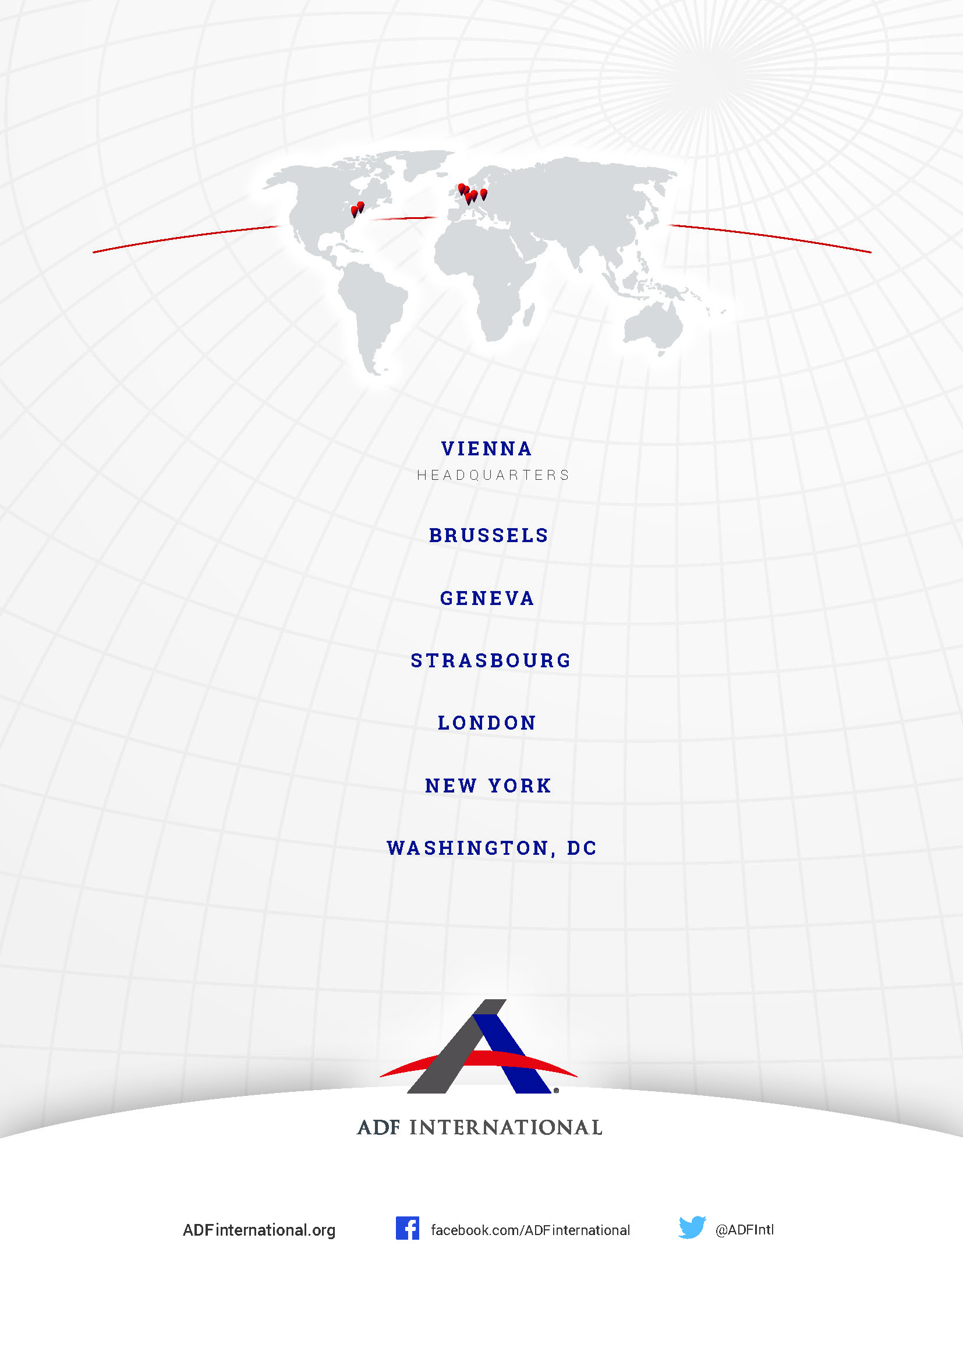

UN Human Rights Council, Second Revised Text of the Draft Convention on the Right to Development, with Commentaries, A/HRC/WG.2/24/2/Add.1.
Comments and Textual Suggestions by ADF International after the 22nd Session of the Working Group on the Right to Development, available at https://www.ohchr.org/sites/default/files/2022-03/adf-international.docx, paras. 14-16.
Second Revised Text of the Draft Convention on the Right to Development, with Commentaries, supra note 1, at pp. 143.
Second Revised Text of the Draft Convention on the Right to Development, with Commentaries, supra note 1, at pp. 130, 134-135 ("This silence is entirely intentional and indicates that the reporting envisaged is voluntary and not mandatory" and "[I]t would be prudent to leave reporting under this draft convention to the discretion and wisdom of each State Party.").
Comments and Textual Suggestions by ADF International after the 22nd Session of the Working Group on the Right to Development, supra note 2, at paras. 17-20.
See, inter alia, the written contributions submitted by the African Group (supported by Saudi Arabia, Singapore, Pakistan, the Russian Federation, Belarus, Bahrain, Yemen, the United Arab Emirates, Nicaragua and Cuba), Algeria, Belarus, China, Eritrea, the Holy See, Nigeria, Singapore, Syria, the Philippines, and the Russian Federation, available at https://www.ohchr.org/en/calls-for-input/co-facilitation-process-treaty-body-review-2020, “Inputs received”.
Second Revised Text of the Draft Convention on the Right to Development, with Commentaries, supra note 1, at pp. 140-141.

