**REPUBLIC OF NAMIBIA**

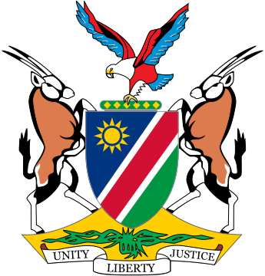

**MINISTRY OF JUSTICE**

**Inputs to the High Commissioner’s Annual Report on the right to development**

1. **How does the Namibian Government leverage human rights obligations, including the right to development through engagement and negotiations with International Financial Institutions (IFIs)?**

In protecting the human rights of all Namibian, the government has ensured that it forms part of the nation’s developmental foundation, by basing the vision 2030 and subsequently the national development plans on its human rights obligations to the citizens. We have ensured that all programs and projects take this obligation into account and becomes a requirement when engaging with International Financial Institutions, and ensured that funding or technical assistance requested will target projects and areas that has impact in addressing socio-economic problems that are affecting the country. For example, projects that are eligible for funding from International institutions are the ones that have a potential to generate employment, reduce poverty and destitutions. These issues are discussed at the early stage of the engagements and forms part of the triggers that have to be achieved before the disbursement is done.

1. **What kind of support, if any would Namibia need from OHCR and other international Partners to include human rights and right to development in engagement with IFI’s? And how is Namibia’s classification as upper middle-income country negatively impact Government’s efforts to progressively realize economic, social and cultural rights, including the rights to development.**

Namibia was classified as an upper-middle Income country in 2009. This classification has consequences, in that the country is not able to access developmental assistance in term of grants and soft loans. As such Namibia can only get technical assistance and commercial related loans that come with high interest rate. The main contention is the fact that Namibia’s GDP per capita is high, income distribution is highly skewed, with only the top 5 percent of the population owning most of the productive assets and income, while the majority of the population depend mainly on subsistence agriculture for livelihoods proving a challenge for government to provide services for the majority of the poor proportion of the population. The country has also been affected by the HIV/AIDS pandemic. Of recent, the government has been investing heavily in the social sector, in order to reduce poverty and inequality.

1. **Kindly provide examples of how financial assistance and funding by IFI’s to Namibia have supported or hindered the realization to development.**

Namibia received assistance from Institutions such as IFC, AfDB, World Bank and IMF, mainly in the form of loans and technical assistance. IFC mostly provide loans to Developmental Finance Institutions that lend to the private sector, AfDB provide project financing and budget support loans, while IMF has provided a Rapid Financing Facility to assist with reducing the impact of Covid-19 on the economy and the population. What we have seen is that these assistances have supported the country in the realization of developmental agenda, however the country could be assisted better, if it could access soft loans and grants from IFI’s, given the point mentioned in question 2 above.