Response to the Special Rapporteur on Cultural Rights

Call for inputs to a report on cultural rights and sustainable development.
This submission is made by Land Body Ecologies (LBE), an interdisciplinary research group seeking to understand the suffering that occurs when land and relationships to land are harmed.

I. The cultures of development
- What is your understanding of what “development” should aspire to?
Development should be an ongoing process that aims to change structures in societies. The current model places ‘growth’ at its heart, when instead it should be based on ‘improvement’. Development should aspire to actions for change with the goal of improving the health and wellbeing of all people, peoples and the environment, equitably.
II. The cultural rights dimension of the sustainable development goals
6. Have the development priorities or the assistance provided by international organisations impacted negatively on some aspects of your country’s (sustainable) development policies?
In Thailand, the central government and UNESCO have either not taken cultural rights into consideration at all or not adequately enough.
For example, in the Kaeng Krachan conflict the Thai government dictates that people do not belong in forests and do not take into account the integral stewardship the Pgak’yau (Karen) community provides. At the heart of the problem, the government does not recognize indigenous communities, accusing them of being migrants from Myanmar, despite the community having lived in Baan Jai Phaen Din for centuries. They refuse to recognise and respect land rights.
Sustainable Development Goal 11 pledges to “makes cities and human settlements inclusive, safe, resilient and sustainable,” and target 11.4 aims to “strengthen efforts to protect and safeguard the world’s cultural and natural heritage.” In 2021, UNESCO officially granted Krachan Forest Complex in Western Thailand World Heritage Site status, despite calls and protests from the Pgak’yau community and human rights experts to reconsider and delay on the basis of violating the community’s land rights.
The creation of the national park and the granting of World Heritage Site status has an immense impact on cultural practices of the community, such as rotational framing. In Karen culture, rotational farming is based around a rotation of 7 plots of land. The number 7 is also central in how they practice their spirituality.
For this submission, Siwakorn Odacho, a farmer and member of the Karen community states:
“7 is important to recover some things that we as humans use or break down the habitat of ecosystems in any way to the Earth. 7 days, 7 months, 7 years, nature (plants, seeds, life stocks, trees, micro organisms, etc.) can heal and fix the system back, but in the case of Monocropping this is not considered.”
Traditional stories told over generations carry the knowledge of this communal practice of rotational farming and particular local plants and wildlife feature heavily in these cultural narratives. Karen practice “is in telling stories” all rooted in the land and their histories with the cycle of living on their ancestral lands. Therefore the development of international parks such as in the Kaeng Krachan Western Forest Complex, sever the communities cultural practice of farming their lands in collaboration with nature, and in turn marginalizes their narratives, ceremonial practices and world views. In addition, the lack of legal government frameworks for Karen to “own their land” means agricultural development remains a constant threat, with many having to sell their plots for last resorts to fund personal healthcare, shrinking the sites on which they practice. Local farms encroaching on their land and introducing pesticides contaminates their nearby crops and soils.
For this submission, Siwakorn Odacho also adds:
“Monocropping continues to use the ecosystem until it is broken and then depends on other input for example chemical fertilizers, chemical herbicide, GMO chemical seeds, and is dependent on the market. People are less self-reliant then this becomes risky for living costs if the knowledge of management is not good, finally people will be trapped. But the marginalized people do not have enough power to push the central government to listen and support compared to big corporations and companies.” - Siwakorn Odacho, a farmer, member of the Karen community and Land Body Ecologies collaborator

- Where cultural resources and creative capacities were leveraged in achieving the SDGs, what were in your experience the results, successes, weaknesses, or lessons learned?
The Batwa in Uganda were evicted from their ancestral forests due to the creation of a national park – Bwindi Impenetrable National Park – in 1991. As a result, they live in significant poverty on the periphery of their ancestral lands or in settlements in districts around it.

SDG 8 focuses on ‘decent work and economic growth’, under which target 8.9 states ‘By 2030, devise and implement policies to promote sustainable tourism that creates jobs and promotes local culture and products.’ There is recognition that Batwa live in significant poverty, and as such, numerous economic initiatives have been implemented to use tourism as a reliable income stream to alleviate poverty. This trend has, however, turned Batwa culture into a tourist attraction.

For example, tourists (mostly foreign), often sign up for what is commonly referred to as ‘the Batwa experience’. This is a guided trail led by Batwa to take guests around the forest and to show how the community used to live in the forest prior to their eviction, how they would hunt, what they would eat, what plants they would pick to cure illnesses and which flowers they would boil to extract a specific colour to feature in the traditional baskets handwoven by Batwa, among other things. Tours often end with a musical performance by Batwa where they dance and sign to tourists.

There are several reports that hail this venture to turn Batwa culture into a tourist attraction a success, however, Land Body Ecologies’s research is unpacking the mental health dimensions of what it means for the Batwa to perform their culture to foreigners, but not be allowed to practice and embody it as a community, since they are not allowed to access the forest – on which their traditional culture is heavily reliant. Leveraging Batwa culture as a tourist attraction is problematic because performing culture for foreign, often western, gaze is unethical.

In this case, the Batwa are only allowed to experience their culture through performance for a foreign, tourist gaze, all in the name of profit. The monetization of Batwa culture when the community itself cannot practice and embody it in their daily reality - due to them being denied the right to access their ancestral lands on which their traditional culture is hugely reliant - presents a model where the enjoyment by an outsider of an indigenous community’s culture is prioritized over the community’s enjoyment itself. This is deeply unethical.

In a study on revenue sharing in Bwindi, a Batwa focus group raised the issue of equity in process to ensure their views were heard and considered. It was “the only focus group to raise issues of recognition saying that the RS scheme should treat the Batwa with respect, including recognizing their unique identity and values.”

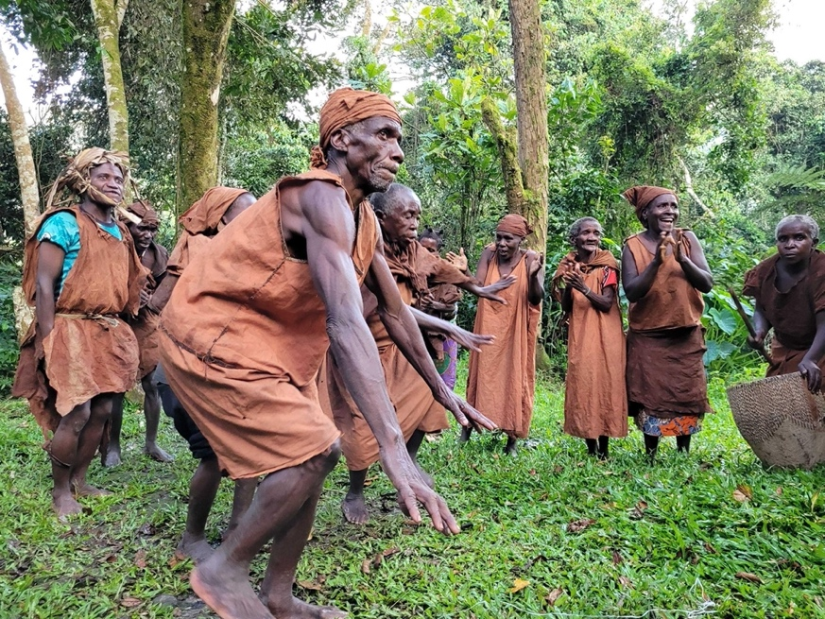
Members of the Batwa community performing a traditional dance in traditional clothing. Credit: Land Body Ecologies

Sylvia Kokunda, Chief Executive Officer of Action for Batwa Empowerment Group, a member of the Batwa community herself and core team member of Land Body Ecologies explains how performing for tourists has become a process of survival for the community. On how that makes her and her community feel, she states:

“This leaves a big wound in our hearts but nothing to do, since we need to survive… soon, I think and believe we are going to lose our identity.”

Additionally, funds that come through these programs often don’t reach individuals within the community or to community members engaged in the performances. Sylvia and Victoria explain that:

“The community sees how individuals and NGOs use their culture for self benefit. The losses expressed are multiple. It is felt by the elders that the younger generation will not understand this because they know the performances take place for survival, and it is feared they will not see the importance in conserving it.”

For this submission, on the matter of whether payment reaches the community, Sylvia Kokunda states:

“Even during the performance, the community will talk about how much we miss most of the things we used to perform or do from our ancestral land. But when tourists pay, the Batwa only receive 5% of the amount paid or they are not paid at all. Instead, they may be promised to be paid another day if they get other visitors.

Money goes directly to people who use the Batwa, and Batwa are paid disproportionately low. Like today what happened, tourists paid 200 USD and Batwa performers were only given 30 USD. They were a group of 30 Batwa. So, each got less than a dollar while the rest of the money remains with the owner of the dancing site – who is not Batwa.”

And lastly, on how this model makes the community feel, particularly older people in the community, she adds:

“We want to practice and preserve our culture so that even our younger generation will know it. It is their right to know their culture.”

Resources
- Walk like a bee - Swae and Joni Odochao in conversation -
This is an interview discussion on Karen philosophies on caring for the earth and the political issues that have impacted this. Watch it here: https://vimeo.com/520915262

“โถ่บีข่า”
This film was made with the Ban Nong Tao Pgak’yau (Karen) community in Thailand. It tells the story of rotational farming culture, a symbiotic practice that is centuries old. Watch it here: https://vimeo.com/599736837?embedded=true&source=vimeo_logo&owner=6338755

- Rotational Farming Photo essay
A photo essay by by Jen Katanoutant and Siwakorn Odacho about traditional rotational farming in the Karen community. Read it here: https://medium.com/@landbodyecologies/rotational-farming-photo-essay-598fb56b5c6a

Environmental Justice Atlas (2020). Land conflict between the state and Karen group in Kaeng Krachan National Park, Thailand. https://www.ejatlas.org/conflict/land-conflict-between-the-state-and-karen-group-in-kaeng-krachan-national-park-thailand
IWGIA (2021). Protect the Indigenous Karen to return home safely https://www.iwgia.org/en/news/3996-protect-the-indigenous-karen-to-return-home-safely.html
Benar News (2021), UNESCO Adds Thai Park to World Heritage List, Amid Karen Rights Concerns https://www.benarnews.org/english/news/thai/heritage-list-07272021162504.html?fbclid=IwAR2VcWhQjp8SfMeRGET1cJXBE7guFaIRP0Qhk5WRoa7-QdM1pDICi_3Fz5g
Phil Franks and Medard Twinamatsiko (2017). Lessons learnt from 20 years of revenue sharing at Bwindi Impenetrable National Park, Uganda. https://www.greengrowthknowledge.org/sites/default/files/downloads/best-practices/Lessons%20learnt%20from%2020%20years%20of%20revenue%20sharing%20at%20Bwindi%20Impenetrable%20National%20Park%2C%20Uganda.pdf
Sylvia Kokunda and Victoria Pratt (2022). Environmental loss is culture loss https://medium.com/@landbodyecologies/environmental-loss-is-culture-loss-42d81adb1921
Sylvia Kokunda and Victoria Pratt (2022). Environmental loss is culture loss https://medium.com/@landbodyecologies/environmental-loss-is-culture-loss-42d81adb1921

