Submission to the Special Rapporteur in the field of cultural rights
Date: 13 November 2023
Re: Call for input on the right to access and take part in scientific progress

Introduction
- Treatment Action Group (TAG) is an independent, activist, and community-based research and policy think tank committed to racial, gender, and LGBTQ+ equity; social justice; and liberation, fighting to end HIV, tuberculosis, and hepatitis C virus.
- TAG envisions the end of the HIV, tuberculosis, and hepatitis C virus pandemics with the discovery, development, and worldwide dissemination of safe and effective diagnostics, preventives, and cures through public health structures that end systemic harms and promote human rights, and that are developed by the diverse communities most affected by these conditions. This vision will be realized based on data and science and achieved through community engagement and equitable access to the benefits of science.
- This submission is based on ongoing analyses of the right to enjoy the benefits of scientific progress and its applications (right to science) that TAG has been developing through a number of UN submissions, academic writing, and learning materials. Our input focuses on question 9 from the call-for-inputs: “How is the right of every person to participate in scientific progress and in decisions concerning its direction understood and implemented? What are the challenges? How are lack of representativeness of marginalized groups and inequalities in participation addressed?”
Definitions: understanding the participation of non-scientists in scientific progress
- Participation is one of the animating values of the right to science and should be broadly understood to include the activities of scientists themselves as well as the meaningful involvement of non-scientists. General Comment 25 (GC 25) of the Committee on Economic, Social and Cultural Rights endorses this inclusive interpretation of participation, stating: “The right to enjoy the benefits of scientific progress cannot be interpreted as establishing a rigid distinction between the scientist who produces science and the general population, entitled only to enjoy the benefits derived from research conducted by scientists.”
- GC 25 uses the term “general population” to refer to the category of non-scientists but operationalizing this notion of participation requires rendering this expansive term with greater specificity — moving from “breadth” (everyone) to “depth” (specific communities, constituencies, categories of participants). Recognizing different types of participants in science will aid states in implementing the right of every person to take part in scientific progress and decisions concerning its direction. Models of participation may look different in different scientific fields even if the underlying ethical and moral commitments on which participation in science rests are shared.
- In TAG’s field – global health research addressing tuberculosis (TB), HIV, and hepatitis C virus – the most common term used to refer to the participation of non-scientists is “affected communities” e.g., “people affected by TB.” This term includes people with and at risk of TB as well as the broader constellation of relations, caregivers, and community members affected by tuberculosis. The rich tradition of community participation in global health research evident today dates back to the start of the AIDS movement, when people living with HIV and dying of AIDS fought for equal footing in HIV/AIDS research.
- The right of people affected by a disease to participate in all decisions concerning their lives has been a core tenant of global health research since the formulation of the 1983 Denver Principles. Rejecting the passivity of labels such as “victims,” “patients,” or “subjects,” a coalition calling itself People with AIDS laid out a vision of self-determination, autonomy, and empowerment that reshaped how global health research is organized and conducted. This vision articulated in the Denver Principles included the right of people with AIDS “to be involved at every level of decision-making;” “to be included in all AIDS forums with equal credibility as other participants;” and to receive “full explanations of all medical procedures and risks, to choose or refuse their treatment modalities, to refuse to participate in research without jeopardizing their treatment, and to make informed decisions about their lives.”
- Activists groups like ACT UP and TAG brought the Denver Principles to life by agitating for people living with HIV to have an equal voice at each stage of the research process — from setting the overall scientific agenda, to shaping the questions studied in key trials, to overseeing how people living with HIV were treated in research, to informing the translation of research results into policy, to finally ensuring that people in need could benefit from new diagnostic, therapeutic, and prevention tools. In the words of Mark Harrington, ACT UP member and founder of TAG:
“AIDS treatment activism in the United States during the 1980s and the 1990s helped to create a new paradigm for responses to epidemics by affected communities [and] [. . .] led to several very important changes in the way that research was done, including expanded access to experimental drugs; the involvement of activists and HIV-infected persons in every protocol committee, research committee, peer review committee, and data safety monitoring board; and the formation of local, national, and drug company community advisory boards.”
- Today, this history has evolved into a widely recognized norm that communities affected by a particular disease or condition have a right to participate in research as more than just clinical trial participants or passive beneficiaries of medical advancement. This norm is sometimes expressed as the “Great Involvement of People with AIDS” (GIPA) or referred to by its ultimate goal: “Nothing about us, without us!” Best practices for operationalizing this norm exist in the form of guidelines, such as the Good Participatory Practice (GPP) guidelines for TB and HIV research, which scientists can use to create space for meaningful community participation. In turn, affected communities have invoked these standards to advocate for a voice in the research process and scientific agenda setting.
Actions: specific models of non-scientist participation
- One specific model by which affected communities participate in medical research is through Community Advisory Boards (CABs). Composed of people living with and affected by TB, HIV, or other diseases, CABs act in an advisory capacity to scientists, funders, and pharmaceutical companies conducting clinical trials or public health studies. They raise community perspectives on research design and practices and create a bridge between scientists and the communities in which science unfolds.
- CABs do more than facilitate the exchange of information between scientists and communities; they actively intervene on the research itself – on a number of levels. In the field of TB research, CABs have proposed studies, objected to the exclusion of certain populations from studies, questioned the utility of specific study procedures, and offered views on whether the overall TB research agenda is moving in a direction that will meet the needs of people with TB. CABs have also helped to improve the visibility and legibility of research within communities. To quote one CAB coordinator from a TB clinical site in Kenya:
“The role of CABs has been very significant in gaining community buy-in for research. When I started coordinating CABs in Kenya, there was a lot of resistance to research. Community members thought that they were being used as guinea pigs. As much as researchers tried, the community resisted—until the CAB was formed.
Through CABs involving different stakeholders, we have been able to gain trust. Communities look at research and they see that this is our own thing; it is something that is going to benefit all of us. Everybody is able to give their views, which get absorbed into the research system. By doing this, every stakeholder sees how research is going to benefit us.”
- In 2011, TAG founded the Global TB Community Advisory Board (Global TB CAB) to act in an advisory capacity to product developers, research funders, and institutions conducting clinical trials of new TB drugs, regimens, diagnostics, and vaccines, and to provide input on study design, early access, regulatory approval, and implementation strategies. To mark its 10-year anniversary, in 2022 the Global TB CAB commissioned an independent evaluation of its impact, the findings of which demonstrate the power of creating spaces for non-scientists to participate in science and decisions concerning its direction. Two examples are worth highlighting:
- The evaluation found that the Global TB CAB contributed to “a ‘transformative change’ that disrupted power dynamics on multiple levels in a way that has reshaped the overall environment of TB R&D. Through the TB CAB’s work, TB survivors and advocates have more power in decisions about research and policies that guide national TB programs.”
- To give one recent example, the Global TB CAB published its view that the dominant paradigm driving TB treatment research—shortening the long duration of TB treatment—overlooked other priorities of people with TB, such as the safety and tolerability of drug regimens. Through its engagement with TB drug developers, the Global TB CAB noted that “most ongoing and planned TB therapeutic trials are focused on shortening the duration of treatment while giving less consideration to other aspects of TB care that are important to people with TB." Global TB CAB members argued that other variables besides duration of TB treatment should be considered when developing new drug regimens, including drug toxicity, side effects, time spent in monitoring, and overall quality of life while on therapy. Moreover, the group noted that where studies have focused on shortening treatment, researchers have narrowly construed duration by focusing only on the amount of time a treatment must be taken while overlooking the time people on treatment need to spend engaging in all aspects of care and recovery.
- In terms of specific impact on clinical trial design, researchers interviewed as part of the evaluation “felt that the TB CAB played an instrumental role in pushing for the inclusion of vulnerable populations in clinical trials, especially children, which resulted in rapid uptake of recommendations for global pediatric treatment guidelines.” The role of non-scientist community members affected by TB in expanding TB research and extending its benefits to include children is an example of the intrinsic relationship between participation and access (discussed in more detail in the section below).
- The participation of members of TB-affected communities carries both inherent and instrumental value for the scientific enterprise (see Figure 1). As states fulfill their obligation to ensure the right of every person to take part in scientific progress, it is important that participation not become instrumentalized as merely a means to the end of “better science,” however defined. Participation must be understood as an indelible part of the right to science as well as a human right in itself — i.e., the right to participate in political and public life (UDHR Art. 21 and ICCPR Art. 25).

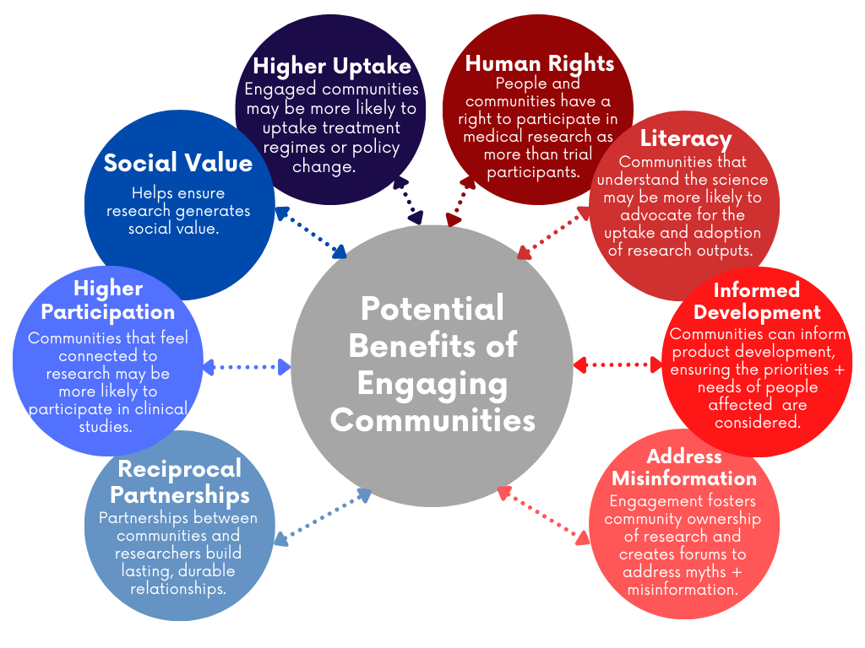
Figure 1: Inherent and Instrumental Benefits of Community Engagement in Global Health Research (credit: TAG)
Intrinsically linked: participation, non-discrimination, and access to scientific benefits
- Participation is also a prerequisite for accessing the benefits of scientific progress. On the most basic level, participation ensures that scientific progress is applicable and relevant to specific groups of people, particularly marginalized populations. To take it a step further: without fostering participation, States cannot live up to the duty of ensuring non-discrimination in access to science and its benefits. Participation as a precondition of non-discrimination in access becomes clear when considering State obligations to deliver on the five elements of the right to science named in GC 25: availability, accessibility, acceptability, quality and the protection of freedom of scientific research.

- The right to science articulates state obligations for the purposive development of science and technology in ways that ensure the availability, accessibility, affordability, and quality of scientific goods, especially for vulnerable or marginalized groups. This so-called AAAQ standard is recognized by GC 25 as containing the “essential elements” of the right to science (as well as other economic, social, and cultural rights such as the right to health and the right to education).,
- Non-discrimination is at the heart of each of the AAAQ elements. With regards to availability, GC 25 notes “States parties should direct their own resources and coordinate actions of others to ensure that scientific progress happens and that its applications and benefits are distributed and are available, especially to vulnerable and marginalized groups.” As a part of accessibility, GC 25 stresses that “States parties should ensure that everyone has equal access to the applications of science, particularly when they are instrumental for the enjoyment of other economic, social and cultural rights.” GC 25 continues by saying: “States parties should remove discriminatory barriers that impede persons from participating in scientific progress, for instance, by facilitating the access of marginalized populations to scientific education.” TAG believes that such access must extend beyond scientific education to encompass participation in scientific activities broadly understood. In our field, this would include participation in clinical trials and other health intervention studies.
- The systematic exclusion of certain groups from research studies reinforces disparities in which some populations shoulder a greater burden of disease than others. In the context of TB, this manifests in the tendency of clinical trials to favor enrollment of “typical” TB patients with easier-to-treat forms of disease. As a result, people with complicating comorbidities (e.g., HIV, diabetes) or severe disease manifestations (e.g., TB meningitis) are left out of trials; they are not allowed to participate in research, even if they would choose to do so after providing informed consent, because they have been labelled as ‘ineligible’ per the protocols governing clinical trials. Other groups deemed vulnerable to scientific harm as a class — e.g., children, adolescents, and pregnant women — are excluded out of a misplaced desire to protect these populations from harm.
- In reality, research protection interpreted as exclusion amplifies TB-related harms. Evidence-based guidelines cannot be made in the absence of evidence that an intervention works in a particular population. Some of the populations most vulnerable to TB are either not represented in normative guidance produced by the World Health Organization or must wait years for well-established interventions to be recommended for their use.
  - To take just one illustrative example: more than 60 years elapsed between when the most common TB preventive treatment regimen (isoniazid preventive therapy) was first introduced and when it was first studied systematically in pregnant women, who face a higher risk of TB infection and disease than the general population. When the first clinical trial of isoniazid preventive therapy was finally completed in 2019, researchers found a higher risk of adverse pregnancy outcomes among women who received the treatment during pregnancy, and a higher risk of liver toxicity among women who received it postpartum – both findings that upended prevailing expert opinion.
  - These risks could have been recognized earlier if pregnant people had not been excluded from studies of TB preventive treatment. Identifying the unsuitability of the prevailing TB preventive treatment for pregnant women could have motivated researchers to develop better, safer therapies – not only for pregnant people but also for others at risk of TB. This specific case of TB prevention and pregnancy is indicative of how the absence of participation by a specific vulnerable group pre-empted access to scientific benefits for members of that group and held back scientific progress overall.
  - Two TB community advisory boards that advocated for mainstreaming the inclusion of pregnant women in TB clinical trials summarized the human rights implications of unequal participation this way: “In the absence of research, each pregnant woman treated for TB becomes an individual experiment. Approaching each pregnant woman with TB as an experiment with a sample size of one precludes conducting the systematic research needed to produce the generalizable knowledge necessary to improve clinical care for all pregnant women with TB.”
- Increasingly, regulators, scientists, ethicists, and health advocates speak of protecting populations through research rather than protecting populations from research. This requires moving from a mindset of “exclude unless” to “include unless.” In other words, starting from an assumption that clinical trials and other studies should be broadly representative of the groups affected by a disease — and make special effort to include marginalized populations that bear the greatest burden of disease — unless there is a particular scientific justification for excluding a certain population in order to protect them from either a known harm or a situation in which risks outweigh benefits.

Participation beyond ‘citizen science’

- Recognizing participation as a vehicle toward ensuring non-discrimination in the right of every person to take part in scientific progress clarifies understanding and use of the term ‘citizen science.’ This is relevant to question 10 of the consultation: “How is ‘citizen science’ (ordinary people doing science) understood in your country? Is it considered important, and what measures have been put in place to support it, particularly in terms of access to information and data, and participation in decision-making?”

- In line with our analyses of participation under the right to science, TAG has discontinued the use of ‘citizen science’ in favor of community science, public science, or similar derivatives depending on context. While the original meaning of citizen science has been described as distinguishing the ‘amateur’ or general public conducting science from the professionally educated scientist, the term remains exclusionary. At first impression, the term ‘citizen science’ suggests exclusion of non-citizens from science. Thus, the term is a poor fit with the globalized nature of the scientific enterprise today; science has been as affected by the rise in global migration — whether driven by labor shifts, the climate crisis, or wars and other disasters — as any other economic, social, or cultural field.
- Our experience of promoting participation in global health research has shown that participation in science is a precondition for the ability of all people to access the benefits of science without discrimination. Community science, whether conducted in informal groupings or by formalized organizations (i.e., NGO, CSO, grassroots networks), has been found to introduce transparency, encourage needs-driven research, and promote inclusiveness and reciprocity.
- In fact, community-driven and community-based research can be a powerful accountability tool in the sense of communities playing a watchdog function over state inaction or non-transparency. This has been shown repeatedly in the context to the right to a healthy environment, both in democratic and autocratic states. A prominent example from the USA is the water crisis in the city of Flint, Michigan, where residents had to negotiate repeated government dismissals to receive acknowledgement and initial aid for high lead levels in the local water supply. In prior employment, the authors have witnessed how essential Chinese civil society has been to prevent further harm regarding water and soil safety following unregulated industrialization in the countryside, SARS and COVID-19, tainted milk powder for infants, and community-initiated testing of domestic HIV medications in WHO-accredited labs outside of China.
- In summary, TAG encourages the Special Rapporteur to take the opportunity of her upcoming report to the Human Rights Council to explore the human rights obligations of States to respect, protect, and fulfill the right of non-scientists to participate in science and decisions concerning its direction. The field of global health research — in particular, the histories of research on HIV and TB — contains many useful models of “affected communities” participating in all aspects of scientific activity through e.g., community advisory boards and other structures designed to give communities an equal voice and active role in all aspects of scientific activity. Furthermore, the experience of global health research shows that participation cannot be separated from State obligations to ensure non-discrimination in access to the scientific process and the enjoyment of scientific benefits.

E/C.12/GC/25 para. 9
Advisory Committee of the People with AIDS. The Denver Principles. 1983. https://data.unaids.org/pub/externaldocument/2007/gipa1983denverprinciples_en.pdf
Harrington M. From HIV to tuberculosis and back again: a tale of activism in 2 pandemics. Clin Infect Dis. 2010;15(50):S260–6. doi: 10.1086/651500.
UNAIDS. The Greater Involvement of People Living with HIV (GIPA): Policy Brief. Geneva: UNAIDS; 2007. https://data.unaids.org/pub/briefingnote/2007/jc1299_policy_brief_gipa.pdf
See, for example, the suite of Good Participatory Practice guidelines for different fields of global health research: https://avac.org/project/good-participatory-practice/
Boulanger R, Seidel S, Lessem E, et al. Engaging communities in tuberculosis research. Lancet Infect Dis. 2013;13(6):540–5. doi: 10/1016/S1473-3099(13)70042-2.
Sara Mulera quoted in Sound Off: Three Activists Reflect on Community Victories and Priorities in TB Research. In: TAGline. 26(1):2019. New York: Treatment Action Group. https://www.treatmentactiongroup.org/resources/tagline/tagline-may-2019/
Andrea Deluca. Global TB CAB 10-Year Anniversary Evaluation Report, 2011–2021. New York: Treatment Action Group; 2022. https://www.treatmentactiongroup.org/publication/tb-cab-10-year-anniversary-evaluation-report-2011-2021-and-podcast/
Rucsineanu O, Agbassi P, Herrera R, et al. Shorter TB treatment regimens should be safe as well. Public Health Action. 2023;13(3):104–106. doi: 10.5588/pha.23.0026.
Andrea Deluca. Global TB CAB 10-Year Anniversary Evaluation Report, 2011–2021. New York: Treatment Action Group; 2022. https://www.treatmentactiongroup.org/publication/tb-cab-10-year-anniversary-evaluation-report-2011-2021-and-podcast/
See, for example, OHCHR and Equal Participation in Political and Public Affairs. https://www.ohchr.org/en/equal-participation
E/C.12/GC/25. Para.16-20.
Frick M, Dang G. The right to science: a practical tool for advancing global health equity and promoting the human rights of people with tuberculosis. In: The Right to Science: Then and Now. Eds. Porsdam H, Porsdam-Mann S. Cambridge: Cambridge University Press; 2021. https://www.cambridge.org/core/books/right-to-science/right-to-science/649044E6E801B08BDE8B014002E5ACA5
E/C.12/GC/25. Para. 16–20.
E/C.12/2000/4.
E/C.12/GC/25 para. 16.
E/C.12/GC/25 para. 17.
Gupta A, Mathad J, Abdel-Rahman S, et al. Toward earlier inclusion of pregnant and postpartum women in tuberculosis drug trials: consensus statements from an international expert panel. Clin Infect Dis. 2016;62(6):761–769. doi: 10.1093/cid/civ991.
Gupta A, Montepiedra G, Aaron L, et al. Isoniaziad preventive therapy in HIV-infected pregnant and postpartum women. New Eng J Med. 2019;381(14):1333-1346. doi: 10.1056/NEJMoa1813060.
McKenna L, Frick M, Lee C, et al. A community perspective on the inclusion of pregnant women in tuberculosis drug trials. Clin Infect Dis. 2017;65(8):1383–1387. doi: 10/1093/cid/cix533.
Lyerly A, Little M, Faden R. The second wave: toward responsible inclusion of pregnant women in research. Int J Fem Approaches Bioeth. 2008;1(2):5–22. doi: 10.1353/ijf/0.0047
See e.g. National Resources Defence Council (2018). Flint Water Crisis: Everything you need to know. <https://www.nrdc.org/stories/flint-water-crisis-everything-you-need-know> (accessed 10 November 2023)

