United Nations Human Rights Special Procedures
THE RIGHT TO PARTICIPATE IN SPORTING LIFE
GA79 10th May 2024

Response to Call for Submissions by Dr J Simon Rofe

The Right to Sport
Nelson Mandela said in 2000, ‘Sport has the power to change the world. It has the power to inspire. It has the power to unite people in a way that little else does.’ This is the opportunity that sport provides. My contribution focuses upon the realm of Sport Diplomacy. Sport Diplomacym or the sport diplomatique, explains the coming together of Representation, Communication and Negotiation – facets of Global Diplomacy – played out through sport as a feature of contemporary society of the past one hundred and fifty years that touches vast numbers of the world’s population across participation, support and spectatorship. Sport has the power to shape the world through diplomatic transactions between not only nation states, but a raft of other actors on a global stage including international sporting bodies. It is understanding each of our roles and responsibilities within this every changing ecosystem that can be enhanced by applying Sports Diplomacy concepts and practices.
Sport Diplomacy: So what?
A definition: Sport Diplomacy is the explanatory framework to the network of evolving networks within the realms of both sport and diplomacy.
Sport Diplomacy offers, under the premise of the three core characteristics of Global Diplomacy: Representation, Negotiation, and Communication, a conceptual and practical understanding of the realms of sport and diplomacy that 1) provides the navigation skills for practitioners to connect with and learn from different parts of the sport diplomacy ecosystem; and 2) helps provide critical reflection for policy makers and practitioners, and scholars, to enhance their practice in these overlapping and conjoined spaces. (Rofe, 2019)

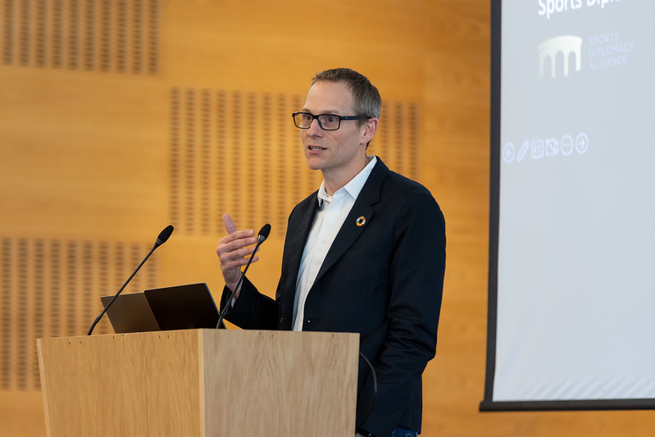

Biography

Simon is Reader and Associate Professor in International Politics at the University of Leeds (2022- ), a Senior Research Fellow and Assistant Programme Director for the MA Leadership in Sports at the Institute for Sport Humanities and Visiting Professor at the Centre of Sports Law, Sports Policies and Sports Diplomacy of the University of Rijeka, Faculty of Law (SLPD Centre). Alongside a team of European experts, Simon recently completed a role as a lead investigator for an Erasmus+ grant (1.3 million Euros) entitled ‘Towards a European Sports Diplomacy Strategy’. He is a standing member of UNESCO’s Intergovernmental Committee for Physical Education and Sport (CIGEPS); Senior Advisor to the UNESCO Chair in Sports Law at Universidad Carlos III de Madrid, and is the independent expert advisor for the UK’s Cross-Government International Sport Working Group.

He developed the first MA module globally to address ‘Sport and Diplomacy: More than a Game’, following a role in the London Organising Committee of the Olympic Games (LOCOG) in 2012. Simon founded the Sport, Diplomacy, and Governance Hub, which provides for multi-directional knowledge exchange, and has established a strong multinational network of relevant contacts in the realms of Sport and Diplomacy. He co-directed, with Dr Lindsay S. Krasnoff, the Basketball Diplomacy in Africa Oral History Project, with a particular focus on the Basketball Africa League.

Overall, Simon has worked with numerous stakeholders from across the sporting and diplomatic realms including, UNESCO & UNITAR, foreign services, and government agencies from around the world, anti-doping organisations, bidding and organising committees.

He is the author and editor of a numerous books and articles including the following:
- Sport and Diplomacy: Games within Games (Manchester: Manchester University Press, 2018):
- Sport Diplomacy and Sport for Development SfD: A Discourse of Challenges and Opportunity, Journal of Global Sport Management 2021
- 'Scholarship and Sports Diplomacy: the Case of Japan and the United Kingdom' with Verity Postlethwaite, Diplomatica: A Journal of Diplomacy and Society.
- 'The Untold Story of FIFA’s Diplomacy and the 1966 World Cup: North Korea, Africa and Sir Stanley Rous'. w/ Professor Alan Tomlinson, The International History Review, 2019 DOI: 10.1080/07075332.2019.1593218;
- 'Sport and Diplomacy: A Global Diplomacy Framework.' Diplomacy and Statecraft, 27 (2). pp. 212-230. 2016;
Contact: Dr J Simon Rofe, @drjsimonrofe

