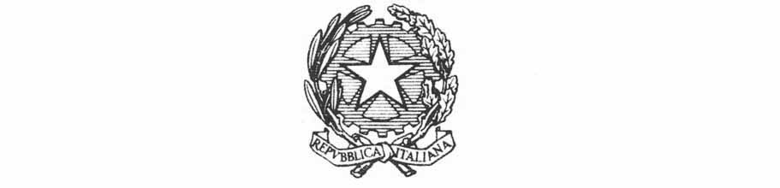
Ministry of Foreign Affairs and International Cooperation
Inter-ministerial Committee for Human Rights

Reply to the call for contributions from the Special Rapporteur in the field of cultural rights pursuant to HRC resolution 46/9

April, 2023

Reply to the call for contributions from the Special Rapporteur in the field of cultural rights pursuant to HRC resolution 46/9

Following the request from the competent Special Rapporteur, Italian authorities are pleased to provide the following contribution.

1. How are human rights generally integrated in your policies and programmes? Please indicate if human rights are mandatory considerations, at what stage of the programme they are integrated and if any, what kind of impact assessment and monitoring is done of their implementation.

Article 9 of the Italian Constitution provides that: “The Republic promotes the development of culture and scientific and technical research. It protects the nation’s landscape and historical and artistic heritage. It protects the environment, biodiversity and ecosystems, including in the interest of future generations. State law regulates the ways and forms of animal protection”: this legislative framework has been granted through the adoption and implementation of ad hoc legislations.

3. Please provide recent examples of programmes, policies and commitments where:
- sustainable development is discussed beyond wealth accumulation model;
- cultural rights are mentioned and explained;
- cultural development is mentioned and explained;
- the expression of cultural diversity is respected, protected and
implemented;
- marginalized voices and aspirations are identified and heard;
- commitment to ensure that development is self-determined and community
led are included;
- commitment to take into account the local aspirations, values and
priorities, rather than work on a one-size-fits-all model, are explicit;
- commitments are made to ensure forward looking development.

Several measures envisaged by the National Recovery and Resilience Plan (NRRP) - marked by a philosophy of environmental sustainability and strong digitization, as well as cooperation between public and private actors - aim to improve the accessibility of cultural sites, while also promoting the attractiveness of small towns (e.g., villages), increase the energy efficiency of cultural venues, and strengthen territorial cohesion.
The enhancement and modernization of cultural offerings generates significant employment spin-offs in a sector with a strong presence of young people and women. These are, therefore, important interventions for achieving the generational and gender targets of the NRRP.
Recipients of the resources are, depending on the case, the state - and, more specifically, the Ministry of Culture (which is divided into central and peripheral administration), local authorities and businesses. Resources allocated to culture finance investments concern particularly Mission 1 ("Digitization, innovation, competitiveness, culture and tourism"), under Component 3 ("Tourism and culture") of the NRRP.

4. Please provide information on any monitoring or evaluation mechanisms assessing the impacts of your development programmes or policies on cultural rights. Also please discuss any mechanism to submit complaints and seek reparation in cases of violations.

Additional questions for Governments and their national development agencies
1. How are human rights generally integrated in your development policies and programmes both in your internal policies and in all programmes of development assistance and cooperation?
2. What human rights guarantees have your Government and its agencies integrated in the development strategies, programmes and cooperation and assistance agreements?
3. Are there participatory processes influencing and informing the elaboration, implementation and evaluation of the development policies and programmes conducted by your Government abroad? If so, how are they integrated?

Within the Programming Document of the Italian Development Cooperation 2021-2023, the following objective is included: Protect and safeguard the world’s cultural and natural heritage: Target 11.4; Develop and implement policies to promote sustainable tourism that creates jobs and promotes culture and local products: Target 8.9.
Indeed culture plays an important role in promoting social cohesion, freedom of expression, identity building, civic empowerment, and intercultural dialogue. It strengthens communities and contributes to the building of resilient, peaceful and stable societies. It promotes economic development, local production and job creation.
So far safeguarding cultural heritage, is a key area for the Development Cooperation in order to generate added value in different regional areas and mainly under the bilateral perspective. The spectrum of areas of intervention is broad: the safeguarding of material cultural heritage - including in emergencies and crisis and conflict situations - and intangible heritage, including that referable to ethnic and religious minorities, cultural and creative industries, handicrafts, responsible and sustainable tourism, as a tool for the socio-economic promotion of territories and for the protection and enhancement of environmental and cultural heritage.

At the same time Education for global citizenship (ECG) is a great opportunity to increase political consensus and public support for global development and international cooperation issues. The implementation of ECG initiatives is in place, following up on the recommendations provided in the Italian Strategy for Global Citizenship Education: involvement of different actors in the territory; interdisciplinary system; systemic approach linking social, cultural, economic, technological, environmental, political aspects; critical understanding of social norms and values (fundamental freedoms, rights, peace, justice); partnerships and exchanges with actors from other territories and cultures; and homing of ECG into the educational system.
For the purpose of defining the Action Plan for ECG, an ad hoc working group will be established composed of representatives from concerned ministries (Ministry of Foreign Affairs and International Cooperation, Ministry of Education, Ministry of University and Research, Ministry of the Environment and Protection of Land and Sea, Ministry of Labor and Social Policies) and the actors that have contributed to the elaboration of the National Strategy for ECG: Regions and Local Authorities, Universities, Public Administration research and training centers, Civil Society Organizations, workers' organizations, and diaspora associations.

