***Organization for Defending Victims of Violence (ODVV)*** **

**Written Contribution for the call for inputs to a report on cultural rights and the governance of development issued by the Special Rapporteur in the field of cultural rights to** **inform the 2023 report to the General Assembly**

**Main questions** (for all stakeholders)

1. Please provide examples of any programmes that contribute to the respect, protection and implementation of cultural rights, in particular:

* The right to choose and maintain one’s identity, and to take part in the cultural life of one’s choice;

ODVV would like to draw the attention of the Special Rapporteur on cultural rights to the bitter reality that Unilateral Coercive Measures (UCM)s, which are imposed on countries beyond the authority of the UN and the international rule of law, negatively affect all human rights including various aspects of cultural rights.

**De-prioritization of Cultural Rights under UCMs**

UCMs undermine the economy of the target countries and deprioritize funding for expansion of cultural rights for all people including for minority and marginalized groups, such as provision of funds to encourage cultural participation for people or integration of minorities into the society through engagement in cultural activities.

* The right to access and transmit creative expressions and knowledge, and to access the creativity and knowledge of others;

**UCMs & Scientific Research and Publishing**

* We would like to echo the concerns expressed by the UN SRs on UCMs, cultural rights and the right to development[1] on the negative impact on UCMs on scientific research and publishing. We emphasize that UCMs discriminate against scientific and academic research and publishing, for the scientists and scholars who are nationals of sanctioned countries. Because of the secondary sanctions, many publishers refrain from working with scholars of target countries and marginalize them in the international academic arena. The situation violates the UN Guiding Principles of Business and Human Rights and Article 1 of the International Convention on Racial Discrimination[2].
* In a similar case, ODVV faced the reluctance of a periodical to receive articles on UCMs, when an ODVV researcher, communicated with the "Forced Migration Review" to write an article for FMR, on the impacts of UCMs on Afghan migrants of Iran, but the periodical advised the author not to write on the issue, because it would be less likely to get published.
* ODVV expresses serious regret over the shrinking space for academics from sanctioned countries whose academic freedom continues to be violated by UCMs. It is alarming that scientific progress is hampered by UCMs in sanctioned countries, making them fall behind in the process of development.

**UCMs & International Academic Gatherings**

* UCM complexities prevent the scholars of sanctioned countries from attendance in international academic gatherings. Some of the complications are as follows: devaluation of national currency makes such trips unaffordable for scientists and scholars who are nationals of target countries; lack of access to international banking system and credit cards, makes it difficult for the members of the academia to book hotels and some fight tickets, forcing them to carry cash in any possible trips, exposing them to dangers of robbery and depriving them from any opportunities of online booking and purchasing items. Members of some Iran based NGOs have experienced theft and robbery in Geneva with such dangers multiplied by sanctions.
* The right to access to the benefits of science and its applications, including scientific knowledge, technology, and opportunities to contribute to the scientific enterprise;

ODVV expresses serious concerns over the impact of UCMs on sanctioned countries' access to new technologies because of the UCMs ban international trade. For example, the targeted States are deprived of nature-friendly technologies and green sources of energy due to illegal imposition of sanctions, which is in contradiction with the principles of non-discrimination. Fazhari, etal.(2016)[3] have summarized the way sanctions directly and indirectly impact the operations of Technology-Based Business (TBB) in Iran:

|  |  |  |
| --- | --- | --- |
| **Initial indicators of the sanctions negative impacts on TBB** | | |
| Direct negative effects | 1 | Limiting access to high quality equipment, special research and laboratory tools, parts and raw materials required by knowledge-based companies. |
| 2 | Crippling the Iranian banking system, and making difficult the international financial relations of knowledge-based companies through the banking system. |
| 3 | The problem of exporting technological products, and the loss of export markets for certain knowledge-based companies |
| 4 | Increasing risk of investing on localized technologies by knowledge-based  Companies |
| 5 | Exchange rate fluctuations, inflation and economic instability, impossibility of planning, and unpredictability of the future |
| 6 | Stabilization of unofficial routes for the import of goods such as imports of intermediate goods, international black market and “draft economy” |
| 7 | Restrictions on the processes of technology transfer, business communication and cooperation with large companies having technology and scientific centers in the world. |

Source: Fakhari, Hossein, etal. (2016).

**Limitation of Online Access**

In many cases, nationals of sanctioned countries are blocked from accessing internet pages or online participation. ODVV has received reports from Iranians who have not been able to find "Iran" in the list of countries where they required to mention their nationality to participate in online events.

In addition, certain websites limit the access of individuals from sanctioned countries. For example if Iranian artists would like to access the artistic contents offered by Etsy, they will see the following page, presented here in print screen[4]:

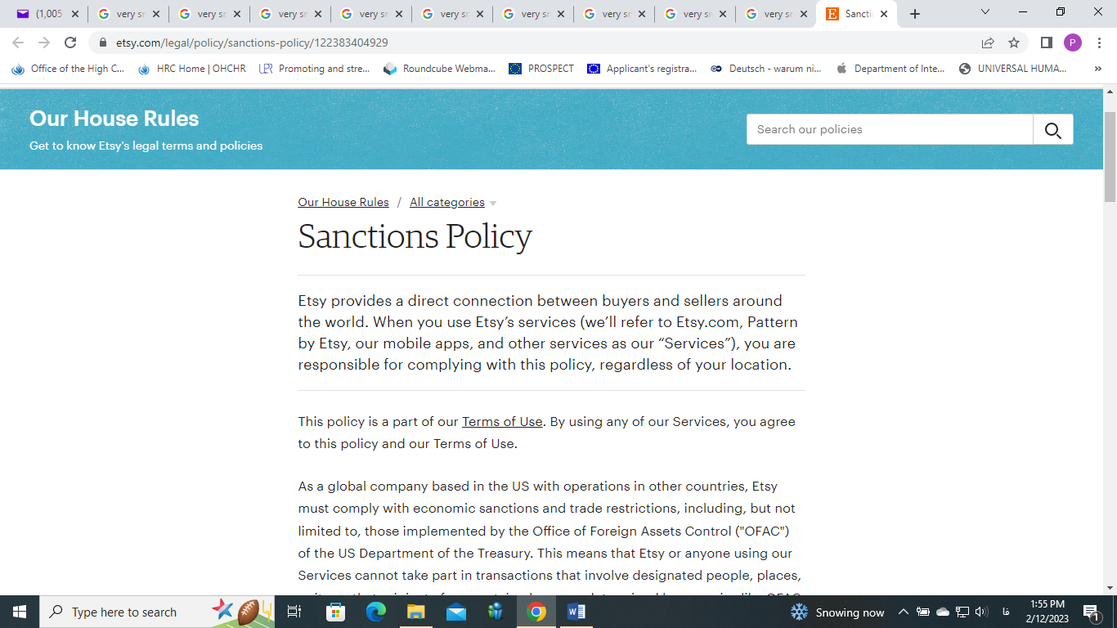

ODVV reiterates on the fact that the human rights repercussions of UCMs are incompatible with international human rights norms and standards, including the fundamental principle of non-discrimination, the rights to freedom of thought, freedom of expression, the right to education and the right to scientific progress as well as the opportunities to contribute to science and scientific research and sharing scientific knowledge in academic gatherings or through academic publications.

**Attachment 1:**

# Etsy Sanctions Policy

Etsy provides a direct connection between buyers and sellers around the world. When you use Etsy’s services (we’ll refer to Etsy.com, Pattern by Etsy, our mobile apps, and other services as our “Services”), you are responsible for complying with this policy, regardless of your location.

This policy is a part of our [Terms of Use](https://www.etsy.com/legal/terms-of-use). By using any of our Services, you agree to this policy and our Terms of Use.

As a global company based in the US with operations in other countries, Etsy must comply with economic sanctions and trade restrictions, including, but not limited to, those implemented by the Office of Foreign Assets Control ("OFAC") of the US Department of the Treasury. This means that Etsy or anyone using our Services cannot take part in transactions that involve designated people, places, or items that originate from certain places, as determined by agencies like OFAC, in addition to trade restrictions imposed by related laws and regulations.

This policy applies to anyone that uses our Services, regardless of their location. It is up to you to familiarize yourself with these restrictions.

For example, these restrictions generally prohibit, but are not limited to, transactions involving:

1. Certain geographic areas, such as Crimea, Cuba, Iran, North Korea, Syria, Russia, Belarus, and the Donetsk People’s Republic (“DNR”) and Luhansk People’s Republic (“LNR”) regions of Ukraine, or any individual or entity operating or residing in those places;
2. Individuals or entities identified on sanctions lists such as OFAC’s [Specially Designated Nationals (“SDN”) List](https://www.treasury.gov/resource-center/sanctions/SDN-List/Pages/default.aspx) or [Foreign Sanctions Evaders (“FSE”) List](https://www.treasury.gov/resource-center/sanctions/SDN-List/Pages/fse_list.aspx);
3. Nationals of Cuba, regardless of location, unless citizenship or permanent residency outside of Cuba has been established; and
4. Items originating from areas including Cuba, North Korea, Iran, or Crimea, with the exception of informational materials such as publications, films, posters, phonograph records, photographs, tapes, compact disks, and certain artworks.
5. Any goods, services, or technology from DNR and LNR with the exception of qualifying informational materials, and agricultural commodities such as food for humans, seeds for food crops, or fertilizers.
6. The importation into the U.S. of the following products of Russian origin: fish, seafood, non-industrial diamonds, and any other product as may be determined from time to time by the U.S. Secretary of Commerce.
7. The exportation from the U.S., or by a U.S. person, of luxury goods, and other items as may be determined by the U.S. Secretary of Commerce, to any person located in Russia or Belarus. A list and description of ‘luxury goods’ can be found in [Supplement No. 5 to Part 746 under the Federal Register.](https://www.federalregister.gov/documents/2022/03/16/2022-05604/imposition-of-sanctions-on-luxury-goods-destined-for-russia-and-belarus-and-for-russian-and)
8. Items originating outside of the U.S. that are subject to the U.S. Tariff Act or related Acts concerning prohibiting the use of forced labor.

In order to protect our community and marketplace, Etsy takes steps to ensure compliance with sanctions programs. For example, Etsy prohibits members from using their accounts while in certain geographic locations. If we have reason to believe you are operating your account from a sanctioned location, such as any of the places listed above, or are otherwise in violation of any economic sanction or trade restriction, we may suspend or terminate your use of our Services. Members are generally not permitted to list, buy, or sell items that originate from sanctioned areas. This includes items that pre-date sanctions, since we have no way to verify when they were actually removed from the restricted location. Etsy reserves the right to request that sellers provide additional information, disclose an item's country of origin in a listing, or take other steps to meet compliance obligations. We may disable listings or cancel transactions that present a risk of violating this policy.

In addition to complying with OFAC and applicable local laws, Etsy members should be aware that other countries may have their own trade restrictions and that certain items may not be allowed for export or import under international laws. You should consult the laws of any jurisdiction when a transaction involves international parties.

Finally, Etsy members should be aware that third-party payment processors, such as PayPal, may independently monitor transactions for sanctions compliance and may block transactions as part of their own compliance programs. Etsy has no authority or control over the independent decision-making of these providers.

The economic sanctions and trade restrictions that apply to your use of the Services are subject to change, so members should check sanctions resources regularly. For legal advice, please consult a qualified professional.

**Resources:** [US Department of the Treasury](http://www.treasury.gov/resource-center/sanctions/Pages/default.aspx); [Bureau of Industry and Security at the US Department of Commerce](https://www.bis.doc.gov/); [US Department of State](https://www.state.gov/economic-sanctions-policy-and-implementation/); [European Commission](https://eeas.europa.eu/headquarters/headquarters-homepage/423/european-union-sanctions_en)

Last updated on Mar 18, 2022

1. Unilateral sanctions threaten scientific research and academic freedom: UN experts, available at: *https://www.ohchr.org/en/press-releases/2022/07/unilateral-sanctions-threaten-scientific-research-and-academic-freedom-un*
2. The case is discussed in the ICJ judgements and opinions on the case of Qatar which was under UCMs by the United Arab Emirates, available at: *https://www.icj-cij.org/case/172*
3. Fakhari, Hossein, etal. (2016). Pathology of Technology-Based Business in Iran in Terms of Economic Sanctions. ***The Open Access Journal of Resistive Economics*** (OAJRE), 5(1), 1-16.
4. See more information in attachment 1