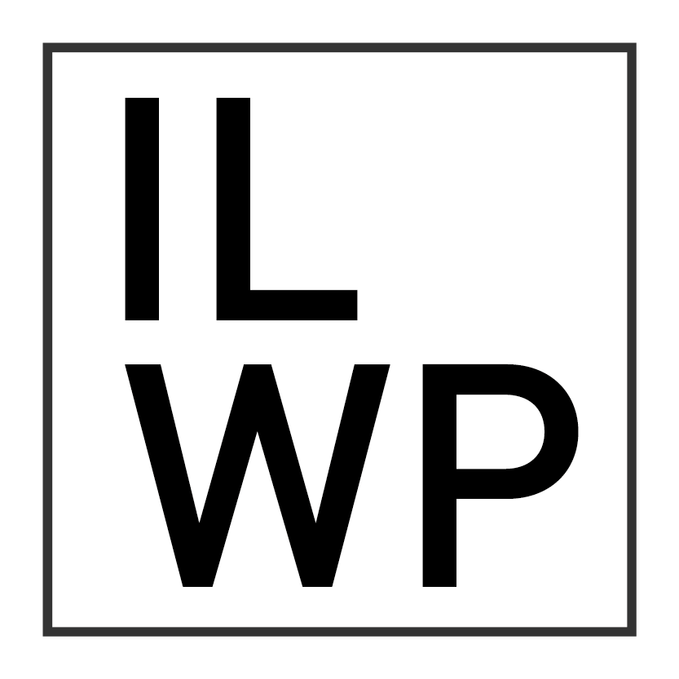

Submission to the Special Rapporteur in the field of Cultural Rights

Written Contribution to inform the Special Rapporteur’s 2023 report to the General Assembly

Submitted by International Lawyers for West Papua

13 April 2023

Executive Summary
This submission has been prepared by International Lawyers for West Papua (ILWP) and highlights issues concerning the violation of cultural rights in West Papua. In particular, it examines the violation of West Papuan cultural rights in relation to deforestation, enforced demographic change, and self-determination.
ILWP is a network of legal professionals who work towards the realisation of West Papua’s right to self-determination, as well as the strengthening and preservation of other human rights, including cultural rights. ILWP helps the indigenous people of West Papua exercise their rights.

Background
- This submission analyses the situation of cultural rights in West Papua, and how they are impacted by the approach the Indonesian government takes to the territory.
- West Papua remains a contested province in Indonesia, referred to by the Indonesian government as two separate provinces, Papua and West Papua, having previously been referred to as Irian Jaya and West Papua, respectively. Indigenous West Papuans see the division of the provinces – and the creation in 2022 of a further three provinces from the original two – as a colonial attempt to divide and rule, causing confusion in the international community about the status of the territory. West Papuans refer to the territory as West Papua (constituting the same territory as the Non-Self-Governing Territory of Western New Guinea) and continue to raise their national flag, the Morning Star.
Cultural rights in West Papua
- Indonesian forces have, for several decades, denigrated and repressed expressions of West Papuan culture.
- In 2016, Geneva for Human Rights issued an Early Warning to the Committee on the Elimination of Racial Discrimination (CERD) on the West Papuan people’s existence and survival as a culture and ethnic entity.
- The Morning Star flag is the national symbol of West Papua. The Morning Star is banned in Indonesia and those arrested for raising it can be charged with treason and punished with prison sentences of up to 20 years. There has been a long history of Indonesian forces. For example, 6 women attempted to raise the Morning Star flag in front of the governor’s office in 1980, but they were arrested, raped, and imprisoned for long terms. The Biak massacre of 1998, during which approximately 200 West Papuans were killed, was triggered by the peaceful raising of the Morning Star by West Papuan protestors. On May 26, 2005, Filep Karma, a West Papuan activist who helped lead the Biak protest, was sentenced to fifteen years imprisonment for his alleged role in organising a rally during which the Morning Star was raised. In December 2021, eight West Papuan students were arrested, charged with treason, and held in custody for nine months after demonstrating with hand-painted Morning Star flags in Jayapura. Three of those students were rearrested in November 2022 for their role in another flag raising protest.
- Punishment for raising the flag is not limited to the threat of arrest or violent attack. In 2018 a mother of three young children was arrested for bringing small Morning Star flags through Manokwari airport. As a result of her arbitrary and unlawful detention, she was separated from her young children, and she lost her job at Sorong City Council. Neither is criminalisation of the Morning Star symbol limited to the raising of the flag. A West Papuan music group were prohibited from performing at the 2021 Papua National Sports Week because one of their members, Jimmy Mansawan, has a Morning Star tattoo on his body. West Papuan women have been prohibited from selling traditional Papuan string bags adorned with the Morning Star. These examples provide a glimpse into the highly restrictive environment that surrounds West Papuan national symbols.
- Many non-indigenous Papuans have moved to the territory as part of government-sponsored ‘transmigration’ programmes. Transmigration deprives indigenous Papuans of their own land and presents a severe threat to their cultural survival. A dramatic demographic change has occurred in West Papua as a result of successive transmigration programme. Though it is difficult to verify demographic statistics, it is estimated that Indonesian transmigrants now make up around 50% of the population in West Papua.
- Transmigration worked in tandem with an Indonesianisation process pursued by the Indonesian government, aimed at compelling Papuans to abandon their customs and to dress and speak as other Indonesians do. In 1971-1972, Indonesian authorities implemented Operation Koteka in the Baliem Valley in West Papua’s central highlands, in an attempt to force indigenous Papuans to stop wearing the traditional Koteka (penis gourd). This saw the Indonesian Government promoted the “'civilising' values of Indonesian development by destroying cultural artefacts, clothing, and indigenous ways of life”.
- The Indonesian military launched a second Operation Koteka in 1977-1978, again to stop highlanders wearing penis gourds. The number of dead during this period is estimated to be between 3,000 and 11,000. These operations were so widespread that they are argued by the Asian Human Rights Commission to amount to a “neglected genocide”.
- West Papuans report the widespread denigration of their culture by Indonesian transmigrants, military, and police. Papuans are ethnically Melanesian, and therefore differ in appearance from the Javanese, who comprise the majority of Indonesia’s population. Derogatory references to Papuans’ curly hair are commonplace, as in 1984, when the then-Governor of Papua Province predicted called for millions of “straight-haired” transmigrants to supplant the “curly-haired” indigenous Papuans.
- For a fortnight in March 2006, Papuans in the regional capital Jayapura wearing dreadlocks were forced to have their hair cut. One Papuan woman recorded being told to change her dreadlocks or risk being fired from her job as a local television presenter.
- Forests cover around 90% of the West Papuan land mass and are essential for maintaining West Papuan culture. As such, deforestation presents a major threat to West Papuan indigenous culture and has become a central issue in the West Papuan struggle. While West Papuan culture varies significantly across its more than 250 tribes, two broad forms of customary life can be identified: between the highlands and the lowlands. Highlands West Papuans primarily cultivate tubers – taro and sweet potato – and keep pigs. Pigs are a vital component of highlands Papuan culture, of gifting and ritual exchange between different tribes and clans. In the lowlands, the primary crop is sago, harvested from the pith of swamp palms. Both forms of living rely heavily on the land.
- Palm oil plantations and large-scale mining is causing extensive deforestation in West Papua. Deforestation is accelerating, with 71% of the of the forest cover decrease since 2001 occurring after 2011. A 2021 study published in Biological Conservation predicts that West Papua will lose 13% of its remaining forest cover by 2036.
- 84% of planning concessions in the Papua province between 1992 and 2019 were granted for oil palm plantations. In producing extensive deforestation, these plantations are responsible for the destruction of local customary West Papuan culture. The Merauke Integrated Food and Energy Estate (MIFEE) in southeast West Papua is a large agribusiness project comprising around 2.5 million hectares of plantations. The Merauke region is inhabited by predominantly by the indigenous Malind people. MIFEE has been described as an “ecologically induced genocide” of the Malind, through the destruction of their relationship to the land, which they often refer to as a “mother” or “ancestor”. Sago palms are essential to Malind culture, celebrated as symbols of fertility and nourishment. Fieldwork conducted amongst the Malind shows the negative cultural and social transformation engendered by the replacement of sago with oil palm. In contrast to the life-giving properties of sago, the Malind see oil palm as a violent intruder, greedy, and destructive to their native ecology.
Cultural rights and self-determination
- In addition, restrictions on cultural rights prevents West Papuans from freely exercising their right to self-determination. The submission of the Special Rapporteur in the field of Cultural Rights to the 77th session of the General Assembly recognises the close connections between self-determination and cultural development – the right of self-determination is the right of all peoples to “freely determine their political status and freely pursue their economic, social, and cultural development”. Further, the United Nations Declaration on the Rights of Indigenous Peoples recognizes that States must obtain their free and informed consent prior to any project that affects indigenous people or their lands or territories and other resources (art. 32.2).
- For several decades, Indonesia has failed to recognise the right of West Papuans to self-determination. In the past, the political movement for self-determination in West Papua broadly occurred under the leadership of four separate organisations which had each campaigned for independence: Federal Republic of West Papua (NRFPB), National Coalition for Liberation (WPNCL), West Papua National Parliament (PNWP) and National Committee for West Papua (KNPB). Since 2014, and with the assistance of the Vanuatu government, these different factions of the independence movement have united to form a new body called the United Liberation Movement for West Papua (ULMWP).
- The ULMWP and their international campaign for self-determination finds support within the Melanesian community of states, most notably, from Vanuatu. Vanuatu appeared in the recent International Court of Justice Advisory Opinion proceedings in respect of the Chagos Islands. The legal principles set down in the Court’s Advisory Opinion demonstrate that Indonesia’s occupation of West Papua is unlawful. The movement for self-determination in West Papua must be considered in this context: it is a just cause under international law.
- The movement has widespread, if not global support within the West Papuan community. Their protests are routinely met with violent reprisals by the Indonesian security forces, including extra-judicial killings, arbitrary arrest and disproportionate use of violence. As outlined above, West Papuans are routinely faced with violence and threat of arrest for cultural expressions, particularly those related to the movement for self-determination. Recognising the right to self-determination for West Papuans is the only way they can fully pursue their cultural development and enjoy their cultural rights.
Recommendations
- In light of the foregoing, we request that the Special Rapporteur to whom this complaint is addressed:
    - Express concern regarding the ongoing situation of cultural rights in West Papua;
    - Call on the Indonesian Government to provide information on the measures it has taken to improve the protection of cultural rights in West Papua, including information on measures relating to deforestation;
    - Provide information on the measures it has taken to safeguard the right to self-determination of cultural development in West Papua.

In this submission, the term “West Papua” is used to refer to the provinces of both Papua and West Papua.
Geneva for Human Rights, West Papua Project, available at: https://gdh-ghr.org/west-papua-project-ghr-wpp/ (accessed April 13 2023)
John Braithwaite et al, “Anomie and Violence”, ANU E Press (2010), pg.63, available here: https://press-files.anu.edu.au/downloads/press/p19121/pdf/book.pdf (accessed 12 April)
Global Freedom of Expression project, Columbia University, “The Case of Filep Karma, available at: https://globalfreedomofexpression.columbia.edu/cases/indonesia-v-filep-karma/ (accessed 13 April)
Papuans Behind Bars, “Sayang Mandabayan”, available here: https://www.papuansbehindbars.org/?prisoner_profile=sayang-mandabayan (accessed 13 April).
Papuan Voice, “Tato Bintang Kejora Batasi Trio Papua Tampil di Pembukaan PON XX”, available at: https://suarapapua.com/2021/10/03/tato-bintang-kejora-batasi-trio-papua-tampil-di-pembukaan-pon-xx/?fbclid=IwAR0mBhiobGQO21QQYwtP9K3JuQUNVzezNX0qRCD6Jeano0FftpJ0ZOWzxH0 (accessed 13 April)
Yance Wenda, “‘It’s our identity’, declare Papua’s defiant mamas over Morning Star”, available at: https://asiapacificreport.nz/2021/10/12/its-our-identity-declare-papuas-defiant-mamas-over-morning-star/ (accessed 13 April)
Politics of Papua Project, 2016, p41, “ASSESSMENT REPORT ON THE CONFLICT IN THE WEST PAPUA REGION OF INDONESIA”. Available at: https://warwick.ac.uk/fac/soc/pais/research/ierg/specialisms/internationaldevelopment/westpapua/papua_assessment_report_final_uk.pdf (accessed April 13)
Ibid, p3.
Leslie Butt, 2001. “KB kills: Political violence, birth control, and the Baliem Valley Dani.” The Asia Pacific Journal of Anthropology, 2(1), 66).
Claire Smith, 2016. “How Mass Atrocities End: Studies from Guatemala, Burundi, Indonesia, the Sudans, Bosnia-Herzegovina, and Iraq, pp. 83 -120.” Available at: https://www.cambridge.org/core/books/how-mass-atrocities-end/46BCFB1925793B55217D81A2C34D1206 (accessed April 13)
Asian Human Rights Commission, “THE NEGLECTED GENOCIDE . Human rights abuses against Papuans in the Central Highlands, 1977–1978” available at: https://www.tapol.org/sites/default/files/sites/default/files/pdfs/NeglectedGenocideAHRC.pdf (accessed April 13)
In David Webster, “Already Sovereign As a People”: A Foundational Moment in West Papuan Nationalism”, p521, Available at https://www.jstor.org/stable/3557804saml_data=eyJzYW1sVG9rZW4iOiIzN2ZhZDdmNy00Y2FhLTRmNDUtYjVkNi02NDc0ZmYwZjEzNDEiLCJpbnN0aXR1dGlvbklkcyI6WyI4MjA0MTVmZC03YTY4LTRmMTktOTdmZi00NTFhZTZiMzFiMGQiXX0 (accessed 13 April).
West Papuan voices from the ground. Available at: https://newint.org/features/2017/05/01/west-papuans-speak (accessed 13 April)
David Gaveau, Douglas Sheil, “Road to uncertainty: Research reveals how Trans Papua may strip 4.5 million hectares of forest by 2036”. Available at: https://phys.org/news/2021-10-road-uncertainty-reveals-trans-papua.html (accessed 13 April)
John McDonnell, “The Merauke Integrated Food and Energy Estate (MIFEE): An Ecologically Induced Genocide of the Malind Anim” Available at:https://www.tandfonline.com/doi/epdf/10.1080/14623528.2020.1799593?needAccess=true&role=button (accessed 13 April)
Sophie Chao, “In the Shadow of the Palm: Dispersed Ontologies among Marind, West Papua” available at: https://journal.culanth.org/index.php/ca/article/view/ca33.4.08 (accessed 13 April)
Ibid.
Report of the Special Rapporteur in the field of cultural rights, Alexandra Xanthaki, https://documents-dds-ny.un.org/doc/UNDOC/GEN/N22/461/66/PDF/N2246166.pdf?OpenElement (accessed 13 April)
Legal Consequences of the Separation of the Chagos Archipelago from Mauritius in 1965 (Advisory Opinion) 25 February 2019, available here: https://www.icj-cij.org/en/case/169/advisory-opinions.
See McCorquodale, Robinson and Peart, “Territorial Integrity and Consent in the Chagos Advisory Opinion”, (2020) 69 International and Comparative Law Quarterly 221, available here: https://www.cambridge.org/core/journals/international-and-comparative-law-quarterly/article/territorial-integrity-and-consent-in-the-chagos-advisory-opinion/EE6620BAF7E51B819431572C0E41365D
See, for example, Elizabeth Brundige et al. ‘Indonesian Human Rights Abuses in West Papua: Application of the Law of Genocide to the History of Indonesian Control’ (Allard K Lowenstein International Human Rights Clinic (Yale Law School), April 2004), available here: https://law.yale.edu/sites/default/files/documents/pdf/Intellectual_Life/West_Papua_final_report.pdf

