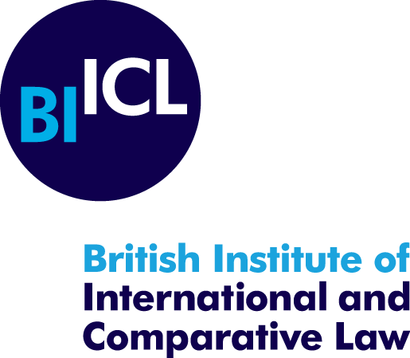

submission on cultural rights and sustainable Development

In October 2021, Berenika Drazewska and Kristin Hausler published a Working Paper online on ‘The Role of Multilateral Development Banks in the Protection of Intangible Cultural Heritage’, which was published online by the British Institute of International and Comparative Law and is available at: https://www.biicl.org/publications/the-role-of-multilateral-development-banks-in-the-protection-of-intangible-cultural-heritage

This submission stems from the research undertaken for this Working Paper, which was not country specific but considered the role of seven Multilateral Development Banks (MDBs) and the impact of the development projects they support around the globe on intangible cultural heritage (ICH) in particular. In brackets, references are made to the relevant paragraph numbers of the Working Paper.

The UN Sustainable Development Goals (SDGs) – part of the 2030 Agenda for Sustainable Development - expressly flesh out a vision of sustainable development which supports the protection of cultural heritage. MDBs have repeatedly endorsed the 2030 Agenda and clearly voiced their commitment to helping realize the SDGs. Given their role in supporting development, in particular through their financing of large infrastructure construction projects, MDBs are key stakeholders defining, driving and monitoring the (sustainable) development process. As such, they must ensure that they also support the protection of cultural heritage, including ICH. [paras 3-4] The preamble of the ICH Convention and the Operational Directives identify processes of globalization and social transformation as an important source of threats to the safeguarding of ICH. [see para12 for examples]

However, a number of cases highlight that the treatment of the impacts of the projects on ICH is often unsatisfactory, with failures to carry out adequate consultations resulting in adverse consequences for the affected communities, and/or for the projects themselves, including complaints to the MDBs’ accountability mechanisms. These include the Rural Water Supply and Sanitation Project for Low Income States project in India, the Alto Maipo Hydroelectric Project in Chile, the Nenskra dam construction project in Georgia, and the Bujagali Hydropower Project (BHP) in Uganda. These cases all raise issues associated with lacking, incomplete or culturally inappropriate consultations in the context of MDB-financed or co-financed projects for the construction of infrastructure which negatively impacted on the safeguarding of ICH. [paras 5-6 and Part III]

The Working Paper advocates for the development sector to adopt a holistic and human rights-based approach to the protection of cultural heritage, which takes into account the need to ensure adequate safeguarding not only of tangible forms of cultural heritage but also of ICH, throughout the life of infrastructure construction projects financed by MDBs. All of the MDBs analysed in the Working Paper have adopted policies (safeguards) to prevent, mitigate and manage the adverse social and environmental impacts of the socioeconomic projects they fund. However, not all MDBs have adopted policies that cover ICH as some remain strictly limited to tangible cultural heritage, as highlighted by the “focus on ‘physical cultural resources’ and ‘cultural resources’ in some of the MDBs policies. This is inconsistent with international standards and with the commitments to respect, protect and fulfil cultural rights, including the human right to access and enjoy ICH, assumed by the Member States of these MDBs through ratifying (or signing) the ICESCR or the UNESCO Intangible Cultural Heritage Convention. Furthermore, the way cultural heritage is defined and whether it covers ICH, as well as the scope of application of the MDBs policies, are also likely to impinge on the identification (and therefore protection) of ICH. [paras 26-27]

In addition, the MDBs that have already addressed ICH in their policies have yet to ensure the adequate implementation of their standards pertaining to such heritage in practice. So far, where ICH is concerned, the focus of existing policies is mostly on definitions – no specific guidelines listing the particular risks facing such heritage in the context of infrastructure construction projects, or how it may be shielded from them, are available. [paras 68-69]

With regard to participatory processes, several MDBs also appear to fall short of international standards as some call for the obtention of simple ‘consent’ or ‘broad support’ while others have replaced ‘Free, Prior and Informed Consent’ (FPIC) with ‘Free, Prior and Informed Consultation’ (FPICon). Additionally, most policies tend to place more weight on FPIC (or similar processes) to be held with Indigenous peoples, devoting less attention to other stakeholders such as local communities which for various reasons may not hold Indigenous status, but still ought to be included in the relevant processes given the potential threats to their cultural heritage. There are also only few MDBs requiring that impact assessments cover the extent to which a project may affect the cultural life of Indigenous or local communities, even though this is a matter of international human rights. Finally, while most of the policies clearly link cultural heritage impacts with the need to consult affected communities, not all refer to the need for the consultation processes themselves to be culturally appropriate (i.e. to integrate ICH into the consultation processes). [paras 54, 70 and Part II.B]

Submission prepared by Kristin Hausler and Berenika Drazewska

British Institute of International and Comparative Law, 21 April 2022.

This Working Paper has now been turned into a book chapter which is due to be published in late 2022.
Note that while the Working Paper discusses the 2019 version of the AIIB policy (‘The Environmental and Social Framework’), the revised version of the policy (2021) also uses the term ‘FPICon’ instead of FPIC where Indigenous Peoples are concerned.
Note that some MDBs’ (the EIB and the EBRD) policies extend the requirement of consent for the project’s use of the cultural resources and traditional knowledge beyond Indigenous peoples and onto ‘local communities embodying traditional lifestyles’ – a reflection of an increasing tendency in international law to treat them as equally entitled to FPIC, at least as a matter of good practice.

