The International Choir
Delivered in partnership by the Göteborg Opera & Swedish Red Cross, 2014-2017
Project overview and reflections, December 2022

To be read alongside the three concert programmes (2015, 2016, 2017) and press coverage.

How it all started
The Göteborg Opera and Swedish Red Cross embarked on a collaboration in autumn 2014. The pilot project centred on the Swedish hit musical Kristina från Duvemåla, which tells the story of a young woman, her family and their migration – motivated by poverty – from Sweden to America in the mid 1800s (further details here). A group of people who had recently arrived in Sweden seeking asylum worked with composer Nigel Osborne and musical theatre artist Tina Glenvik.

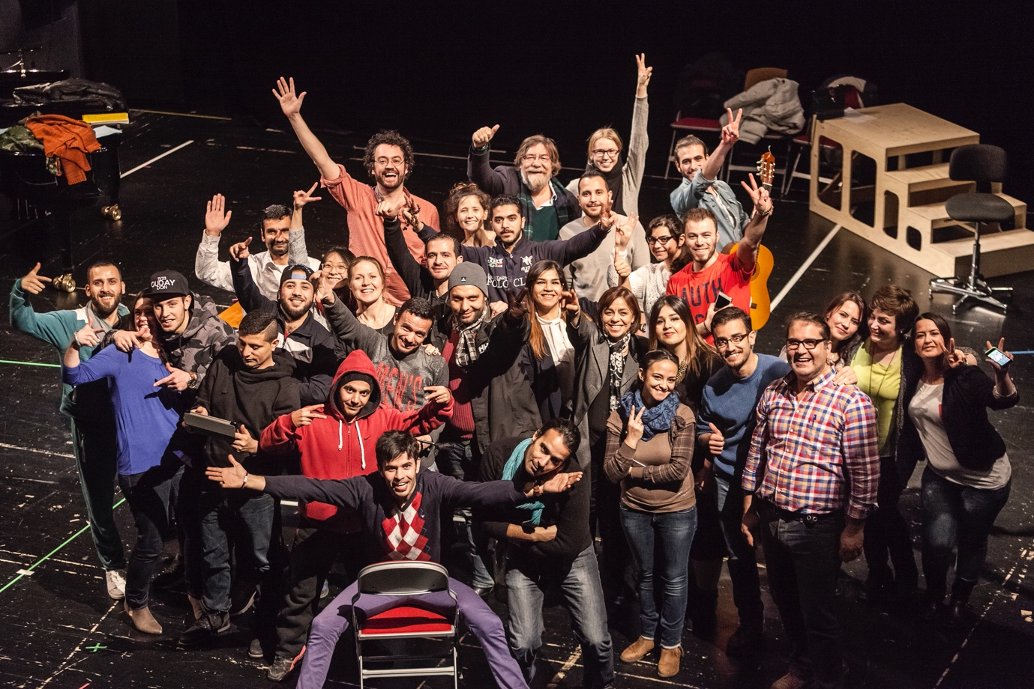
The culmination of the pilot project, on the Göteborg Opera’s small stage (photo: Tilo Stengel)

How the International Choir started
We carried out an informal but purposeful evaluation of the pilot project with participants. Two clear wishes emerged on their part:
- The desire to sing;
- The desire to meet a range of people in Göteborg, both other newly-arrived people and people firmly established in the city.

The process
Following the evaluation, we devised a model for the International Choir. Each iteration of the choir took place in three phases.
- Song collecting workshops at the asylum seekers’ camp and other grassroots venues in the suburbs. We held a series of informal workshops led by singers and choral conductors, inviting the people we met to share with us folksongs that were important to them. We recorded the songs and collaborated with the people who had contributed them to understand them better – the music and the meaning. We selected a set of songs and commissioned accessible choral arrangements.
- We established an international choir. In the first iteration (2015), members came from 20 different countries and were aged between 18 and 72. Some choir members were full-time professional singers with the Göteborg Opera, other people were singing in a group for the first time in their lives. Rehearsals took place backstage in the Göteborg Opera’s orchestra rehearsal room every Wednesday evening. Each rehearsal was followed by coffee, buns and socialising in the Opera’s staff canteen. The rehearsal process culminated in public concerts on the Opera’s small stage, accompanied by a band of professional musicians.
- The choir performed on the main stage of the Göteborg Opera (audience capacity 1,300) as part of the city’s annual culture festival. At these events, the choir was accompanied by full symphony orchestra.

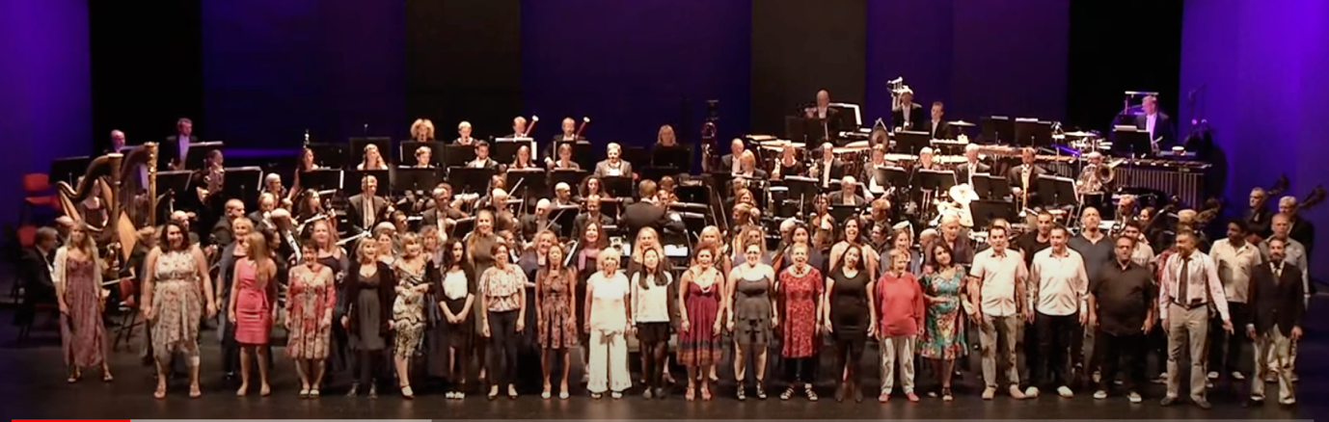
The International Choir on stage with the Opera’s symphony orchestra, performing “El bint el shalabiya” – video here: https://www.youtube.com/watch?v=MeD75zkHlRc (photo: screenshot from video)

A similar process was repeated in 2016 and 2017. Between choir projects, the partnership comprised other initiatives, some of them taking the repertoire of the Göteborg Opera as the starting point and inviting participants to create original music theatre based on their own ideas and experiences.

Unexpected outcomes
Many aspects of the collaboration were planned; others were the result of the people and opportunities encountered along the way. For example…
- We encountered professional musicians who were migrants in Sweden and contributed their own original songs. In this strand, the choir performed new arrangements of original songs with Assyrian songwriter Nawfal Shamoun and performer Jiji Seven from Burundi.
- During the collaboration, the Swedish Red Cross opened a treatment centre for people suffering trauma as a result of war, torture or difficult migration experiences. The choir was invited to perform at its opening event.
- The collaboration between the Göteborg Opera and Swedish Red Cross was shortlisted for the UN Intercultural Innovation Award in 2017. Although the project did not go on to win, the nomination alone increased the project’s legitimacy within the Göteborg Opera.
- Through the project, we met Palestinian drama practitioner Fathi Al Jamala, at that point seeking asylum in Sweden. Fathi is a specialist in psycho drama, a form of therapy that draws on various drama techniques. He wanted to deliver psycho drama workshops in Göteborg and achieved that in partnership with the Göteborg Opera and Swedish Red Cross. The Red Cross’ magazine Henry wrote a feature on the first workshop (see press clips).

Collaborating with Athens
In 2017, the Greek National Opera in Athens set up a choir inspired by the Göteborg model. I visited Athens to consult on the project and discuss possible collaborations between the two choirs. At the time I was leaving the Göteborg Opera in late 2017, plans were underway for a joint concert, with the two choirs performing together digitally. That took place in April 2018. The Greek choir is still running (details here).

Reflections
Looking back, what were the special characteristics of the model that underpinned the International Choir?

- The project responded to what newly-arrived people said they wanted to do.
- The project valued different kinds of expertise and could not possibly have taken place without the input of diverse people. For example, advice on pronouncing Kurdish, or help understanding the meaning of a song in Quechan. These parts of the process “flipped” the hierarchy in the rehearsal room: the know-how was not always coming from the institution or its staff.
- The project was co-delivered with volunteer project assistants who were awaiting the outcome of their asylum applications. They contributed with – for example – language skills, knowledge of different cultures, understanding of lived experience of migration.
- Staff from the Red Cross built understanding among the team at the Göteborg Opera of what support choir members might need. The partnership with the Swedish Red Cross enabled staff at the Göteborg Opera to signpost other services and opportunities to members of the choir.
- The project enabled diverse people to share and celebrate their cultures, including newcomers in the “host” society. The repertoire of the Göteborg Opera was enriched with cultural resources and assets that originated in other parts of the world but now exist in the city of Göteborg thanks to its changing population.
- Choir members formed an important social network both within and outside the project. For example, some participants found living accommodation via contacts in the choir. Others organised surprise parties for choir members when they finally received their “uppehållstillstånd” (residence permit) in Sweden. Many choir members still play an important role in each others’ lives today, having met in a rehearsal room one Wednesday evening some years ago.

A final thought
From the programme notes for the concert “Imagine a world”, May 2016
“Of course, as a cultural organisation the Göteborg Opera plays an important role in preserving our cultural heritage. Another part of our role is to interpret and re-interpret that heritage, to reflect today’s society in large and small formats, to create new works, new creative ventures that explore and are influenced by the here and now. The international choir consists of Gothenburgers from all around the world. The songs we sing are the songs we carry with us. They say something about who we are and what is important to us.”

Hannah Griffiths
From 2014-2017, Head of Participation at the Göteborg Opera, Sweden
From 2019-present, General Manager at Birmingham Opera Company, UK
hg@birminghamopera.org.uk
+44 7739 952 329

