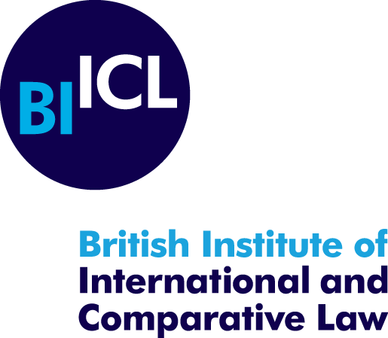

submission on cultural rights and MIGRATION

In 2022, Kristin Hausler, Alina Holzhausen, and Berenika Drazewska conducted research for a project considering the role of intangible cultural heritage in strengthening climate resilience.
Our submission draws on that research, focusing on forced displacement induced by climate change, which is more likely to cause internal than cross-border movement. According to the UN Guiding Principles on Internal Displacement, internally displaced persons (IDPs) are persons or groups of persons who have been forced or obliged to flee or to leave their homes or places of habitual residence, inter alia as a result of or in order to avoid the effects of armed conflict, situations of generalised violence, violations of human rights or disasters (and which have not crossed an internationally recognised state border). In addition, our submission focuses on the situation in the Asia-Pacific region as this is where over 12 million people were internally displaced due to disasters in 2020 alone, i.e. 40% of the 30.7 million people who were internally displaced due to disasters that year throughout the world.
While the negative impact of climate change on tangible cultural heritage is often visisble and evident, in particular when a cultural site is the victim of a disaster, the negative impact of climate change on intangible cultural heritage may be more difficult to ascertain. Indeed, the safeguarding of intangible cultural heritage is foremost dependent on the survival of its bearers. There may, therefore, be a misconception that the relocation of the bearers of intangible cultural heritage is sufficient to ensure the safeguarding of their intangible cultural heritage. However, traditional ways of life are threatened by climate change, for example due to reduced access to plants used for traditional medicine or other resources. For example, in the Fiji Islands, although a relocation process has been community-led, balancing climate risks and the value of cultural heritage, the voluntary relocation of residents from the old Korolevu to the new Korolevu has been challenging as the villagers lost their traditional, daily connection to the sea by relocating to a new spot two kilometres away and uphill from the coast. The now limited access to the sea has affected the villagers’ fishing traditions, which reduced daily fishing to one or two days a week.
A particular issue that has faced IDPs has been their removal from traditional territories and, thus, from the graves of their Ancestors, which has in turn impeded on their religious, cultural, and spiritual practices. This issue has also been raised in relation to relocation within the Fiji Islands. The Vunidogoloa village in Cakaudrove province in Vanua Levu needed to be relocated from the sea to a new site a couple of kilometres inland and uphill from the initial coastal location because of climate change. In addition to a series of difficult decisions to make, the villagers had to go through the ‘harrowing decision to disentomb and shift the remains of their ancestors to a new burial site’. A village representative stated that ‘[w]e didn’t want to leave the cemetery where it was, to be washed away, so the church arranged for the burial site to be moved. Sadly the first burial at the new site was that of a still-born child which is interpreted as a bad omen from our ancestors’. In the case of the Tukuraki village in Ba province, which needed relocation after having been devastated by a landslide that took place after a week of unusually heavy rain, 80% of the village was buried, with most homes having been destroyed and the death of four residents. Due to the destruction of their homes and livelihoods without an option of rebuilding, the villagers needed a new home which is now located in a safer location, but away from their fields and ancestral lands.
In case of internal climate displacement, the obligations of States to promote and protect the human rights of all people within their territory or jurisdiction is clearly stated under international human rights treaties, as well as further clarified by relevant soft law instruments and guidelines such as the UN Guiding Principles on Internal Displacement. Even domestic law, such as the Fiji Climate Change Act (2021) for example, recommends that at-risk communities should be relocated pursuing approaches which ‘(i) are human-centred including prioritising community needs from the bottom up; (ii) support the continuation of livelihoods; (iii) are human rights based’. In addition, relocation can only take place following a consultation, having obtained the free, prior and informed consent of the communities.
However, if internal displacement is forced, additional protections for IDPs are needed. This is particularly relevant for the Pacific region where there is no equivalent of the African Union’s Kampala Convention for the Protection and Assistance of Internally Displaced Persons in Africa. While the UN Guiding Principles on Internal Displacement could offer a legislative and/or policy model for formalising existing frameworks of temporary protection, they do not directly mention the need to protect culture. However, the Guiding Principles referring to the protection of IDPs’ property, right to religion, opinion and expression, right to education respecting the cultural identity, and language and religion are relevant to the safeguarding of intangible cultural heritage. For example, culturally acceptable education, which may include traditional knowledge, may be crucial for displaced groups to maintain their cultural identity.
Finally, regarding climate displacement across international borders, some Small Island Developing States (SIDS), for example Kiribati, have bought land in Fiji for resettlement purposes. Tuvalu has entered into a bilateral agreement with New Zealand in 2001, stipulating an annual immigration quota of Tuvaluans leaving the country due to sea level rise, valid for 30 years. However, such plans to address cross-border relocations have not been divised with regard to all Pacific SIDS, which means that inhabitants of SIDS which will lose their homes because of climate change ‘might fall through the cracks when it comes to protection’. Indeed, contrary to the frameworks in place for IDPs, there exists currently no legal framework which protects ‘climate migrants’ such as SIDS inhabitants who must flee because the State’s territory is entirely submerged. Moreover, not only ‘climate migrants’ lack protection, but also their traditional knowledge and cultural practices are at heightened risk of being lost in the displacement process. It is, therefore, essential to integrate the cultures of climate-displaced Pacific Island States into climate action and relocation.

Submission prepared by Kristin Hausler and Alina Holzhausen

British Institute of International and Comparative Law, 22 November 2022.

Jane McAdam, ‘Climate Change Displacement and International Law: Complementary Protection Standards’, (UNHCR 2011), 8.
Guiding Principles on Internal Displacement, Introduction, para 2.
UN Development Programme, Special Report ‘New threats to human security in the Anthropocene, Demanding greater solidarity’ (2022), p. 103, citing typhoons, floods, earthquakes, and volcanic eruptions as the immediate cause of displacement.
Nithin Coca, ‘Balancing climate, culture, and community: Fiji’s relocation challenge’ (11 March 2021), available at https://devex.shorthandstories.com/balancing-climate-culture-and-community-fijis-relocation-challenge/index.html.
ibid.
ibid.
Dhrishna Charan, Manpreet Kaur and Priyatma Singh, ‘Customary Land and Climate Change Induced Relocation – A Case Study of Vunidogoloa Village, Vanua Levu, Fiji’, in Walter Leal Filho (ed), Climate Change Adaptation in Pacific Countries (Springer 2017).
ibid.
ibid.
Coca (n 4).
Jane McAdam and Marc Limon, ‘Policy Report. Human Rights, Climate Change and Cross-Border Displacement: the role of the international human rights community in contributing to effective and just solutions’ (August 2015), available at https://unfccc.int/files/adaptation/groups_committees/loss_and_damage_executive_committee/application/pdf/cc_hr_displacement_urg.pdf.
Republic of Fiji, Climate Change Act (2021), sec77(1) (j) and (e).
ibid.
‘“Intolerable tide” of people displaced by climate change: UN expert’, (ohchr.org), available at https://www.ohchr.org/en/press-releases/2022/06/intolerable-tide-people-displaced-climate-change-un-expert.
Gül Aktürk and Martha Lerski, ‘Intangible cultural heritage: a benefit to climate-displaced and host communities’, Journal of Environmental Studies and Sciences, 2021, Vol. 11, 305-315, p. 307.

