Check against delivery
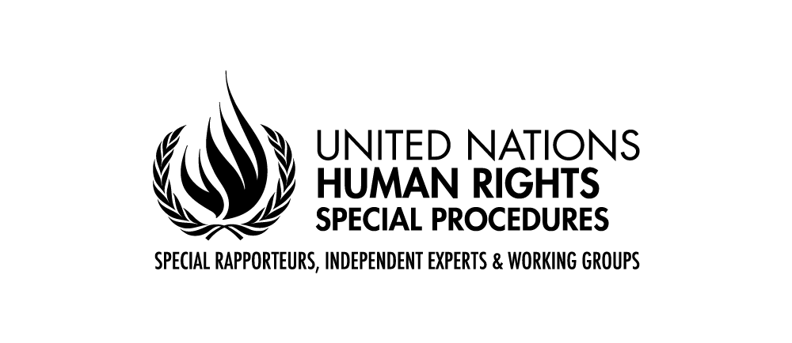

Interactive Dialogue Statement

Special Rapporteur in the field of cultural rights
Alexandra Xanthaki

Human Rights Council, 52nd Session
Item 3

15 March 2023

Geneva

Good afternoon Your Excellencies and all,

I am very pleased to come back to the HRC after completing my first year as the Special Rapporteur.

Since I have been here, the mandate has had a very productive year. I connected with many stakeholders working on cultural rights and started a clear process of interaction with other UN bodies on the issues of common interests, including treaty bodies, UNESCO and other agencies. I attended many conferences and conducted expert consultations. I sent calls for contributions to learn more about the challenges and questions cultural rights raise across the world. A new call for contributions on sustainable development and the international governance has been shared last week, and I invite you all again to send me your contributions by 14 April. I hope that this ongoing dialog with so many stakeholders continues.

At the end of last year, I had the opportunity to conduct my first country visit to Germany. I thank the Government for the invitation and its cooperation. My report on this visit will be presented in March of next year. Although most of the Governments I approached have standing invitations to Special Procedures, securing country visits has proven to be quite difficult. I hope to soon have answers from the countries I have contacted, and remain available to engage with other countries that would be interested, so I can fulfil this important activity that the HRC has mandated me with.

Since I started as Special Rapporteur, I sent almost 100 communications (as of 14 March 2023), most of them joined with other Special Rapporteurs. Some of them have sparked a debate, some of them have brought important changes. I thank all the Governments and other stakeholders who expressed their commitment to clarify and improve the human rights situation by responding to our communications. But I do regret that many communications have remained without answers until this date, despite the fact that some actions have been taken. I encourage and invite those stakeholders to reach out to us to discuss the allegations.

Let me now turn to my current report.

I am honoured to submit to you my report on migration and cultural rights. Although especially after the adoption of the Global Compact on Migration, we have a solid basis to push forward the rights of migrants, who are no less than 280M people around the world, these efforts seem to neglect their cultural rights. Yet, the report identifies important gaps that exist in the protection of cultural rights of migrants that are not picked up by States, neither, I have to say, by many civil society working on migrant rights. The focus seems to be on rights of non-refoulement, right to asylum, right against arbitrary detention etc; all timely priorities, but cultural rights of the individuals are neglected. If cultural rights are about the right to aspire, the right to dream, by ignoring these rights, we fail these individuals. Migrants in the wide sense, as the report addresses, long term migrants, asylum seekers and refugees and undocumented migrants, have the right to fulfil their future based on their own values, philosophies dreams and aspirations.

The report emphasises that migration has positive effects both for the individuals migrating and the host society. The mixing of cultures, contexts and cultural resources that takes place through migration is an enriching and dynamic exercise that brings new ideas and promotes the re-evaluation of values and practices, both of the migrants and of host societies. The positive effects of migration for the cultures of both the migrants and the populations of the host states have to be further acknowledged and shared.

At the same time, migrants’ cultural rights are put in danger by the process of migration. It brings with it the loss of important places, communities and relationships, tools or instruments; the loss of a broader supportive community that fosters intergenerational transmission; and sometimes brings up even resistance or opposition to continuing certain heritage practices in the new home country.

The report identifies specific areas that need attention:

- States need to ensure that the scope of cultural rights of migrants be understood in all their structures and bodies, including local authorities, cultural public bodies and decision-making public bodies.

In the submissions I received, there were occasions where the States referred to the cultural rights of citizens, rather than all individuals as international law standards require. Other statements talked about only long-term migrants and their cultural rights, a category which could also benefit from minority protection but not discussed. Some States are not clear about their obligations vis a vis international law. In some states, the State system and/or lack of communication between the Ministry of Foreign Affairs and the other state bodies result in a lack of understanding of the obligations all public bodies have, sometimes focusing on the right of migrants to access only or their right to the dominant culture only. Also, there have been occasions where initiatives were discussed as good practice when they are really minimum standards of merely fulfilling the obligations that the states have undertaken. Finally, some submissions focus only on the cultural sector, portraying a very restrictive understanding of cultural rights, not in sync with current standards.

We all need to work to ensure that all state bodies have the right current understanding of what culture means and what cultural rights of migrants entail.

- I also identify in the report that discrimination in the exercise of the cultural rights of migrants still persists. International human rights law explicitly recognizes cultural rights for everyone, hence any migrant of any background, status and in any situation has the right ‘to take part in cultural life’. This is customary international law and cannot be denied to anyone.

We all have to intensify our efforts to eliminate the obstacles that migrants face in accessing cultural life. States need to take specific, clear and at times positive measures to ensure that substantive equality in exercising cultural rights is achieved. This can be done with: more translations in museums and cultural events; more public exhibitions and cultural events that relate to the experiences and needs of migrants; more visibility of migrants and their experiences in the media and popular culture; and more employment of migrant personnel in the cultural sector, and particularly, in the decision-making positions of the cultural sector. It also has to do with initiatives introducing to the local population the amazing wealth of cultures in migrant communities and the varied, interesting and inspiriting art produced by migrant artists. Many States do recognise the importance of cultural diversity in legislation, many States recognise the importance of culture and arts. Yet, we need to move beyond the protection of ‘high culture’ and the protection of only the State’s culture and ensure that culture is understood in an inclusive, broad and current manner. Civil society organizations are doing a remarkable job in bringing cultural events to refugee reception centres, communities and to the wider public; but this is the obligation of the State.

Migrant artists often talk about their invisibility in the host society and its arts world. They report that there are extremely few initiatives that support refugees and migrants who are actual artists. Even when the State promotes international art and culture; foreign artists are chosen rather than migrant artists. In addition, migrant artists often find themselves having to focus their art on their displacement as this is what the funders expect. And sometimes they are unable to vocalize criticism of the host State and society, as they are then seen as ungrateful or disloyal.

- An important element of my report focuses on migrants’ rights to their living cultures. Migrants often face the undermining of their cultural values, the uncritical perception that their cultures of origins are too traditional, too illiberal, inferior to the prevailing culture of the host state. We often hear that migrants have to ‘adopt to the host society’s way of life’ as if the population of any States had only one way of life! International law insists that cultures are of equal value. Often, populist media, politicians and parts of civil society join the chorus about the alleged perils of migrant cultures. Migrant women are particularly the recipients of intersectional discrimination and their cultural rights are violated both within their group elites resisting to change, and by the host society having a predetermined stereotype for them that disempowers them. Such uncritical voices pose human rights against each other falsely and in some situations, work towards the dehumanization of migrants opening the way for further prejudice and racism against them

On this flawed basis, integration, a concept and policy celebrated in the last several decades, is implemented as a one-way route and used to promote policies that assimilate migrants, old and new.

- My report underlines the importance of participation of migrants in decision-making on cultural matters. Following the General Comment No. 21 (2009) the Committee on Economic, Social and Cultural Rights states that cultural rights include the right to take part in the definition, elaboration and implementation of policies and decisions that have an impact on the exercise of a person’s cultural rights (para. 15 (c)). There must be a shift of paradigm, where migrants are not seen as mere recipients of cultural policies but are active partners in the shaping and vision of the society and the cultural life. Often, other persons speak in the name of migrants, be it experts, State officials or even civil society organizations. It is imperative that migrants share their own experiences and claims and have their own visions implemented about their cultural rights.

I hope that this report acts as a catalyst to focus more on the cultural rights of migrants and ensure further visibility and active participation of migrants in the societies in which they now live. Public spaces and continuing opportunities for interaction and dialog with the migrants are important vehicles for the fulfilment of the international obligations regarding cultural rights.

The contributions received are available on the web page of the mandate at www.ohchr.org/en/calls-for-input/2022/call-inputs-report-cultural-rights-and-migration.

