INPUT FOR SG REPORT ON CLIMATE CHANGE AND THE RIGHT TO FOOD
SCHOOL CANTEEN DOMAIN
- Please describe through concrete examples and stories how climate change is affecting the full realization of the right to adequate food in your country.

In italy there is a concrete example of a school canteen that has initiated a process of ecological change in order to transform this service into a tool of environmental policy as well as sustainable land development.
The protagonist of this change is a public company called Quality & Services that provides 9,000 meals a day in schools in 6 municipalities in the province of Florence. The metamorphosis of this public company represents the transition from an industrial model governed by numbers, in a logic of efficiency, to a virtuous reality where numbers have an ethical value above all. With this vision, the canteen has linked up with local producers who have been encouraged to reorganise and structure themselves in order to respond to the invitation from Qualità & Servizi to participate in tenders as suppliers. In this new capacity, farmers have increased production, converted conventional crops to organic, and introduced new sustainable crops that benefit the health of the children and the soil, such as pulses, millet, sorghum and ancient grains.
In five years, from 2017 Quality & Services has taken actions that have shaped the culture and business activities in a 'green' logic by initiating ecological solutions in business processes. These solutions include eliminating processed dishes in order to develop recipes from the sustainable raw materials of the local area; teaching cooks to cook recipes with environmentally friendly foods using even parts that are generally considered 'waste' introducing recipes from the local gastronomic culture; eliminating plastic from all business processes, including from children's diets generally served in lunchboxes; recovering leftover food to give to charitable organizations; using electric vehicles for transportation; and initiating training activities to create a community that recognizes itself in values related to health and sustainability. All of these actions are not only beneficial to the Planet but also have a significant positive economic impact on the Tuscany company's business processes and local suppliers that have a constant profit.
The Municipalities have obtained a broader consensus: from the children who use the catering service, who eat better and healthier food, an expression of the local economy and gastronomic culture, from the families who have understood and supported the change of direction of the canteen, and from the school community, which has been involved in the process of changing the catering, which has taken on a real educational value.

- Please describe any specific measure, including public policies, legislation, practices or strategies that your Government has undertaken, in compliance with applicable international human rights law, to promote an approach to climate change mitigation and adaptation, as well as loss and damage, that ensures the full and effective enjoyment of the right to food. Please also note and identify any relevant mechanisms for ensuring accountability for these commitments including their means of implementation.

In Italy the law called MINIMUM ENVIRONMENTAL CRITERIAS is a decree passed by the Ministry of the Environment on March 10 2020, with special reference to school and hospital catering. In its definition of the rules for calls for tenders with regard to public canteens, the Ministry acknowledges to contractors an important social function in helping to promote users health and environmental protection by supporting a more sustainable agricultural model. In parallel, it encourages the agro-industrial sector to be on the same wavelength as national and EC agri-food policies by promoting an increase in farmland given over to organic agriculture. The key features of the new MECs are: more organic, less waste and symbiosis between canteen and local territory.
The new MEC, which replace those established in 2011, set out rules to control competition procedures for tenders called by public administrations. De facto, they are a lever to obtain more sustainable services from economic operators, who undertake to work with public administrations insofar as they impose and valorize bids that reduce environmental impacts.
The aim of the law is to transform the cafeteria into an instrument of 'green' policy in the area, developing the local economy and good practices that have direct impact on children's health and the environment.
Among the objectives of MINIMUM ENVIRONMENTAL CRITERIAS there are: the promotion of the Mediterranean diet, with healthy and sustainable foods: more organic local, seasonal, food; elimination of processed food, and plastic, monitoring of waste, a less industrialized service and connected to sustainable local productions (short chain and KM0).
The Foodinsider survey of 2021/22 it is clear that thanks to the application of the new MECs, the quality of food served at schools is changing and improving, with kitchens resuming their central role. Following years in which “conventional” canteens progressively shaped themselves around an industrial model that favored the offer of processed food in schools, the new regulation sets limits on the use of pre-processed items, banning the use of V range produce and recomposed fish and meat products. This guideline intends also to reduce the quantity of refuse generated by a service largely entrusted to pre-processed products requiring packaging and plastic, and producing a large amount of waste at the processing stage.
Within this regulatory framework is the continuous training of cooks, communication to families, questionnaires of teachers', parents' and children's (aged 7 and up) satisfaction, to rebuild a relationship of trust between all the actors.

- Please describe any mechanisms and tools that are in place to measure and monitor the impacts of climate change on the full realization of the right to food

The Foodinsider Observatory in Italy annually monitors the state of school canteens and the attention this service has towards sustainability. This year the survey focused on carbon footprint and asked the municipalities surveyed whether the impact on the environment is also considered in the formulation of menus. The survey showed that there are already a number of municipalities that are preparing to use, or are already using, tools to measure the environmental impact of school menus. As many as 6 municipalities responded that they were already active on the issue of carbon footprint.
Most notably, the Municipality of Jesi (Marche Region) has already set up a table that measures the dishes offered in relation to the emission of C02 into the atmosphere, proportioning the figure to the portion offered in the cafeteria.  From this table, which draws data from the University of Bologna database, the municipality can define the environmental impact of its school menu. | 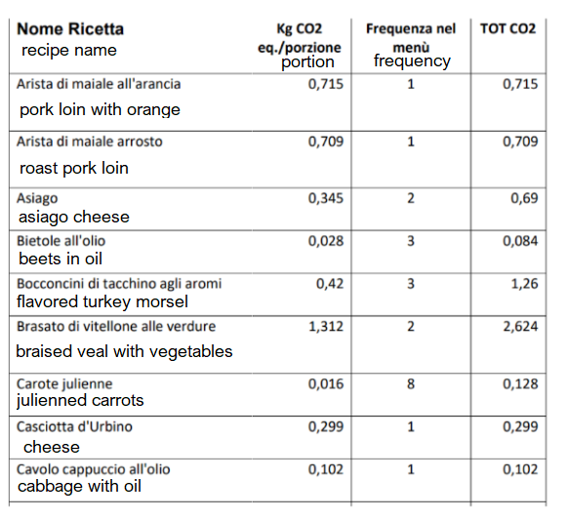

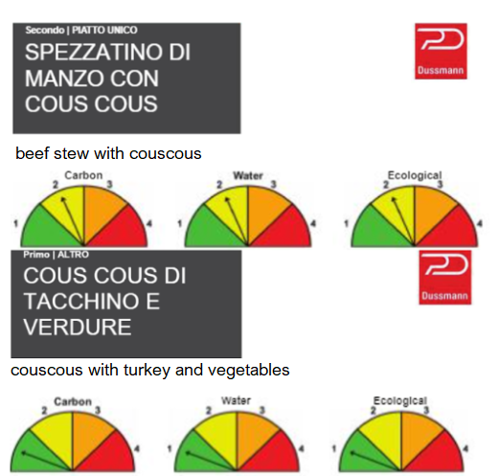 | In Fano, (Marche Region) on the other hand, the carbon footprint measurement tool is already active and allows recipes to be chosen based on the carbon footprint of the dish, using the supplier's bromatology sheet within which there is an indicator of the recipe's environmental impact.  Using this tool, a dish was chosen to be modified, replacing beef with turkey, maintaining the same pleasantness of taste, but reducing the environmental impact of the meal.

More and more municipalities, but also some collective catering companies, are demonstrating greater green awareness with school menus with a lower environmental impact, coinciding with a healthy diet: a diversification of protein sources, more organic, purchasing from short supply chains and fresh local products, elaboration of recipes instead of processed food, washable and no longer disposable plates. All aspects that contribute to a "green conversion" of the school cafeteria with choices that help mitigate the effect of climate change.

FOODINSIDER
Foodinsider is an observatory on school canteens which every publishes a survey on the state of the school canteen service in order to identify virtuous models and best practices that become benchmarks for those Administrations that want to improve the quality of service at school.
The objective of the Foodinsider association is to train, raise awareness and educate all the players involved in the school canteen on responsible consumption, involving schools, institutions and families in order to promote healthy and sustainable eating habits.
Foodinsider.it

