The Association for Roma Memory Studies (also known as Romani Godi) is a Roma civil society organization that works and advocates in the fields of Roma social memory, Roma language, culture, and history, as well as rights violations, inequalities, and discrimination experienced by Roma in Türkiye. Romani Godi is a member of the Roma Rights Network and a partner of the European Roma Rights Center (ERRC) in Turkey.
Our goal at Romani Godi is to ensure climate change is not considered a violation of human rights, that the degradation of the environment caused by climate change, which is a global environmental issue, does not violate human rights, and that all people share in the benefits and harms of the environment. Also, we would like to thank the Special Rapporteur for his efforts to ensure that climate change, a global environmental problem, does not pose a threat to access to clean water, food security, and the right to food.
In this text of opinion, Romani Godi will share the difficulties and obstacles in front of access to clean water and food safety in particular, by touching on the climate crisis brought about by climate change in Turkey. In addition, climate change and the rights violations experienced by Roma groups in Turkey will be discussed. We will also present case studies that we have heard about through the press in addition to the data collected from our field side visits.
Although Roma do not have official minority status in Turkey, they are one of the largest minority groups in the country in terms of population. According to Roma associations, approximately six million Roma live in Turkey, but there is no official data on the Roma population in Turkey as the Turkish government does not share disaggregated data. Despite the lack of visibility, the violations experienced by Roma are not identified enough because of non-inclusive policies, poor visibility, and limited political opportunities. Also, the uncertainty of data makes it difficult to create protective measures and plans for a global crisis such as climate change that specifically affects Roma populations.
Therefore, climate change-related human rights violations and environmental discrimination experienced by the Roma in Turkey are rarely brought to justice by any judicial authority. It has become a common occurrence for victims. As a result of the government and civil society's neighborhood-based data collection strategy, Roma studies ignore the unique problems of the Roma, and sometimes stigmatize them as "Roma neighborhood". It means the marginalization of the Roma in their environment.
Due to the oppressive environment in Turkey, which is aggravated by extra-legal practices, we kindly ask you not to share this opinion in public and to keep it confidential.

Current Status in Turkey
Turkey is located in the east of the Mediterranean Basin, the region most vulnerable to climate change The country suffered the driest year of the last 44 years in 2017. Factors such as globalization, climate change, urbanization, population growth, social and economic development, as well as polluting industry and unsustainable agricultural practices, have led to environmental problems that pose a threat to water and food security. Water and food security under climate change have become unprecedented challenges for Turkey and its future. The country is currently experiencing a period of drought and climate projections point to a decline in water potential. According to the Global Food Security Index, Turkey ranks 49th out of 113 indexed countries in terms of food security and is estimated to rank 8th when countries around the Middle East and North Africa are considered. Agricultural areas decreased from 26.3 million hectares in 2001 to 23.1 million hectares by 2020, largely due to climate change-induced drought.
Agriculture is the largest consumer of water in Turkey, a water-stressed country, and about 70% of the water used for agricultural purposes is consumed in irrigation. The risk of drought is in conflict with the vision and steps for sustainable development to which Turkey adheres. It can lead to deviations from the UN's 2030 Sustainable Development Goals and potential human rights violations resulting from climate change.
The Turkish government has published its climate change action plan for 2011-2023, however, with one year left to go, the majority of activities and targets remain unfulfilled. In practice, no realistic, sustainable and climate-crisis-preventing efforts have been undertaken to realize the action plan. There is no specific target on how to protect socio-economically vulnerable minority groups (the Roma in particular) from the environmental deterioration and potential human rights violations that climate change will entail. The word minority is not even mentioned in the action plan. Furthermore, the action plan and the policies of the Ministry of Environment, Urbanization, and Climate Change do not contain any strategies to fight intersectional and multiple discrimination in access to clean water and safe food that may be brought about by climate change and contradicts the Development Goals.
The impact of climate change on the Roma in terms of clean water and food security, An overview

The Roma, who do not have official minority status in Turkey, are an ethnic minority that is severely exposed to climate injustice, deep poverty, environmental discrimination, and territorial stigmatization.
The existence of segregated areas in Turkey such as stigmatized "Roma neighborhoods-ghettoes" and "Roma-Gypsy" parks in city centers is well known. This phenomenon leads to territorial segregation. Roma are often compelled to live in active or abandoned industrial zones, in the most isolated corners of the city, on the banks of streams with high flood risk, and in areas where waste recycling facilities are located, and pollution is associated with an identity for the Roma. This conscious, systematic, and institutionalized dynamic of environmental segregation generates environmental discrimination and climate injustice. In addition, this also leads to serious violations of the rights of Roma people to access clean water and food.
In disaster areas and areas where the effects of climate change are felt, those who do not experience financial difficulties can quickly move to safer areas. However, the Roma facing poverty are either unable to migrate or are forced to migrate to a worse environment. As a result of the effects of climate change, access to food has become more expensive; the Roma do not have access to food or can now access it at a much higher cost. It is thought that the Roma people, the poorest community in Türkiye, have the biggest problems in terms of access to clean water and healthy food. Particularly for communities at risk of intersectional discrimination, such as Roma LGBTI+, disabled, women, and young , the right to access food is increasingly challenging.
a-) The Gentrification of Urban Structure
a-1) Urban transformation policies carried out by the Housing Development Administration (TOKI) under the Ministry of Environment, Urbanization, and Climate Change of the Republic of Turkey.
As a result of TOKI-led urban transformation policies in Roma neighborhoods located within the city center, the Roma have been driven away from the city and into floodplains that are more vulnerable to climate change. Due to gentrification efforts carried out by the Republic of Turkey, the Roma are forced to pay more for access to clean water and healthy food in the new settlements to which they have migrated. The Roma have been compelled to live in remote corners of the city, floodplains, and other areas where climate change will have the most brutal impact.
a-2) The Inaccessibility to Urban Infrastructure Services
The unofficial ghettos to which they migrated are not recognized by the state, and they face problems in accessing urban infrastructure services in these new settlements. There are many Roma neighborhoods in Turkey that lack running water, sewage, and electricity infrastructure. The floods triggered by irregular rainfall due to climate change result in the accumulation of non-universal toxic wastes in front of tents, houses, and huts.
Roma people living in tents in Sakarya/Karasu district exemplify the problem of not having access to clean and sufficient food due to a lack of infrastructure.
B-) Neoliberal Policies and Polluting Industry
In the Marmara region of Turkey, where the polluting industry is highly concentrated, many Roma neighborhoods are located in industrial areas. In this regard, it can be argued that Roma people, who have the least contribution to, and therefore the least responsibility for, the greenhouse gas emissions that lead to climate change, are more affected by the consequences of climate change. This translates into climate injustice. It is also known that these Roma neighborhoods in western Turkey are located in the most polluted airspace in Turkey, resulting in serious health problems for the Roma living in the region.

Case Studies on the Violation of the Right to Access to Clean Water and Safe Food for Romas by the Climate Crisis Caused by the Climate Change in Turkey

The Ergene Basin Example

One of the largest practices of industrialization in Turkey began in the 1980s with the establishment of textile, chemical, and leather factories in the Thrace region. More than 3,000 factories have been established in the region, which is home to Turkey's largest Roma population, most of which are legally unlicensed and have no waste treatment system. Industrial liquid wastes are discharged into the Ergene River, which is the primary source of water for agriculture in the Ergene basin.
In Turkey, 55% of the total rice production is sourced from the Ergene basin, where the majority of the Roma make a living from farming-related work. In the Ergene basin, which is one of the most vulnerable basins in Turkey in terms of climate change, there have been decreases in crop yields of agricultural lands due to temperature increases.
Policy negligence in natural resource management in the Ergene River has led to many environmental challenges such as soil contamination, food insecurity, biodiversity loss, water quality degradation, and vegetation loss.
The Ergene River is currently identified as the "River of Death" due to the high levels of heavy metal pollution produced by industrial wastes, which spread death to its surroundings; for example, according to a TurkStat report, one out of every four deaths in Kirklareli is associated with cancer.
There are many Roma neighborhoods located along the river across the Ergene basin, and the Roma are more vulnerable to environmental deterioration than the non-Romas.
Agricultural activities are the main source of income for the Roma population in Edirne, and climate change-related drought in the basin and pollution from the Ergene River have decreased the yield of agricultural land, leading many Roma agricultural workers to become unemployed. Population data from Ascioglu, a Roma neighborhood in the Uzunkopru district of Edirne, reveals that the Roma population had to migrate from this region to other parts of Turkey.
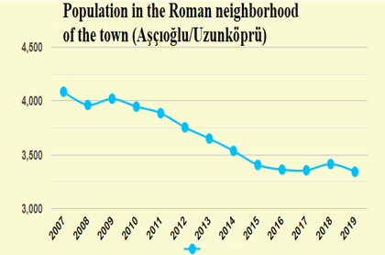
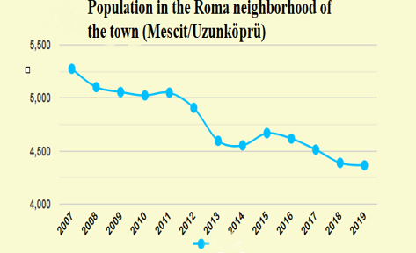

Figure 1. Population in Roma neighborhood (Ascioglu) of Uzunkopru
Figure2.. Population in Roma neighborhood (Mescit) of Uzunkopru

The population of the Roma neighborhoods of Ascioglu and Mescit decreased by 18% and 20% in 17 years, respectively. Every year, the Roma are forced to migrate from their homelands to industrialized cities due to diminishing agricultural activities as a result of climate change and environmental deterioration.

Pollution, Identity, and the Climate Conflict
According to our research, pollution in the Ergene basin has acquired an identity, and Roma are associated with the polluted river. "If you ask the Gajos (non-Roma) where the Roma neighborhood is, they will tell you that they live next to the dirty river," said one of the participants in the research.

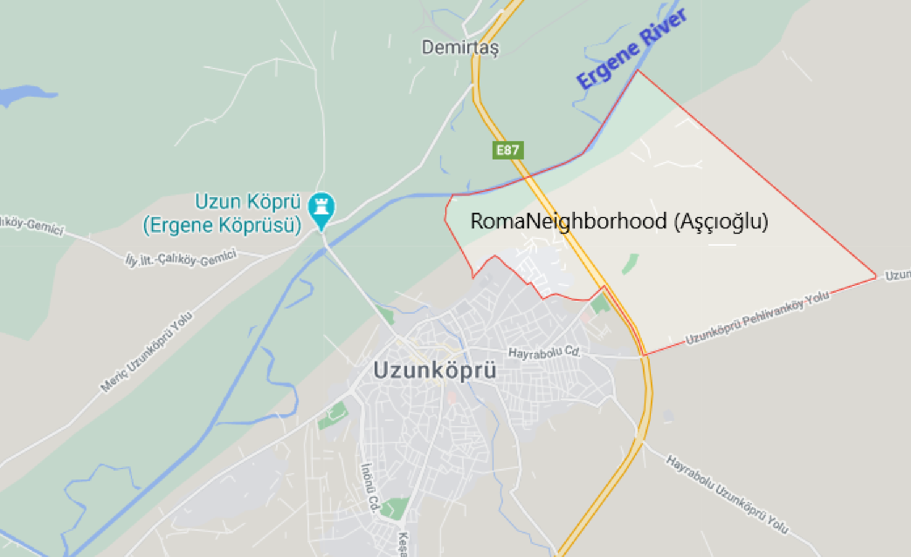
Especially in the fall, with irregular rainfall linked to climate change, the Ergene River overflows and the Roma people living in the riverbed are at risk of flooding. Liquid waste from Turkey's most polluted river can pose serious health problems and violations of the right to health for the Romas living in the region. The government authorities and the local municipality do not provide flood protection measures (retaining walls) for the section of the river that crosses the Roma neighborhood. In non-Roma neighborhoods, there are flood warning systems and protective walls.
Figure 3. A Roma settlement in Ergene River Bed

Additionally, social housing for Roma in Uzunkopru's Ascıoglu neighborhood was built by TOKI on the banks of the Ergene river, where flood risk is high. This is a sign of institutional racism.

The Problem of Access to Clean Water and Clean Food
In the Ergene basin, there are numerous reports that the Ergene River pollutes the groundwater and that this pollution also enters the spring water. In fact, the Edirne Provincial Directorate of Environment and Urbanization mentioned the pollution of the river in its 2017 environmental status report and noted that the city has not taken any measures to fight climate change. The issue of water and heavy metal pollution in the basin has been frequently addressed. During our visits to the region, the people of the region stated the following:
"The Roma have to drink the drinking water contaminated by Ergene, they have to cook with and to bathe their children with that water"
Due to the lack of infrastructure in the area where the Roma live, they are compelled to use polluted river water for cooking and drinking. Research conducted in the Ergene basin reveals that heavy metal contamination is detected in rice samples, plants and vegetables, and fruits grown in the region. Thus, it can be argued that violations of food security and the right to food are more deeply affecting Roma communities, the most vulnerable people in the region.
Corlu / Hidiraga (Koro) Neighborhood - Corlu Stream

Corlu Hidiraga Roma neighborhood is located in the stream bed of Corlu Stream, the most polluted stream in Turkey. Due to irregular rainfall linked to climate change, the Corlu stream overflows and the Roma people living in the stream bed are at risk of flooding. With recurrent floods, the Roma living in the area are in danger. In the map below, the yellow frame indicates the Corlu Stream, which sometimes flows red and sometimes blue, while the red frame indicates the Roma neighborhood.

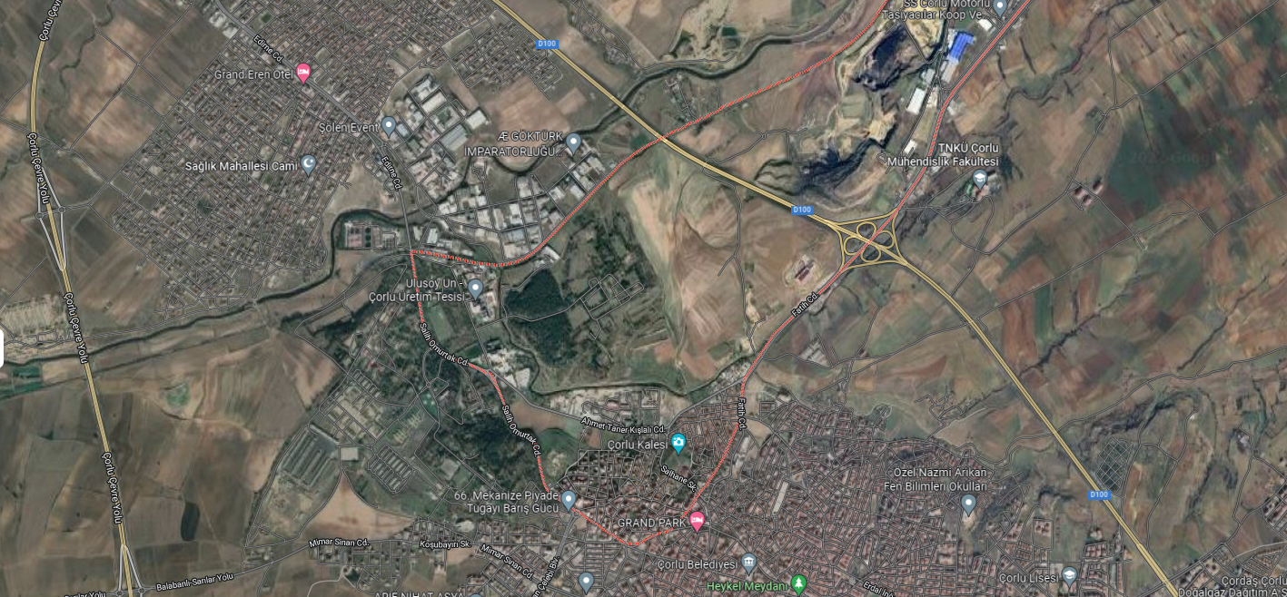
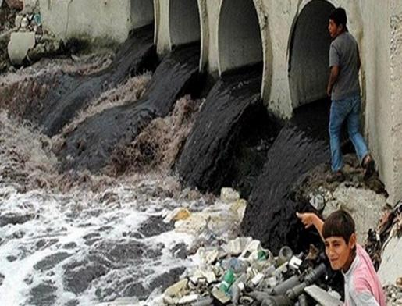
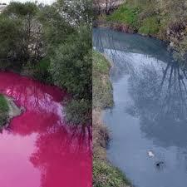
c

Figure 4. The Corlu Stream

Antep-Urfa-Euphrates River
According to 2017 data, the most vulnerable provinces in Turkey to climate change are Sanliurfa, Mardin, Diyarbakir, Kars, Erzurum, and Agri. There are many Roma communities living in these provinces in Eastern and Southeastern Anatolia and these groups are referred to as Dom communities. Although many Dom communities have adopted settled life, there are also nomadic Dom communities in Turkey, albeit in small numbers. They work as seasonal agricultural workers by setting up tents near the Euphrates River in the fertile Euphrates basin, especially during the summer months. These communities, which meet their water needs from the Euphrates River, face problems in accessing clean water as a result of drought due to climate change.
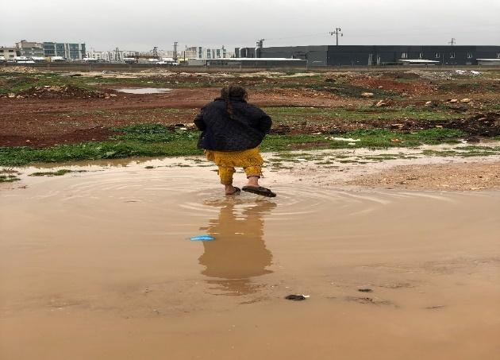
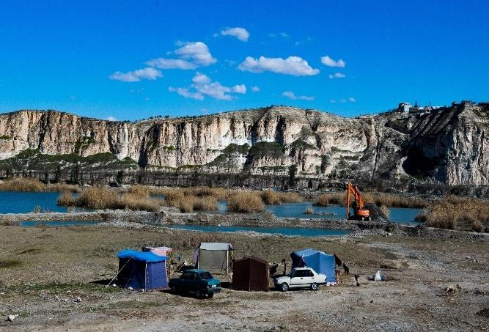
Figure 4. A picture from Dom groups living in Urfa

“Global Food Security Index,” The Economist Group, 2018, accessed January 15, 2018, http://foodsecurityindex.eiu.com/Country/ Details#Türkiye
“Drought Analysis,” Republic of Turkey Meteorological Service, last updated January 3, 2018, https://www.mgm.gov. tr/veridegerlendirme/kuraklik-analizi. aspx?d=aylik#sfB
“Drought Analysis,” Republic of Türkiye Meteorological Service, last updated January 3, 2018, https://www.mgm.gov.
https://www.sbb.gov.tr/wp-content/uploads/2021/10/2022-Yili-Cumhurbaskanligi-Yillik-Programi-26102021.pdf
D. Bozkurt and O.L. Şen, “Climate change impacts in the Euphrates–Tigris Basin based on different model and scenario simulations,” J. Hydrology 480 (2013): 149–161.
United Nations, Sustainable Development Goals, 2016, accessed January 15, 2018, http:// www.un.org/sustainabledevelopment/hunger/
https://webdosya.csb.gov.tr/db/iklim/banner/banner591.pdf
https://www.haberturk.com/sakarya-haberleri/95497834-kar-en-cok-onlari-etkiledikaldiklari-barakalar-coken-roman-vatandaslar-kalici-konut
Pamuk, Ş., 2008. Globalization, Industrialization and Changing Politics in Türkiye. New Perspectives on Türkiye, 38, pp.267-273.
GÖK, C., 2015. IMPLEMENTATION OF WATERSHED SUSTAINABILITY INDEX IN Türkiye: ERGENE BASIN CASE STUDY. Master. Hacettepe Üniversitesi
Tokatlı, C., & Varol, M. (2021). Impact of the COVID-19 lockdown period on surface water quality in the Meriç-Ergene River Basin, Northwest Türkiye. Environmental Research, 197, 111051. doi: 10.1016/j.envres.2021.111051
http://www.edirneyenigun.com/haber/21147/kirliligi-kabul-eden-rapor.html

