Call for input on the “Promotion and protection of human rights in the context of mitigation, adaptation, and financial actions to address climate change, with particular emphasis on loss and damage”, for 2022 UNGA77

Submitted by Opportunity Green on 21 June 2022.
Opportunity Green is a UK-based environmental non-profit working on shipping and aviation decarbonisation, with an expertise in law, economics and policy.

Executive Summary
Shipping is a major polluter, and a poorly regulated one when it comes to its greenhouse gas (GHG) emissions. In response to questions 2 and 3 of the questionnaire, this submission makes the case for the UN’s International Maritime Organization (IMO) to adopt stringent global measures to phase out the sector’s GHG emissions in line with the Paris Agreement’s 1.5°C goal, including a revenue-generating GHG / carbon pricing measure, with a portion of the funds being allocated to developing countries, particularly Small Island Developing States (SIDS) and Least Developed Countries (LDCs). The upcoming IMO climate meetings in December 2022 will be a key moment to call for further ambition from the IMO and its delegates on this matter.

Introduction

Climate change is severely and disproportionally impacting vulnerable countries, especially developing countries, and particularly SIDS and LDCs. An inadequate global response to climate mitigation, adaptation, and loss and damage will further weaken their adaptation capacity, and jeopardize the human rights of their populations.

Many low-lying developing countries and SIDS in the tropics and subtropics, have large extents of their populations and critical infrastructure in coastal areas, making them ever more vulnerable to climate change hazards, particularly those associated with the ocean, such as is the case for sea-level rise, tropical cyclones, marine heatwaves, ocean acidification, coastal erosion, extreme flooding, among others.

The added vulnerability of these frontline countries is also deeply intertwined with their socioeconomic conditions. Analysis of economic impacts of climate change across the globe shows that the consequences are significantly higher for SIDS with, for example, a projected average annual gross domestic product (GDP) loss of between 0.75% - 6.5% by 2030 for Pacific SIDS, compared to the global average of 0.5%. And the ever more frequent and intense hurricanes in the Caribbean and the Pacific regions are, increasingly so, leaving a trail of destruction in their wake, having recently damaged up to 90% of buildings and causing damages in some cases exceeding the country’s annual GDP.

Despite their best efforts, many of these countries’ governments do not have sufficient personnel, funds, and technical data to effectively and efficiently address and prepare for the impacts of a warming planet. As the average global temperature continues to rise, a vicious circle is generated whereby these countries are having to divert an escalating percentage of their limited resources from other vital public programmes – that would support them in the attainment of a sustainable development - to responding to immediate climate impacts and disaster response.,

It was in response to this urgent and growing problem - coupled with the insufficient levels of climate finance, ahead of COP26 – that, in October 2021, the UN Special Rapporteur on Human Rights and the Environment, Mr. David R. Boyd, supported the creation of aviation and maritime shipping levies to “help close the gap in SIDS and LDCs finance for losses, damages, and adaptation in an expeditious, equitable and efficient manner.” This submission further elaborates on this point, focusing on the potential for the further development and agreement on a maritime pricing mechanism, at upcoming key IMO climate meetings.

Shipping Emissions

Shipping is a lifeline for many of these frontline countries, particularly SIDS. But the sector is also a major emitter, further exacerbating these countries’ vulnerabilities to climate change. If shipping were a country, it would be the world’s sixth-largest carbon emitter, topping major developed economies such as Germany. Alarmingly, the GHG emissions of the sector are only increasing. From 2012 to 2018, GHG shipping emissions increased about 10% from 977 million tonnes in 2012 to 1,076 million tonnes, and its CO₂ emissions are projected to increase to 90-130% of 2008 levels by 2050.

While much attention is given to the implementation of the Paris Agreement goals, shipping has somehow benefited from a lesser public scrutiny of its actions to effectively mitigate, adapt, and compensate for its contributions to climate change. International shipping largely sits outside the United Nations Framework Convention on Climate Change (UNFCCC) remit, with this responsibility being instead on the IMO to regulate this.
In April 2018, the IMO adopted its Initial GHG strategy on the reduction of greenhouse gas emissions from shipping setting out, inter alia, the UN agency’s commitment to reducing emissions from international shipping by at least 50% by 2050, compared to 2008. However, as stated by the UN Secretary-General António Guterres, this goal is more consistent with a warming of above 3°C - and urging the IMO to commit to zero emissions by 2050, to ensure 1.5°C alignment.
And the opportunity to see that, and other ambitious changes, to the IMO’s Strategy is now.

Addressing Shipping Emissions and Developing Countries’ Finance Needs

At the point of adoption, the Initial Strategy was projected to be revised in 2023, at the 80th session of the IMO’s Maritime Environment Protection Committee (MEPC 80), and the work on those revisions has already been initiated by delegations coming together at MEPC and at the Intersessional Working Group on GHGs (ISWG-GHG) meetings.
At the same time, delegations are also currently working on the so-called ‘mid-term measures’ of the Strategy, which are policies to be adopted at IMO, with a view to reduce and phase out international shipping emissions. According to the Committee’s agreed workplan (see figure 1), following the initial collation and consideration of mid-term measures (spring 2021 – spring 2022), the delegations at the IMO will now enter the second phase of the workplan (spring 2022 – spring 2023), and initiate the assessment and selection of these measures. Alongside this, they will conclude the revision of the Initial Strategy – and its emission targets – by MEPC80.
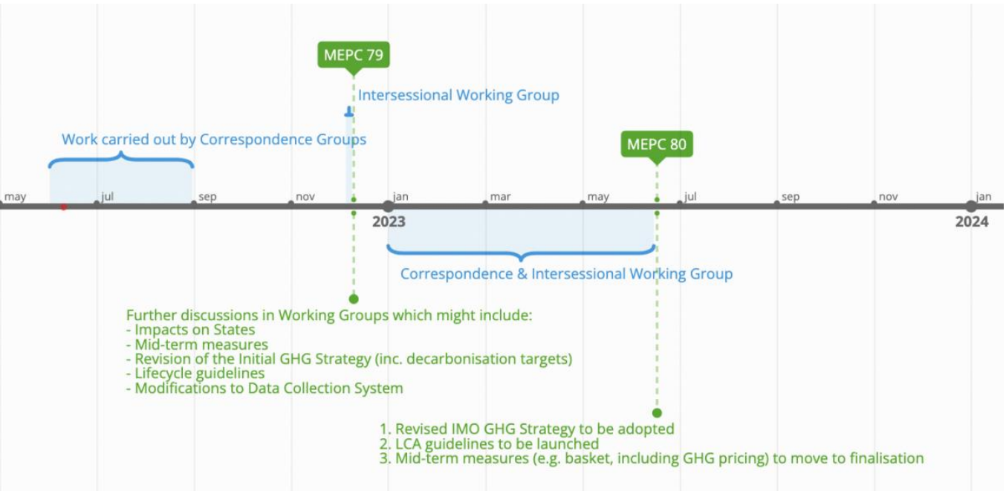

Figure 1: Timeline of IMO meetings on GHGs (2022 – 2023).

The discussions at the most recent IMO meetings – namely the 12th Intersessional Working Group on GHGs (ISWG-GHG 12), and the 78th session of the Maritime Environment Protection Committee (MEPC 78), in May and June 2022 respectively - saw reconfirmation of the intent to raise the ambition of the Strategy (e.g. several delegations coming forward, defending zero CO₂ / GHG emissions by 2050), alongside a convergence surrounding the need for an equitable transition, and the components that this entails. This could include an agreement on a mid-term GHG / CO₂ pricing measure, with the possibility of out-of-sector deployment of revenues raised.

But the IMO is currently not on track to meet the Paris Agreement goals. The success and ambition of these upcoming meetings will be crucial to changing this. It is of paramount importance that the IMO secures, by MEPC 80, a selection of a robust, stringent and global basket of mid-term policy measures, that phase out the sector’s GHG emissions in line with the 1.5°C temperature goal.

To secure a fair and equitable transition, this basket of measures should include a revenue-generating market-based measure (MBM), of global application. Not only would this send a strong market signal for industry to invest in the necessary technologies to effectively decarbonise shipping, but it would also allow the allocation of a portion of the generated revenues to support developing countries in their own transition, adaptation, and to address loss & damage, as well as possibly supporting the funding of the technologies and infrastructure necessary to decarbonise shipping worldwide. The funds should be managed and distributed in a transparent based on transparent rules to ensure funds’ continued reliability, and effective and use.

As defended in the UN Special Rapporteur on Human Rights and the Environment’s policy brief of October 2021, negotiations on market-based measures to reduce GHG emissions from ships put forward by different delegations these past 12 months — including, for example, the shipping levy proposal advanced by the Marshall Islands and Solomon Islands, two frontline SIDS - should be prioritised at upcoming meetings, namely the upcoming ISWG-GHG 13 and MEPC 79 (December 2022), and MEPC 80 (spring 2023), that will support an equitable and fair transition, and protect the rights of the most climate vulnerable.

Thomas, A. et al. (2020) ‘Climate Change and Small Island Developing States’, Annual Review of Environment and Resources, 45(1), pp.1-27.
Intergovernmental Panel on Climate Change (2019) ‘Summary for policymakers’, IPCC Special Report on the Ocean and Cryosphere in a Changing Climate.
UN-OHRLLS (2015) ‘Small Island Developing States In Numbers: Climate Change Edition 2015’.
Boyd, D.R., and Keene, S. (2021) ‘OHCHR Policy Brief No. 2 Air Travel and Maritime Shipping Levies: Making Polluters Pay for Climate Loss, Damages and Adaptation’.
Thomas, A. et al. (2020) ‘Climate Change and Small Island Developing States’, Annual Review of Environment and Resources, 45(1), pp.1-27.
Benjamin L, and Thomas A. (2018) ‘Climate change impacts and research in the Caribbean: constraints, opportunities and the role of tertiary institutions’, University Initiatives in Climate Change Mitigation and Adaptation, pp. 131–42.
Thomas, A. et al. (2020) ‘Climate Change and Small Island Developing States’, Annual Review of Environment and Resources, 45(1), pp.1-27.
Boyd, D.R., and Keene, S. (2021) ‘OHCHR Policy Brief No. 2 Air Travel and Maritime Shipping Levies: Making Polluters Pay for Climate Loss, Damages and Adaptation’.
Fabel, J. et al. (2020). Fourth IMO Greenhouse Gas Study. International Maritime Organization.
Ibid.
IMO (2018), Initial IMO Strategy on Reduction of GHG Emissions from Ships.
Lo, J. (2021) ‘UN boss calls for stronger aviation and shipping climate goals in line with 1.5C’, Climate Home News, 14 October. Available at: https://climatechangenews.com/2021/10/14/un-boss-calls-stronger-aviation-shipping-climate-goals-line-1-5c/ (Accessed: 20 June 2022).
IMO (2018), Initial IMO Strategy on Reduction of GHG Emissions from Ships.
Ibid.
Shaw, A. and Smith, T. (2022) ‘An overview of the discussions from IMO MEPC 78 – read out from UMAS’, UMAS, 10 June. Available at: https://www.u-mas.co.uk/wp-content/uploads/2022/06/MEPC-78-overview-UMAS.pdf (Accessed: 20 June 2022).
Ibid.
Boyd, D.R., and Keene, S. (2021) ‘OHCHR Policy Brief No. 2 Air Travel and Maritime Shipping Levies: Making Polluters Pay for Climate Loss, Damages and Adaptation’.
Ibid.

