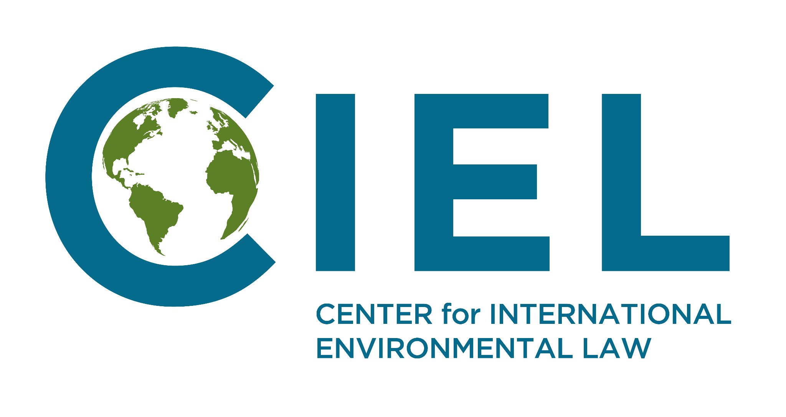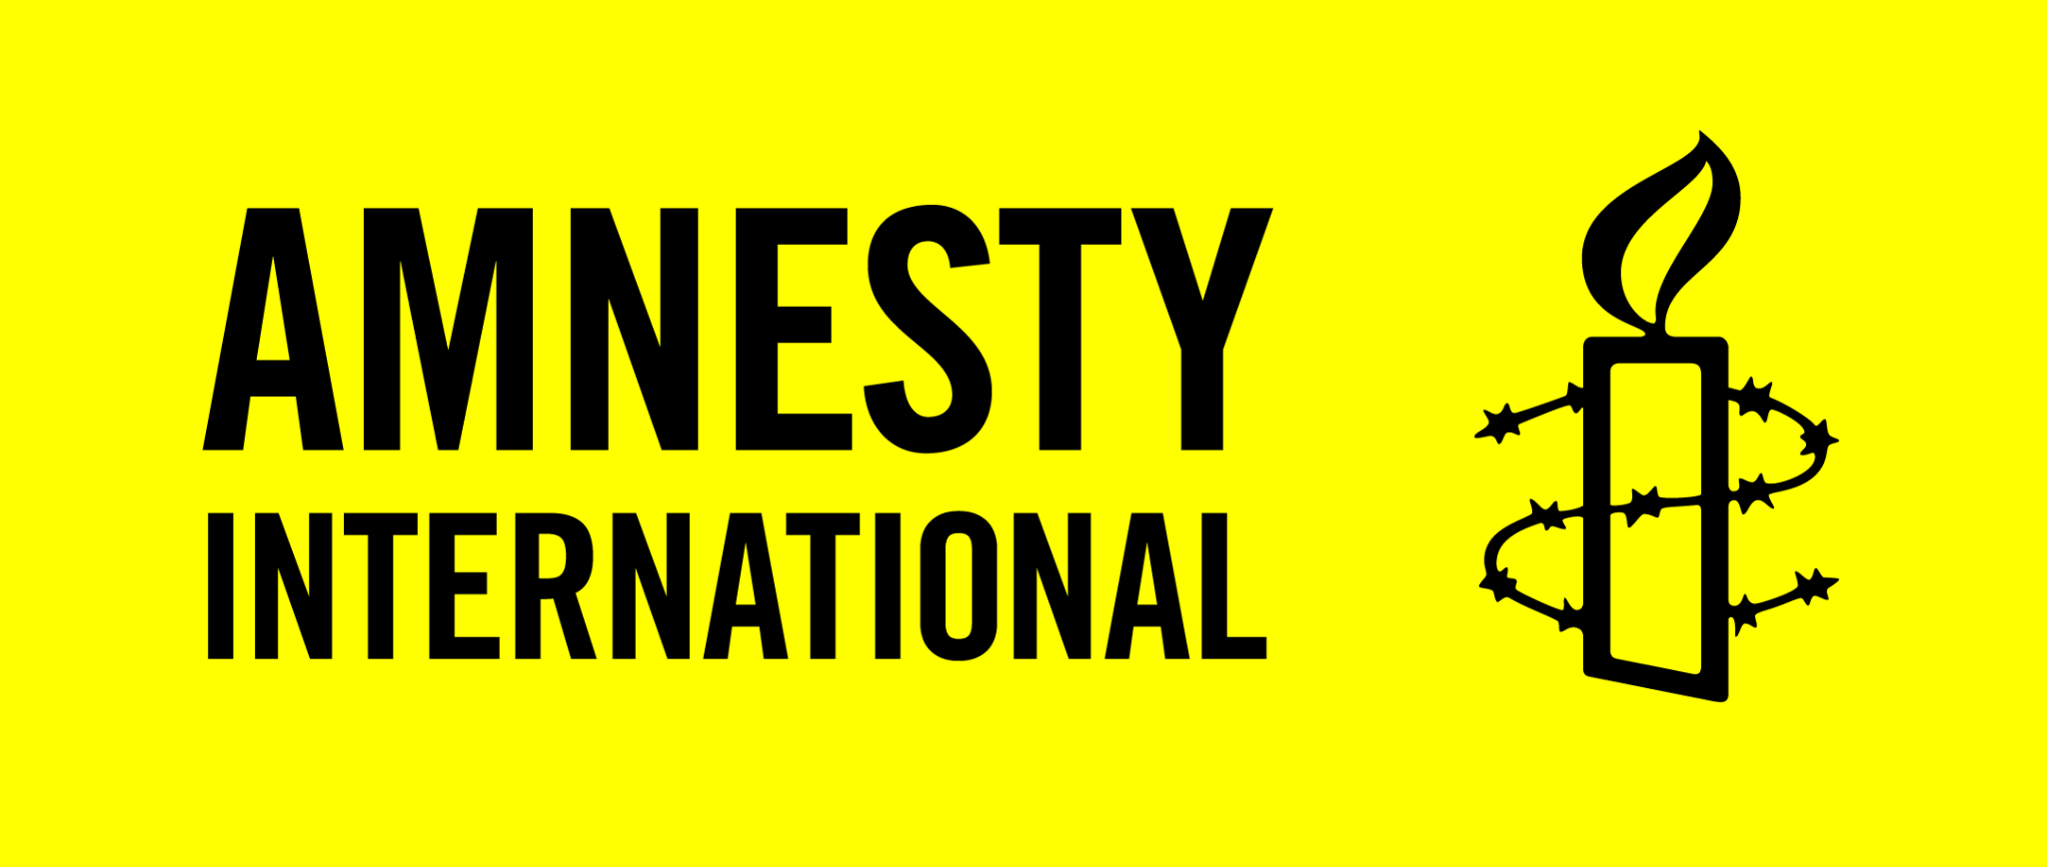
‘Promotion and protection of human rights in the context of mitigation, adaptation, and financial actions to address climate change, with particular emphasis on loss and damage’
Amnesty International and the Center for International Environmental Law (CIEL) present their submission in response to the call for input by the Special Rapporteur on the promotion and protection of human rights in the context of climate change, focusing on questions 1, 2, 6 and 7.

States have the obligation to protect the enjoyment of human rights from the impacts of climate change. This entails the duty of States to step up mitigation and adaptation efforts in order to avert and minimize loss and damage (L&D). The IPCC has warned about the irreversible impacts of overshooting 1.5°C (CIEL, 2022). All States that have not submitted an enhanced Nationally Determined Contribution (NDC) or have submitted one that does not reflect their fair share to limit warming to below 1.5°C, should urgently submit more ambitious NDCs, and States should immediately commit to a full, rapid and equitable phase-out of fossil fuels (avert L&D). Wealthy States should drastically scale-up international finance for adaptation, in order to fulfill the Paris Agreement commitment to achieve a balance between finance for mitigation and adaptation (minimize L&D). However, mitigation and adaptation efforts will not be able to prevent all climate harms. As recognized by the IPCC, limits to adaptation for human and natural systems have already been reached and will increase with increasing global warming (IPCC AR6, WGII, Summary for Policymakers, C.3). Ignoring this amounts to denying remedy to the people who will be harmed. It is therefore equally important to address L&D through specific, human rights-based measures and dedicated funds.

Experiences and examples of Loss And Damage
At an average warming of 1.1°C, millions of people’s human rights such as the rights to life, health, food, adequate housing, education, work, culture, and self-determination are harmed by climate-induced L&D, in particular individuals and groups who are already subjected to multiple and intersecting forms of discrimination or who are marginalized as a result of structural inequalities. For example, in April and May 2022, the KwaZulu-Natal province in South Africa suffered two devastating flood events. This resulted in severe damage to infrastructure, interruptions in basic services, injury, and loss of life. Scientists determined that climate change had doubled the probability of an event such as the April rainfall that resulted in devastating flooding. The poor state of water infrastructure, coupled with the lack of implementation of climate-friendly urban planning policies in the municipality, contributed to the devastating impact. This included the death of 461 people (with 88 people missing); 8,584 houses completely destroyed; 13,536 houses damaged; 6,000 people still homeless (as of 13 June 2022); 630 schools affected with over 100 inaccessible in the aftermath; and the entire province without water for weeks, with some communities still without water two months later.
Heatwaves around the world are causing L&D, both economic due to reduced labor productivity and impact on crops, and non-economic, such as impacts on the right to life and health, access to education, and water and food security. For example, in May and June 2022, thousands of people in India and Pakistan experienced searing heat waves crossing 50°C in some places. According to early reports - which are likely to provide only an underestimation of total heat-related deaths - at least 90 people were estimated to have died in India and Pakistan due to heat related causes between March and early May. At least three children were reported dead in Pakistan and schools were closed for a prolonged period of time. Heat waves in Pakistan in 2021 resulted in disproportionate impacts on people living in poverty and day-wage workers, and women have been particularly exposed to extreme heat, as they do not have equal access to cooling mechanisms due to discriminatory practices and social conventions (Amnesty International, 2021).
The damage to and loss of ecosystems such as the Arctic, tropical and mountain forests, and semi-arid pastoralist areas, translate in incalculable L&D on the cultural rights of the peoples who live there and protect these very ecosystems, as a result of changes to and even complete destruction of livelihoods, which form an intrinsic part of culture, and loss of access to cultural heritage such as medicinal herbs and sites of cultural rites and ceremonies. For example, Indigenous Peoples across the Arctic, are facing losses to their culture and traditional way of living as reindeer herders, which is integral to their nomadic lifestyles and cultures, and is being severely damaged by climate change, including changes to the thaw cycle, drought, and unpredictable summer weather. Similarly Indigenous Peoples and local communities in low-lying islands and other territories predicted to become uninhabitable as global warming increases are at risk of irreversibly losing their land and territory, which threatens their right to self-determination and all their cultural rights.

Human rights standards relating to Loss and Damage
Based on the duty of international cooperation and assistance, a key extraterritorial obligation (Maastricht Principles on Extraterritorial Obligations of States in the area of Economic, Social and Cultural Rights, 2011; ETO Consortium, 2014), all States in a position to provide resources have the obligation to do so in order to respect, protect and fulfill human rights. This obligation includes ensuring that human rights are protected from climate-related harms, and ‘may include compensating people for harm incurred as a result of climate change’ (UNEP, 2015). Five human rights treaty bodies stated that: “States must cooperate in good faith in the establishment of global responses addressing climate-related loss and damage” (CEDAW, CESCR, CMW, CRC, CRPD, 2019).

Under human rights law, all persons who suffer human rights violations are entitled to access effective remedies. Relevant human rights bodies have clarified that this principle extends to human rights violations caused by environmental harm. Therefore, States must ensure the right to remedy for those whose rights are affected by L&D. All States that have failed to take steps within their ability to limit emissions or to support global adaptation efforts are collectively responsible for the L&D resulting in human right violations within their territory and abroad in accordance with their respective contribution to the harm caused (Amnesty International 2021).

Based on these duties and obligations, wealthy countries must provide adequate financial means, technical support and access to remedy, including compensation, to people in developing countries whose rights have been negatively affected as a result of L&D. However, the lack of sufficient international assistance does not excuse any state from taking steps to comply as much as it can with its human rights obligations, and in the case of economic, social and cultural rights, from realizing these rights to the maximum of available resources.

A human rights compliant approach to addressing Loss and Damage
3.1. Access to information, public participation and stakeholder consultation
To ensure that any response to L&D, from national approaches to international mechanisms, fits the needs of affected communities and respects, protects and promotes human rights, access to information, public participation, and meaningful stakeholder consultation, including respect of Indigenous Peoples’ right to Free, Prior and Informed Consent (FPIC), are key.

3.2. Human rights-centered Loss and Damage Needs Assessments
Parties should conduct inclusive and participatory Loss and Damage Needs Assessments (LDNAs), considering the adverse effect of climate change on the enjoyment of human rights, such as the rights to life, health, food, adequate housing, education, work, culture, and self-determination. These LDNAs should inform national and sectoral policy planning and budgeting. Affected individuals and groups should be involved in LDNAs to determine the magnitude of the L&D, including those that do not have a measurable economic value, and to improve understanding of how to provide effective remedy.

3.3. Inclusivity, equality, and intersectionality
All responses to L&D need to be inclusive, intersectional, gender-responsive, and consider substantive equality for individuals who are already marginalized. The way entities such as ‘households’ are described (e.g. in a heteronormative way) could lead to exclusion of relief for LGBTQI+ individuals and couples (Oxfam Australia, 2018). Responses related to labor could lead to exclusion of people working in the informal sector (Amnesty International, 2022), often people living in poverty (ILO, 2018). And persons with disabilities are often disproportionately affected by climate hazards, and among the least able to access emergency support (OHCHR, 2020). These are just some examples of how L&D responses need to be targeted to ensure all people who have been made vulnerable are reached. Moreover, specific policies and practices are needed to ensure appropriate security and remedies to violence that may occur, including gender-based violence, in the aftermath of sudden onset climate hazards such as cyclones and in temporary shelters and when people are displaced.

Policies and practices
4.1. National data monitoring
There is a gap in available data about how L&D is manifesting at the local and national level. While an increasing number of countries, especially Small Island Developing States and LDCs, are including references to estimations of L&D as well as responses and initiatives in their NDCs, this is not systematic (CCLAD, 2021; La Ruta Del Clima, 2022). The Paris Agreement rulebook does not contain modalities for including L&D in NDCs. There is a need to develop standards and mechanisms at the UNFCCC level for analyzing and reporting on economic and non-economic L&D caused by climate change, and linking this to NDC reporting and LDNAs (see above). Methodologies for data collection should be community-based and allow for disaggregated data capturing L&D and its impacts on the enjoyment of human rights of groups who are particularly vulnerable and/or have been marginalized, to ensure adequate responses.

4.2. Social protection schemes
“The right to social security is of central importance in guaranteeing human dignity for all persons when they are faced with circumstances that deprive them of their capacity to fully realize their human rights.” (OHCHR). L&D is creating such circumstances. Both in the face of slow-onset climate impacts and climate hazards, social protection mechanisms - fundamental to decent work and essential to a just transition - such as income support and employment guarantees can significantly increase the resilience of people dealing with L&D, protect their human rights, and prevent communities from falling into a poverty spiral (Action Aid, 2021; ITUC, 2018). Similarly, social protection measures ensuring access to adequate healthcare and food are crucial to protect the rights of communities at risk of climate shocks and facing L&D. States urgently need to scale up and systematize universal social protection schemes that are accessible to everyone, adequate, gender-responsive, inclusive of the most marginalized, and adjusted to both slow-onset and sudden climate-related challenges (ActionAid, 2021), at the national level and within the UNFCCC.

4.3. Climate-induced displacement
Climate-induced displacement is a form of L&D affecting human rights. All States must establish mechanisms to protect the human rights of people who have been displaced by the impacts of climate change, internally and across borders. States most responsible for climate change must accept their collective responsibility to provide a remedy to displaced persons. This includes accepting and integrating in their territory people forced to move on account of climate change and cooperating to support people who need to relocate because the place they live in is becoming uninhabitable due to climate change. States should ensure that following a genuine consultation process, affected people can re-establish themselves and maintain their collective identity and right to self-determination in a safe and adequate location that ensures all their human rights are guaranteed. Finally, they should cooperate to ensure adequate resources are available to respond to human mobility in the context of climate change (Amnesty International 2021).

4.4. UNFCCC related processes
The UNFCCC state Parties should urgently put in place real solutions for addressing L&D, building on the duty of States to cooperate internationally towards the realization of human rights. COP19 saw the establishment of the Warsaw International Mechanism on Loss and Damage (WIM) to promote the implementation of approaches to address L&D. To date, the WIM has focused mainly on enhancing knowledge and understanding and strengthening dialogue, coordination, coherence, and synergies, while neglecting its third, important function to enhance action and support to address L&D.

In order to fulfill its third function, an urgent and rights-based operationalization of the Santiago Network (SNLD) is needed. The guiding principles that drive the SNLD and the terms of reference of its coordinating body should explicitly include human rights, including the rights of Indigenous Peoples (Loss and Damage Collaboration (L&DC), 2022; OHCHR, 2022). The operational modalities should be inclusive and transparent, allowing for meaningful public participation, in particular of people most affected by L&D. The activities it undertakes should be needs-based and country-driven, and address all types of L&D: economic and non-economic, and sudden-onset and slow-onset. The SNLD can play an important role in supporting the conduct of inclusive and participatory LDNAs, and the transition to human rights-based implementation. An effective and efficient SNLD requires the provision of sufficient resources.

The Glasgow Dialogue to discuss funding arrangements for L&D should lead to concrete outcomes that provide adequate, new, and additional support for people whose rights are the most impacted (CAN International and L&DC, 2022). The dialogue should be inclusive and transparent, allowing for meaningful participation. It should be rooted in the UNFCCC principles of equity, justice, fairness, and access, and centralize the L&D impact on human rights, and the polluter pays and do-no-harm principles. The dialogue should focus on addressing existing gaps and lead to the establishment and operationalization of a Loss and Damage Finance Facility (see below). The discussions on L&D finance should happen in coordination with the ongoing discussions on a New Collective Quantified Goal on international climate finance, which should be based on finance needs on the ground, and include new and additional finance for L&D (L&DC, 2022, CAN International, 2022).

Rights-based finance for addressing Loss and Damage
In order to protect human rights in the context of climate-induced L&D, new and additional, needs-based, rights-based, and gender-responsive finance for L&D is crucial. Based on state obligations under international human rights law and important principles under the international climate regime such as equity and common but differentiated responsibilities, a significant share of the funding should be provided by countries with a historic responsibility for the climate crisis. Additionally, innovative sources of finance, some of them based on the polluter pays principle, such as international levies on commercial air passenger travel and emissions from international shipping, redirection of fossil fuel subsidies, a Climate Damages Tax, as well as debt cancellation and debt relief, can ensure finance for addressing L&D is available at the scale required (Boyd and Keene, 2021; CAN International, Christian Aid, Heinrich Böll Stiftung, Practical Action and Stamp Out Poverty, 2022; Stamp Out Poverty, 2018).

A Loss and Damage Finance Facility (LDFF) should be established no later than COP27, and should be fully operational by COP29. The governing arrangements of the LDFF should be guided by human rights principles and standards. The LDFF should have the modalities in place to enable responses to both rapid-onset and slow-onset events (CAN International, Christian Aid, Heinrich Böll Stiftung, Practical Action and Stamp Out Poverty, 2022).

Finance for L&D must be guided by a human-rights based approach (CIEL, 2021). This means specifically that it:

- Is based on inclusive and participatory human rights-centered LDNAs, actively engaging local communities, Indigenous Peoples, and marginalized groups, ensuring that finance is based on the actual needs of people in the most vulnerable situations, and their proposals for remedy.
- Prioritizes country ownership, direct access, and small grant funding, ensuring that finance effectively reaches the local level and those whose rights have been the most impacted.
- Prioritizes grant-based funding, ensuring that it does not create new debt and therefore compound economic problems or exacerbate structural inequalities and vulnerabilities.
- Establishes social (human rights, equity and non-discrimination, gender, Indigenous Peoples, cultural heritage, involuntary resettlement, at-risk and marginalized groups, labor) and environmental (biodiversity and critical habitats, pollution prevention) safeguards as well as procedural protections (access to information, public participation and stakeholder consultation, right to remedy) to ensure L&D funds do not lead to human rights violations.

6. Clarifying States’ obligations in the context of climate change
The current gravely inadequate response to the climate crisis is leading to violations of human rights. For this reason, Vanuatu is seeking an Advisory Opinion from the International Court of Justice on climate change as it specifically affects developing countries particularly exposed to the adverse effects of climate change. This Advisory Opinion is essential, as it can clarify States’ obligations and provide guidance to address the climate crisis in a human rights-consistent manner, safeguarding the rights of those most impacted and sharing the burdens and benefits of climate change and its resolution equitably and fairly.

Contact
Amnesty International  Chiara Liguori  chiara.liguori@amnesty.org | Center for International Environmental Law (CIEL)  Lien Vandamme  lvandamme@ciel.org

