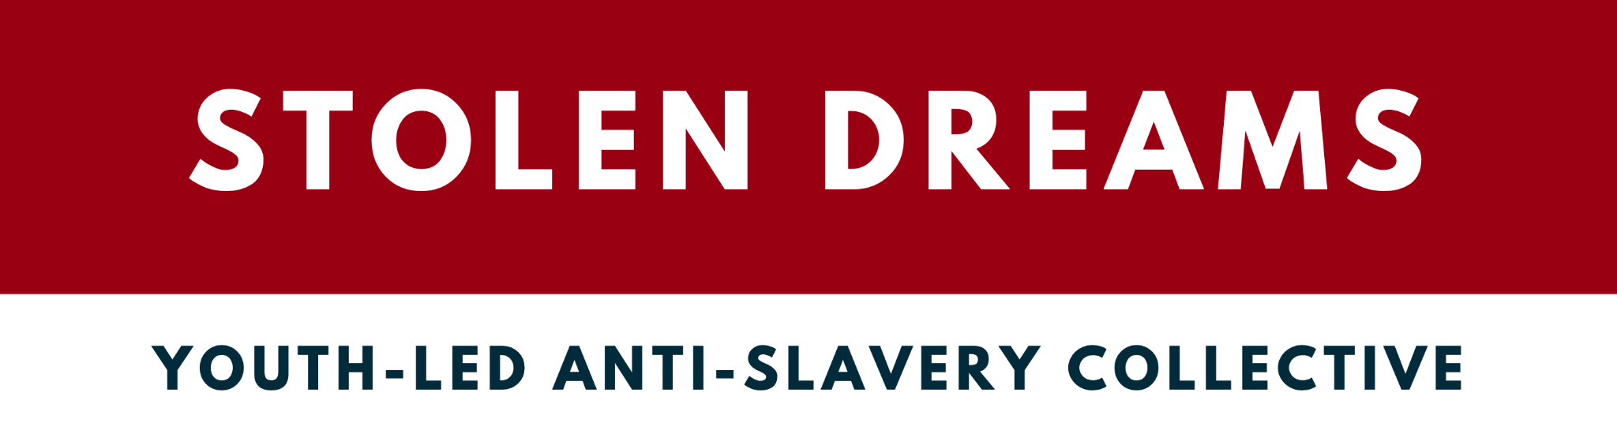

November 2022

Response to the call for inputs:

Report of the Special Rapporteur on the promotion and protection of human rights in the context of climate change on “Addressing the human rights implications of climate change displacement including legal protection of people displaced across international borders”.

This response is being submitted on behalf of Stolen Dreams and the Youth for Freedom Collective, two international youth-led collectives working to counter contemporary forms of slavery and trafficking in persons, in consultation the Migration Youth & Children Platform (MYCP), the largest youth-led facilitator of youth engagement in migration-related United Nations processes, and grassroots youth. The submission reaffirms, reiterates and incorporates evidence and recommendations from existing research on the climate change displacement, contemporary forms of slavery and trafficking in persons nexus.

According to the Walk Free Foundation, on any given day in 2021, it is estimated to be that 50 million people were in modern slavery globally. The research provided and supported by organisations in the sector provides complete evidence that climate change and climate-induced displacement are exacerbating vulnerabilities to contemporary forms of slavery and trafficking in persons. This points to a crucial need to concretely implement and build upon substantive legal actions that provide substantive human rights protections for people displaced by climate change.

People internally displaced within their own country and those that are displaced across international borders as a consequence of climate change are disproportionately at risk of contemporary forms of slavery and trafficking in persons. This includes women, girls, children, persons with disabilities, indigenous peoples, local communities, and other people working in rural areas, people living in conditions of water scarcity, drought and desertification, persons belonging to minority groups, homeless persons, persons living in poverty, older persons, migrants including those without documents, refugees and internally displaced persons, those living in conflict areas and those already in vulnerable situations.

It should be noted that in all processes regarding combatting contemporary forms of slavery and trafficking in persons, including in the context of addressing the human rights implications of climate change displacement including legal protection of people displaced across international borders, survivors and people with lived experiences, must be ensured the full respect of their human rights, and, for their perspective, experience and expertise to be centred across all relevant efforts and decision-making as co-leaders, co-creators, and co-owners.

What international, regional and national policies and legal approaches are necessary to protect people and communities displaced by climate change?

In this regard, we recommend the following legal actions that Member States should take to prevent contemporary forms of slavery and trafficking in persons and ensure people vulnerable to, as well as survivors/people with lived experiences, are protected and provided with adequate support:

- Recognizing the crucial intersection between the ‘triple planetary crisis’ and contemporary forms of slavery and trafficking in persons, reaffirm in the strongest terms possible the commitment and strong will to fully, effectively and meaningfully implement, as a matter of priority, the United Nations Framework Convention on Climate Change, the Paris Agreement adopted under the Convention and the Glasgow Climate Pact, as well as the Convention on Biological Diversity, the United Nations Convention to Combat Desertification in Those Countries Experiencing Serious Drought and/or Desertification, Particularly in Africa, 2030 Agenda for Sustainable Development, the SIDS Accelerated Modalities of Action (SAMOA) Pathway, the Sendai Framework for Disaster Risk Reduction 2015–2030, the Addis Ababa Action Agenda of the Third International Conference on Financing for Development, as well as, the Protocol to Prevent Suppress and Punish Trafficking in Persons, Especially Women and Children, and the Protocol Against the Smuggling of Migrants, supplementing the United Nations Convention against Transnational Organized Crime, as well as the International Convention on the Protection of the Rights of All Migrant Workers and Members of Their Families, the New York Declaration for Refugees and Migrants, the Global Compact for Safe, Orderly and Regular Migration, the Global Compact for Refugees, and the outcomes of relevant United Nations conferences and summits and the follow-up to those conferences and summits.

- Call upon Member States to enact or update national laws and establish complementary and comprehensive policies, programs and other measures that provide for the legal protections of trafficked persons from revictimization, with appropriate assistance and protection, stressing the importance of coordinating both national and international cooperation to enhance positive efforts.

- Commit to international cooperation to facilitate safe, regular and orderly migration, both internally and internationally, that is less bureaucratic, accessible and affordable, through the implementation and strengthening of relevant international and national legal instruments, ensuring access to remedy at non-state levels and securing access to legal status, and adequate basic services at both sources and destination, inter alia, education, housing, sexual and reproductive health and rights, healthcare, training, decent work and employment opportunities, interpretation services, legal support and the full respect of their human rights.

- Reaffirm the importance of adopting a gendered lens to addressing the human rights implications of climate change displacement including legal protection of people displaced across international borders, addressing the root negative social norms, policies and practices that sustain gender inequality and discrimination, including the culture of tolerance towards sexual and gender-based violence that makes women and girls particularly vulnerable to contemporary forms of slavery and trafficking in persons.

- Commit to ensuring survivors and people with lived experiences of contemporary forms of slavery and trafficking in persons, including persons who have been displaced or forced to migrate, internally and/or internationally, as a result of climate change, especially children, are not criminalized nor threatened with detention, deportation, or other forms of punishment or repercussions for crimes committed during their period of trafficking or exploitation, or as a direct result or consequence of their exploitation, inter-alia, breaches of laws, immigration procedures, possession and use of forged official documents, or drug offences; and in this regard, ensure survivors are provided with the relevant humanitarian, legal and financial support through established channels of assistance, through human rights-based approaches.

- Recognizing that under international human rights law, states are obliged to prevent cases of trafficking in persons, commit to mainstreaming considerations to counter modern slavery and trafficking in persons in all climate change-related responses, including the implementation of a multi-pronged, counter-trafficking in persons action plan in all climate change, environmental and disaster risk reduction responses, policies and legislation across all forms of internal crisis displacement, including internal and international climate-induced displacement; recognizing that young women, girls and youth, who already face disproportionate risk to contemporary forms of slavery and trafficking in persons, are even more vulnerable during climate-induced crises.

- Commit to adopting legislation that provides adequate, accessible and substantive support, including basic protections, as well as physical and mental health services and provisions for survivors of contemporary forms of slavery and trafficking in persons as a result of climate change, especially for children and vulnerable groups, and to ensure that survivors are protected from, inter alia, re-victimisation, abuse, violence, physical and/or mental health challenges, during legal justice and investigation processes.

- Recognize that displacement generated by environmental degradation caused by extractive industries and agri-business can lead to people finding work in exploitative conditions in these same industries, completing a vicious circle in which climate change drives, and is driven by, contemporary forms of slavery.

END

International Labour Organization (2022), “Global Estimates of Modern Slavery: Forced Labour and Forced Marriage.” https://www.ilo.org/global/topics/forced-labour/publications/WCMS_854733/lang--en/index.htm.
Anti-Slavery International (2021), “Climate-induced migration and modern slavery”, available at: https://www.antislavery.org/wp-content/uploads/2021/09/ClimateMigrationReportSep2021_low_res.pdf
“Addressing Climate Change, Environmental Destruction and Contemporary Slavery from a VICIOUS to a VIRTUOUS CIRCLE.” n.d. https://www.antislavery.org/wp-content/uploads/2021/04/ASI_ViciousCycle_Report_web2.pdf.

