Input to Special Rapporteur on the promotion and protection of

human rights in the context of climate change

regarding addressing the human rights implications of climate change displacement

Submitted November 11th, 2022

Satya Bumi was officially launched on August 10, 2022 with the support of civil society organisations. It was founded with visions to save and conserve forests and other crucial natural ecosystems in Indonesia, including the biodiversity and human livelihood dependent therein, as well as advocating for the respect and protection of the values of human rights and peace for generations present and to come.

Satya Bumi
Jalan Jatipadang Poncol No. 25, Pasar Minggu, Jakarta Selatan,
DKI Jakarta 12540 - Indonesia
Email: info@satyabumi.org
Website: http://www.satyabumi.org
IG: @satya.bumi

Satya Bumi’s input to Special Rapporteur on the promotion and protection of human rights in the context of climate change

This individual submission was prepared by the Satya Bumi, civil society organisations was founded with visions to save and conserve forests and other crucial natural ecosystems in Indonesia, including the biodiversity and human livelihood dependent therein, as well as advocating for the respect and protection of the values of human rights and peace for generations present and to come.

Satya Bumi welcomes the opportunity given to contribute to the upcoming report on addressing the human rights implications of climate change displacement including legal protection of people displaced across international borders prepared by the Special Rapporteur on the promotion and protection of human rights in the context of climate change. With respect to the questionnaire presented by the Special Rapporteur, Satya Bumi has prepared the following response.

- What experiences and examples are you aware of, of individuals or communities, displaced by climate change?
The area of Indonesia that has seen quite a change and has resulted in population displacement is in the northern coastal area of Pekalongan which experiences tidal flooding that extends from year to year. In the city, one village has moved from the area they have been living in, to another higher area and this relocation was prepared by the local government and its apparatus. However, around 60 heads of families still live in areas that are currently being hit by tidal flooding.
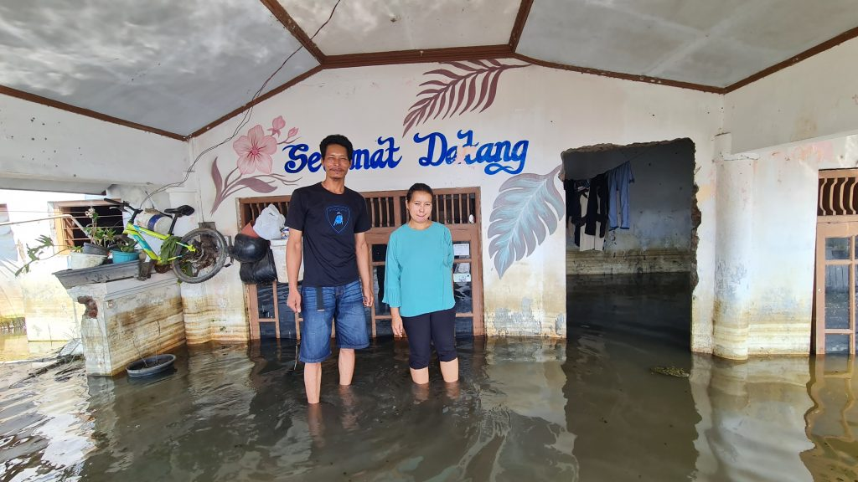
source: tanahair.net
The expert's prediction is that almost all of them will be affected by tidal flooding in the northern coast of Java (Pantura), such as Tangerang, DKI Jakarta, Bekasi, Karawang, Cirebon, Tegal, Pekalongan, Semarang, to Surabaya. Of those cities, areas that experienced the highest land subsidence were Pekalongan, Semarang, and Jakarta. Based on the calculation of the vertical land subsidence rate during the 2015-2020 period, Pekalongan Regency and its surroundings were affected by a decrease varying between 2.1-11 cm per year. Then, Semarang and its surroundings vary between 0.9-6.0 cm per year. Also, DKI Jakarta and its surroundings vary between 0.1-8 cm per year.
Research conducted by the Indonesian National Research and Innovation Agency (BRIN) shows that one of the other causes of widespread tidal flooding is land subsidence. Remote sensing is also used to identify land subsidence from 2015-2021 which shows that the land subsidence level of Pekalongan Coastal is the highest among 4 other Pantura cities such as Jakarta, Cirebon, Semarang and Surabaya. Land Subsidence in Pekalongan's coast can reach more than 12 cm per year. Land subsidence occurs because most of the northern coast of Pekalongan is geologically dominated by soft soil that is prone to subsidence. Based on the simulation results, it is estimated that the Pantura of Pekalongan will be inundated by 3565 ha of water in 2031. One thing that has actually happened is the loss of Semonet Island due to tidal flooding.
- Do you think there are differences between the notion of climate change migrants and people displaced by climate change? If yes, what are these differences?
These two things are different, based on what we know, that in the situation of climate change migrants there is a tendency for lower levels of disaster, where there are still choices and time in making decisions to move for migrants due to climate change. While people displaced by climate change, means people who are displaced and experience disasters/events from climate change who are forced to move places with higher degrees of accepted natural disasters or events, and greater impacts and threats, such as continuous flooding, drought and lack of water sources. . Both of these things have not been regulated or emphasized in international laws and regulations, especially at the national level.
- What legislation, policies and practices are you aware of that are in place to give protection to the rights of individual and communities displaced by climate change?
The 1945 Constitution Article 28H paragraph (1) provides a mandate in protecting the rights of citizens to obtain a good and healthy living environment, where climate change and its impacts can hinder the protection of these rights. Referring to the legal system in Indonesia, regulations related to climate change are limited to ratification, namely Law No. 6 of 1994 concerning Ratification of the United Nations Framework Convention on Climate Change and regulations at the law level, so there is a need to adopt this climate change issue in various ways, development policies and implementation. In the context of implementation, the Directorate General of Climate Change at the Ministry of Environment and Forestry has been established. Although there are no specific regulations that limit development activities with strict environmental conditions in order to prevent the impact of climate change, all currently existing instruments regarding environmental requirements, environmental permits and so on can be a minimum reference in tackling climate change. However, it must be admitted that there is nothing at all related to the protection of the rights of individuals and communities displaced by climate change. The context of a disaster is an important and urgent matter, but in the implementation of disaster prevention and mitigation due to climate change by the Government, there are obstacles to capacity, regulatory systems, coordination and funding.
- Please provide examples of policies, practices and legal remedies and concepts of how States, business enterprises, civil society and intergovernmental organizations can provide protection for people and communities displaced by climate change.
Jane McAdam in her book states that many countries have ad hoc or discretionary schemes for people fleeing natural disasters, these schemes being inconsistent and unpredictable—both in terms of when they apply and the status they agree to. For example in New Zealand, Denmark, Sweden and several other countries, where the state protects people who move and apply for protection to the destination country, due to natural disasters, by requesting a temporary residence permit or a request for permanent residence in the destination country. This can be a reference for disasters caused by climate change. In some cases or incidents, temporary protection will suffice. However, it is possible that some people fleeing climate change-related impacts will need permanent solutions (such as residents of some small island nations). In the context of the example that occurred in Indonesia, the displacement of residents of Pekalongan Regency, residents or affected victims living in Semut Village, the majority have moved to the relocation site, due to heavy tidal waves and abrasion at sea. They moved to a location provided by the District Government. This handling mechanism is incidental, because at the point of the disaster it is predicted that it will be caused by climate change and is exacerbated by the handling and support that is not serious by the related parties. Therefore, efforts to deal with it with a more systemic and comprehensive approach are needed, which Indonesia or perhaps other countries have not been able to do.
- What international, regional and national policies and legal approaches are necessary to protect people and communities displaced by climate change
The United Nation has an important role in emphasizing the importance of protecting citizens and groups of people who have been forced from their homes due to climate change. This can be done by providing definitions and international legal frameworks through conventions, so that the vulnerability of people affected by climate change and forced to move from their places can be protected. In addition, considering that there are limitations from countries in dealing with refugees, at the initial stage at least the UN provides guidance in handling or protecting people and communities displaced by climate change, and this can be modified according to the ability of countries to deal with climate issues. change, including encouraging countries to take steps to help countries that are vulnerable to climate change.
- Please provide separate considerations for people or communities internally displaced and those displaced across international borders
Internally displaced communities are communities that are forced to move or are no longer able to inhabit their original places of residence, and seek temporary or permanent housing within their own country, in this case, building the capacity of the state and the overall system to protect its citizens from the impacts of climate change is key. Meanwhile, for displaced communities that cross international borders means communities that move from their countries to other countries of destination for shelter, in this case neighboring countries, including countries that have more capacity, are very important in handling these communities, including how the joint system of coping becomes maybe by promoting equality.
- What do you understand by the concept of “climate change refugee”? Do you think that the UN Refugee Convention should include a separate category for climate change refugees? How do you think this would work? What other legal options may be possible?
Climate change refugees can mean people who move and become refugees due to experiencing the major impacts of climate change. For example, agricultural land is arid and no longer can be planted, then their homes can no longer be occupied due to natural changes (floods, hurricanes, sea floods, etc.). It is very important to provide a separate category for climate change refugees, this is because there are specific events, and thus have specificity in handling. When referring to The 1951 Refugee Convention, it has limitedly identified who can be considered as and have refugee status. The movement of people who are part of the impact of climate change is not on the list of The 1951 Refugee Convention. So that they will be legally weak and the fulfillment of their rights in international legal instruments. For example, by requiring the state to predict or identify the level of vulnerability of an area to the impacts of climate change and have an implementable mitigation plan, where funding can be done through insurance schemes or government budget allocations in dealing with climate refugees.
- Should separate and particular considerations be given to indigenous peoples with respect to climate change displacement? What are these particular considerations?
Yes, we agree that it needs to be separated, considering that Indigenous peoples have limited capacity in tackling climate change. In an effort to protect Indigenous peoples, for example in Indonesia including Indigenous Peoples groups as one of the targets in the National Action Plan for Human Rights (RANHAM), this is based on the fact that until now there is no adequate legal protection framework for Indigenous Peoples Groups and violations land rights for Indigenous Peoples Groups are still common. Given these limitations, the State authorities need to look more specifically at what is experienced by the Indigenous Peoples and the specific handling as well. In the Indonesian situation, where state recognition of indigenous peoples themselves is very weak, this will be a challenge in itself.

https://www.kompas.com/properti/read/2021/10/07/150000921/selain-jakarta-kota-kota-ini-potensial-tenggelam-pada-2031-apa-saja-?page=all and for the detail about land subsidence of Pekalongan can refer to https://iopscience.iop.org/article/10.1088/1755-1315/1065/1/012009/pdf
https://tanahair.net/the-sinking-city-of-pekalongan/
http://ditjenppi.menlhk.go.id/peraturan-perundangan.html
Jane McAdam, Climate Change, Forced Migration, and International Law, Oxford University Press, 2012
Presidential Decree No. 53 / 2021 on the National Action Plan on Human Rights (RANHAM) year 2021-2025. Another targets group include in RANHAM are: Women, Children and People with disabilities.

