Climate Change and the Urban Poor of Baseco, Manila
Submitted by the Associates of the Urban Poor, Inc.
Quezon City, Philippines
It was exactly one week after Severe Tropical Storm Nalgae (local name: Paeng) forced more than 300 families in Baseco, the biggest informal settlement along the coast of Manila, to evacuate as storm surge from the bay and rushing rainwater from newly constructed elevated concrete streets entered their houses. They had no choice but to leave and stay at a government-built evacuation center until it is safe for them to go back and recover whatever was left of their belongings. This has been their “normal routine” whenever a strong cyclone passes through or near Metropolitan Manila. By the time Nalgae cut through the capital region, it was packing maximum sustained winds of 95 kilometers per hour (kph) near the center with gustiness of up to 160 kph. Fortunately, Nalgae did not leave any injured or dead in Baseco.
The evacuees come from a neighborhood in the southwest part of Baseco called Aplaya (a Filipino word for “seaside”). They represent just a tiny fraction of the estimated 24,000 household population (or 66,000 individuals) of Baseco. What used to be a sparsely populated community of families living in self-built houses on stilts standing on haphazardly dumped debris and waste in the early 2000s is now a dense informal settlement extending almost a kilometer out over the Manila Bay. Residents of Aplaya are among the poorer members of the community usually found beside the breakwaters and along the coast; the better-off ones have concrete, multistory houses along the main roads bustling with food and goods vendors.
By government standards, Baseco is considered a “danger area”. Soil liquefaction during earthquakes is expected to take place in the future, but climate change-related disasters are of increasing concern. Without protective physical infrastructures in place along parts facing Manila Bay, storm surges can easily destroy houses and inundate low-lying areas. High speed winds during typhoons and even thunderstorms can rip off the roofs and walls of the residents’ substandard housing structures. Unpaved streets lined with self-made dig out drains turn into muddy alleys after an incessant rainfall, submerging tangled plastic water pipes for days that increase the risk of contamination and water-borne illnesses. Many have also noticed some pathways have puddles of water, indicating that sea water has seeped through the soil. (Or it could be due to sea level rise.) Roads that have been recently improved by the office of the district representative to lessen flood hazards are at least one meter high, bringing rainwater into the houses on rainy days and an ordeal for those without an additional floor to retreat to.
The heat during the dry season (which reaches its peak around March to May) has also been oppressive in a dense and poorly planned community like Baseco. Some residents claim that because of extreme heat, exacerbated by people’s inability to install air conditioning units or to improve the ventilation in their houses, respiratory diseases such as pneumonia have become common especially among the elderly and children. Hypertension is also a prevalent condition among older residents. The sea breeze could no longer alleviate the heat as concrete dominates the structures and roads in Baseco. Trees and vegetation that could lower surface and air temperature are nowhere to be found.
Climate change has been indirectly used by the Philippine government to justify the eviction of informal settlers and their resettlement to supposedly safer but distant areas. Baseco used to receive such threats in the past, but its current size would certainly overwhelm the government’s resettlement program. It was not included in the communities targeted in the Metro Manila-wide relocation program for informal settlers in danger areas, but parts of it are subject for demolition. These are said to make way for infrastructure projects such as a bridge connecting the port district to a major highway in the mainland and a road that will be used for the construction of a planned reclamation project (with high-end hotels, exclusive residential buildings, commercial establishments, and casinos) in Manila Bay.
A missed opportunity
In February 2002, former president Gloria Macapagal-Arroyo issued an order declaring 52 hectares of Baseco as a socialized housing site. (There were at least 6,000 families then.) A presidential land proclamation means that the national government shall endeavor to develop the area to make it fit for human settlement. Such a proclamation has been a practice exercised by the national government to address the problem of homelessness is cities and to improve the standard of living of slum dwellers by allocating funds for site development. It may also be a precursor to giving the occupants legal right to stay on a government-owned land that they have been occupying for years. The land proclamation covering Baseco came one year after the Asian Development Bank (ADB) and the Pasig River Rehabilitation Commission (PRRC) identified Baseco as a “high priority area” for onsite urban renewal. It was also perceived as a political strategy to soften the devotion of the residents to former and populist President Joseph Estrada whom Arroyo replaced after a military-backed popular revolt that ousted the former in 2001.
Since then, however, Baseco has seen no substantial progress in terms of improving the living conditions of residents, especially in strengthening their protection against and building their resilience to climate change. Not a single family has been awarded title to the plot of land they have been occupying for years. Even those in housing projects initiated by nonprofit organizations such as Habitat for Humanity cannot be considered landowners. The recently completed relocation project of the city government for at least 200 families who lost their homes to a fire—a frequent occurrence in Baseco—requires beneficiaries to pay ₱2,000 (around $34) per month, an amount that many families cannot afford with their meager incomes.
The city government constructed an elementary school and an evacuation center; a public hospital is being built, thanks to the elections. These structures have more than two stories, which exceed the allowed height limit based on the soil tests conducted in Baseco. This makes some residents wonder what is taking the government so long to realize the land proclamation issued two decades ago. Until measures to make Baseco habitable are undertaken, thousands of residents—men and women, children and elderly, healthy and sick—have threats of eviction hanging over their heads.
A matter of survival
It is not surprising for people affected and displaced by climate-related disasters in underdeveloped areas of the Philippines to transfer to urban informal settlements like Baseco. Traumatic experiences of floods and landslides have made it more attractive for those in regions rife with poverty and conflicts (including indigenous communities and areas in Muslim provinces in the southern island of Mindanao) to move to cities and take a chance in living in informal settlements where accommodation is cheap but are likewise vulnerable to natural and even manmade disasters. Baseco residents say it is not uncommon to have newcomers from a disaster-stricken province rent small spaces or build shacks on vacant plots; not even the barangay government could monitor and regulate the entry of local migrants and maybe refugees.
It is also not surprising for communities like Baseco to grow so fast. They accommodate the underserved populations and provide them opportunities—no matter how small these are—to survive and support their families. It seems, however, that dealing with disaster risks and climate change is easier than ensuring that they earn enough to have food on their tables. Residents who evacuated at the height of Tropical Storm Nalgae said that while cleaning—or even losing—their homes and assets is inconvenient, keeping their means of livelihood, be it in Baseco or in the city proper, is a more important consideration for staying where they are now. Having lived in Baseco for years, it would be difficult for them to move to another place, especially in government resettlement projects where basic services are lacking and access to work, schools, and public hospitals is cut off.
Good policies, inadequate action
Baseco proves that the urban poor in the Philippines have yet to meaningfully benefit not only from land and housing policies but also from local climate change policies and from programs and projects undertaken using national allocations and with external financial support.
Republic Act No. 9729 or the Climate Change Act of 2009 provides a comprehensive legal framework for climate change governance in the Philippines. With regard preventing and reducing the adverse impacts of climate change, the law mandates the Climate Change Commission to identify the most vulnerable communities and to ensure their participation in initiatives that will strengthen their capacity to prepare, respond, and cope with climate change. But it falls short in recognizing and urging the government to address fundamental issues that make these communities exposed to climate change. In the case of urban informal settlers such as those in Baseco, poverty and inequality, government neglect, and lack of access to security of land and housing tenure are among the most glaring and persistent.
The National Climate Change Action Plan of the Philippines for 2011 to 2028 identified climate change adaptive housing and land use development as one of the government’s target outputs. In urban areas, the plan encourages local governments to “implement a climate-smart ridge-to-reef sustainability plan” as well as “mixed-use, medium-to-high density integrated land use-transport plan in developing new urban communities or in expanding existing ones” (Climate Change Commission 2011). The timetable for carrying out the plan will end in five years’ time, and while Baseco has seen massive physical changes over the years, such development is far from the ideal.
Significant financial resources and political will are needed to make informal settlements like Baseco able to address the risks associated with climate change and disasters. The Climate Change Act created the People’s Survival Fund (PSF) to support projects of local government units and accredited community organizations that aim to equip vulnerable communities to deal with the impacts of climate change. It was only in 2015, however, that the national government appropriated replenishable annual allocation for the PSF. Accessing the fund has also been cumbersome for organized communities and civil society groups. Local politics also play a role in whether an informal settlement will be prioritized or not.
Meanwhile, utilization of international climate finance has been concentrated in climate change mitigation projects in the Philippines (ICSC, ACCORD, and CARE Philippines 2020). This suggests misplaced prioritization since the country emits only 0.3% of carbon emissions globally yet experiences the worst impacts of climate change that adaptation measures can drastically reduce. Increasing the adaptive capacity of communities exposed to multiple hazards like Baseco could well fit in the aim of climate finance of “reducing vulnerability of, and maintaining and increasing the resilience of, human and ecological systems to negative climate change impacts” (UNFCCC SCF 2014, 2).
Conclusion
The effects of climate change disproportionately fall on the poor, and urban informal settlers—those without security of land tenure, living in inadequate and unsafe housing, and situated on vulnerable, marginal lands—are as exposed to climate change impacts as other sectors. They are “on the front line” (World Bank 2012). Baseco may not be illustrative of a community displaced by the impacts of climate change, but it offers insights about how inaction to address other forms of deprivation can aggravate their exposure and vulnerability to climate-induced disasters. Informal settlements like Baseco also prove to be a solution to the woes facing the poor—including climate migrants and refugees moving to cities in search for a more viable place to live—so it is crucial to make these communities more able to withstand the effects of climate change.
Sustainable Development Goal 11 aims to make cities and human settlements inclusive, safe, resilient, and sustainable. For this goal to be met in the context of climate change, the issue of lack of access to housing and tenure security, which constitutes a crucial dimension of poverty in cities, must be addressed. This is “an important entry point for improving other elements of resilience” (ADB 2022, 137) among the urban poor. Indeed, one finds housing at the intersection of poverty reduction and climate change adaptation—safe and secure housing provides stability to poor families and increases their capacity to cope with a range of climate-related shocks and stresses. ■

Figure 1. Location of Baseco
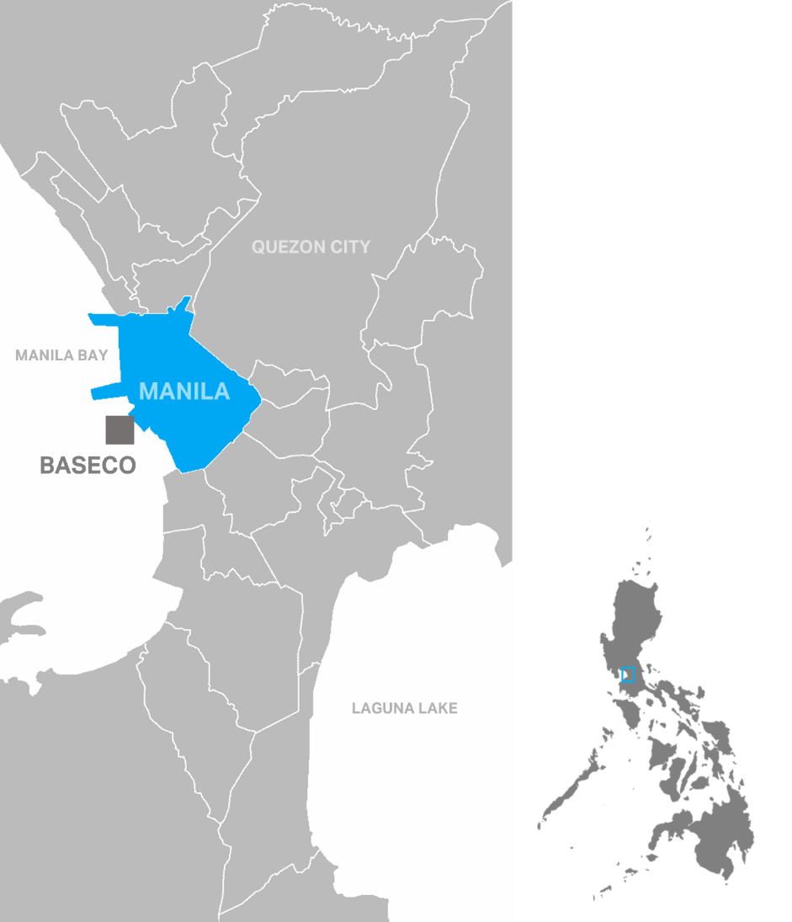

Figure 2. Satellite images showing Baseco in 2001 and in 2022
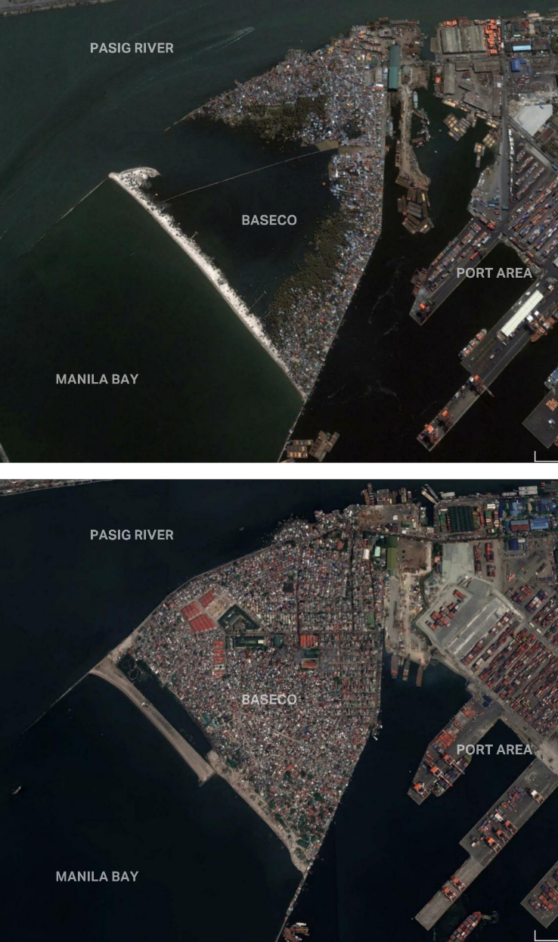
Source: Google Earth

Figure 3. Location of Aplaya and other community facilities and sites
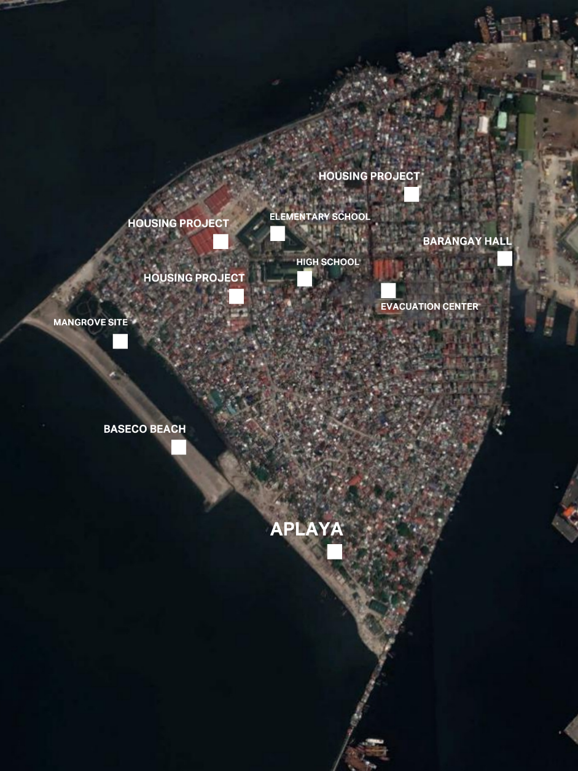

Figure 4. An alley in Aplaya one week after Tropical Storm Nalgae
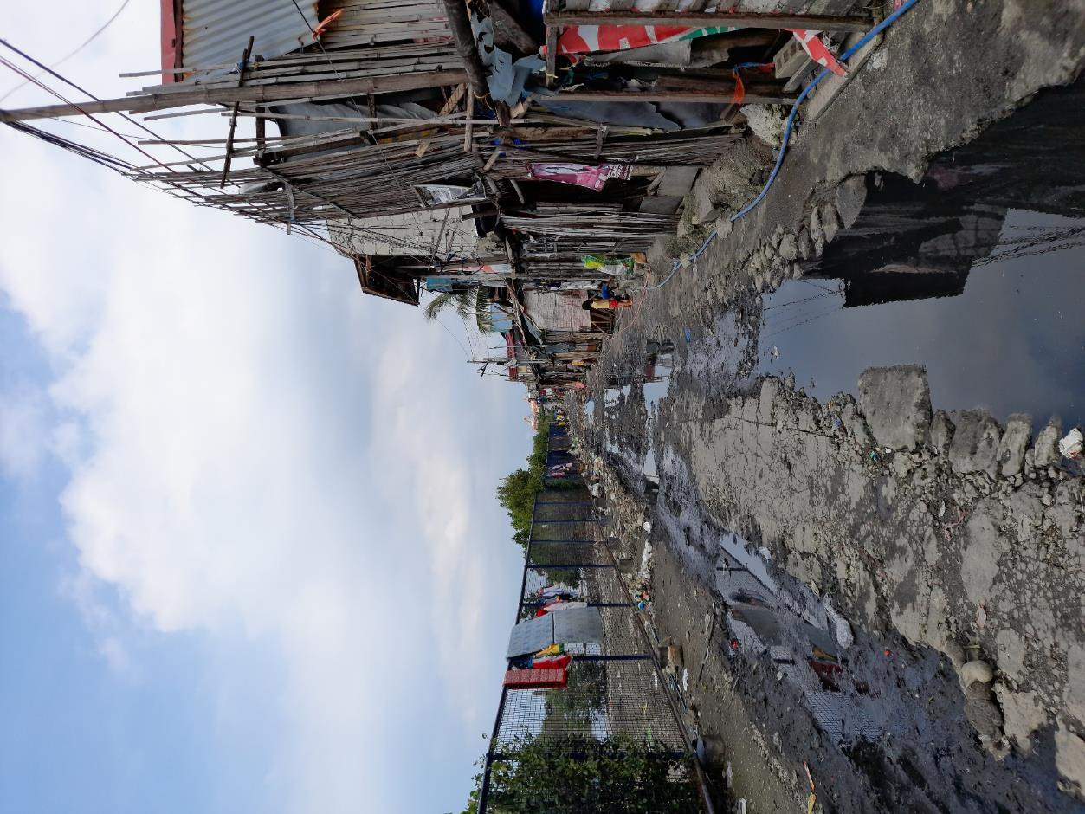

Figure 5. Common alleys in Baseco
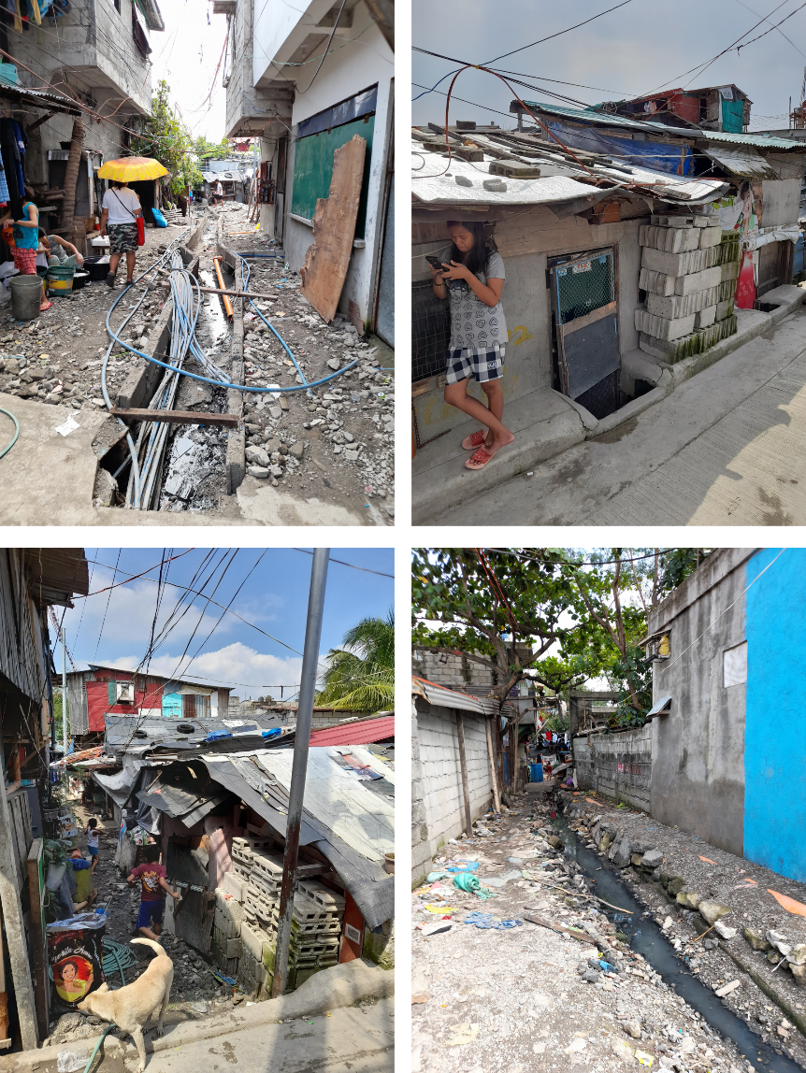

Also known as the Urban Poor Associates (UPA). For more information, contact Alicia G. Murphy, Executive Director, at (632) 8426.4119/ (632) 8426.7615 or at urbanpoorassociates@gmail.com.
A focus group discussion with the members of the Kabalikat sa Kaunlaran sa Baseco (Partners in Development in Baseco), a people’s organization assisted by UPA, was held on 5 November 2022 to gather insights for this submission. The eye of Tropical Storm Nalgae was closest to Metro Manila on October 29-30.
A barangay is the smallest political unit in the Philippines. Baseco is part of Barangay 649, which is within the Port Area district of the City of Manila.

