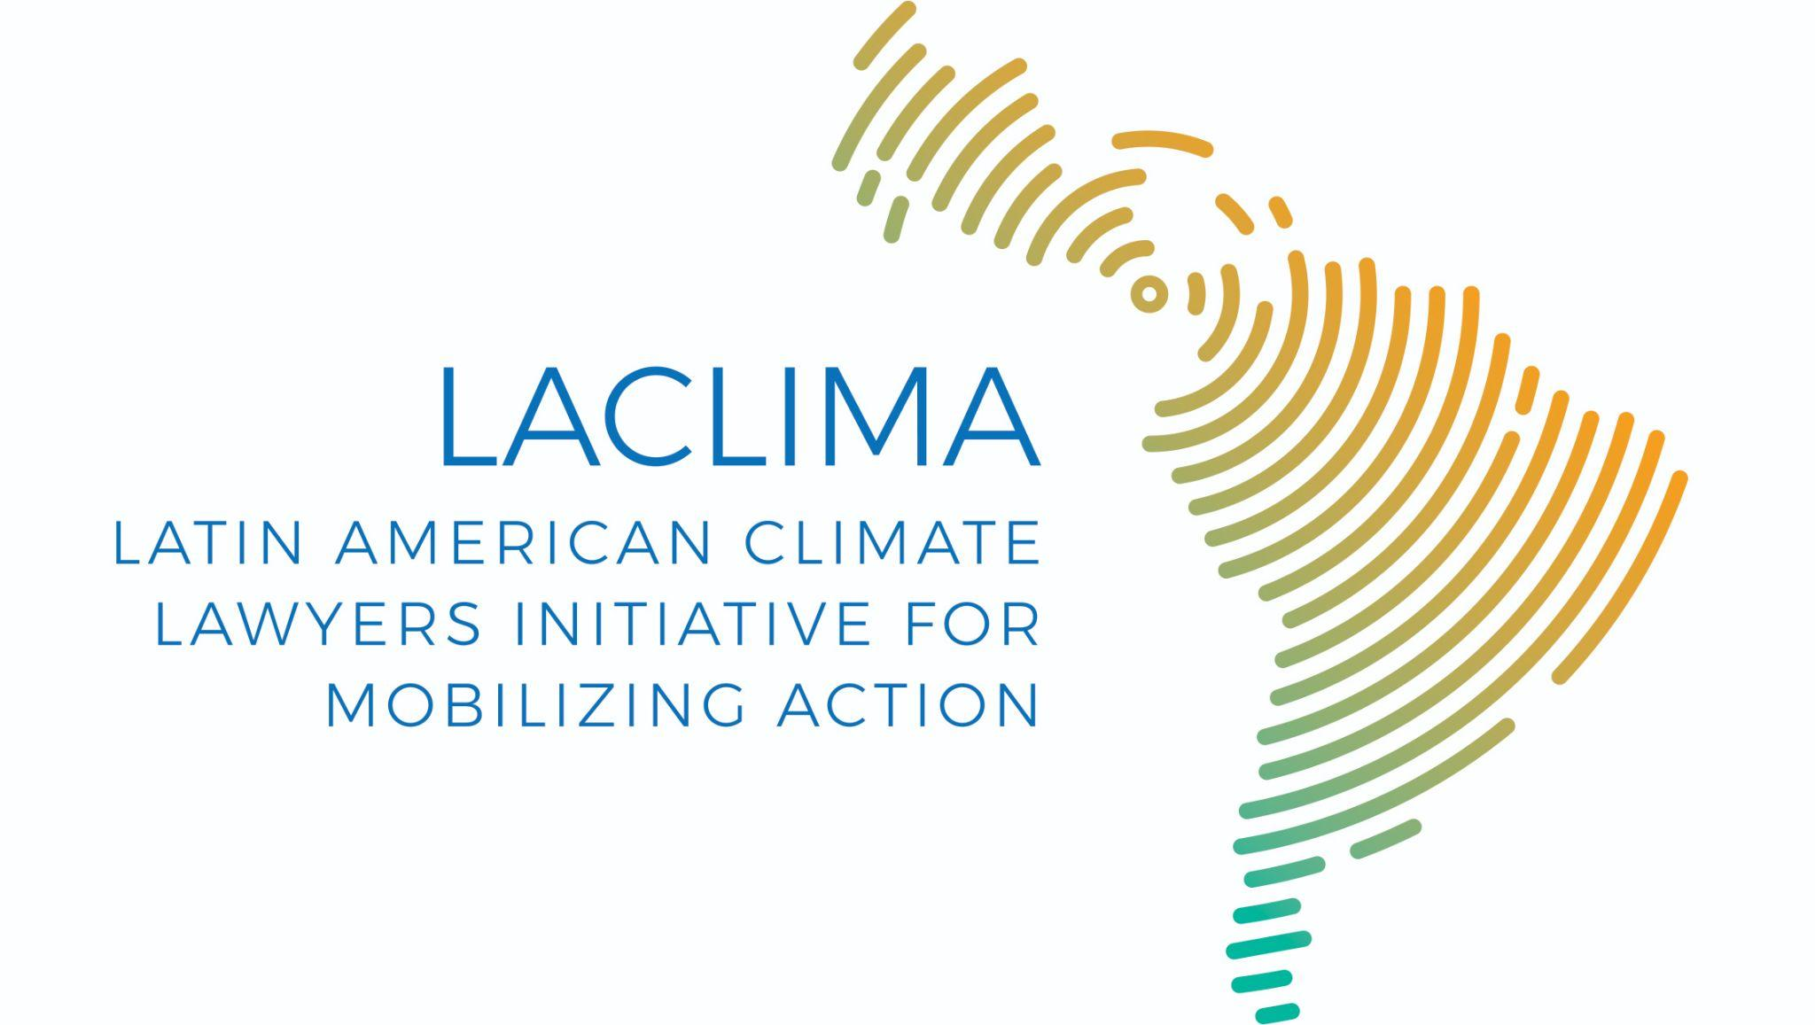

LACLIMA - Latin American Climate Lawyers Initiative for Mobilizing Action
710, Jesuíno Arruda, São Paulo, Brazil
info@laclima.org

May 25, 2023

Mr Ian Fry
Special Rapporteur on human rights and climate change
OHCHR-UNOG
8-14 Avenue de la Paix
1211 Geneve 10, Switzerland
ohchr-srclimatechange@un.org

Ref: Submission for Special Rapporteur’s call for inputs on the promotion and protection of human rights in the context of climate change - LACLIMA's Climate Litigation Working Group

Dear Mr. Special Rapporteur,

This submission, signed by the Climate Litigation Working Group of the Latin American Climate Lawyers Initiative for Mobilizing Action (LACLIMA), presents contributions about the relationship between human rights and climate change in the Brazilian context. .

05. How are human rights considerations being incorporated into climate change litigation?

As the scientific community publishes data on climate change and climate damage spreads, climate litigation works on the connection between this reality and human rights. An example of this connection in Brazil is the ADPF No. 708, ruled by the Supreme Court (STF).. In this case, it is argued that the fundamental right to an ecologically balanced environment guarantees the right to a decent future for all human beings. In this way, the right to climate protection is affirmed as a human right. The STF ruled that environmental law treaties constitute a type of human rights treaty, which enjoy “supranational” status. This means that they are above ordinary laws in the legal hierarchy. Therefore, any Brazilian law or decree that contradicts the Paris Agreement may be invalidated, and any action or omission in this regard is a direct violation of the Constitution and of human rights.

06. Are there issues with making the link between human rights and climate change litigation?

Although interpretations of constitutional mandates and ratified treaties reflect the relationship between human rights and climate stability, Brazil still does not have an explicit norm that makes the link unquestionably evident. Regardless, recent the above mentioned Supreme Court precedent brings more clarity to a legal interpretation that allows linking human rights and climate change.

States need to establish or retrofit the relationship between national law and international law with respect to human rights in order to actualize the goals of the Paris Agreement. International instruments for climate rotection neither establish obligations nor enforcement mechanisms.

07. What do you think are the major barriers to initiating climate change litigation?

Major barriers to initiating climate litigation include structural capacity issues and lack of knowledge about climate issues from regulatory agencies and public litigation offices (State Public Prosecutor's Offices or Public Defender's Offices). Other barriers include: interference from political interests, disproportionality of access to the judiciary that is weak for affected communities and, on the other hand, is more robust for large emitters and polluters that hold economic power and political influence. In addition, the complexity of climate change’s causes and effects, non-recognition of the right to climate protection, the difficulty in identifying violations of climate protection, the lack of adequate involvement of the judiciary in the legal process of managing climate change, the question of legitimacy of the judiciary with regard to climate protection, and the difficulty of holding the private sector accountable for damages and hazards arising from climate change.

08. Are the barriers different in different parts of the world? What are they?

The lack of public access to information as well as the lack of broad social participation in constructing and executing public policies is a global problem. The differences that exist in this regard reflect differing levels of education, empowerment, socio-environmental justice, repression, and corruption levels in each nation. There are layers of intersectionality here that help or hinder access to justice and that need to be evaluated in their particularities.

In Brazil, it is possible to identify the conformation of the territory that reflects the indices of climate injustice in the country. In other words, there are regions that are more susceptible to climate damage and these same regions are not representative of lawsuits in favor of climate and also show policies of increasing activities powered by fossil fuels. As an example, when analyzing the map of climate lawsuits in the Brazilian judiciary, it is possible to see a low number of lawsuits filed in the Northeast region. This despite the Northeast being one of the regions most susceptible to the extreme effects of climate change.

10. How could this be improved?

Offering training courses for judges, prosecutors, public defenders, civil society, and parliament members would improve the judiciary’s understanding of the connection between human rights and climate change. Publication of statements or even UN resolutions reinforcing the causal link between human rights and the climate, as well as disseminating figures about the realities of the impact of climate change on human dignity around the world would help as well. Lastly, strengthening the private sector's abilities to support, and highlighting their responsibilities to do so, would contribute greatly as well.

11. Are there particular issues with getting access to the courts?

Issues of access include the costs of paying for specialized lawyers, lack of knowledge about climate rights, difficulty in accessing information about the control and execution of public policies and administrative acts by the Government and private entities, the slow speed of the judiciary, the need for advocacy support parallel to judicial measures, the non-admissibility of climate disputes (situations in which the judge does not grant preliminary requirements to proceed with the climate action), and the difficulty in accepting the cause and effect relationship of climate change.

This submission includes contributions from Luciana Monteiro Mülstroh, Sabrina Stoll e Klaus Maciel.
In literal translation into English, the acronym “ADPF” stands for Argument of Noncompliance with a Fundamental Precept.

