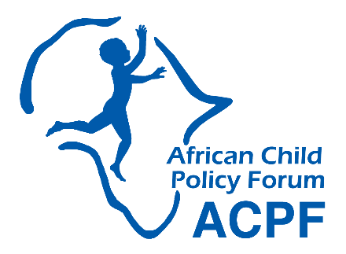

**Contribution to the Report of the UN Special Rapporteur on the Sale and Sexual Exploitation**

**of Children to the HRC Report 2023**

**African Child Policy Forum (ACPF)**

**November 2022**

# **Introduction**

Pursuant to the Human Rights Council Resolution 43/22, the UN Special Rapporteur on the sale and sexual exploitation of children, including child prostitution, child pornography, and other child sexual abuse material has initiated the preparations of her next thematic report for the 52nd session of the Human Rights Council, to be presented in March 2023. As part of this process, the Special Rapporteur has called upon for input to inform the Special Rapporteur’s annual thematic report on reparation for child victims and survivors of sale and sexual exploitation. This is a response to that call for submissions.

African Child Policy Forum (ACPF) is a Pan-African organisation that promotes policy change to advance child rights and child well-being in Africa. ACPF’s work is guided by the African Charter on the Rights and Welfare of the Child and the UNCRC. As a child rights-focused policy research and advocacy organisation, ACPF is making this submission focusing on the need to ensure and strengthen access to justice for victims and survivors of child sexual exploitation (CSE). ACPF strongly believes that the issue of reparation for child victims and survivors of sale and sexual exploitation cannot be addressed without ensuring access to justice for CSE victims and survivors.

# **Scale and magnitude of the problem in Africa**

Child sexual exploitation is a vicious and egregious form of violence that is, unfortunately, prevalent and taking on many forms in Africa. A report by ACPF- ‘Sexual exploitation of children in Africa: a silent emergency’- identified the following forms to be the prevalent forms of sexual exploitation in the continent:

1. Child exploitation through “transactional sex”,
2. Online child sexual exploitation,
3. Trafficking of children for sexual purposes,
4. Sexting,
5. Sexual extortion/sextortion and corruption of children for sexual purposes,
6. Online grooming, live online child sexual abuse/live streaming of sexual abuse, and
7. Sexual exploitation of children in the context of travel and tourism.

Existing prevalence studies indicate that sexual exploitation and abuse of children, especially girls, is a serious problem throughout Africa. For instance,

* In Malawi, about 22% of females reported having experienced child sexual abuse in one form or another.[1]
* Exploitation of children through “transactional sex” was found to be growing in, among other places, Lomé, the capital of Togo; Liberia; Sierra Leone; Burkina Faso; Angola[2]; Ethiopia, Mozambique (primarily in Maputo, Beira, Chimoio, and Nacala)[3]; South Africa; and Zambia.
* According to a 2021 report by We Protect Alliance, 57% of children in Southern Africa face online sexual exploitation.[4]
* Worldwide, regular customers of the travel and tourism sector account for 35% of sex offenders. Occasional customers account for 65% of sex offenders.[5] According to 2017 data from the World Tourism Organization (UNWTO), each year three million persons take a trip in order to have sexual relations with minors.[6]
* Studies of CSE in conflict environments in Africa have indicated that young women and girls are at the greatest risk of sexual exploitation, since 2009, Boko Haram had reportedly sexually exploited more than 7000 girls and women whereas in South Sudan 3090 children were abducted and 1130 children were sexually exploited by armed forces and armed groups.[7]

The above figures on the scale of child sexual exploitation are likely to be an underestimation, because of the hidden nature of the crime and low levels of disclosure and reporting. Data on child sexual exploitation in Africa is particularly poor, a problem compounded by inadequate and outdated crime data collection systems. There is also a lack of uniformity in terms of legal definitions of CSE and reporting mechanisms.

# **Challenges to redress and reparations of CSE victims/survivors**

It is important to note that legal protection is the bedrock of other interventions in ensuring the realization of reparation rights of child victims and survivors of sale and sexual exploitation. In the absence of **domestic legal frameworks that guarantee the right to reparation** of child victims and survivors, it is difficult to seek justice in a court of law.

There has been an encouraging trend towards the ratification of international instruments related to sexual exploitation of children. For example, the Optional Protocol to the CRC on the Sale of Children, Child Prostitution, and Child Pornography has been ratified by 47 countries.[8] Declarations and political commitments in relation to CSE have been adopted by the Regional Economic Communities. However, at the national level, the 2022 Out of the Shadows report revealed that only seven African countries scored above 50% on their overall national efforts to prevent CSE .[9]Within the legal system, several barriers hinder child victims and survivors of sale and sexual exploitation from getting redress and reparation.

**Low minimum age of marriage:** One of the barriers to redress and reparation for child victims and survivors of sale and sexual exploitation relates to insufficient legal protection of children from sexual exploitation in the context of child marriage. [10] For instance, some countries allow the marriage of children under the age of 18 years.[11] In such legal systems where the law allows marriage before 18 years, the victim or survivor has no legal redress to get reparation as the act is considered legal in that jurisdiction. As a child in this context is not considered a victim of sexual exploitation, which limits any legal pathway to seek reparation,

**Map 1: Countries with victim compensation laws**

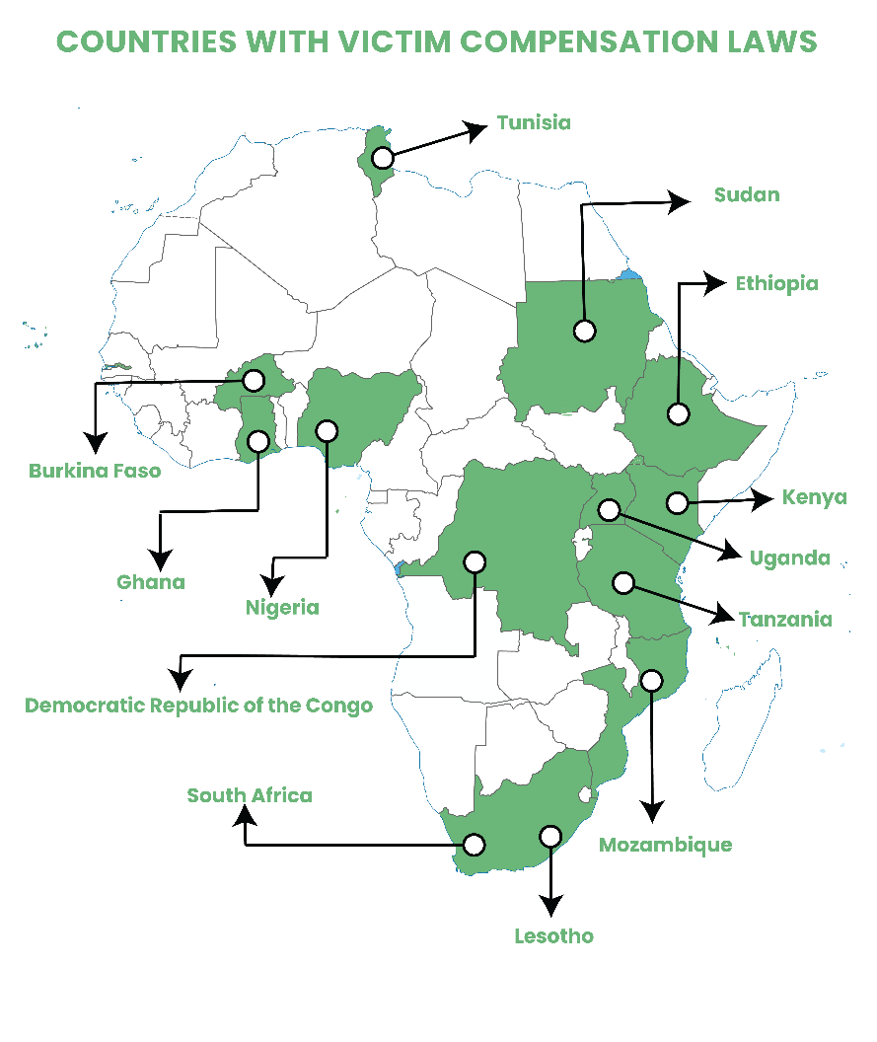**Lack of adequate reparation**: There are limitations in the law in terms of providing for full and adequate reparation to all victims and survivors. There is a slow but a growing trend in Africa towards enacting laws that require the state to provide for compensation for child victims of sexual abuse and exploitation. Map 1 shows that 12 countries have such laws or some form of legal mechanism. **Burkina Faso** provides a mechanism for compensation to women and girls who are victims of violence; however, it is unclear if it applies to all child victims of sexual abuse.[12]

In **DRC**, the Civil Code and the Criminal Procedure Act have legal mechanisms for victim reparations. The legal reference does not, however, define the amount for reparation, which is left to a judge’s discretion. Moreover, survivors face many impediments that hinder them from receiving the reparation.[13]

**Ethiopia** has the legal mechanisms to provide victim compensation, but limited information makes it difficult to assess the particulars of these mechanisms and how effective they are. The 1961 Criminal Procedure Code of Ethiopia and Proclamation No. 909/2015 on Prevention and Suppression of Trafficking in Persons and Smuggling of migrants both include mechanisms for victim compensation.[14]

**Ghana** has a legal mechanism to provide victim compensation, though it appears to only apply to victims of human trafficking. The Human Trafficking Act, 2005 set up the Human Trafficking Fund, which may be used to provide financial assistance to victims.[15]

In **Kenya** the country’s law does have a mechanism of providing a victim compensation, but this is sourced only from the offender.[16]

**Lesotho, Mozambique, South Africa, Sudan, Tanzania, Tunisia, and Uganda[17]** are other African countries that have set up legal mechanisms to provide compensation. In the case of **Nigeria**, the government has established a fund to make compensation arrangements for victims of sexual violence against children, which is a much better modality of reparation as obtaining full and adequate compensation from an offender through the court process can be challenging.[18]

**Lack of child-friendly justice systems in Africa:** Child-friendliness of justice requires that children are protected before, during, and after judicial proceedings. Making the justice system child-friendly is one of the important measures that should be prioritised to ensure the realisation of child victims’ and survivors’ right to redress and reparation.

There is, however, a lack of child-friendly justice systems in Africa, which is due to many factors. One is the inadequate mainstreaming of child rights issues in law enforcement agencies. When the law enforcement system is not sensitive to the unique vulnerabilities and special needs of children, especially girls, cases of sexual violence are less likely to be reported and enter the formal prosecution channel. In some cases, professionals working in the sector, due to lack of knowledge or due to gendered stereotypes rooted in the socio-cultural life of the community, may end up blaming the child victims and survivors. Victim blaming deters others from reporting similar cases.

**Limited access and quality of victim support programmes**: Access to victim support programmes was also fairly dire in the majority of countries in Africa. According to the Out of Shadows index report (2022), in some of the countries with a relatively high level of availability of victim support services, such as South Africa and Uganda, accessibility of the services remains a challenge. In other countries, where CSE victims were able to access support, the quality of care was not adequate. Even in an environment where the justice system is child-friendly, accessing legal services has never been easy for vulnerable groups of children, including children with disabilities, children deprived of parental care, children living or working on the street, children from poor households and children living in the context of armed conflicts, among others.

**Customary justice and its impact on reparations for child victims/survivors**: In most African countries, formal justice systems operate with limited infrastructure and resources and barely cover rural and peripheral areas. Hence, most aspects of community life are governed by informal justice systems which apply customary laws. In many cases, customary laws co-exist and operate with formal legal systems. In jurisdictions with such plural legal systems and those where there is less access to formal justice institutions, it is highly likely for child victims and survivors of sale and sexual exploitation to resort to the customary legal systems to seek reparation. Unfortunately, not all customary laws and system are child-friendly and the best interests of the child is not at the heart of these arrangements. For instance, a child victim or survivor of rape might be persuaded to marry her rapist.

Moreover, the concept of legal representation is not common in informal justice systems. When children are represented by their families, often the compensation goes not to the rehabilitation of child victims and survivors but to the benefit of the larger family. In the worst case scenarios, due to stigma and stereotypes associated with sexual matters, child victims and survivors of sale and sexual exploitation may prefer not to seek justice at all and suffer in silence.

# **Initiatives and good practices in the provision of reparation for child victims and survivors of sale and sexual exploitation**

**One-stop-centres**: Addressing the challenges of child victims and survivors of sale and sexual exploitation requires a holistic and multidimensional response. It necessitates strong coordination and collaboration among various stakeholders including governments, civil society organisations, community-based organisations, development partners, media, and many more.

Although the primary duty bearer to ensure child-friendly justice is government, this does not exclude or undermine the role that non-governmental organisations can play. ‘One Stop Centers’ – mostly run by NGOS with government oversight- offer an example of the government-NGO interface. These centres provide a good example of coordination and collaboration where children who are victims and survivors of violence and violations of rights get multi-sectoral services including health, welfare, counselling, and legal services in one location. More and more African countries are putting in place one-stop-centres for prevention and response to gender-based violence as well as to provide integrated services to victims. These include Morocco, South Africa, Tanzania, Uganda, Kenya, Malawi, and Ethiopia.[19] However, most are concentrated in capital cities or a few major cities.

‘One Stop Centers’ ensure a strong linkage between law enforcement bodies, health, child protection, and other relevant stakeholders, which play a critical role in preserving evidence that helps the child victims and survivors to prove their cases before a court of law or any other tribunal. Therefore, strengthening coordination systems including the establishment of one-stop-centres and effective and efficient referral mechanisms is vital in ensuring child victims and survivors of sale and sexual exploitation get reparations.

**Children’s Legal Protection Center (CLPC): A model for improving access to justice for children**: Ensuring that all child victim of sexual abuse and exploitation effectively access legal remedies is not just a technical exercise involving strategies and skills. It also encompasses initiatives that depend on establishing partnership, networks and links with a variety of stakeholders, such as government, civil society, religious institutions, community and the private sector as well as developing sustainable long-term capacity building agenda. The CLPC was established as a legal and psychosocial referral network of governmental and non-governmental organisations that promoted standard of care for professionals, accountability processes and structures for inter-agency communication and collaboration in service provision. The Center also introduced a *Court Advisory System (CAS)*, a mechanism that ensured a trained social worker(s) or counsellor assisting the child friendly benches or judges in conducting and providing comprehensive assessment of the child’s psychological, social, emotional, physical and cognitive situation and ensuring that judgment is carried out in the best interest of the child.

The model was tested and piloted in Ethiopia between 2005 and 2012 and has subsequently contributed significantly to improving the administration of child justice in the country by building the capacity of government institutions and civil society actors not only to respond to child sexual abuses but also reduce potential risks by accelerating preventative action. In 2012, after conducting bilateral discussions with the Ethiopian government, an agreement was reached to run the CLPC as a joint project under the auspices of ACPF and the Federal Supreme Court. Subsequently, to ensure the sustainability and national ownership of the intervention, the CLPC was handed over to the government and continues to provide services to, among others, victims and survivors of CSE.

# **Recommendations**

Addressing the challenges of reparation for child victims and survivors of sale and sexual exploitation requires making the justice system child-friendly. This requires among other things, the following measures:

* Providing information and advice to children in a manner adapted to their age and maturity, in a language they can understand, and in a gender- and culture-sensitive way;
* Protecting the privacy and personal information of children who are or have been involved in court proceedings or administrative proceedings under national law;
* Protecting children from harm, especially secondary victimization, in all judicial and non-judicial proceedings and other interventions;
* Training all professionals working with and for children on the rights and needs of children of different age groups, and on proceedings that are adapted to them;
* Encouraging close cooperation between different professionals in order to obtain a comprehensive understanding of the child and assessment of his or her legal, psychological, social, emotional, physical, and cognitive situation;
* Ensuring that children have the right to their own, separate legal assistance where there is, or could be, a conflict of interest with their parents. This could be through curator or guardian ad litem (‘for the suit’), or an independent legal representative for the child;
* Applying the urgency principle in all proceedings involving children to enable a speedy response and to protect the best interests of the child, while also respecting the rule of law; and
* Ensuring that courts and other forums respect the child’s right to be heard and giving due weight to the child’s views and wishes, in accordance with his or her age and maturity.[20]

Apart from ensuring a child-friendly justice system, the following actions could also be considered as a means of laying ground for reparations for child survivors in Africa:

* Setting the minimum age of marriage at 18 years with no exceptions;
* Criminalizing FGM and child marriage and attaching severe punishment for the violation of such laws;
* Investing in the child rights sector by prioritising the prevention of sexual violence and putting in place effective response mechanisms;
* Training law enforcement agencies on children’s rights; and
* Establishing effective and efficient referral mechanisms including one-stop-centres.

1. ACPF, Sexual Exploitation of Children in Africa a Silent Emergency, 2019
2. All Africa, Angola: “Children Prostitution Cases Increases,” 29 June 2011.

   http://allafrica.com/stories/201106291433.html
3. United States Department of State (2013). Trafficking in Persons Report - Mozambique, 19 June 2013, available at: http://www.refworld.org/docid/51c2f39f4d.html
4. We Protect Global Alliance, Global Threat Assessment 2021
5. ECPAT International (2016). Global Study On Sexual Exploitation of Children in Travel and Tourism.
6. World Tourism Organization (UNWTO) (2017). A look at child abuse on the global level.
7. UN (2017). Joint report of the Special Rapporteur on the sale and sexual exploitation of children, including child prostitution, child pornography and other child sexual abuse material and the Special Rapporteur on trafficking in persons, especially women and children, A/72/164, Seventy-second session, Distr.: General 18 July 2017.
8. Only eight countries have not yet ratified it.
9. Scored 0-100, 0= the worst environment for children and 100= the best environment for children.
10. Article 2 of the ACRWC; Article 1 of the CRC.
11. Just to mention some, Gabon Mali, Niger and Sudan.
12. Law No. 061-2015/CNT on Prevention, Repression and Reparation of Violence against Women and Girls and Support for Victims. Adopted 6 September 2015
13. https://sipa.columbia.edu/file/3193/download?token=xnYw6A24
14. Federal Democratic Republic of Ethiopia, Criminal Procedure Code of Ethiopia, Proclamation No. 185 of 1961
15. Human Trafficking Act, 2005, Ghana
16. https://statelaw.go.ke/wp-content/uploads/2020/11/Victim-Protection-Act-17-of-2014.pdf
17. <https://reformar.co.mz/documentos-iversos/leo-24-2019-lei-de-revisao-do-Codigo-penal.pdf>; The Penal Code Act 1945, as amended by Tanzania: Act No. 4 of 1998 Sexual Offences Special Provisions Act, 1998; Penal Code (Amended) Act 2007, Uganda, and Criminal Procedure Act No. 51 of 1977, South Africa
18. Ochayi, C. 6 September 2016. FG creates fund to rehabilitate trafficking victims. Vanguard Nigeria; APEVAC & ACPF (2021). National Capacity to Address Violence against Children: Assessment in Ten African Countries
19. ACPF, Sexual Exploitation of Children in Africa a Silent Emergency, 2019
20. For further reading, see African Child Policy Forum “Spotlighting the Invisible: Justice for Children in Africa” (2018) available at chrome- extension://efaidnbmnnnibpcajpcglclefindmkaj/https://defenceforchildren.org/wp-content/uploads/2018/05/Spotlighting-the-Invisible-Justice-for-children-in-Africa-Final.pdf.