Call for Input to inform the High Commissioner’s report to the Human Rights Council on the impact of casualty recording

Submission by Insecurity Insight and Every Casualty Counts

7 March 2023
Insecurity Insight’s approach to casualty recording
Insecurity Insight records the death and injury of aid and health workers, educators, and of civilians within protection settings, such as refugees and IDPs, and those who experienced sexual violence in conflict. This casualty recording is an integral part of our violence monitoring carried out to generate policy recommendations of how to improve the delivery of humanitarian aid and essential services by protecting health, education, food aid and protection from violence and the impact of conflict. We carry out violence analysis and therefore code the intent, means and vulnerability of victims within any violent event that affects aid work, healthcare, education, and protection. We also focus on selected means of violence such as conflict related sexual violence (CRSV) and violence with explosive weapons. Our database includes information on civilians murdered after they have been subjected to sexual violence. However, for violence with explosive weapons, like with other violence, we limit the casualty recording to those who work within key aid sectors and those who seek these services (e.g. patients, students, and people living in IDP or refugee settings). We also limit our recording to the information about the profession and circumstances of the violence and do not record other personal details.
Insecurity Insight is a H2H (an international humanitarian to humanitarian organisation) who works closely with aid agencies to strengthen humanitarian access and the protection of civilians through our data work. We have an intervention focused approach to monitoring and data analysis with the objective to strengthen responses to save lives. Our data collection is action focused and used to make recommendations of how to prevent and mitigate the impact of violence. We are bound by the humanitarian principles of neutrality, independence, and impartiality. Our advocacy focuses on calls for respect for International Humanitarian Law (IHL).

Impact of our casualty recording on IHL and the protection of civilians
As our casualty monitoring is directly related to the protection of healthcare, education, protection of civilians policies and delivery of aid in conflict, we make unique contributions to the understanding of IHL. Our data shows how protected sectors, such as health and aid, are directly affected by conflict and where IHL protection policies are failing.
Examples of our outputs include:
- The recorded number of health worker casualties is discussed in the context of IHL related concerns for the protection of health care. See for example our report on Ukraine, Myanmar and our annual report on attacks on health care.
- We make our data widely available on interactive sites (global, Ukraine) which leads to media organisations citing our data: See for example CNN.
- We supply subject specific data to support for example the UnPoC report and Commission of Enquiry on Ukraine.
- We publicly share the data on the Humanitarian Data Exchange (HDX) where aid agencies and other stakeholders use the data for further analysis and policy work.
Impact of our work
Our work raises awareness but it also strengthens prevention and mitigation of violence by working closely with aid risk managers.
Awareness:
Our reports contribute to creating awareness among donor agencies, governments, journalists and the wider policy community of the extent to which these vital services are vulnerable to the impact of conflict.

Prevention:
Through our documentation we inform stakeholders of specific risks and encourage and support the development of preventive systems.
Example 1:
Learning from the risk of violence from Ebola health programmes for future health interventions
At least 25 health workers were violently killed during the Ebola outbreak in the DRC in 2019 and 2020 according to our monitoring. Attacks-on-Health-Care-During-the-10th-Ebola-response-in-the-DRC-November-2020-FINAL.pdf (insecurityinsight.org) Much of this violence was driven by community perception of misunderstood intentions of the health interventions. We produced a series of recommendations. Since then, the UN and INGOs have developed a community feedback system (see poster).
Insecurity Insight contributes to prevention by monitoring rumours and attitudes on social media at the time of new disease outbreaks to warn the aid community of e,erging misperceptions similar to those that in 2019-2020 triggered the murder of health workers. Following our data analysis, we built a mailing list of stakeholders within aid agencies. When Ebola was detected in Uganda in 2022, three years after the 10th Ebola outbreak in the DRC that cost so many lives, our social media analysis of potential triggers for violence against a health response was accessed by over 100 stakeholders working directly on the Ebola response. The were few instances of violence in Uganda reported. Awareness among stakeholders of how to respond to misperceptions may have been one of the preventive measures that contributed to protecting the health workforce. | 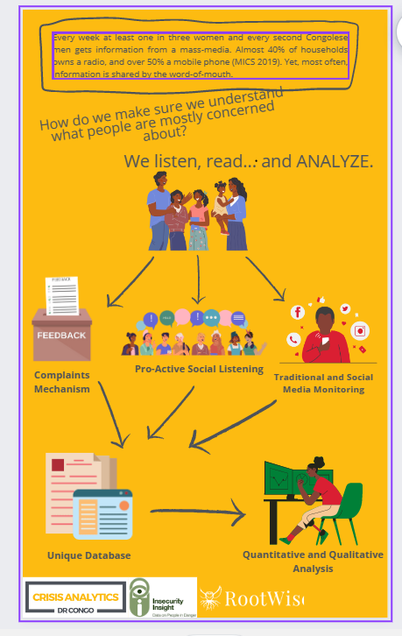

Mitigation:
Our approach to mitigation is based on the expectations of violence during conflict. We believe that when aid agencies and health care providers anticipate particular attacks, they can prepare for them in ways that not only protect staff but also mitigates the impact of this violence on their ability to continue providing vital services.
Example 2:
Mitigating violence based on survey information from local health workers identifying risks
Following the documentation of how many health workers were killed (Nigeria, South Sudan), together with the International Rescue Committee, we carried out surveys (Nigeria, South Sudan) that asked health workers about their safety and security concerns and collected data with a view to supporting the development of mitigation policies among aid and health providers. This information helps to put mitigation measures in place, such as:
- If workers are at high risk of attack when travelling from and to work, employers can offer the possibility to stay on site overnight, provide transport and employ staff to be on call alert for travelling staff.
- If the risks are related to attacks on health workers within health facilities or aid workers within project sites, employers can put stricter access policies in place and provide safe rooms within health buildings and offices that staff can access during emergencies.
- If health or aid workers are at risk as a result of particular programmes they engage in (for example distributing highly sought after supplies such as food during a famine) or providing services that may be controversial (such as abortion or family planning) employers can ensure improved communication around these programmes that support the safety of aid workers.
- We advice health and aid workers to adhere to the principles of neutrality and impartiality as a preventive protection measure. This means not taking sides in conflict but to concentrate on life saving activities that are offered to all conflict affected populations. We provide mobile guides on these principles:
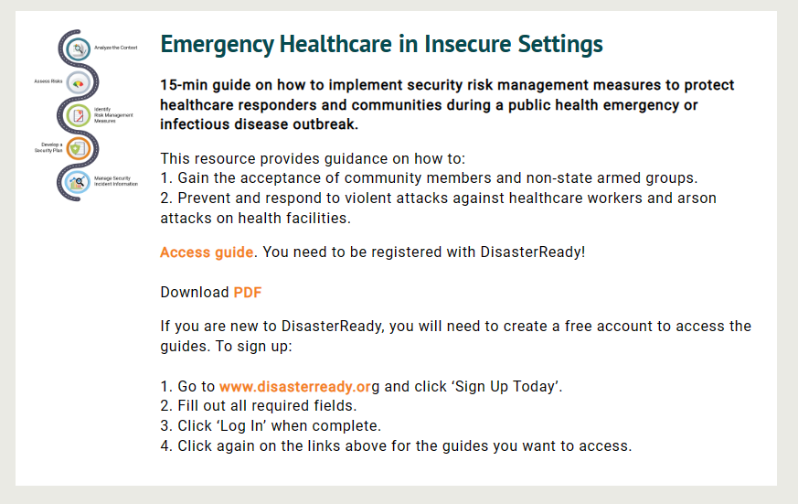
Impact on the fight against impunity
Insecurity Insight is an H2H organisation bound by the Humanitarian Principles. We call for respect for IHL. We call for accountability, including by aid agencies towards affected populations.
Data to support the fight against impunity
We partner with advocacy organisation and provide data and support efforts to address impunity.
Example 3: Attacks on healthcare in Ukraine
We partnered with Physicians for Human Rights, eyewitness, the Ukrainian Centre for Healthcare and the Media Initiative in Ukraine to produce a report on attack son health care in Ukraine. This report has been submitted to the Commission of Inquiry on Ukraine and we are exploring for submissions under universal jurisdiction.
Encouraging accountability by the aid sector towards affected populations
We run a social media monitoring programme, which allows us to track how aid operations are discussed on social media. This contributes to holding aid agencies accountable towards the communities they serve, in addition to identifying dangerous mis- and disinformation. Insecurity Insight » Social Media Monitoring
Impact on women, minorities, the disabled and elderly
Insecurity Insight focuses on aid and health worker, and educator casualties based on a ‘help the helper’ approach. We advocate for support for community leaders who are best placed to provide vulnerable populations with the care and aid they need. Through this approach we seek to ensure protection and access to services for vulnerable groups, such as young children, pregnant women, the chronically ill, the disabled, the elderly and survivors of sexual violence.
Helping the Helpers
Aid, health workers and teachers are of course civilians and as such not different from any other casualty. We focus on the vulnerabilities of these groups to gain insight of how to strengthen aid interventions and build the capacity of the aid sector to save more lives through care for the most vulnerable. We advocate for an approach of ‘helping the helpers’ to increase the reach of humanitarian aid.
Health workers are key in providing care to pregnant women, children, the elderly, disabled and those with chronic health needs as well as war wounded. We advocate to the international community to strengthen these local structures providing this care.
Aid agencies offer lifesaving food aid during conflict and other key services. Teachers give children the skills and confidence enabling them to work towards a better future.
With humanitarian aid remaining insufficient for global needs, and in the context of commitments to localisation, our approach focuses specifically on analysing the vulnerability of the health and education sectors to build the capacity within international partners to support and strengthen community leaders more effectively who have the skills and capacity to serve their communities.
We also engage with local health structures (such as those run by Ministries of Health) to strengthen the capacity of these institutions to protect the health workforce. We further work the Global Interagency Security Forum, the Safeguarding Health in Conflict Coalition, the Global Coalition to Protect Education from Attack, the Conflict and Hunger alliance and the Explosive weapons monitor.
Our monitoring of conflict -related sexual violence covers a highly gendered aspect of violence and casualties.
Recommendations
Ensure access to information
Our monitoring relies on communication about specific events from affected communities, aid agencies and local media. For this it is essential that independent news media and humanitarian organisations are able to access and report from conflict-affected areas and that affected communities have internet access to report their experiences.
- The international community should ensure that adequate attention and support is given to protecting media access and journalists at all times.
- The international community should provide independent internet satellites when governments turn the internet off to stop communities reporting
The quantity and quality of data compiled, and the analysis thereof, is enhanced by the involvement of multiple actors. Monopolisation of casualty recording and analysis, for example by specific UN agencies (notably the WHO with its SSA on healthcare or UNICEF on attacks on education), reduces independent oversight and can lead to perceived or actual bias which undermines trust in the findings.
- States and the international community should enable and facilitate the involvement of a range of actors in the gathering and analysis of casualty records.
- Internationally agreed standards and principles should be developed to enable casualty data to be shared and interpreted effectively across multiple actors.
- The WHO should implement the recommendations put forward in this study Strengthening Data to Protect Healthcare in Conflict Zones | International Peace Institute (ipinst.org)
- UN Bodies (such as the WHO, UNICEF) should share their data more widely with dedicated casualty recorders for cross-checking and referencing.
- Donors should provide support that allow for better connection between casualty recorders in affected countries and organisations that can aggregate data and feed it into policy processes.

