Annex 1: Background information on the role of indexes, including ESG indexes
What is an investment index, and how does the index influence capital flows?
The 21st century has seen a rapid change in the relationship between asset managers and index providers. Historically, asset managers bought index data to benchmark (or compare) their actively managed funds against an index that represented “the market.” To this day, the industry standard benchmark index is the S&P 500, an index created by S&P Dow Jones that tracks the performance of 500 large companies traded on stock exchanges in the United States. When an asset manager says its fund has “beaten the market,” this typically means that the fund has achieved better returns on investment than the S&P 500.
Due to the recent increase in passive investing, (i.e., the adoption of passively managed index funds and electronically traded funds [ETFs]), index providers have gained even greater importance, significantly influencing the decision-making of asset managers and the holdings of their funds. For a passive fund or ETF, the asset manager purchases the index holdings data from the index provider, so that the asset manager can mimic the index exactly, or with very little deviation.
Today, more than half of all US domestic equity funds are passively managed. This has effectively shifted the point of decision-making, and the power that flows from it, to a different set of financial actors. As former SEC chairman Robert Jackson said: “Fundamentally, millions of American families don’t choose what they invest in, an index provider chooses what they invest in.” Similarly, in 2019 the Wall Street Journal dubbed index providers “the new kings of Wall Street,” calling them “the biggest power brokers in the industry.” According to Responsible Investor, index providers are “the de facto gatekeepers of trillions of dollars in global capital.”
The Role of ESG indexes
An ESG index plays the same role as a conventional index, outlined above, but for funds seeking to invest in companies with high environmental, social and governance (ESG) performance. Just like conventional investment indexes, ESG indexes play a vital role in directing the flow of passively managed ESG investments.
ESG index providers determine which companies will appear on ESG indexes based upon the companies’ financial performance and ESG ratings, which score companies on how environmental, social and governance issues affect a company’s “financial materiality” (not how a company’s conduct affects people, communities and the environment). In order to create an ESG index, companies on the conventional index that fall below a certain ESG ratings threshold are removed from consideration for the ESG index. The remaining companies with high enough scores are placed on the ESG index. The index provider then “weights” each company, meaning it allocates each one a certain percentage of the ESG index’s total investment value. This weighting system tells the fund managers how much money to invest in each company. For indexes created by providers like MSCI and S&P Dow Jones Indices, weighting is based on the companies’ market capitalization.
The index providers then sell the indexes to asset managers, who use them as guides to construct funds that carry the “ESG” or “sustainable” label. For ESG funds that are passively managed, the fund manager will follow the index more or less exactly. Active fund managers, who have wide discretion to pick stocks, may deviate, but the index is nonetheless the starting point, the investible universe.
Although the majority of assets under management in ESG funds are still actively managed, the rate of growth for passively managed funds is rapid. In 2020, 75% of total net investment flows into ESG funds were into passively managed ESG funds.
The top three index providers (of ESG and non-ESG indexes) are MSCI, S&P Dow Jones Indices, and FTSE Russel.
ESG ratings: the numbers underlying ESG indexes
A company’s ESG rating determines whether it is allowed to appear on an ESG index. ESG ratings—also referred to as ‘scores’—are generally intended to measure how environmental, social and governance issues affect a company’s financial materially and/or reputation.
The ESG ratings industry is expansive, with over 600 ESG ratings and rankings systems operating globally as of 2019. The majority of these are boutique ratings firms, specializing in specific thematic areas, which supply data to larger rating firms. In the last several years, the ESG industry has undergone large-scale consolidation, creating a small oligopoly of large ratings firms, including MSCI, Sustainalytics, RepRisk and Institutional Shareholders Service.
The three biggest index providers, MSCI, S&P Dow Jones Indices, and FTSE Russel have benefitted by the industry’s recent consolidation—each of the three firms are now vertically integrated, producing their own ESG ratings, which inform the creation of their ESG indexes. None of the three firms publicly disclose the details of their ratings methodologies, but general descriptions can be found here: MSCI, S&P DJI, and FTSE. Each of the three firms gather data for their ratings from various sources, including by partially integrating data supplied by other major ESG research and ratings firms, such as RepRisk, Sustainalytics and Institutional Shareholders Service.
Each ESG firm creates its own methodology for scoring companies, as well its own rules-based procedure for determining when and how companies may be removed from the index. For MSCI, S&P, and FTSE, there is a high threshold for removal from the index. For instance, once MSCI includes a company on an ESG index, only the highest-profile, most financially risky scandals—those that receive the worst “controversy” score, zero, on a 10-point scale MSCI uses to gauge controversies—are removed. The scoring of companies based on internally devised rules, and the decision to include them in or remove them from the index gives MSCI and other ESG firms enormous leverage over the investee companies.

Graphics of ESG Ecosystem
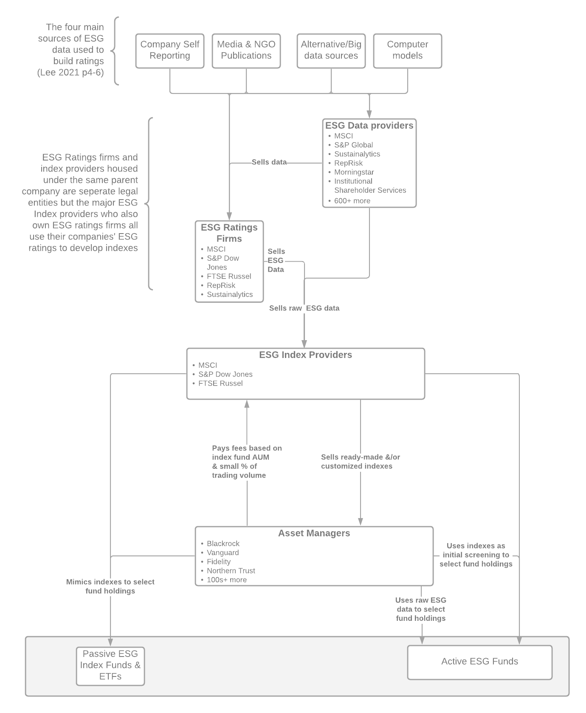
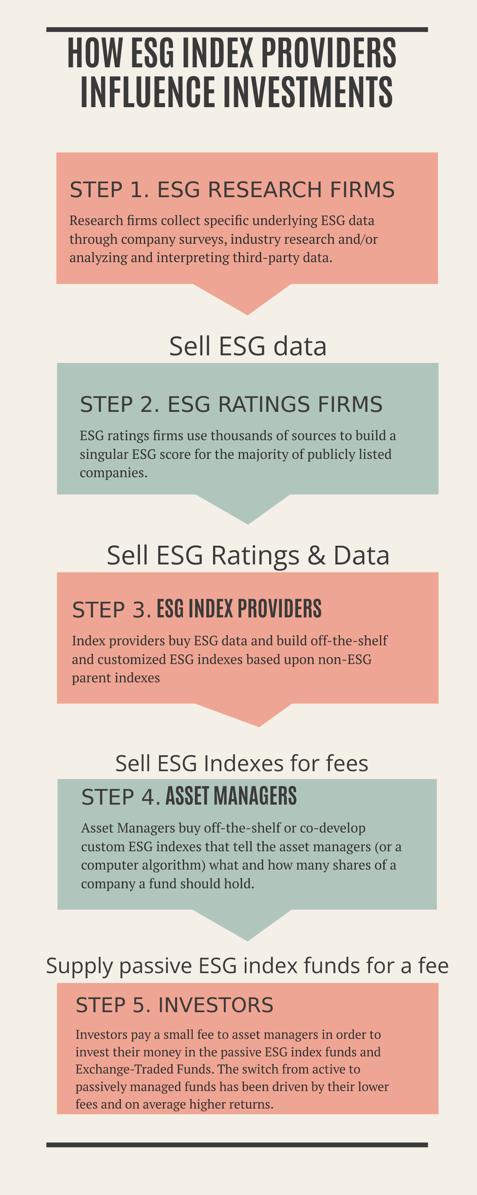

https://www.investopedia.com/ask/answers/03/100903.asp
https://www.sec.gov/ix?doc=/Archives/edgar/data/1408198/000156459020004992/msci-10k_20191231.htm
https://www.marketwatch.com/story/the-secs-next-regulatory-target-could-be-index-providers-11642177134
https://www.wsj.com/articles/index-funds-are-the-new-kings-of-wall-street-11568799004
https://www.responsible-investor.com/articles/index-firms-can-no-longer-ignore-gross-human-rights-abuses-in-mainstream-indices
For more explanation, see: https://www.bloomberg.com/graphics/2021-what-is-esg-investing-msci-ratings-focus-on-corporate-bottom-line/
https://www.ussif.org/files/Publications/Rise_of_ESG_%20passiveinvestments_2020.pdf, pg. 8.
https://www.ftserussell.com/blogs/esg-passive-investing-us-equity-fund-faucet-opens
https://www.sustainalytics.com/esg-ratings; https://www.msci.com/our-solutions/esg-investing/esg-ratings
https://www.reprisk.com/news-research/resources/methodology
https://www.sustainability.com/globalassets/sustainability.com/thinking/pdfs/sustainability-ratetheraters2020-report.pdf
https://www.spglobal.com/marketintelligence/en/news-insights/latest-news-headlines/consolidation-among-esg-data-providers-continues-amid-covid-19-pandemic-58306410
https://hbswk.hbs.edu/item/what-does-an-esg-score-really-say-about-a-company

