WALHI South Sulawesi
JL. Aroepala, Kompleks Permata Hijau Lestari Blok Q1, No.8,
Rappocini, Kota Makassar, Sulawesi Selatan 90221
muhammad.al.amien@gmail.com / walhisulsel@gmail.com
+62-8229-3939-591
Executive Director
Muhammad Al Amin

Subject: Input on increasing land and social conflicts as well as environmental damage due to extractive business (nickel mining) for supporting energy transition.
Dear,
Working Group on Business and Human Rights
Palais des Nations, 8-14, Avenue de la Paix. 1211 Geneva 10
Switzerland
Tel: +41 22 917 9159
E-mail: hrc-wg-business@un.org
We, WALHI South Sulawesi, an environmental and human rights organization in Indonesia, together with Yes to Life No to Mining, would like to provide inputs on increasing human rights violations (land and social conflicts as well as environmental damages) due to nickel mining, an extractive mining industry for supporting energy transition.
The energy transition is currently a global agenda driven by developed countries at the urging of civil society in the world to reduce extreme climate change. However, the solutions designed and implemented by developed countries have the potential to cause greater problems and are very dangerous for the environment, especially rainforests and people's lives, especially women and children.
As developed countries push for an energy transition and popularise the use of electric vehicles, nickel mining permits have increased on the islands of Sulawesi and North Maluku. In addition, the construction of smelters has also continued to increase. Especially since Indonesian President Joko Widodo banned the export of nickel ore, companies from various countries have come and built nickel smelters in Sulawesi and North Maluku Island, Indonesia, such as China, Switzerland, the United States. This will of course increase environmental impacts (destruction of rainforests, pollution of rivers, lakes and community water sources) and social (land grabbing and impoverishment of communities, especially women).
In a previous report, we sent input to Dr Marcos Orellana, a Special Repporteur on toxics and human rights regarding the increasing pollution of rivers and community water sources due to PT Vale Indonesia's mining activities in East Luwu, South Sulawesi. This proves that nickel mining, which is touted as part of the energy transition, does not necessarily reduce its environmental impact.
Climate Crisis is Real
Monday 20 March 2023, the United Nations Intergovernmental Panel on Climate Change known as the IPCC released their latest report contained in the Synthesis Report (SYR) IPCC Sixth Assessment Report (AR6). In the report, the IPCC states that the world's current climate conditions are increasingly worrying due to human behaviour such as greenhouse gas emissions, unsustainable energy use, land use change, lifestyle, and human consumption patterns.
Furthermore, the IPCC in its report reveals the fact that currently the global surface temperature has reached 1.1°C above 1850-1900 (pre-industrial) in 2011-2020 (see Fig. 1). Furthermore, extreme changes in the world's climate conditions ultimately encourage the high intensity and frequency of extreme weather that occurs in various regions such as prolonged drought, drought, heavy rain, and tropical cyclones.
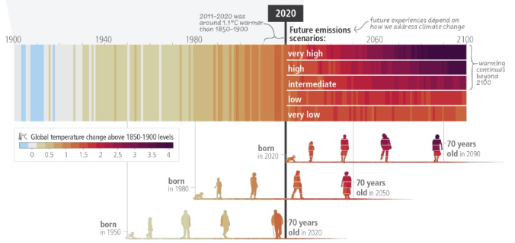
Figure 1. Predicted Changes in Earth's surface temperature from 1900-2100 (IPCC, 2023)
Today, the Earth's temperature has reached 1.1°C and is heading towards an average global temperature rise of 2.8°C by 2100 based on countries' commitments in their Nationally Determined Contributions (NDCs). This is almost double the 1.5°C target set in the Paris Agreement, which is the Earth's safe limit for global warming (Greenpeace Indonesia, 2023). With this fact, the IPCC predicts that the conditions and impacts of climate change will be experienced by the three generations born in 1950, 1980 and 2020. In particular, the generation born in the 1980s to 2020s will see an increase in global surface temperature of 1.1°C to 2.8°C with a much more dire disaster intensity.
Not only the increase in global surface temperature, based on data from the International Energy Agency (IEA), carbon dioxide (CO2) emissions from energy combustion and global industrial activities will reach 36.8 gigatonnes in 2022. This is an increase of about 0.5 gigatonnes compared to 2021, and a new record high in history as shown in the graph.
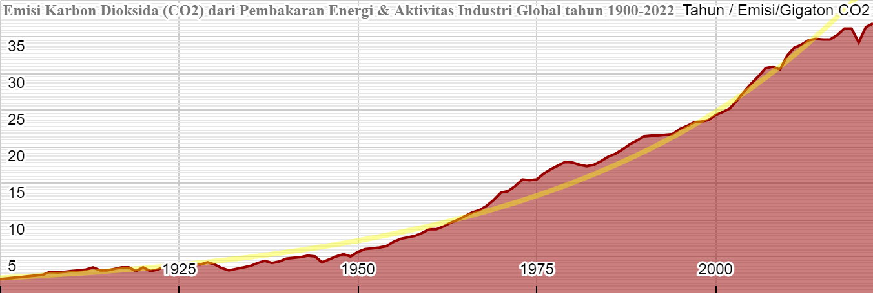
Figure 2. Increase in CO2 Emissions from Energy Combustion and Global Industrial Activities from 1900-2022 (Source IEA processed by WALHI South Sulawesi, 2023)
In its 2022 CO2 Emissions report, the IEA said that amid a wave of natural gas to coal conversion during the global energy crisis, CO2 emissions from coal rose 1.6% (year-on-year/yoy) to nearly 15.5 gigatonnes. This far exceeds the average growth rate in the last decade and is an all-time record high.
So, what about the condition of our oceans when global surface temperatures rise. The ocean has long borne the brunt of man-made global warming. As the largest carbon sink on the planet, the ocean absorbs excess heat and energy released from rising greenhouse gas emissions trapped in the Earth system. Today, the ocean already absorbs about 90 per cent of the heat generated by rising emissions (UN & Climate Change, 2022).
There are at least three major impacts on marine ecosystems as a result of global warming: (1) Sea level rise; (2) Sea temperature rise; and (3) Loss of marine biodiversity. Based on data released by Climate.gov (see Figure 4) by 2022, the global average sea level has risen 8-9 inches (21-24 centimetres) since 1880.
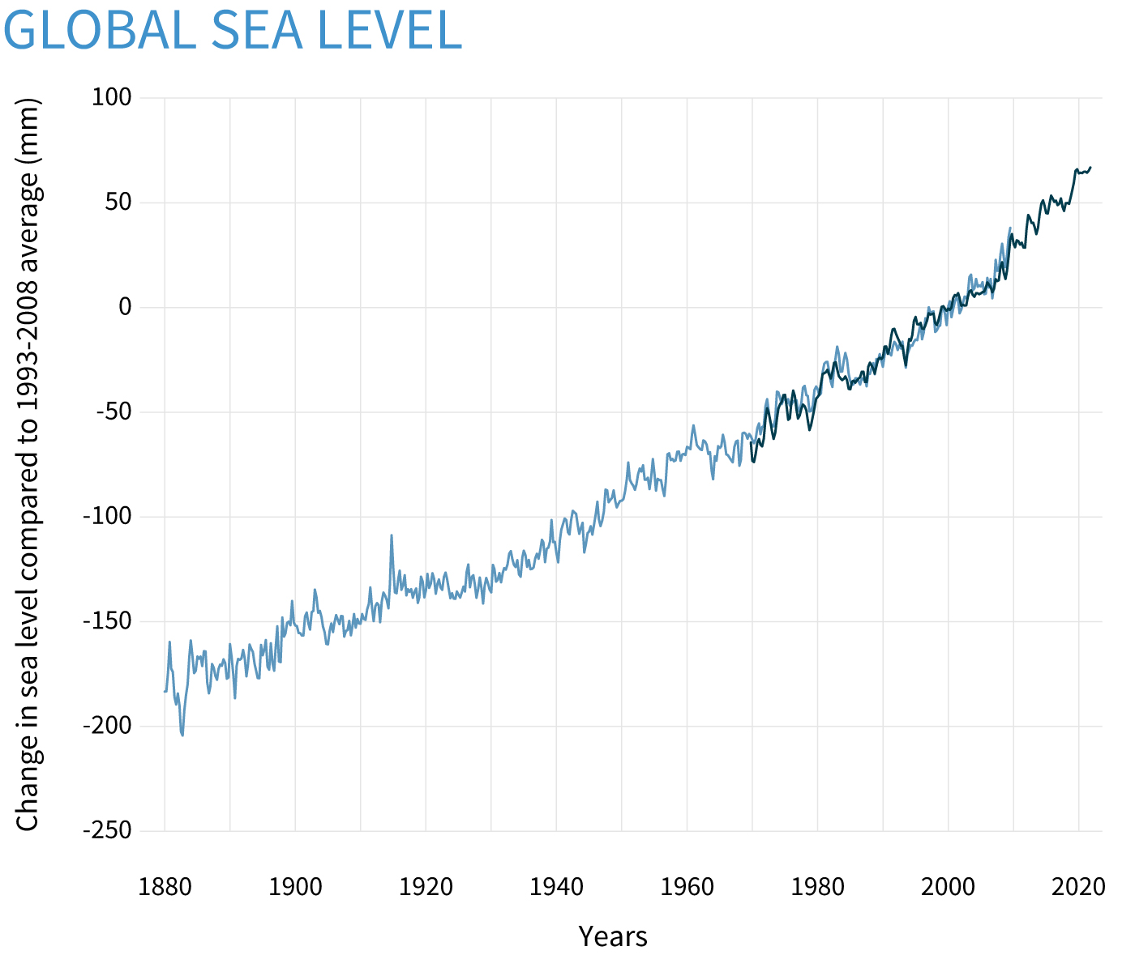
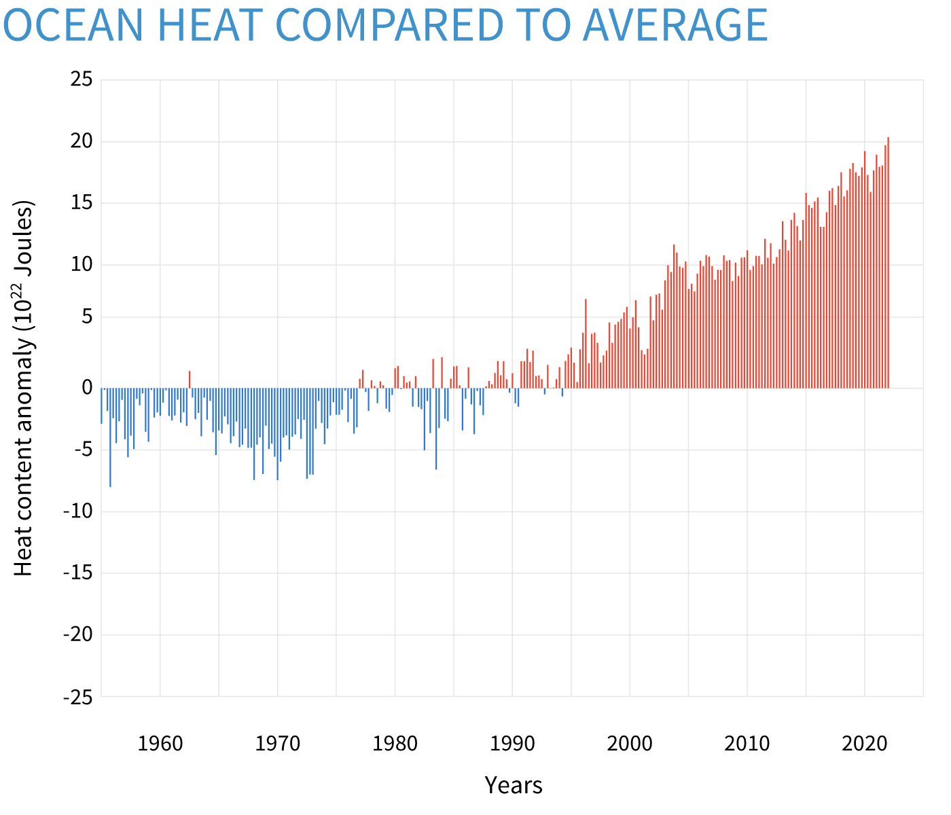
Figure 4. Percentage Sea Level Rise (1880-2020) and Ocean Temperature from (1960-2020) (Climate.gov, 2022)
Furthermore, in 2021, global sea level set a new record high of 97 mm (3.8 inches) above 1993 levels. Meanwhile, averaged over the entire depth of the ocean, the rate of heat gain from 1993 to 2021 is about 0.64 to 0.80 Watts per square metre. The high rate of sea level rise and ocean temperature ultimately threatens marine life, especially coral reefs, with bleaching.
Women and the Climate Crisis
Climate change indirectly interacts with gender inequalities and produces impacts that generally disadvantage women and children, especially among the poor.
Women and children tend to be at greater risk than men, especially in low-income and poor countries. Natural disasters and climate change generally exacerbate inequalities and discrimination against women. This condition is not only influenced by biological and social factors, but also by economic factors and women's low participation in decision-making.
If the natural disaster crisis is not controlled, by 2030 climate variability will threaten food security and water demand. This is because the world's population is already causing an increase in food demand about 50% greater than today, 45% more energy will be needed, and 30% more clean water will be needed.
It is estimated that the number of undernourished people will increase by more than 20 million, 884 million people will not have access to clean water and 2.6 billion people will not have access to basic sanitation (Alston and Whittenbury, 2013).
False Energy Transition and its impacts on Rainforests and Peoples´s Lifes
In the High-Level Task Force on ASEAN Economic Integration (HLTF-EI) meeting which took place on 2-3 March 2023 in Belitung (Indonesia) which was attended by ASEAN High Level Officials from ten ASEAN member states and the ASEAN Secretariat. At this meeting, Indonesia raised 3 specific issues that will be driven by electric vehicles, energy transition, and blue economy. Not only that, at this meeting Indonesia will also encourage the approval of the ASEAN Leaders Declaration on Developing Regional Electric Vehicle Ecosystem to strengthen Southeast Asia's position as the centre of the world's electric vehicle industry.
So, is it true that electric vehicles are environmentally and climate friendly, like the 'jargon' that has been campaigned massively or just the opposite. The first thing to know is that the massive development of the electric vehicle industry will encourage the production and demand for batteries as one of the main components of the electric vehicle to increase.
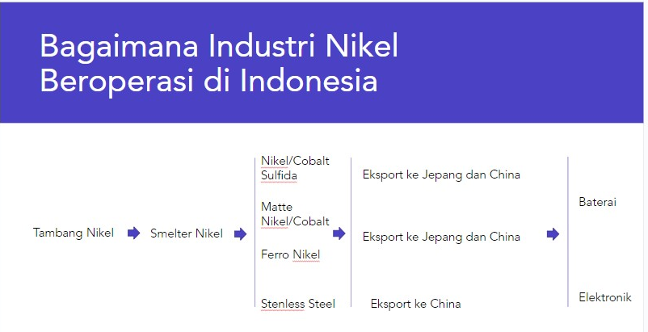
Figure 5: Process and Management Stages of the Nickel Industry in Indonesia
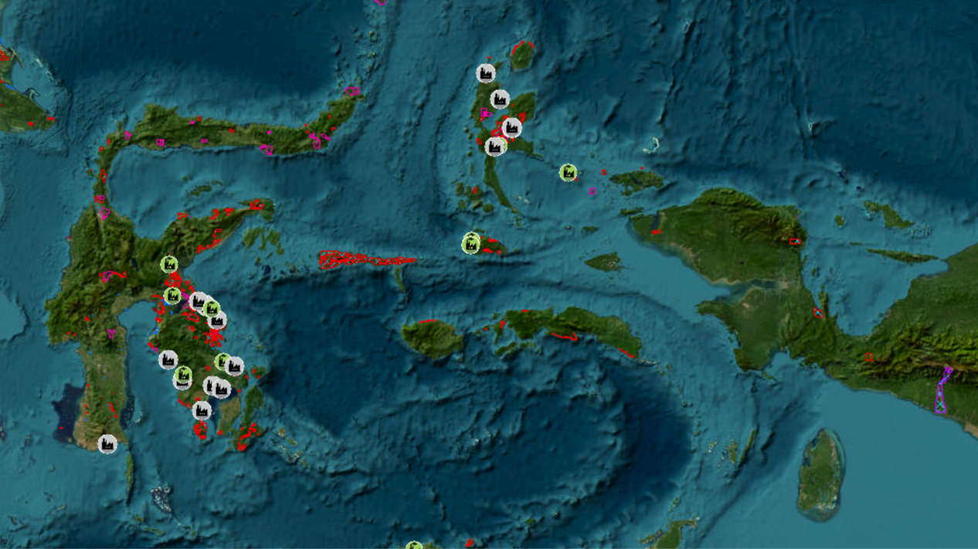
This condition then encourages the expansion of nickel mining which is used as the main raw material for making Lithium-ion batteries which are widely used in electric vehicles today. The need for electric vehicle commodities ultimately encouraged the massive granting of licences for mining companies, especially nickel mining on the islands of Sulawesi and Maluku.

Figure 6: Mining consessions and Nickel Smelter on Sulawesi island and in the North Moluccas.
As we know, Indonesia is one of the largest nickel deposit countries in the world. In our records, there are at least seven companies that own the largest nickel mining concessions in Indonesia. However, more than 300 companies actually own nickel mining concessions in Indonesia ranging from 200 to 17,000 Ha.
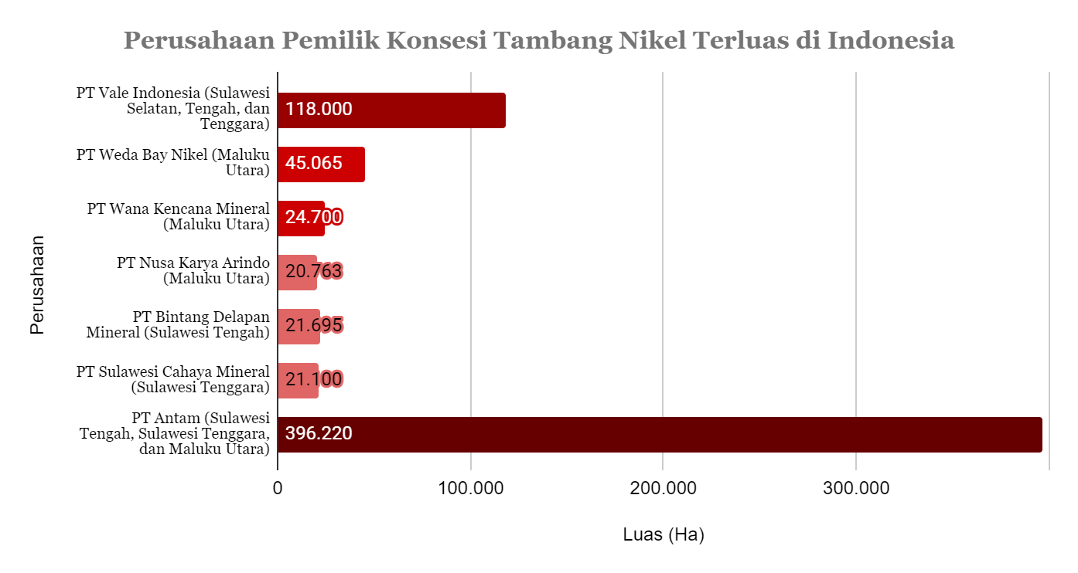
Figure 7. Percentage of Companies Owning the Largest Nickel Mining Concessions in Indonesia
After calculation, the total area of the largest nickel mining concession in Indonesia is 647,543 Ha or 6,475 Square Km or equivalent to 37 times the area of Makassar City or equivalent to 906,923 football fields.
Not only are companies that own nickel mining concessions increasing, but nickel processing companies (smelters) in Indonesia are also increasingly appearing along with the massive campaign for the use of electric vehicles. Based on a number of data collected, there are at least 11 existing nickel processing companies and two companies that are currently in the planning stage of smelter development in Indonesia (see Figure 8).
No | Company | Country | Nickel product | Capacity (MT) | Energy supply
1 | PT COR | China | Ferronickel | 100,000 | coal
2 | PT Vale Indonesia | Kanada, Jepang. | Matte Nickel, | 80,000 | water, diesel and coal
3 | PT GNI | China | Ferronickel | 2,000,000 | coal
4 | PT IMIP (Tsingshan Steel Indonesia dan Sulawesi Mining Investment | China – Indonesia | NPI | 807,000 | coal
5 | PT Virtue Dragon Nikel Industry | China | NPI | 1,000,000 | coal
6 | PT Wanxiang Nickel Indonesia | China | NPI | 351,081 | coal
7 | PT Antam | Indonesia | Ferronickel | 90,000 | coal
8 | PT Obsidian Stainless Steel | China | Ferronickel | - | coal
9 | PT Wanatiara persada | China | Ferronickel | - | coal
10 | Harita Group | Indonesia - China | Ferronickel | 780,000 | coal
11 | WEDA BAY NICKEL | China | NPI dan Ferronickel | 55,000 | coal

Figure 8: Existing and proposed smelters in Indonesia.
By looking at the series of facts and the impact felt by the community and the environment, it is very clear that the promotion and government policies related to electric vehicles as part of the energy transition and reducing greenhouse gas emissions are only an 'illusion'. Because in fact, electric vehicles cannot be separated from the nickel extractive industry, which in the process uses more coal energy and is supported by electrical energy sourced from Captive PLTU which also uses dirty energy.
The Impact of Nickel Mining and Industry in South Sulawesi
- Social and Environmental Impacts of Nickel Mining and Industry in South Sulawesi
Social and environmental impacts in around Vale Indonesia mining and smelting
Sosial |  |  | Environment
Indigenous People | Local Communities | Workers
Marginalisation | Land grab | Low salary | Massive rainforest destruction
Difficult access to clean water | False Livelihood Restoration | High health risiko | Landslides and floods
Access to forest lost | Meaningless Consultation | High Risk of Accidents in workplace | Sedimentation, river and lake pollution
Access to jobs difficult | Non-transparent Information |  | Toxic metal pollution in rivers, lakes and community water sources
 | Criminalisation |  | Air pollution
Tabel 1. Socio-Environmental Impacts in PT Vale Indonesia's Mining & Smelter surroundings
- Impacts of Nickel mining by PT Citra Lampia Mandiri and PT Huady Nickel Alloy in South Sulawesi
- Social and Environmental Impacts of Nickel mining by PT Citra Lampia Mandiri and PT Huady Nickel Alloy
Sosial |  |  | Lingkungan Hidup
Petani | Nelayan | Pekerja
Land grabbing | Fishermen's fishing grounds are getting farther and farther away | Low income | Massive Rainforest destruction
Destruction of seaweed farmers' land | Cost of fishery high | High Health risks | Sedimentation, river pollution
Failed harvests | Declining fishing yields | Increase Job accidents | Coastal and marine pollution by sludge and oil from nickel ore transport vessels
 |  |  | Toxic metal pollution to rivers, and community water sources
 |  |  | Air pollution

Recommendation
From the explanation above, we represent the community (farmers, farm labourers, fishermen, women) who are currently living amidst the impact of extractive activities (mines and smelters) of nickel calling on OHCHR to act immediately to see and discuss directly with victims of nickel mining in Indonesia, especially in South Sulawesi. So that OHCHR can issue a call to companies to stop their nickel mining and smelter activities that have seized land, destroyed plantations and polluted and poisoned rivers, lakes and community water sources.
We also through this report urge the OHCHR to act immediately and urge the governments of countries where their companies are carrying out nickel mining extractive activities in Indonesia, such as China, Canada, Brazil, Japan, Norway, to implement extraterritorial obligations to stop the destruction of rainforests, land grabbing, human rights violations and impoverishment of communities.
Concretely, we urge OHCHR to:
1. Urge the government and the Chinese company (PT Huady Nickel Alloy) to stop the nickel smelter in South Sulawesi because it has polluted the air, impoverished farmers and fishermen and poisoned the community's water sources with heavy metals.
2. Urge the government and the Brazilian, Canadian, Japanese company (PT Vale Indonesia) to remove community gardens from their mining concessions. Stop polluting rivers and community water sources with heavy metals. And respect and implement international principles correctly.
3. Urge German (Volkswagen) and US (Ford) automotive companies to cancel investments in Indonesia, especially related to the development of the electric vehicle ecosystem. German and US investments will accelerate the destruction of rainforests, increase human rights violations and impoverish communities, especially women in nickel mining areas.
4. Urge the Indonesian government to repeal the Job Creation Law which has the potential to reduce the social and environmental protection system in Indonesia.
5. Urge governments around the world to protect rainforests around the world as a concrete solution to the current climate crisis.

Annex:
https://docs.google.com/document/d/1YrBGBaUuXUh85WQDev88zKGeWPkpEpyPPGJWE41k-Hc/edit#

