VOICE OF PORGERA WOMEN IN MINING TODAY
PRESENTED BY:
PORGERA RED WARA WOMENS ASSOCIATION INCORPRATED (PRWWA)
Compiled by:
Cressida Kuala
24th October 2015.
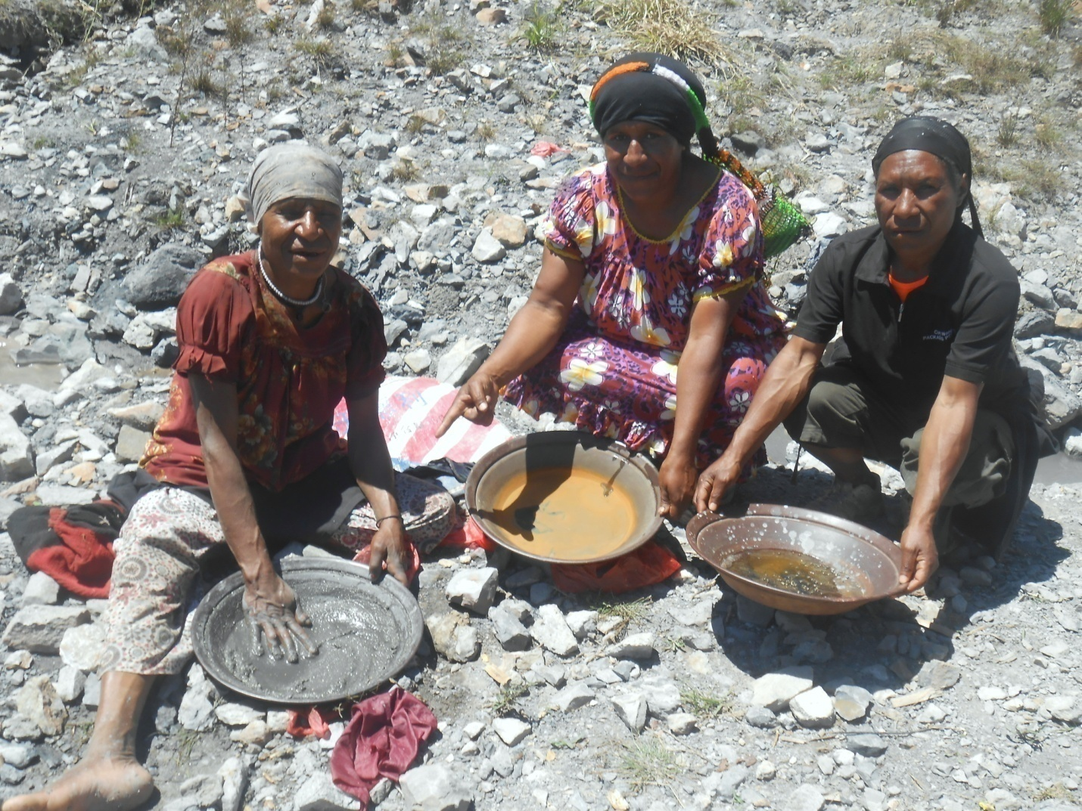Local Ipilli women using mercury to collect gold in pans at North Anawe tailing-pipe outlet site. Shots taken on the 25th September 2015.

VOICE OF PORGERA WOMEN IN MINING TODAY.
Voice of Porgera Women is an incorporated entity that represents the female population of Porgera district in Enga Province, Papua New Guinea. The primary concern of the group is central to equal participation in social, economic and political affairs of various district population packets; including Porgera Urban, Porgera Rural, and Paiela/Hewa local level government areas. The Voice of Porgera Women was formed to exist as mouthpiece of a large rural and the urban female population that had been in rapid transit through cultural labyrinths of language, religion, technology or various other diverse cultures based human interactive businesses of contemporary Porgera. The primary goals of the group is simply; compatibly mixing multi-cultural components towards producing an outcome that enhances conducive atmosphere for maximizing economic growth in Porgera.
The VPWMT is more or less like an affiliated Porgera, Paiela and Hewa womens’ group for a confederated representation in broader provincial and national issues crucial to development of female population. For instance, Porgera Red Wara Women’s Association Inc. (PRWWA), a recently incorporated womens group has pervasive representation in both VPWMT and Porgera District Womens Association (PDWA). The universal goal of VPWMT is to frame together the diverse interests of various Porgera district women and determine presentation for national and global awareness.
The PDWA being the oldest established group that had been operating for almost 26 years is presenting this article with the help of other women’s interest groups. And this article presents in a condensed nature, the grievances of the women of Porgera District and Paiala/Hewa sub-Districts. This presentation in other words stresses the passage of women from rural subsistence livelihood to contemporary market economy and its adventures associated with “culture shocks”; i.e. the life-changing impacts the Barrick-PJV operation had been dishing out to the women of the area seen from the dimensions of environment and subsistence livelihood perturbations.
PORGERA MINE AND ITS IMPACT ON THE LIVES OF WOMEN
Before Porgera Mine’s construction, there were small scale mining in at Alvis and alluvial gold mining along Porgera River from Mt. Warowoti to Kaiya/Pongema Rivers junction. Mining operations that time took up little subsistence life supporting land. The male population of Porgera went to work at these small scale mines or pan for gold along river banks while women were family gardeners that produced food for family livestock and family members. The mothers and girls woke up early to cook breakfast, feed children, released the pigs into their foraging waste lands and went to the garden to work the family land. Later in the afternoon, the women and the girls came home with food from their gardens to feed the male members, the children and their livestock. These activities were routine tasks that occupied the lives of Porgera women from as early as age 10 to old ages of 70 years. The women of Porgera had inseparable relationship with land, particularly gardening land, before Porgera mine was constructed in 1988.
The explosive changes that occurred to lives of women during and after mine construction shattered an ancient bondage between the Porgera woman and her land. The women here saw huge trucks and earth moving equipment cut down mountains and pushed millions of tons of surface overburdens down Porgera River. The women helplessly lived through that era of their gardens along low plains or benches along the river ways being submerged under sediment build-ups. The men were too quick to claim compensation from Porgera Mine and when paid, they went out to spend them all on beer, women and gabling. After the natural clan boundaries had been buried in sediment layers, competitive interests to claim more money each year motivated men and boys to dispute boundaries; I.e. the strong encroached well into the weak’s territories and the weak went complaining to police that charged and still continue to charge service fees for all complaints brought before its general duties counters. The women of Porgera virtually were deprived their rights to maintain subsistence livelihood and pressed into a life of feeling inadequate and valueless. Being forcefully rendered idle in their former subsistence life, the Porgera women now are finding occupation niches as sitting for hours in local markets selling food, remain at home to raise livestock, or venture into various informal business operations.
After 25 years of mine operation the general atmosphere, in terms of cash-flow, had been extremely discouraging for the Porgera women. The mine operator’s fly-in/fly-out arrangements of mine employees does not help much in variations to the cash-flow situations of Porgera. That truth therefore is, Barrick who operates Porgera mine is robbing the Porgera women their opportunities to participate in spin-off businesses. That leads us to commonly asked questions as the following;
- Is sacrificing gardening land and houses for just a year’s meal a fair compensation Barrick paid to Porgera women?
- Where do we get water and firewood for household uses?
- Will we ever go back to subsistence life again after Porgera Mine closure?
- If we do return to subsistence life, how will our children who do not have hands on training now fare?
- Why doesn’t Barrick consider buying land outside Porgera for Porgera women to engage in livestock husbandry and market crop growing?
- Does anyone in Porgera or PNG realize that Barricks presence dwarfs the presence of State authority in Porgera?
- How could we create a female population friendly Porgera public attitude?
- Why must the subsistence livelihood deprived Porgera women become a street vendor all her life?
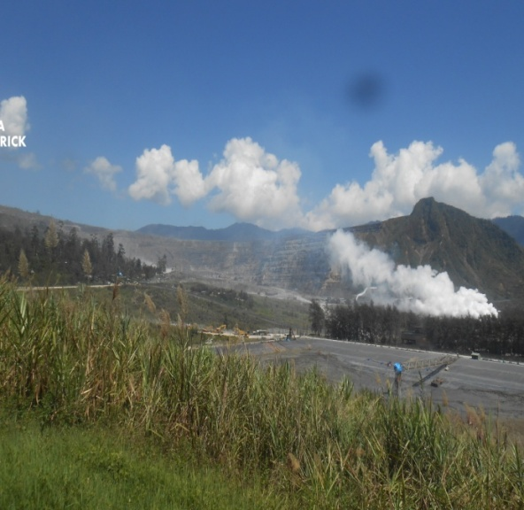
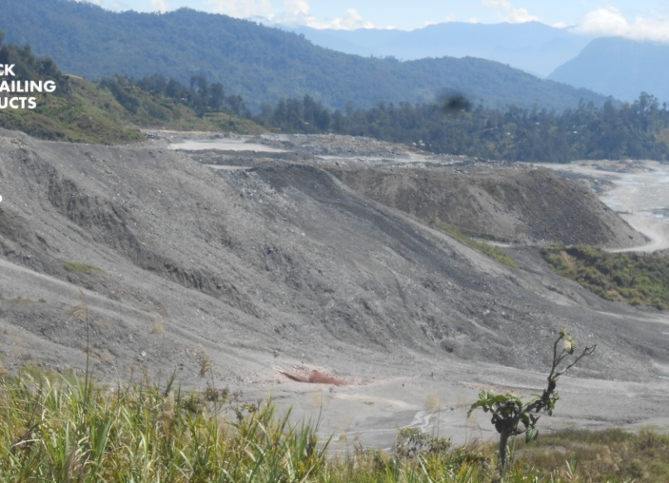
Picture of the Open-Pit mine. 25/09/2015 The North/ South Anawe dump and tailing site. 25/09/2015

ILLEGAL MINING AND PORGERA WOMEN
The rape, sexual abuse and torture cases registered in Porgera so far are mostly synonymous with the word “illegal miner”. The guards and mine police of the period between 2002 and 2012 had felt insulated by company policy to break laws within Special Mine Lease areas and not tried or jailed as do the ordinary people of local clan communities. Although a few expatriates had been caught raping local women and sexually abusing some, national hire employees of the mine had developed rape and sexual abuse of Porgera women as their special occupations on site.
On the other hand, the male illegal miners caught searching for gold within SML sites had been mostly shot dead until investigations into some killings over the years caught NGO organization’s attention in Canada or caused global alarm. The female illegal miners had been either raped and released or chased into the murky polluted tailing discharge for drowning. The women had kept quiet for a long time until the PRFA began gathering complaints of sexual abuse, torture, and rape reports for compensation payments in 2012. The synonymous catch to rape, sexual abuse, torture and killing by mine police and security guards is illegal mining and other deaths and being drown in dirty tailing flow had been viewed locally as chemical poisoning. There are some women that had been repeatedly raped and sexually abused here that tell different stories; they had become constant contacts of these policemen and guards for ease of passage. There are other women that had been impregnated during encounters with mine police and guards too that tell of naming the child after those rapists. In the end, there are many women that have caught the dreaded virus, HIV and became AID positive over time while others reared fatherless children that over time have become the community’s liabilities. The incidences of prostitution, the escalating state of lawlessness, corruptions in high offices, drug and alcohol abuse, property thefts and trespassing properties with deliberate goals of financial advancements are some symptoms of Barricks corporate negligence in encouraging respect for rule of law.
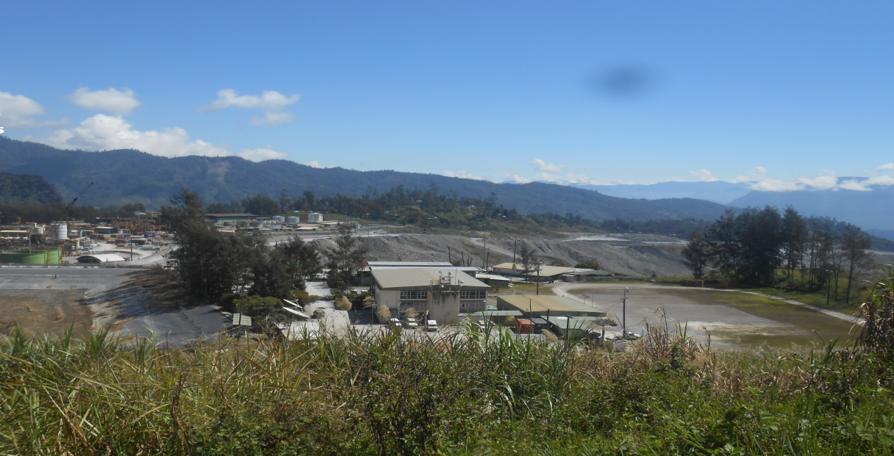
The Porgera mine administration office facing Anawe Dumpsite. 15/09/2015
PORGERA MINE AGREEMENT 1988 AND DISCOURAGEMENT OF REVIEW
The special mine lease (SML) granted in May 1988 through Porgera Agreement features fingerprints of Porgera SML landowners while the national and Enga provincial government representatives have their signatures. The agreement partners’ failures to review Porgera Agreement goes to show that there is something buried in there that must not be exposed. Although we have no proofs, we feel free to suspect that the time of Porgera agreement signing was during the height of Bougainville crisis. The young nation of PNG confronted its worse national budget collapse and needed alternative mines to patch up the collapsed budget. The prospect of building Porgera mine occurred just about that time of Bougainville Copper Mine closure. It could be likely that the two governments, EPG provincial and national government caught and kept the ignorant, fingerprinting Porgera landowners in captivity and determined the prospect of killing a few Porgera women and children to save the nation from collapse. Any structural devices of genocide nature and against a minority ethnic Ipili/Paiela/Hewa women population would be accepted as sacrifice for salvation of entire nation of Papua New Guinea. Are we therefore suspecting correctly that whatever the government is trying at all cost to hide are the “menacing agendas” purposefully hidden from captivated landowners for over 2 decades but through a review, the sons and daughters of the past ignorant, fingerprinting population could expose?
The Bougainville Copper Mine closure has had profound impacts on PNG national budget from 1988 to 1996. Any or all threats of counter-productive nature in Porgera within this period was met with barrel of gun pointed at the landowners that seemed smart. Any Ipili landowner posing as counter-productive threats was met with full force of a Placer Dome management hired mine police and corporate security guards. The Porgera district population was forcefully ordered into a pro-Porgera corporate interest groups and the others; and such discriminatory practices exist up to this day; even after Placer Dome management is gone but their partners-in-crime against Porgera women; Enga provincial and national government, and Porgera Landowners Association remain in Porgera. These remaining partners are struggling at all cost to maintain status-quo in Porgera so that the false foundations upon which Porgera mine had been sitting on are not exposed before mine closure. That is how we explain why the state prolongs any attempts at reviewing Porgera Agreement for over 25 years.
The telling effects of the government’s past menacing agendas in Porgera and the Porgera landowners conspicuous conducts are seen in the following symptoms;
- The VIP treatment given to Pakiru Pundi family of Tieini clan in every cycle of social, economic and political arena of Porgera exposes the investment security threat Porgera Mine is encountering from its foundations of varying falsehood. It is common knowledge in Porgera that Pakiru Pundi, a Tieini councilor at that time, refused to sign Porgera Agreement in 1988 on the condition that he be assured that future generation of his clan will appreciate whatever provisions the agreement needed and he blamed the state for hasty facilitations that gave landowners no time to consider options.
- The SML was a narrow-sited outcome of a panic stricken government that had been driven by hysterical motives to establish an alternative revenue source after the forced closure of Bougainville mine. That became evident in July 1989 when Anawe Plant construction surface overburden pile at Aipaka mini-dump broke-out and spilled over into Maipangi, Waiwa Luanda, Pakien, Timain, Aipakain, Kungurin, Pianda, Pulumaini and Kiyo clan territories sprawled at the lower slopes of Anawe/Pandadaka ridges. Millions of tons of waste buried gardens, housing sites, livestock foraging sites, forest product sources, economic trees, sacred sites, cemeteries and forced the clan members, particularly the women to drift around Porgera, land-poor.
- This Aipaka Mini-Dump break-out, a dreadful engineering error, was covered up through imposition of a concept that came to be known later as the lease for mining purposes (LMP). Porgera mine has expanded outwards into non SML areas and displaced a large population of clan women from Pandadaka, Aipaka, Anawe, Yanjakale, Peyari, and Munlep villages. These women, are just some of the LMP women that had been made land-poor and for decades, foraging for gold or waste from the mine that could be sold to local scrap dealers.
- One telling symptom of such hidden agendas of Porgera Agreement exists in the form of a Maipangi clan family that lost over 72 hectares of land in Anawe South LMP being labelled non ethnic Ipili landowners of Anawe LMP. This historical icon of Ipili men, Kuala Lapia, who the first Australian colonial patrol into Porgera valley captured and took away for cultivating as future interpreter was a Maipangi clan kid. His capture by John Black at Tamakale village in April 1938 coincides with Porgera gold discovery on the same day but Porgera Agreement partners publicized that icon’s family as recent immigrant guests of Maipangi clan. The land the Kuala family owns as private family land is now regarded as one public clan property in Porgera valley that Barrick today references as Block 1-A-24 Yanjakale. Various Kuala family members sided up with Councillor Pakiru Pundi during Porgera Agreement so we could expect the agreement participants to deny the family participative roles somehow.
- Apart from complaints of rape, sexual abuses and tortures, the awe-inspiring realities that confront women of Porgera is their losses of subsistence survival rights. That awe-inspiring reality of subsistence survival alternative search by Porgera women, drives them to disregard the looming dangers of being caught and raped when they participate in searching for gold at the low-grade stock piles and tailing outlets.
The mine management may argue that corporate plans exist for relocation of affected landowners and they had been relocating the Tuanda and Waiwa clans to Apalaka relocation village. And all the others in Kulapi, Munglep and Yarik relocation villages. However, these location being within the SML and LMP boundaries, the ethnic Ipili people perceive this as; “sitting on one’s own excreta”. These relocation villages should be relocated well away; out of the mining corridor and the landowners deserving corporate attention should remain as the LMP landowners only. In other words, the SML landowners’ time has expired in the past 25 years but they are still screaming to captivate corporate attention for relocation out of SML corridors.
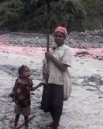
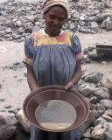Women and children of the Lower Porgera , Anga Clan panning gold at the river tailings.
Women, young girls and children at the mine river tailings dump site. 25/09/2015 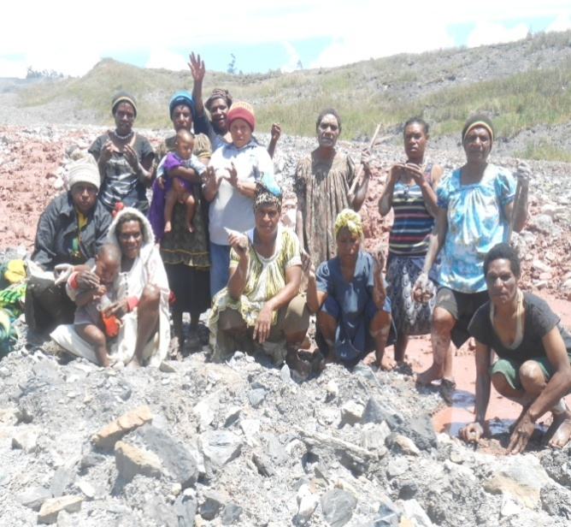 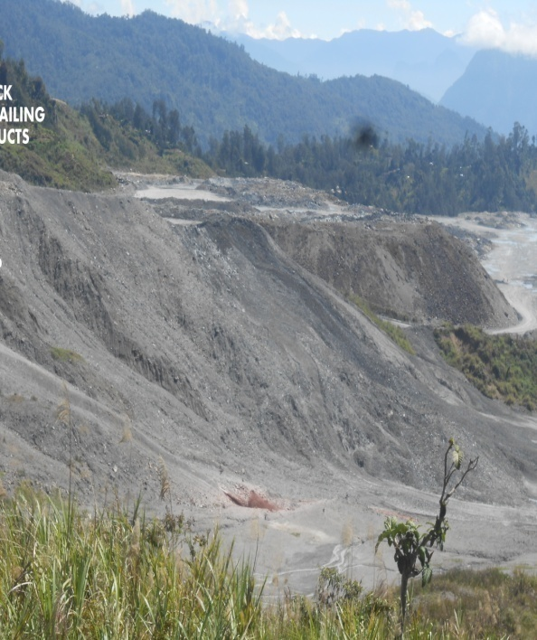
LIVES OF THE PEOPLE WHO LIVE IN VILLAGES NEAR THE DUMPING SITES.
In the past years women have been giving birth to deformed babies and have not known what the causes until human rights advocates in Porgera pointed that chemical discharged from the mine could deform unborn children. Few young adults have gone crippled at an early age and exist as burden of liability in their poor parents’ lives.
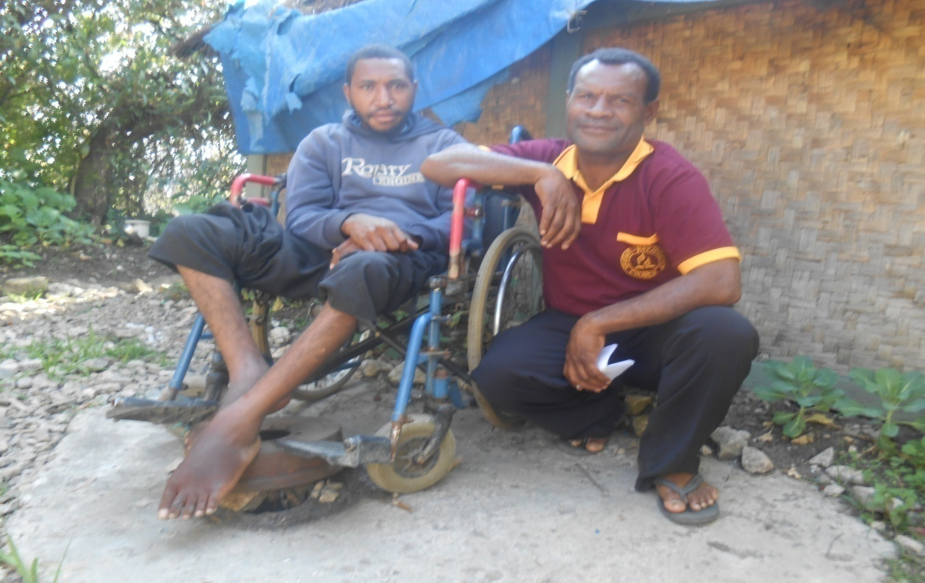
19 years old Joman Jimmy from Nekeyanga village in Lower Porgera, has been paralyzed in 2010. It is believed he had contacted tailing waste for over 6 years.
The photograph above, taken on 24th September 2015, is one allegation of chemical poisoning that VPWMT has received. 19 year old Joman Jimmy from Nekeyanga village in Lower Porgera, has been paralyzed since schooling in Mugulep primary school doing grade 6 in 2010. He grew up with it from an early age and has become a permanently disabled person. His father, Jimmy Polopa who’s pictured with him has lived with this burden of rearing a disabled child.
There had been many complains of chemical poisoning at Anawe Waste Dumps and along the length and breadth of Porgera river system. These complaints come in the form of reports and records of treatment at aid-posts in remote Fly/Strickland River plains. However, there had been little medically examined and proven cases of chemical poisoning. Many of such complaints from women living at the edges or within the SML and LMP have visited doctors at various hospitals in Enga and Western Highlands provinces. The VPWMT possess no concrete evidence on the topic of chemical poisoning and we hope to research further before commenting.
HIGH RISKS TAKEN BY VILLAGERS FOR SURVIVAL.

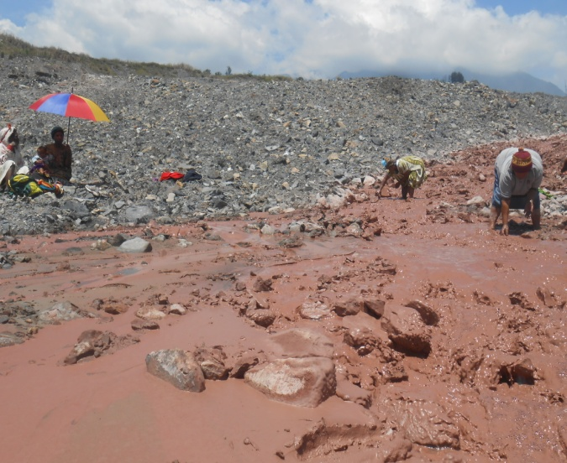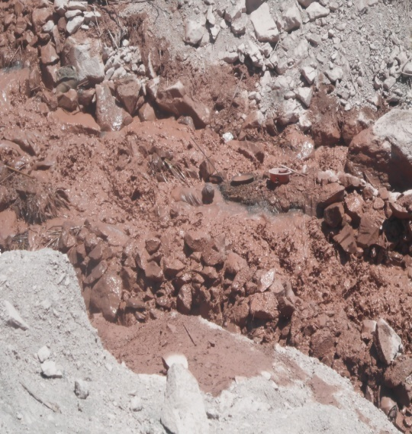
The chemical polluted waste discharged from Anawe Plant may have driven physiological terrors into the local land-poor population, the ever-consuming need for food on the table each evening is an indispensable fear. The picture above shows women working in this heavily polluted tailing waste flow in Anawe Dumps. The women here sometimes dive into such heavily polluted waste flow to collect gold bearing sediments for panning.

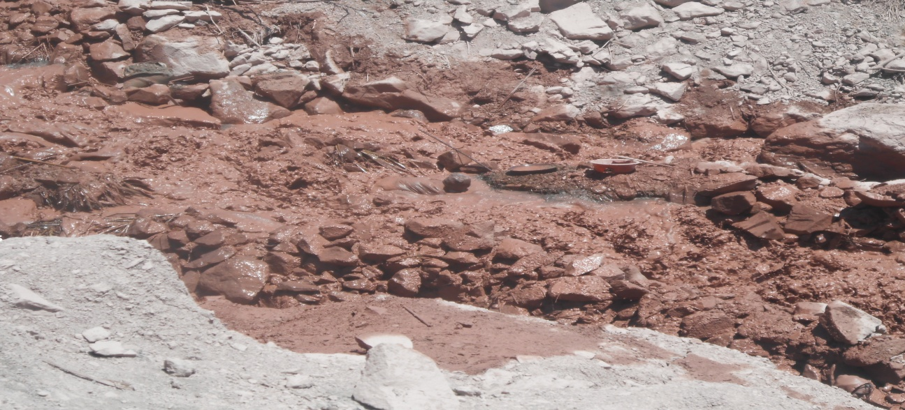
A woman from Pandadaka Village, taking a dive into the chemical river tailing to collect sand contained gold from beneath .15/09/2015
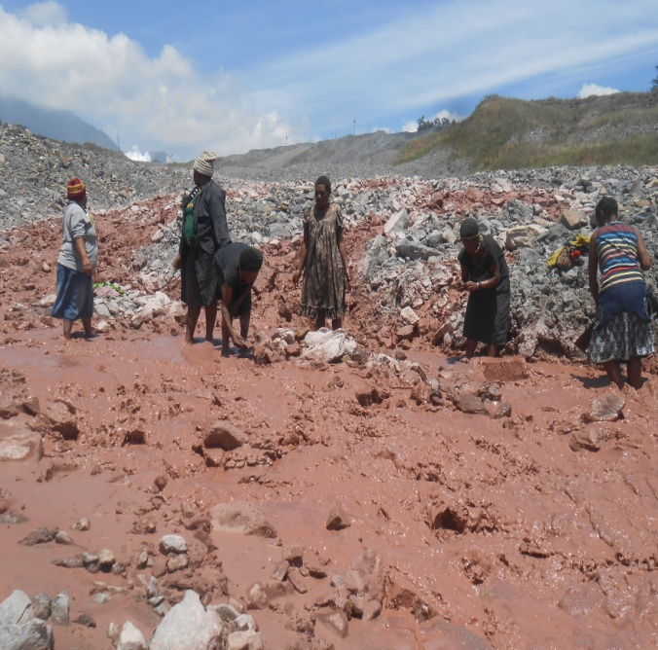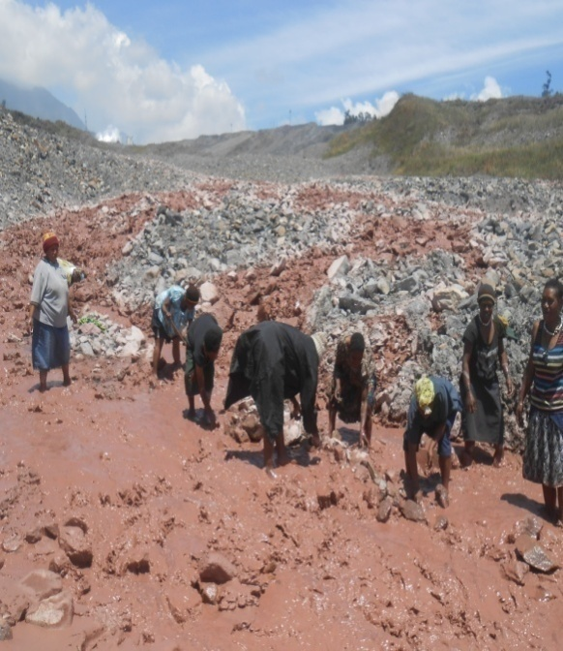
More pictures of women and young girls at Anawe tailing outlet on the 25/09/2015.

DESIRED ACTIONS TOWARDS REDRESSING THESE CRUCIAL HUMAN ISSUES.
The catch-phrase that coins VPWMT’s principal goal is- “create alternative niches for rural Porgera women population flushed out of their ancient subsistence survival niches” by Porgera mine operation.
So how do we go about it?
We desire a centralized establishment comprised of national and international NGO organization personnel that must possess extreme traits of steady commitment, dependable and trust that are godly qualities. We hope to form a team that must instill and set into dynamism the “spirit of maximizing output with less inputs”; Production culture that can be likened to local Porgera homebrew addicts’ popular chant- “liklik moni, bigpla spak” (little money, getting dead drunk). This development strategy the VPWMT envisages is merely creating a dual survival mean for Porgera women so they have 50% of their lives engaged in market economy powered life while the other half unconsciously remains in contact with ancient subsistence livelihood.
Thereby the current Porgera women population wonder about feeling hopeless, inadequate and valueless may face their futures with confidence of seeing a brighter tomorrow.

