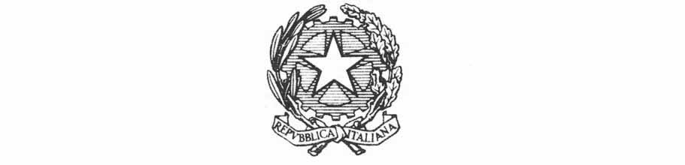
Ministry of Foreign Affairs and International Cooperation
Inter-ministerial Committee for Human Rights

Contribution following the request of the UN Working Group on Business and Human Rights - Multi-stakeholder Consultation on “Corporate Influence in the Political and Regulatory Sphere”

May 2022

Contribution following the request of the UN Working Group on Business and Human Rights - Multi-stakeholder Consultation on “Corporate Influence in the Political and Regulatory Sphere”

Following the request from the UN Working Group on Business and Human Rights, Italian authorities are pleased to provide the following contribution.

The relationship between public authorities and business companies could be based on a mutual engagement where appropriate, assumed that the common goal to be pursued by public and private actors aims at encouraging an higher business culture and performance along the principles of the so called HBRA.
To this scope the interaction promoted at the national level is worth of mentioning, also in order to prevent and address corporate activities that may undermine the State’s ability to protect human rights and businesses’ responsibility to respect human rights.
Indeed an open and constructive dialogue has been facilitated within the first and the second National Action Plans on Business and Human Rights (2016-2021/2021-2026). Under the mandate of a special Working Group on Business and Human Rights (GLIDU), set up at the Inter-ministerial Committee for Human Rights (CIDU), whose members are representatives of the central Administrations concerned and which convenes for two sessions a year, dialogue with non-institutional stakeholders has been promoted in a consultative manner. This consultative group has been usually conveyed in an open dialogue meeting with the GLIDU, following the second annual meetings, and its participants have been invited to propose contributions on the issue representing business associations, trade unions, non-governmental organizations, civil society, human rights defenders, experts in the field and the academic world. These actors also sent their contributions on the occasion of an online assessment e-consultation in 2021 and also in the process for the compilation of the second NAP, whose results, completed by contributions from the GLIDU, were relevant for assessing the implementation outcomes of the first NAP, as mentioned, and of course for drafting the structure and contents of the second NAP.
In relation to questions concerning specific human rights risks posed by corporate influence in the political and regulatory sphere to groups in most vulnerable situations (e.g. women and girls, indigenous communities, human rights defenders, persons with disabilities, persons with different sexual orientation or gender identity or migrant workers), and about consequent negative impact on ability of victims of business-related human rights abuses to seek access to effective remedies, of course the relevance attributed by Italy to the UNGPs and the need for their full and best implementation by state-owned and private national companies has been reinforced in the above mentioned second National Action Plan on Business and Human Rights by a complex point of view, starting from the 1st pillar of the UNGPs.
For those companies which perform their business being not in line with UNGPs, this means to affect directly and/or indirectly over rights of specific categories of holders in daily life, at the workplace, without providing them the access to special assistance measures when their rights are compromised.
Along this reasoning, among key-commitments, the following one is provided: 1. The promotion of corporate processes of Human Rights Due Diligence, aimed at identifying, preventing and mitigating potential risks, with particular attention to small and medium-sized enterprises. Over this issue the Inter-ministerial Committee for Human Rights has received and submitted to the attention of the GLIDU, an "open letter" addressed to institutions by academia on the issue of Due Diligence, in the perspective of the synergic relationship between business and human rights. In order to strengthen this approach, the NAP includes among planned measures, that one referring to OECD Guidelines and National Contact Point, to promote the dissemination of EU and international Due Diligence standards to businesses. This measure has been complemented by the further intervention, ensured through coordination between the Inter-ministerial Committee for Human Rights and the Anti-Corruption National Authority to provide, through new mechanisms of monitoring and recognition of business activities, for an analysis of the Due Diligence of public or state-controlled companies, including non-financial reporting.
At the same time businesses could be able to provide for an effective access to remedy through the establishment of informative tools and procedural mechanisms to advance in the access to judicial remedies in favour of right-holders whose rights have been compressed. In the second NAP the creation of remedial mechanisms - in terms of operational frameworks and procedures – is considered a crucial step to ensure access to justice for victims of human rights violations, as a result of the implementation of productive activities by companies, is one of the core goals of the UN 'Accountability and Remedy' project. Italy has participated in this project, reporting the introduction of legislative measures aimed at this purpose and at facilitating even corporate structures for the introduction of remedial mechanisms-models, referring to multiple legal disciplines (contracts, competition, arbitration, labour law, consumer law, environmental law, privacy, non-discrimination and legislative measures for equality, protection of freedom of information and protection of whistle-blowers).

