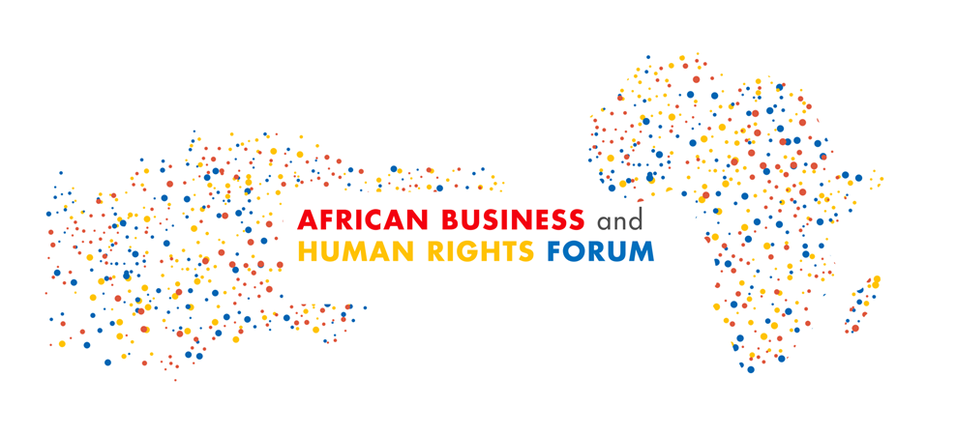

## Concept Note

## **African Business and Human Rights Forum 2023**

## *For Africa, from Africa*

6-7 September 2023, Hybrid: Addis Ababa and Online

1. **Background**

Over the past decade, Africa has consistently grown in Gross Domestic Product, increased employment, and improved infrastructure. Business has played a critical role in these developments, as shown by the yearly increases in investment and trade flows toward the continent. However, Africa faces numerous challenges on the economic, social, governance and environmental fronts, as well as when it comes to the enjoyment of internationally recognised human rights standards. These differ widely across countries, but issues such as adverse environmental impacts and inconsistent implementation of international and African Union (AU) treaties relating to respecting human rights in key economic activities and investments, remain pervasive in several parts of the continent.

Indeed, the United Nations Development Programme (UNDP) [baseline research survey](https://www.undp.org/africa/publications/baseline-assessment-business-and-human-rights-africa-first-decade-next) highlighted several challenges to promoting responsible business conduct in Africa, including weak regulatory, policy and enforcement frameworks in the Member States and ineffective, inaccessible remedies for human rights and environmental harms arising from business activities.

Despite these challenges, significant progress has been made. Following the UN Human Rights Council’s adoption in 2011 of the [UN Guiding Principles on Business and Human Rights](https://www.ohchr.org/sites/default/files/Documents/Publications/GuidingPrinciplesBusinessHR_EN.pdf) (UNGPs), in recent years, African governments, national human rights institutions (NHRIs), civil society actors, and businesses have increased their action to promote responsible business conduct. For example, Kenya became the first country in Africa to develop a national action plan on business and human rights (NAPs) in 2019, followed by Uganda in 2021. Furthermore, several NHRIs have become active in this field. For instance, the Sierra Leone Human Rights Commission has developed Guidelines for Monitoring Business and Human Rights and has conducted public inquiries into business-related abuses. At the same time, Mozambique, Nigeria, Tunisia, Ghana, Liberia and Senegal have made public commitments to develop instruments to prevent, mitigate and remedy business-related abuses. In addition, many countries in the region have made policy commitments or initiated consultations on developing national baseline assessments on business and human rights.

At the regional level, the AU has developed a Policy Framework on Business and Human Rights, which is being discussed for adoption. The AU’s current institutional framework enables it to address business-related human rights abuses through its organs, such as the African Commission on Human and People’s Rights (ACHPR)[1]. For example, the ACHPR's Working Group on Extractive Industries, Environment and Human Rights Violations in Africa monitors adverse human rights impacts in natural resource extraction. In addition, establishing the African Continental Free Trade Area (AfCFTA)[2] in 2020 and its operationalisation in 2021 represents a significant milestone in the African integration and development journey. The AfCFTA stands as a catalyst for new ways of doing business, producing, working, and trading within Africa and the rest of the world, bearing in mind the importance of integrating human rights at all stages.

A notable positive milestone was the African Business and Human Rights Forum, held in Accra, Ghana, from 11th to 13th October 2022. The 2022 Forum was the first continental gathering on Business and Human Rights in almost a decade. The Forum was convened by the AU and co-organized together with UNDP, the Office of the UN High Commissioner for Human Rights (OHCHR), the Working Group on Business and Human Rights (the Working Group) and Deutsche Gesellschaft für Internationale Zusammenarbeiten (GIZ) in close collaboration with local and regional, continental and international actors, such as the African Coalition for Corporate Accountability (ACCA), the Network of African National Human Rights Institutions (NANHRI), the Danish Institute for Human Rights, the Friedrich Ebert Stiftung, the UN Global Compact, the Global Business Initiative, with support from the Governments of Japan, Sweden and Switzerland.

The 2022 Forum brought together over 300 in-person and about 500 online participants from more than 96 countries (over 40 African nations were represented online or in-person), including practitioners, experts and representatives of civil society organisations (CSOs), businesses, academia, indigenous communities, media, trade unions, NHRIs and governments. Civil society representatives accounted for almost 40% of the attendees. The three-day event was an opportunity to exchange and hold dialogues, engage in peer-to-peer learning, network and exchange information and positive practices to position business respect for human rights as a priority in Africa. The African Union and the United Nations committed to taking forward a continental platform of peer learning in the years to come, reaffirming its commitment to establishing an annual African Business and Human Rights Forum.

It is imperative that the positive momentum in Africa, as exemplified by the 2022 African Forum on Business and Human Rights, is capitalised upon with intensified efforts by all stakeholders. Consequently, the African Union, UNDP, OHCHR, the Working Group and the United Nations Children's Fund (UNICEF) and other partners have joined efforts again to convene key stakeholders on business and human rights in Africa in 2023.

1. **Forum Objectives**

The African Business and Human Rights Forum 2023 will be held on 6-7 September 2023, with 5 September 2023 (referred to as "Day 0") dedicated to pre-Forum sessions, including private meetings before the official start day of the regional Forum. The event will bring together stakeholders across Africa to take stock of progress and discuss challenges and opportunities for promoting responsible business and human rights conduct and corporate accountability in the region**.** The Forum will be convened by the AU and co-organised by UNDP, OHCHR, the Working Group and UNICEF, in close collaboration with local and regional, continental and international actors.

The theme of the African Business and Human Rights Forum 2023 is **For Africa, From Africa,** which reflects the importance of local perspectives and solutions in the collective effort to implement the UNGPs in relation to operationalising the AfCFTA. Given that “accelerating the Implementation of the AfCFTA" is the AU theme of 2023, the forum will first focus on the linkages between the implementation of the UNGPs and the operatinalization of the AfCFTA. In addition, the Forum will focus on African experiences and challenges related to business and human rights. It will seek to generate innovative solutions tailored to the continent's unique context. By highlighting African voices and perspectives, the Forum will emphasise the African way of delivering the UNGPs. Unanimously endorsed by the UN Human Rights Council in 2011, the UNGPs are directed at States and companies and clarify their respective duties and responsibilities to protect and respect human rights in the context of business activities and the need to ensure access to an effective remedy for those whose rights have been adversely affected by such activities.

Bringing together all actors with a role and an interest in advancing the business and human rights agenda in Africa, the Forum will be designed to achieve the following outcomes:

* **Sustain the momentum** built on the 2022 African Business and Human Rights Forum, and offer a dynamic regional multi-stakeholder platform for dialogue on business and human rights;
* **Promote policy coherence at the national and regional level,** including the adoption of the AU policy on business and human rights;
* **Assess progress made in implementing the UNGPs** and promote collaboration and networking between and among governments, businesses, investors, CSOs, academia, NHRIs, human rights defenders and other stakeholders;
* **Exchange and learn from positive practices and challenges**, including in the context of the AfCFTA and responsible business, implications of the EU Corporate Sustainability Due Diligence, respecting human rights in the informal economy, resource governance, business and technology, and in the context of the situation of individuals or groups at heightened risk of abuses, including women, Indigenous Peoples, children, youth, persons with disabilities and other vulnerable and marginalised groups.

1. **Format and Content**

The African Business and Human Rights Forum 2023 is intended to have an in-person format to foster active networking and build constructive relationships, as well as an online format to provide opportunities for remote participation for those unable to travel.

The Forum will be held over two days (6-7 September 2023) and consist of plenary, panel discussions, and breakout sessions. The plenary sessions will feature keynote speeches from high-level African leaders and international experts, who will provide an overview of the current state of business and human rights in Africa and offer insights into potential solutions. The panel discussions will bring stakeholders from different sectors to discuss specific business and human rights themes, such as labour rights, environmental protection, just transition in the extractive industries, and community engagement. Finally, the breakout sessions will allow participants to engage in more detailed discussions and brainstorming around specific topics.

The day before the Forum, 5 September 2023, will represent "day 0", aimed at hosting partner-led side events. Regional organisations will be invited to host side events; coalitions of CSOs and NHRIs will be invited to conduct parallel stakeholder-based sessions.

* **Venue:** The Forum will be held in Addis Ababa, Ethiopia.
* **Participants**: The Forum will gather representatives of CSOs, business enterprises and associations, labour organisations, governments, NHRIs and other human rights actors, think tanks, international organisations and institutions active in business and human rights across Africa.
* **Languages:** The Forum communications, and the event, will be conducted in English. French, Arabic and Portuguese simultaneous interpretation will be provided.

1. The African Commission has adopted a resolution on Business and Human Rights in Africa at its 74th Ordinary Session held virtually from 21 February to 07 March 2023 (based on the resolution adopted in April 2022 by the NHRIs’ forum to the 71st Ordinary Session of the African Commission)
2. The African Commission also adopted a resolution on Human Rights-Based Approach to the implementation of the African Continental Free Trade Area at its 74th Ordinary Session held virtually from 21 February to 07 March 2023 (based on the resolution adopted in October 2022 by the NHRIs’ forum to the 73rd Ordinary Session of the African Commission)