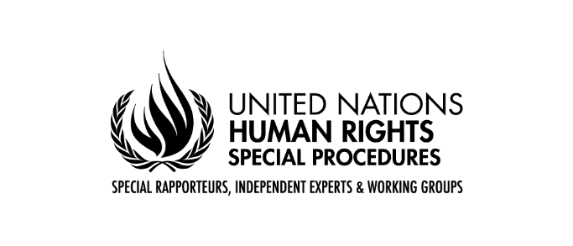
Working Group on Business and Human Rights
Corporate influence in the political and regulatory sphere: Ensuring business practice in line with the Guiding Principles on Business and Human Rights (A/77/201)
EXECUTIVE SUMMARY
Background
As part of its mandate to promote the United Nations Guiding Principles on Business and Human Rights (“the Guiding Principles”), the United Nations Working Group on Business and Human Rights (“the Working Group”) over the course of 2021 and 2022 examined corporate political engagement practices around the world. The aim of this process was to better understand:
- The primary modes by which business entities engage with political processes, both directly and indirectly.
- The different means used by States to regulate business attempts to influence policymaking.
- The characteristics of specific corporate political engagement practices and/or regulatory contexts that are likely to enable business-related human rights abuses, as well as the full scope of human rights harms that may result from various forms of corporate political engagement, when carried out irresponsibly.
- The extent to which business entities understand that their responsibility to carry out human rights due diligence includes close examination of how their political activities may result in human rights risks.
- Best practices for States and business entities to ensure that corporate political engagement practices are consistent with the Guiding Principles and do not facilitate business-related human rights abuses.
To understand these dimensions, the Working Group undertook research, invited interested stakeholders to provide written inputs, and conducted a series of bilateral and multi-stakeholder consultations with States, civil society organizations, business representatives and experts in several regions of the world. The results of this work, with recommendations to States (including as members of multilateral institutions) and business actors, are presented in the report (A/77/201) to the United Nations General Assembly (October 2022).

Highlights
In the report, the Working Group recommends a range of best practices that States—whether acting alone or as members of multilateral institutions—and businesses should implement to ensure that business contacts with political processes do not lead to human rights abuses. As the report makes clear, when businesses participate in, and attempt to influence policymaking, they have a responsibility to conduct this participation transparently, responsibly and in a rights-respecting manner. Likewise, where States permit corporate political engagement, they have an obligation to ensure that engagement is adequately regulated to avoid impairing the State’s ability to safeguard against resulting human rights harms.
Key findings from the report include:
- Business actors engage in political processes through both overt methods (such as direct lobbying contacts) and less overt methods (such as sponsorship of scientific research). In all cases, there is the potential for human rights harms where engagement is conducted irresponsibly and/or regulated inadequately.
- A lack of transparency, oversight and disclosure requirements around corporate political engagement practices is both a widespread problem and a key indicator of dynamics that may carry serious risk of business-related human rights abuses.
- Insufficient transparency often results in misalignment between a business’ public human rights statements, policies, and responsibilities and the goals and/or outcomes of their political engagement.
- Across the world, relatively few business enterprises appear to have acknowledged that their human rights due diligence responsibilities extend to their political activities. Few businesses have taken steps to report publicly on how they have assessed their political activities for human rights risks and what steps they have taken to prevent, mitigate and remediate such risks.
- There are some good practice examples in use by both businesses and States that others should look to in modeling their own corporate political engagement practices and regulations to avoid facilitating human rights harms.
- The Guiding Principles are a key tool for both States and businesses to use in addressing potential adverse human rights impacts linked to corporate political engagement.

Selected recommendations to States (including as members of multilateral institutions)
- Provide guidance to businesses on the connection between corporate political engagement and human rights risks, and the need to account for such impacts in human rights due diligence processes.
- Take steps to enact, and then regulate the implementation of, mandatory human rights due diligence legislation and ensure that all such legislation explicitly applies to all forms of corporate political engagement.
- Require all individuals and entities engaged in lobbying to enrol in mandatory lobbying registers and disclose information regarding lobbying activities, contacts, and expenditures.
- Require timely disclosure by business entities of political expenditures and activities, including spending on lobbying, political contributions, political advertising, and third-party non-profit groups.
- Ensure that large corporate interests and industry associations are not disproportionately represented in lobby meetings with public officials. Commit to balanced consultations with other actors (e.g. civil society organisations, individual citizens, indigenous peoples’ groups).
- Enact independently monitored conflict-of-interest laws and income and asset disclosure systems for government officials and regulators to provide greater transparency in policymaking processes.
- Ensure that multilateral institutions and multistakeholder spaces in which the State is a member take steps to prevent human rights harms resulting from corporate political engagement.

Selected recommendations to businesses
- Refrain from engaging with political processes in support of aims that are not consistent with the business responsibility to respect human rights.
- Implement robust human rights due diligence processes to ensure that all political engagement is aligned with both the business’ public human rights commitments and its responsibility to respect human rights under the Guiding Principles, including by integrating political engagement as a salient category in existing human rights impact assessment processes.
- Publicly communicate about human rights due diligence processes with respect to political engagement activities. Provide a level of information sufficient for outside observers to evaluate the adequacy of the human rights impact assessment process.
- Even where not required to by law, release annual political engagement reports with details of all political activities and political spending, including on political candidates and parties, lobbyists, industry associations, and all other political organisations and actors.
- Require all political engagement to be approved by the business’ board of directors and to be communicated internally and externally, including to third party lobbyists and industry associations, and integrated into any contract with such parties.
- Exercise board-level oversight of how the business manages human rights risks related to political engagement activities.
- Enact written policies to govern the business’ political engagement practices, linked directly to the business’ human rights policy commitments.
Links
Full report:
https://undocs.org/Home/Mobile?FinalSymbol=A%2F77%2F201&Language=E&DeviceType=Desktop&LangRequested=False
Project page:
https://www.ohchr.org/en/documents/thematic-reports/a77201-report-corporate-political-engagement-and-responsible-business

