Check against delivery

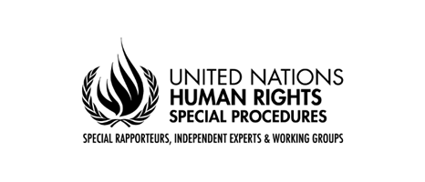

Statement by Mr. Surya Deva
Chairperson, Working Group on the issue of human rights and transnational corporations and other business enterprises

High-Level International Investment Agreements Conference 2021
7th World Investment Forum 2021
19 October 2021

Excellencies, distinguished delegates, ladies and gentlemen,

I am delighted to speak at the High-Level International Investment Agreements Conference 2021 to share some thoughts on how to accelerate the reform of international investment agreements.

My remarks will be based on a recent report (A/76/238) of the UN Working Group on Business and Human Rights on what States need to do to negotiate human rights-compatible international investment agreements in line with the UN Guiding Principles on Business and Human Rights.

Let me start by highlighting why an urgent reform of international investment agreements is required. The current international investment regime reflects three “I”s: imbalance, inconsistency, and irresponsibility. States must take multiple measures to ensure that international investment agreements do not provide a “safe harbour” for irresponsible investor conduct.

First, there should be a reorientation of the purpose of investment. Realizing human rights should be a core purpose of attracting foreign investment. States should adopt a bottom-up and consultative model of investment governance which is geared to achieving sustainable and inclusive development.

Second, States must ensure that international investment agreements do not undermine their duty to regulate investors and their investments to protect all internationally recognized human rights. States may, for example, incorporate explicitly the “clean hands doctrine” in such agreements: investors not conducting meaningful human rights due diligence or involved with human rights abuses could be barred from pursuing any arbitration claims against States to enforce their rights under the agreements.

Third, international investment agreements should include investors’ legally enforceable obligations regarding human rights and the environment. Including such obligations will be in line with the trend of mandatory human rights due diligence laws in Europe.

Fourth, States should create access to remedy pathways for affected communities within international investment agreements. Such agreements may, for example, expressly allow communities affected by investment-related projects to pursue international arbitration claims against investors for human rights abuses or pursue claims before courts of investors’ home countries.

Fifth, as the investor-State dispute settlement process is not fair to all parties, States should replace this with an alternative mechanism which is free from defects of the current system. The new mechanism should be able to handle all investment-related disputes, be staffed with independent adjudicators, be accessible to marginalized or vulnerable communities, deliver consistent decisions, and have an in-built appeal system.

Let me conclude by saying that States must use all bilateral and multilateral openings to accelerate the reform of international investment agreements. They should make best use of opportunities offered by the UNCITRAL’s Working Group III process as well as the Human Rights Council’s process to negotiate an international legally binding instrument.

Thank you very much for your attention.

