Check against delivery
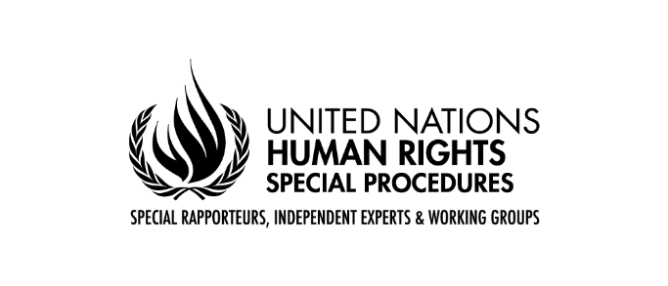

Oral Statement by Mr. Surya Deva
Chairperson, Working Group on the issue of human rights and transnational corporations and other business enterprises
76th session of the United Nations General Assembly
New York, 14 October 2021 (via videoconference)

Mr President, Excellencies, Distinguished delegates, Ladies and Gentlemen,

I am honoured to present the report of the Working Group on Business and Human Rights to the General Assembly. This report focuses on human rights-compatible international investment agreements. It calls for fundamental and transformative reform of the international investment regime as a matter of urgency.

The report unpacks implications of Principle 9 of the UN Guiding Principles on Business and Human Rights for States in negotiating new international investment agreements or reforming old agreements. Principle 9 says that States “should maintain adequate domestic policy space to meet their human rights obligations when pursuing … investment treaties or contracts”. The commentary to Principle 9 further provides that “the terms of international investment agreements may constrain States from fully implementing new human rights legislation, or put them at risk of binding international arbitration if they do so”.

While Principle 9 has direct implications for States, it also has indirect implications for foreign investors availing the protection of such agreements, and communities affected by investment-related projects. Therefore, the report focuses on all three pillars of the Guiding Principles: the State duty to protect human rights, the corporate responsibility to respect human rights, and access to remedy.

Before outlining the recommendations of the Working Group, let me note the three major concerns with the current international investment regime that the report highlights: imbalance, inconsistency, and irresponsibility.

International investment agreements, especially those concluded before 2010, confer legally enforceable rights upon investors, but hardly any obligations regarding human rights and the environment. Despite not being parties to these agreements, investors can rely on them to initiate arbitration proceedings against States for an alleged breach of investment protection standards. However, States or communities affected by investment-related projects do not enjoy such an option.

Inconsistency is also embedded in the architecture of international investment agreements. Investors and proponents of investment agreements justify the need for the investor-State dispute settlement process because they distrust the legal system in host States. At the same time, when affected communities pursue claims against investor companies for human rights abuses, investors plead for cases to be heard by the very legal system that they call unreliable and unsuitable. Inconsistency is also seen in arbitration awards delivered by a dispute-specific group of party-appointed arbitrators who are not bound by any system of precedent.

These imbalances and inconsistencies in international investment agreements contribute to irresponsibility on the part of investors. The asymmetrical protection offered by such agreements, and the lack of transparency in investor-State processes, creates incentives for investors to focus on protecting their investment and pay inadequate attention to their human rights responsibilities under international standards. Investors sometimes invoke protection under international investment agreements to obstruct attempts by affected communities to hold them accountable for human rights abuses.

Efforts are on-going in various settings to reform international investment agreements. The recommendations made by the United Nations Conference on Trade and Development are most notable. States should terminate or urgently reform all existing international investment agreements in line with these recommendations, and those offered in the present report.

The Working Group III of the United Nations Commission on International Trade Law has also been working on reform of the investor-State dispute settlement process. However, it would be a missed opportunity if this multilateral reform process does not address substantive human rights concerns related to international investment agreements.

States could also use their national action plans on business and human rights to commit to reforming international investment agreements. The Human Rights Council’s open-ended intergovernmental working group, which is negotiating an international legally binding instrument as per resolution 26/9, provides another potential avenue to encourage States to negotiate human rights-compatible international investment agreements.

Distinguished delegates

The report outlines five complementary reform pathways.

First, there should be a reorientation of the purpose of investment. Realizing human rights should be a core purpose of attracting foreign investment. Foreign investment should contribute to addressing economic inequality rather than entrenching it further.

However, the current top-down model of investment hardly considers the needs and preferences of marginalised communities such as indigenous peoples, who suffer disproportionately due to foreign investment-related development projects.

A major shift is required. States should ensure that international investment agreements are designed to harness the potential of foreign investment to contribute to achieving the Sustainable Development Goals. One good example that could be replicated elsewhere is article 1 of the Pan-African Investment Code, which describes the objective of the Code being “to promote, facilitate and protect investments that foster the sustainable development of each Member State”.

Second, States must ensure that international investment agreements do not undermine their duty to regulate investors and their investments in such a way that all internationally recognized human rights are adequately protected.

This would require defining narrowly what is protected as “investment” under international investment agreements. The “most-favoured-nation” standard should be articulated precisely, while the “fair and equitable treatment” clause should be replaced with a clearer standard of investor protection. Moreover, States may incorporate explicitly the “clean hands doctrine” in such agreements: investors not conducting meaningful human rights due diligence or involved with human rights abuses could be barred from pursuing any arbitration claims against States to enforce their rights under the agreements.

Third, international investment agreements should include investors’ legally enforceable obligations regarding human rights and the environment. Including such obligations will be in line with the trend of mandatory human rights due diligence laws in Europe.

Fourth, States should create access to remedy pathways for affected communities within international investment agreements. Such agreements may, for example, expressly allow communities affected by investment-related projects to pursue international arbitration claims against investors for human rights abuses. Alternatively, international investment agreements may incorporate a clause allowing affected communities to pursue claims before courts of investors’ home countries.

Fifth, as the investor-State dispute settlement process is not fair to all parties, States should replace this with an alternative mechanism which is free from defects of the current system. The new mechanism should be able to handle all investment-related disputes, be staffed with independent adjudicators, be accessible to marginalized or vulnerable communities, deliver consistent decisions, and have an in-built appeal system

Distinguished delegates,

In closing, let me draw your attention to the 2021 Forum on Business and Human Rights which will take place virtually from 29 November to 1 December. The Forum this year will focus on increasing the pace and scale of action to implement the UN Guiding Principles during the next decade. The Working Group encourages the participation of Governments in the Forum.

I thank you for your attention and look forward to hearing your views.

