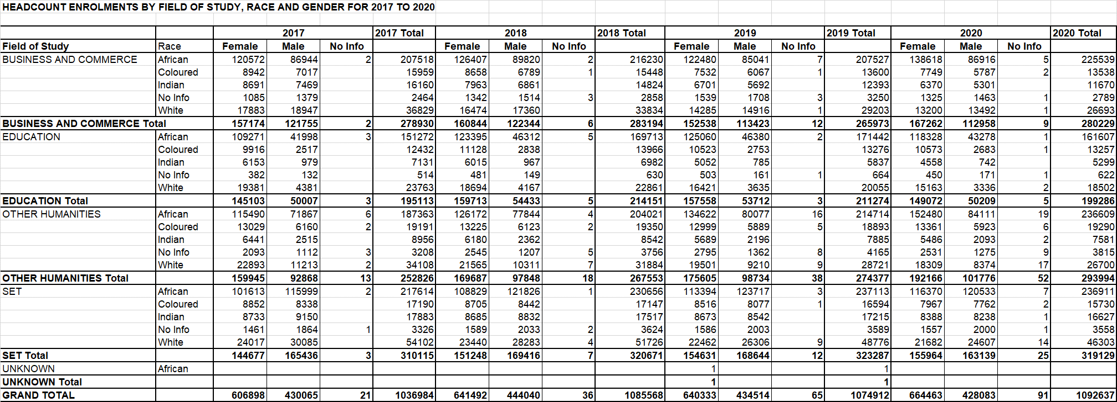
In 2017 there were 1 036 984 headcount enrolments. This number increased to 1 092 637 in 2020, a 5.4% increase. In 2017, of the 1 036 984 enrolments 73.7% were African, 6.2% were Coloured, 4.8% were Indian, 14.3% were White and 0.9% no Information. In 2020 the percentage of African students increased to 78.8%, the percentage of Coloured students, Indian students and White students decreased to 5.7%, 3.8% and 10.8% respectively. In 2017, 58.5% of the enrolments were female and 49.5% were male. In 2020 this increased to 60.8% female and there was a decrease in male enrolments to 39.2%. Of the 2017 Science, Engineering and Technology (SET) enrolments, 70.2% were African, 5.5% were Coloured, 5.8% were Indian, 17.4% were White and 1.1% no Information. In 2020 the percentage of African students in SET increased to 74.2%, while the percentage of Coloured, Indian and White student enrolments in SET decreased to 4.9%, 5.2% and 14.5% respectively. In 2017 of the SET enrolments 46.7% were female and 53.3%. By 2020 this had changed to 48.9% female and 51.1% male.
.

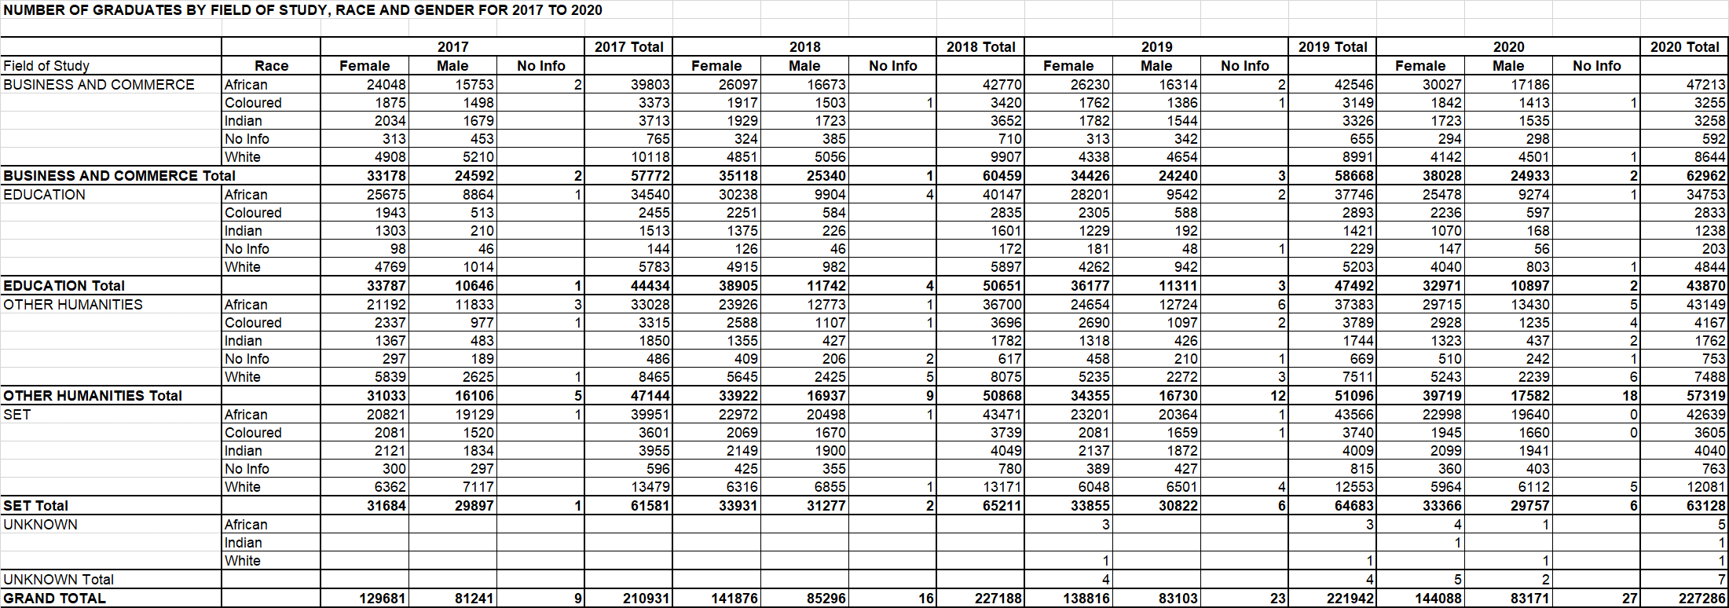
In 2017 there were 210 931 graduates. This number increased to 227 286, a 7.8% increase. In 2017, of the 210 931 graduates 69.8% were African, 6.0% were Coloured, 5.2% were Indian, 17.9% were White and 0.9% no Information. In 2020 the percentage of African and Coloured graduates increased to 73.8% and 6.1% respectively, while the percentage of Indian and White graduates decreased to 4.5% and 14.5% respectively. In 2017, 61.5% of the graduates were female and 38.5% were male. In 2020 this increased to 63.4% female and there was a decrease in male graduates to 36.6%. Of the 2017 Science, Engineering and Technology (SET) graduates, 64.9% were African, 5.8% were Coloured, 6.4% were Indian, 21.9% were White and 1.0% no Information. In 2020 the percentage of African graduates in SET increased to 67.5%, while the percentage of Coloured and White graduates decreased to 6.4% and 19.1% respectively, while the percentage of Indian graduates remained unchanged at 6.4 %. In 2017 of the SET graduates 51.1% were female and 48.5% were male. By 2020 this had changed to 52.9% female and 47.1% male. It is significant to note that although the percentage of female enrolments in SET is lower than that of male students, the percentage of in graduates in SET is higher for females than males.

