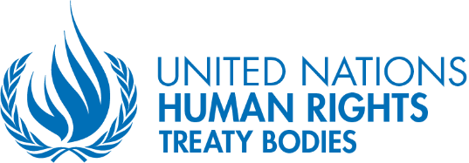
Human Rights Day
10 December 2022

UN committee Chairpersons call for collective efforts and institutional support

Geneva (9 December 2022) – To safeguard fundamental human rights and freedom for all in these challenging times, the Chairpersons of the UN Human Rights Treaty Bodies called on States to provide institutional support, including adequate and sustainable resources. On the eve of this year’s Human Rights Day, the Chairpersons issued the following statement to reaffirm their continuing and unwavering commitment to the effective protection and full realisation of all human rights.

“Seventy-four years ago, the United Nations General Assembly adopted the Universal Declaration of Human Rights, providing a general framework for a common understanding of the rights to which all people are entitled and thus paving the way for fundamental human rights treaties.

The road travelled since then has been complex. In spite of the progress achieved, concerns of the years following the founding of the United Nations have greatly expanded. Challenges such as poverty, climate change, pandemics, armed conflicts, discrimination and inequality in all spheres have continued to persist, threatening the enjoyment of human rights.

In the face of those growing challenges, the rights enshrined in the Universal Declaration have been consolidated through the adoption of ten core human rights treaties that both recognised the evolving human rights and created the Human Rights Treaty Bodies to monitor compliance with such instruments. As a result, international human rights law is more important than ever.

Today, the Chairpersons of the Human Rights Treaty Bodies, upholding the Universal Declaration on Human Rights, reaffirm their continued commitment to strengthening their monitoring role in accordance with their respective human rights instruments and United Nations General Assembly Resolution 68/268.

At our last meeting in June of this year, we, the Treaty Body Chairpersons, agreed to maximise the impact of our work and substantially improve its effectiveness through establishing a predictable calendar of State reports review every eight years with a mid-term follow-up review. This is also to harmonize our working methods, provide reasonable accommodation for committee experts with disabilities, and enhance digital uplift.

We are convinced that all this will prompt more effectiveness in the role of the Treaty Body System. For our effort to be completed, we need the participation of civil society, national human rights institutions, and all the stakeholders involved in human rights protection. We call upon States to join this collective effort with their institutional support, including sufficient and sustainable resources.

On commemorating the adoption of the Universal Declaration of Human Rights, we reiterate our continuing and unwavering commitment to the effective protection and full realisation of all human rights.”

Committee against Torture
Committee on Economic, Social and Cultural Rights
Committee on Enforced Disappearances
Committee on Migrant Workers and Members of Their Families
Committee on the Elimination of Discrimination against Women
Committee on the Elimination of Racial Discrimination
Committee on the Rights of Persons with Disabilities
Committee on the Rights of the Child
Human Rights Committee
Subcommittee on Prevention of Torture

END

