Bilateral Meeting between the Interamerican Court of Human Rights and the Chairs of the United Nations Human Rights Treaty Bodies

San José, Costa Rica; Geneva, Switzerland, February 24th, 2023.- Today the Inter-American Court of Human Rights and the Chairs of the United Nations Human Rights Treaty Bodies held a bilateral meeting to strengthen their cooperation and share experiences in defending human rights.

The meeting aimed to create a permanent space for sharing experiences and, at the same time, to open channels of cooperation that will allow each system to learn from the other, but also for both systems to build, when possible, common solutions.

The President of the Inter-American Court, Judge Ricardo C. Pérez Manrique, considers that: ‘‘The dialogue between human rights protection bodies is essential. Even though we have diverse mandates our common end is to protect human rights of the persons regardless of where they are located. This meeting marked the beginning of a permanent dialogue and collaboration between our two systems promoting a robust protection of human rights for all’’.

For the chair of the ten Human Rights Treaty Bodies, Mr. Edgar Corzo Sosa: “A rapprochement between the two systems is something natural and worth pursuing, since they shared similar work but also face common challenges and problems. This is a great opportunity to lay the foundations for a dialogue that we hope will be permanent between both human rights protection systems, always seeking to strengthen the defense of human rights so that no one is left behind”.

The meeting resulted in several short- and long-term initiatives including an annual virtual meeting, bilateral meetings between the Treaty Bodies and the Inter-American Court, and case law and technical meetings between the staff.

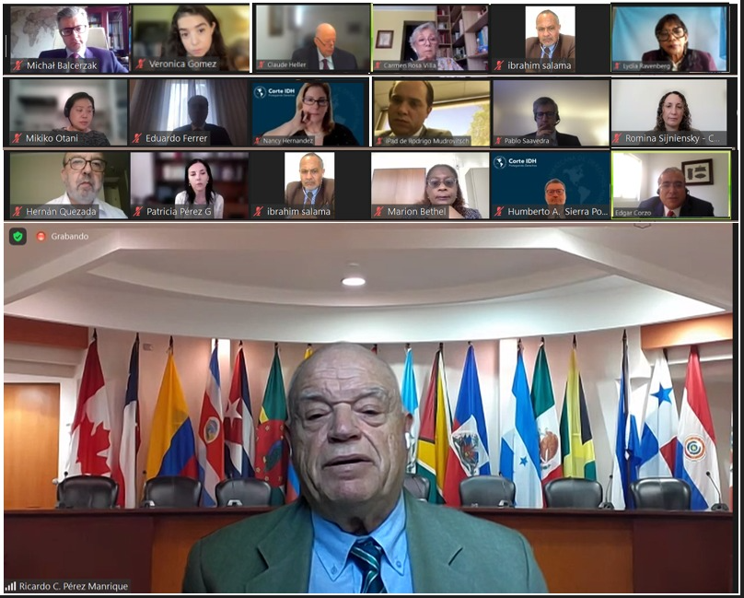

PARTICIPANTS

Judges that participated in the meeting representing the Interamerican Court of Human Rights

Mr. Ricardo C. Pérez Manrique – President, Judge, Interamerican Court of Human Rights
Mr. Eduardo Ferrer Mac-Gregor Poisot, Judge, Vice-President, Interamerican Court of Human Rights
Mr. Humberto Antonio Sierra Porto, Judge, Interamerican Court of Human Rights
Ms. Nancy Hernández López, Judge, Interamerican Court of Human Rights
Ms. Verónica Gómez, Judge, Interamerican Court of Human Rights
Ms. Patricia Pérez Goldberg, Judge, Interamerican Court of Human Rights
Mr. Rodrigo Mudrovitsch, Judge, Interamerican Court of Human Rights

Chairs and Committee Members that participated in the meeting representing the Human Rights Treaty Bodies

Mr. Michal Balcerzak, Vice-Chair, Committee on the Elimination of Racial Discrimination
Ms. Marion Bethel, Vice-Chair and Rapporteur, Committee on the Elimination of Discrimination Against Women
Mr. Edgar Corzo Sosa, Chairperson, Committee on Migrant Workers
Mr. Claude Heller, Chairperson, Committee against Torture
Ms. Rosemary Kayess, Chairperson, Committee on the Rights of Persons with Disabilities
Ms. Mikiko Otani, Chairperson, Committee on the Rights of the Child
Mr. Hernán Quezada, Focal Point for the Inter-American Human Rights System, Human Rights Committee
Ms Lydia Ravenberg, Vice-Chair, Committee on Economic, Social and Cultural Rights,
Ms. Carmen Rosa Villa, Chairperson, Committee on Enforced Disappearances

