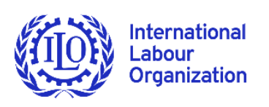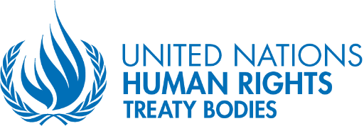

Third anniversary of the UN Secretary General’s Call to Action for Human Rights
24 February 2023

Universal human rights including international labour standards essential to sustainable development and crisis control: UN experts

GENEVA (24 February 2023) – “Universal human rights and international labour standards are fundamental to sustainable development and serve as a guardrail against various crises,” the UN Human Rights Treaty Bodies Chairpersons and the ILO Committee of Experts on the Application of Conventions and Recommendations said today. The experts issued a joint statement to mark the third anniversary of the UN Secretary General’s Call to Action for Human Rights.

Following a fruitful dialogue on their complementary role as custodians of human rights, including international labour standards, the two groups of experts stated:

• Inspired by the UN Secretary-General’s Call to Action for Human Rights and the imperative to place human rights, including international labour standards, at the centre of the implementation of the 2030 Agenda and UN action at the country, regional and Headquarters levels;

• Welcoming the UN Secretary-General’s call for a renewed social contract in “Our Common Agenda” and the ILO Director-General’s call for a Global Coalition for Social Justice aimed at a shared and comprehensive vision, based on trust, towards social justice and sustainable development among Governments and their people including employers’ and workers’ organisations as social partners;

• Motivated by a desire to renew synergies in support of a UN Development System committed to respecting human rights of which international labour standards are an integral part;

• Reaffirming the common values of universal peace, freedom, equal rights, human dignity, social justice and the rule of law lying at the core of their respective mandates, which are complementary and mutually reinforcing;

• Observing that protracted and interlocking crises generated by unprecedented challenges linked to the COVID-19 pandemic, economic globalisation, violence and insecurity, including gender-based violence and harassment, climate change, technological transformation, long-term demographic shifts and geostrategic tensions, jeopardise the realisation of the 2030 Agenda for Sustainable Development and the Sustainable Development Goals (SDGs) by accentuating inequalities within and among countries, undermining the exercise of fundamental rights and further shrinking civic space;

• Underscoring that human rights and international labour standards provide the guardrails to navigate these crises;

• Recognising that labour rights are human rights and that integrating human rights and international labour standards into economic and legal policy frameworks is critical to reducing inequalities and creating an environment conducive to more equitable and inclusive economic development to uphold the 2030 Agenda’s pledge to leave no one behind;

• Recognising the potential of repositioning the UN Development System to strengthen the promotion and protection of UN human rights norms and standards, and its commitment to support States to realise the 2030 Agenda and achieve a transformative, inclusive and sustainable future for everyone, everywhere;

• Taking note of the findings and recommendations of a recent UN inter-agency analysis of the integration of human rights, leave no one behind (LNOB), and gender equality and women’s empowerment (GEWE) in new generation Common Country Analyses (CCAs) and UN Sustainable Development Cooperation Frameworks (UNSDCFs);

• Emphasising the importance of defending the effectiveness of the international human rights monitoring and international labour standards supervisory bodies, inter alia, by putting the human rights mechanisms on a more sustainable financial footing in line with the Secretary-General’s Call to Action for Human Rights and Our Common Agenda;

• Underscoring the joint contribution of the UN human rights mechanisms, including the UN human rights treaty bodies and the ILO supervisory bodies, in reinforcing human rights and international labour standards, at the country level through their analyses and recommendations as well as addressing socio-economic development challenges with human rights-based solutions, placing people and planet at the centre of the realisation of the 2030 Agenda;

The Chairpersons of the UN Treaty Bodies and the ILO Committee of Experts further:

• Re-affirm the responsibility of the UN human rights treaty bodies and the ILO Committee of Experts to promote within their respective mandates the effective fulfilment of human rights, including labour rights, especially for those at risk of being left behind, and to continue ensuring the full realisation of civil, political, economic, social, and cultural rights to all without discrimination.

• Call upon all stakeholders without exception to maximise efforts for the effective implementation of the recommendations from the Human Rights Treaty Bodies and the ILO Committee of Experts.

• Join efforts to fully respect, defend, fulfil and promote all human rights, including international labour standards, through joint analyses, concerted action, and thematic periodic meetings to effectively address the challenges referred to in the present statement.

Committee of Experts on the Application of Conventions and Recommendations

Committee on the Elimination of Racial Discrimination
Committee on Economic, Social and Cultural Rights

Committee on the Elimination of Discrimination against Women
Committee on the Rights of the Child
Committee on Migrant Workers and Members of Their Families
Subcommittee on Prevention of Torture
Chairperson of the Committee on the Rights of Persons with Disabilities
Committee on Enforced Disappearances

ENDS

