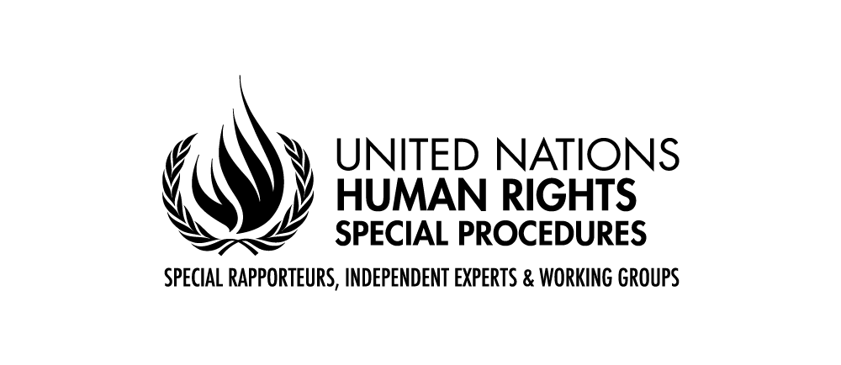

**Statement by Tlaleng Mofokeng**

**Special Rapporteur on the right of everyone to the enjoyment of the highest attainable standard of physical and mental health, on behalf of:**

* **her mandate;**
* **the Special Rapporteur on the human right to a clean, healthy and sustainable environment;**
* **the Special Rapporteur on the promotion and protection of human rights in the context of climate change and;**
* **the Special Rapporteur on the right to food**
* **Coordination Committee of Special Procedures**

High-level informal Presidential discussion on the link between climate change, food security and health security, and their impact on the enjoyment of human rights

20 June 2024

Geneva

Ms. President,

Distinguished Delegates,

It is a great honour for me to participate in this important discussion on behalf of my colleagues the Special Rapporteur on the right to food, the Special Rapporteur on the promotion and protection of human rights in the context of climate change, the Special Rapporteur on the human right to a healthy, clean and sustainable environment and the Coordination Committee of Special Procedures. Last year, we observed the 75th anniversary of the Universal Declaration of Human Rights. It is important to underscore the **universality of human rights**, their prevention, solution-orientated and foundational nature to advance peace, security, humanitarian, and sustainable development agenda and that no one should be left behind.

Today’s discussion is also extremely linked with the global commitments made by States under the 2030 Agenda for Sustainable Development. The right to health which is the mandate the Human Rights Council entrusted me, also included in Goal 3 on good health and well-being, should be analyzed from a broader perspective than the right to receive timely and appropriate healthcare, as it encompasses the right to underlying determinants of health, such as food and nutrition, access to safe and potable water and sanitation as well as a healthy environment, among others.[1]

Mr. President,

For the first time in its history, the United Nations has recognized that everyone, everywhere, has the right to live in a clean, healthy and sustainable environment. Resolutions from the Human Rights Council in 2021[2] and the General Assembly in 2022[3] add this fundamental human right to the library of internationally recognized rights. As humanity confronts unprecedented multiple planetary crises, it is our genuine hope that the right to a clean, healthy and sustainable environment will serve as a catalyst for systemic and transformative changes to produce a just, inclusive and sustainable future in harmony with nature.

While Goal 2 of the Sustainable Development Goals aims to end hunger and malnutrition and promote sustainable food systems, yet, Goal 3, focusing on good health and wellbeing is also affected by food insecurity and the lack of regular access to adequate, safe and nutritious food for normal growth, and development, thereby affecting also the health and well-being of more than 2.4 billion people, 800 million of whom experience hunger.

Climate disasters are destroying homes, land, ecosystems, coral reefs, livestock, crops and other food supplies, causing food prices to skyrocket as supplies dwindle and forcing people to migrate.[4] Climate change is projected to increase the risk of foodborne, airborne and waterborne diseases and increasing food insecurity and competition for natural resources drives instability and conflict.[5] I am further concerned that parties to conflict continue to use food as a weapon of war by controlling food production and distribution and exploiting hunger and poverty.

Mr. President,

There is a need to reduce food waste and high-emissions diets as a contribution to climate change mitigation and advance adaptation.[6] Food systems have a crucial role to play in climate change mitigation, notably a transition to agro-ecology and other sustainable agriculture practices that reduce greenhouse gas emissions, avoid hazardous chemicals, prevent further destroying of ecosystems and biodiversity loss, and sequester carbon in the soil.[7] States must take immediate action to transform industrial agriculture and fisheries to protect the right to a healthy environment, in particular for children[8] and future generations. On the other hand, utmost caution must be applied vis-a-vis other climate change mitigation measures that can disrupt agricultural practices, and can have disproportionate impacts on human rights holders.[9]

Food systems are also crucial for climate change adaptation.[10] Together with the importance of protecting food-related rights and knowledge, which includes the knowledge of Indigenous Peoples, peasants, local communities and other people living in rural areas, including the distinctive knowledge of women; and promoting policies supporting economic diversification of agriculture and food production, which can increase climate resilience.[11] Also, a greater attention to enhancing sustainable livelihoods and resilience for women working in agriculture and fishing to respond to climate impacts is needed.[12] It is therefore more important than ever to fully realize the rights of peasants, food and agricultural workers and other rural workers, women, and Indigenous Peoples. They are the people who constitute our sustainable food systems and only by respecting, protecting and fulfilling their rights can we have a resilient food system.

In this regard, greater attention is also needed towards restoring and protecting human connections with nature as part of climate change mitigation and adaptation, to facilitate individual and community healing and encouraging inter-generational alliances.[13] It is also of vital importance to advance reparations and restoration of lands, ecosystems and food systems.

Climate change negatively impacts health security. Before concluding I wish to refer to the last pandemic that had affected us – the COVID-19 pandemic, resulting in at least six million deaths officially registered globally, deepened economic and social inequalities, and exposed structural discrimination within societies.[14] In this regard, I would like to reiterate that Special Procedures mandate holders have systematically called on States to adopt a human-rights based approach in international agreements on pandemic prevention, preparedness and response.

Mr. President,

A safe climate and healthy and sustainable food are essential elements of the right to a clean, healthy and sustainable environment. Today, we are currently facing the triple planetary crisis, with climate change, biodiversity loss and pollution that is impacting and aggravating food and health security.

To prevent the deterioration of this triple planetary crises, it is important to count on a strong language on human rights in the Summit of the Future outcomes, that enshrine the rights to a clean, healthy and sustainable environment, health and food, including for future generations. It is also important that, the World Health Assembly, which has been working towards an historic achievement – the conclusion of the first multilateral, binding instrument seeking to comprehensively address pandemic prevention, preparation and response – adopts a human rights-based approach in the final document.

Special Procedures are looking forward to continuing cooperating with the Council and States on these important aspects, to ensure that billions of people throughout the world realize the full enjoyment of human rights in a time where climate change, food insecurity and health insecurity are putting these rights at serious risk.

Thank you.

*****

1. [E/C.12/2000/4](https://documents.un.org/symbol-explorer?s=E/C.12/2000/4&i=E/C.12/2000/4_5048954), para. 4.
2. [A/HRC/RES/48/13](https://eur02.safelinks.protection.outlook.com/?url=https%3A%2F%2Fundocs.org%2FA%2FHRC%2FRES%2F48%2F13&data=05%7C02%7Ckarin.hechenleitner%40un.org%7C9a4482bccdec4afbd48508dc8f9e2de6%7C0f9e35db544f4f60bdcc5ea416e6dc70%7C0%7C0%7C638543156730710359%7CUnknown%7CTWFpbGZsb3d8eyJWIjoiMC4wLjAwMDAiLCJQIjoiV2luMzIiLCJBTiI6Ik1haWwiLCJXVCI6Mn0%3D%7C0%7C%7C%7C&sdata=8%2BrwtSvT%2Ft1rgqruhQmkKO%2Fy6%2B9b9zxxRl9sD6h6Jpo%3D&reserved=0).
3. [A/RES/76/300](https://eur02.safelinks.protection.outlook.com/?url=https%3A%2F%2Fundocs.org%2FA%2FRES%2F76%2F300&data=05%7C02%7Ckarin.hechenleitner%40un.org%7C9a4482bccdec4afbd48508dc8f9e2de6%7C0f9e35db544f4f60bdcc5ea416e6dc70%7C0%7C0%7C638543156730723432%7CUnknown%7CTWFpbGZsb3d8eyJWIjoiMC4wLjAwMDAiLCJQIjoiV2luMzIiLCJBTiI6Ik1haWwiLCJXVCI6Mn0%3D%7C0%7C%7C%7C&sdata=m%2BC3fWTc42dTPW1FhI50s1lRISaHWmL0hayQokAg1Pc%3D&reserved=0).
4. [A/78/185](https://www.ohchr.org/en/documents/thematic-reports/a78185-food-nutrition-and-right-health-report-special-rapporteur-right).
5. *Ibid*.
6. *Ibid*. and [A/HRC/55/37](https://undocs.org/Home/Mobile?FinalSymbol=A%2FHRC%2F55%2F37&Language=E&DeviceType=Desktop&LangRequested=False).
7. [A/HRC/54/25](https://undocs.org/Home/Mobile?FinalSymbol=A%2FHRC%2F54%2F25&Language=E&DeviceType=Desktop&LangRequested=False).
8. See also: [CRC/C/GC/26](https://tbinternet.ohchr.org/_layouts/15/treatybodyexternal/Download.aspx?symbolno=CRC%2FC%2FGC%2F26&Lang=en).
9. [A/HRC/47/46](https://undocs.org/Home/Mobile?FinalSymbol=A%2FHRC%2F47%2F46&Language=E&DeviceType=Desktop&LangRequested=False).
10. [A/74/161](https://undocs.org/Home/Mobile?FinalSymbol=A%2F74%2F161&Language=E&DeviceType=Desktop&LangRequested=False).
11. [A/HRC/55/37](https://undocs.org/Home/Mobile?FinalSymbol=A%2FHRC%2F55%2F37&Language=E&DeviceType=Desktop&LangRequested=False).
12. [A/77/136](https://undocs.org/Home/Mobile?FinalSymbol=A%2F77%2F136&Language=E&DeviceType=Desktop&LangRequested=False).
13. [A/HRC/44/48](https://undocs.org/Home/Mobile?FinalSymbol=A%2FHRC%2F44%2F48&Language=E&DeviceType=Desktop&LangRequested=False).
14. <https://www.ohchr.org/en/statements/2022/05/negotiations-international-instrument-pandemic-preparedness-must-be-guided-human>