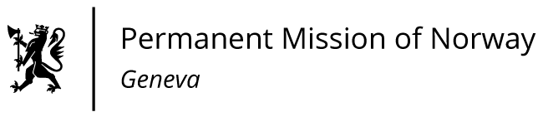

STATEMENT

5th Intersessional meeting of the UN HRC on Human Rights and the 2030 Agenda for Sustainable Development.

Statement delivered by Ms Sigrun Stigen HOLTER

First Secretary, Human Rights.

Check against delivery

19 January 2023
Norway thanks the panelists for their important contributions to this topic.

“Leaving no one behind” is the central promise of the 2030 Agenda. This commitment of all UN member states, to eradicate poverty, end discrimination and reduce inequalities is at the heart of SDG implementation. It also applies to responses in times of crises.

The impacts of crises are not felt evenly. And the way states address crises, determines the possibilities of reducing inequalities.

Inclusive development, social justice and low levels of inequalities, accelerate progress towards all SDGs. Not only for vulnerable groups, but for everyone.

Inclusive societies deepen trust – and trust is essential for building and preserving sustainable societies and for conflict prevention.

To recover from crises and make us resilient, we need to place human rights at the core of our action.

Polices grounded on human rights, will help develop stronger economies. A human rights enhancing economy, is the road towards more inclusive and participatory societies: delivering access to health care, social protection, quality education, clean water, housing and other fundamental rights.

We are looking forward to hearing from the panelists on these important issues /on the connection between sustainable societies and conflict prevention.

(eventuelt et konkret spørsmål til panelet)

