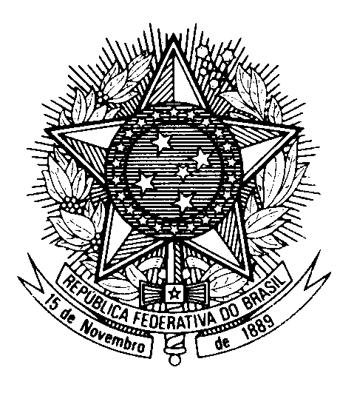

Statement by Ambassador Tovar da Silva Nunes during the fifth intersessional meeting for dialogue and cooperation on human rights and the 2030 Agenda for Sustainable Development

19 January 2022

Thank you Mister Chair,
Brazil is convinced that there is no other way to overcome the current multiple global crises but through the strengthening of our commitment to the SDGs, the 2030 Agenda and the promotion and protection of human rights. The very concept of sustainable development is intrinsically intertwined to the fulfillment of human rights at all levels.
In his inauguration speech, our minister of foreign affairs highlighted Brazil's full commitment to sustainable development as well as social justice, advanced through our best traditions of dialogue and respect.
Our new Administration devotes special attention to human rights and sustainable development not only in speech but also in structure. Besides revitalizing the Ministry for Human Rights and Citizenship and the Ministry of Environment and Climate Change, the new Administration has reestablished the Ministry of Culture, the Ministry of Labour, the Ministry of Social Development, and created, for the first time, the Ministry for Racial Equality, the Ministry of Women, and a specific Ministry of Indigenous Peoples headed by a woman indigenous leader.
To fulfill our shared commitment to leave no one behind, human rights must be at the center of the implementation of the 2030 Agenda and inform decisions across the board, from budget to health, from education to social security, and so on. Let us take this opportunity to renew our spirit of cooperation and solidarity to implement the 2030 Agenda and together overcome the multiple crises we are currently faced with.

