**36th special session on the human rights impact of the ongoing conflict in the Sudan – Information note for NGOs**

***(Latest update: 08 May 2023 – Subject to change)***

Contents

Introduction 1

Relocation of Pass & ID badging services (closing of Pregny Gate) 1

1) Dates and important information 3

2) Accreditation to the special session 3

3) Oral statements and list~~s~~ of speakers 3

Recommended technical specifications for video messages 4

4) Online co-sponsoring of NGO statements 5

5) Confirmation of speaking slots 6

6) Reprisals 7

**ANNEX I – CHECKLIST FOR NGO ORAL STATEMENT** 8

# Introduction

The purpose of this document is to provide information to civil society representatives participating in the forthcoming **36th special session on the human rights impact of the ongoing conflict in the Sudan,** scheduled for **Thursday, 11 May 2023 at 10:00 a.m. (Geneva time)**, in Room XX.

**IMPORTANT: This document is subject to change.** For updated information, consult the website: <https://hrcmeetings.ohchr.org/HRCSessions/SpecialSessions/36/Pages/default.aspx>

# Relocation of Pass & ID badging services (closing of Pregny Gate)

On 31 August, UNOG shared a Broadcast informing about the final phase of the renovation of the Pregny Gate. To enable these extensive works, **the building** **will be closed to pedestrians until the end of May 2023**. Pedestrian exit via the turnstiles will remain operational.

During the entire renovation period, there will be a different location to obtain access badges to the Palais des Nations. For conference participants, media, NGOs and members of Permanent Missions, the new location is as follows:

***Villa Les Feuillantines***

***Avenue de la Paix 13, 1211 Genève 10***

***Weekdays from 8 a.m. to 4.45 p.m.***

Following issuance of a badge, access to the Palais des Nations will be through the Peace Gate “bis”, a new temporary access screening point. **Please refer to the following plans indicating** [**the location of Villa Les Feuillantines**](https://eur02.safelinks.protection.outlook.com/?url=https%3A%2F%2Fcontactmonkey.com%2Fapi%2Fv1%2Ftracker%3Fcm_session%3D12201367-a209-45cf-a134-dc7a49743bfa%26cs%3Dd40cf76e-b7b9-4d3a-b6b7-bcec0a3a0547%26cm_type%3Dlink%26cm_link%3Db173cc63-dfe7-48ab-baf7-2e05ca4536d3%26cm_destination%3Dhttps%3A%2F%2Fcm-email-assets.s3.amazonaws.com%2Fimages%2FContactMonkey-Team-KePFHdcDMO9T3wIryM9FYueMb0wfCX9FkiU9dkdY29ASmeHGN4OyoOMGZrWKsIt9Fz6zOsUir7ToL5AGxeLwlEqKh086Ag9S05vOuZYpehZm1TOPwmIQtOTb4vK8Ho3p%2FBroadcast%252029%2520August%2F1.jpg&data=05%7C01%7Cantonio.nicolini%40un.org%7C8dd85acedf3f49e8be9e08da89b6402b%7C0f9e35db544f4f60bdcc5ea416e6dc70%7C0%7C0%7C637973713360612377%7CUnknown%7CTWFpbGZsb3d8eyJWIjoiMC4wLjAwMDAiLCJQIjoiV2luMzIiLCJBTiI6Ik1haWwiLCJXVCI6Mn0%3D%7C3000%7C%7C%7C&sdata=ZGsgvz8eNKnJWTFGfESGH2XuSVPtCtulae86t%2FW0XTU%3D&reserved=0) **and** [**how to access the premises through the Peace Gate "bis"**](https://eur02.safelinks.protection.outlook.com/?url=https%3A%2F%2Fcontactmonkey.com%2Fapi%2Fv1%2Ftracker%3Fcm_session%3D12201367-a209-45cf-a134-dc7a49743bfa%26cs%3Dd40cf76e-b7b9-4d3a-b6b7-bcec0a3a0547%26cm_type%3Dlink%26cm_link%3D4f60046b-a532-4ae9-a0ca-14d6cbf73a49%26cm_destination%3Dhttps%3A%2F%2Fcm-email-assets.s3.amazonaws.com%2Fimages%2FContactMonkey-Team-KePFHdcDMO9T3wIryM9FYueMb0wfCX9FkiU9dkdY29ASmeHGN4OyoOMGZrWKsIt9Fz6zOsUir7ToL5AGxeLwlEqKh086Ag9S05vOuZYpehZm1TOPwmIQtOTb4vK8Ho3p%2FBroadcast%252029%2520August%2FPlan%252002.jpg&data=05%7C01%7Cantonio.nicolini%40un.org%7C8dd85acedf3f49e8be9e08da89b6402b%7C0f9e35db544f4f60bdcc5ea416e6dc70%7C0%7C0%7C637973713360612377%7CUnknown%7CTWFpbGZsb3d8eyJWIjoiMC4wLjAwMDAiLCJQIjoiV2luMzIiLCJBTiI6Ik1haWwiLCJXVCI6Mn0%3D%7C3000%7C%7C%7C&sdata=xES6ak79871%2B5VyCNckfpubZGuGxzhb8ue%2BpWmj6wfY%3D&reserved=0).

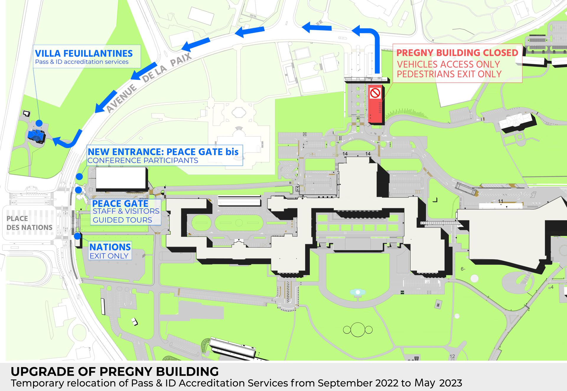

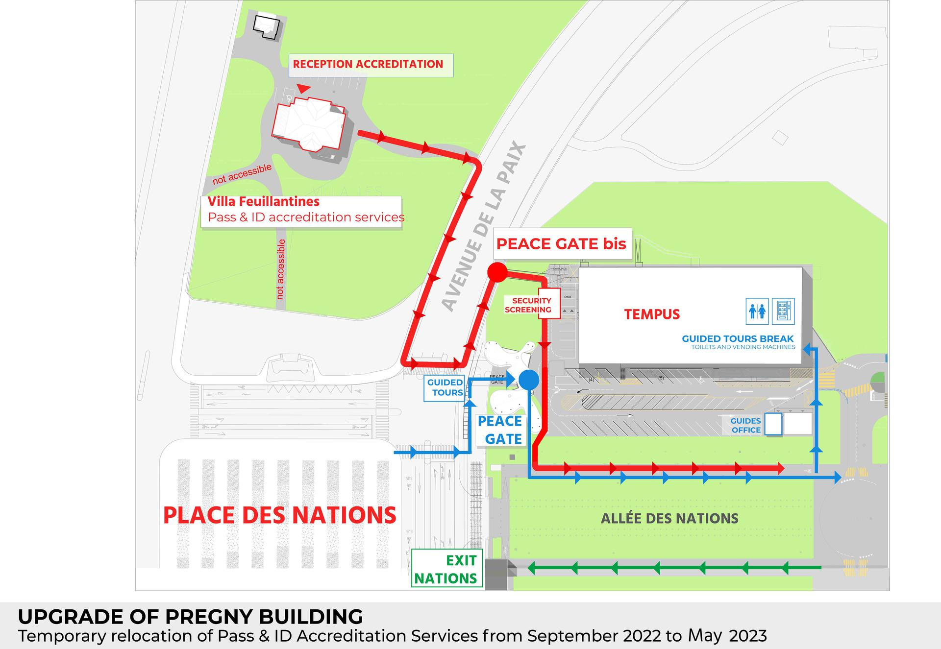

# Dates and important information

**The 36th special session on the human rights impact of the ongoing conflict in the Sudan is scheduled to take place on Thursday, 11 May 2023 at 10:00 a.m. (Geneva time)**.

**IMPORTANT:** In accordance with Bureau minutes of 8 May 2023, NGOs in consultative status with ECOSOC and NHRIs with “A” status would have the possibility to deliver their statements in person or via pre-recorded video statements. In order to balance the importance of inclusivity and what is feasible in terms of time and resources, the list of speakers for NGOs will be set to **29 speakers**, in line with the average number of NGOs that had registered for the past three special sessions.

Consequently, NGOs in consultative status with the ECOSOC and active Designations with UNOG for 2023 wishing to participate in the session are invited to register and to indicate their method of participation (in-person or via video statement) through **the online registration system** [**https://ngoreg.ohchr.org**](https://ngoreg.ohchr.org) **and fulfil all the relevant requirements** *(see Annex I for a complete checklist for oral statements).* All video messages should be uploaded via the same system. The method of participation can be amended at a later stage.

# Accreditation to the special session

All NGO representatives will have to be duly registered and approved through INDICO, here: <https://indico.un.org/event/1005499/>

When submitting an accreditation request, NGO representatives are invited to indicate if they already possess an annual badge or a valid temporary ground pass at UNOG. If so, by uploading a picture of it in the relevant field in INDICO platform, this will be accepted in lieu of the accreditation letter, which remains mandatory for all temporary accreditations. It is mandatory, for all participants, to provide a valid phone number, possibly mobile phone, for contact tracing purposes.

# Oral statements and list~~s~~ of speakers

The online registration system for the special session can be found on the usual website: <https://ngoreg.ohchr.org>. **The system opens on Tuesday, 9 May 2023 at 2 p.m. (Geneva time).**

**NGOs will be able to choose their preferred method of participation, either in-person or by a video message**. After signing up to the session, **NGOs can upload the video-message at a later stage**. It is not necessary to upload it at the moment of registration. **The deadline to upload the video-message is at 6 p.m. on the day prior to the session.** Video-messages received past this deadline will not be processed.

NGOs will also have to enter the name of the speaker and upload the following files:

1. The transcript of the statement in accessible format (Word or Accessible PDF);
2. A scanned copy of the passport of the speaker;
3. The letter requesting the accreditation of the speaker;
4. The video file.

**The full official name of the NGO should be displayed within the video**. Please note that the name displayed should be the one of the NGO delivering the statement only (no co-sponsors or non-ECOSOC NGOs), and it should be in accordance with that registered in the database of NGOs in consultative status with ECOSOC.

As decided by the Bureau of the Human Rights Council, with the exception of an official representative of a UN Member State speaking in front of the national flag and/or the official picture of the Head of State, **the background of video-messages should be neutral without any other flag, banner, flyer, picture or symbol.**

As mentioned above, the video and the accompanying files can be uploaded at a later stage. Please note that the video file has to **adhere strictly** to the speaking time limits of **1 minute and 30 seconds**.

**Captioning of the video is strongly encouraged** in order to ensure accessibility of persons with disabilities. In order to facilitate this procedure, NGOs are able to upload a specific file for subtitles directly in the online registration system. This is not a mandatory field, and it can be left blank:

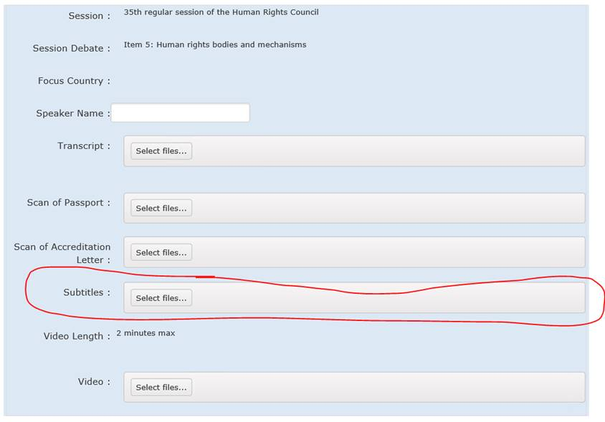

**REMINDER**: **The accreditation through INDICO is mandatory for all NGO representatives delivering a statement, including those participating by video statements. Failure to comply will result in the exclusion of the NGO from the list of speakers.**

*By submitting a video statement to the HRC Secretariat for the purpose of screening it during an official meeting of the HRC, the video statement will become an official record of the HRC session and considered as a UN audio-visual asset that can be re-disseminated to media organizations worldwide on a non-commercial basis, in accordance with guidelines of the Department of Global Communications and will be included in the webcast archive of the meeting on webtv.un.org.*

### Recommended technical specifications for video messages

**Please note that video messages that do not comply with the speaking time limits or exceed the maximum weight of the file (250MB) will not be accepted by the system.**

1. **MP4**The MP4 or MPEG-4 file format is a digital multimedia container format most commonly used to store video and audio, but it can also be used to store other data such as subtitles and still images.
   * video encoding: **H.264**
   * audio encoding: **Min 44100Hz**
   * video resolution: **Min 640x480**

**Max 1920x1080**

**Frame rate 24, 30 fps**

1. **MOV**MOV is the Apple Inc. Quicktime multimedia container file that contains one or more tracks, each of which stores a particular type of data: audio, video, effects, or text (e.g. for subtitles).
   * video encoding: **H.264**
   * audio encoding: **Min 44100Hz**
   * video resolution: **Min 640x480**

**Max 1920x1080**

**Frame rate 24, 30 fps**

1. **AVI/WMV**Audio Video Interleaved (AVI) is a multimedia container format introduced by Microsoft that can contain both audio and video data in a file container that allows audio-with-video playback.

Windows Media Video (WMV) is a video compression format for several proprietary codecs developed by Microsoft.

* + video encoding: **WMV3** (Windows Media Video 9)
  + audio encoding: **Min 44100Hz**
  + video resolution: **Min 640x480**

**Max 1920x1080**

**Frame rate 24, 30 fps**

When using a smartphone, shoot the video in landscape (horizontal) mode.

Please note that no professional equipment is required to record video messages. Most modern consumer electronics (smartphones, laptops, etc.) are capable of recording video that complies with the specifications.

**All files will be played using VLC Media Player.** **Please note that the Secretariat does not bear responsibility if files that do not comply with the recommended specifications cannot be displayed in our audio-visual system. Depending on the quality of the video-statement, interpreters may stop interpretation.**

# Online co-sponsoring of NGO statements

The Secretariat has implemented a feature that **allows NGOs to** **co-sponsor other NGOs’ statements directly through the online registration system** <https://ngoreg.ohchr.org>. **The previous method, *i.e.* sending the co-sponsorship form via email, will no longer be accepted.**

**Only NGOs with the ECOSOC status and a valid annual designation with the United Nations Office at Geneva can sponsor a statement made by other NGOs.**

In order to co-sponsor the statement of other NGOs, you will have to login with your credentials in the online registration system <https://ngoreg.ohchr.org> and click on the tab titled **“Cosponsoring a statement by another NGO”:**



In this tab, you will have to select the debate in which the NGO you are willing to co-sponsor is delivering its statement, and then select the name of the NGO from the drop-down menu. This menu will show all the NGOs registered listed in alphabetical order. If the NGO you are trying to co-sponsor does not appear, they have probably yet to register.

Once you have selected the NGO, you must click on “Co-sponsor”. A list of the statements you are co-sponsoring will subsequently appear below. You will also have the possibility to remove a co-sponsorship to any debate at a later stage.

# Confirmation of speaking slots

As per usual practice, all NGOs are requested to confirm their speaking slots.

In-person participants are required to confirm their participation by uploading the transcript of their statement(s) on NGOREG as per the deadline set (6 p.m. on the day before the debate is scheduled to start). Please note that the speaking slots of those NGOs that have not confirmed their participation before the deadline will be removed from the list of speakers.

For participants through a video message, their participation will be confirmed once both their transcript and the video statement are uploaded on the online registration system as per the deadline set (6 p.m. on the day before the debate is scheduled to start). Please note that the speaking slots of those NGOs that have not uploaded a video statement before the deadline will be removed from the list of speakers.

The list of speakers will be made available on the HRC Extranet.

# Reprisals

Any act of intimidation or reprisal for cooperation in the context of the HRC session should be promptly reported to the HRC Secretariat.

***

For updated information, consult the website: <https://hrcmeetings.ohchr.org/HRCSessions/SpecialSessions/36/Pages/default.aspx>

# **ANNEX I – CHECKLIST FOR NGO ORAL STATEMENT**

This checklist is designed to facilitate NGOs’ participation in the session by summarizing the mandatory steps that they are required to take in order to deliver oral statements (in-person or via pre-recorded video messages). Please note that failure in following these steps will result in your request not being processed.

**Checklist:**

* Your NGO is in consultative status with ECOSOC (<http://csonet.org/>)
* Your NGO has duly accredited Designated representatives with UNOG for 2023 (<https://www.ungeneva.org/en/practical-information/civil-society>)
* You have registered to deliver an oral statement through the online registration system (<https://ngoreg.ohchr.org>)
* You and/or the person who will deliver the statement on behalf of your organisation is/are accredited and approved for the session in INDICO (<https://indico.un.org/event/1005499/>)
* You have checked your position on the list of speakers uploaded on the HRC Extranet (<https://hrcmeetings.ohchr.org/HRCSessions/SpecialSessions/36/Pages/default.aspx>) and on the draft final list of speakers affixed on the board in Room XX, near the seats reserved for NGOs delivering a statement.
* You have uploaded all relevant documents, including the video file in case of video statement, to the online registration system (<https://ngoreg.ohchr.org>) before the deadline of 6 pm on the day before the debate is scheduled to start. Please remember that uploading the transcript of your intervention is **mandatory** for both in-person and video statements.
* For video statements: You have made sure that your video statement(s) abide by the rules applicable for video statements, *i.e.* the background should be neutral without any flag, banner, flyer, picture or symbol and the full official name of the NGO in consultative status with ECOSOC should be displayed in the video. You have confirmed your participation by uploading your video statement and the transcript of your statement to the online registration system before the deadline
* For in-person participants: You have confirmed your participation by uploading the transcript of your statement in the online registration system before the deadline.
* For joint statements: You have co-sponsored the respective statement(s) directly through the online registration system <https://ngoreg.ohchr.org> .