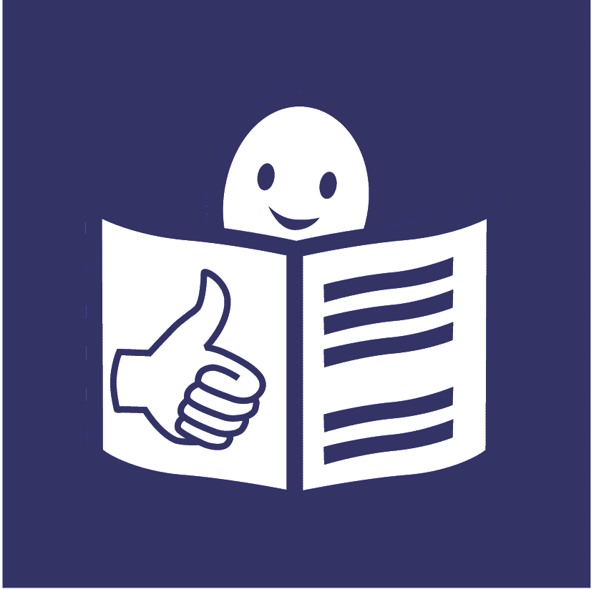United Nations logo **United Nations Human Rights Council**

**United Nations High Commissioner**

**for Human Rights**

**Easy to read**

**Making sure that everyone gets their right to health by having the medicines, vaccines and other health things they need**

# A picture containing logo Description automatically generatedAbout this report

We are called the **United Nations** **Office of the High Commissioner for Human Rights**.

Or **OHCHR** for short.

We are part of the **United Nations** (UN).

The United Nations is a group of countries that works together to make the world better and safer.

Our work is about making sure that everyone gets their **human rights**.

Human rights are about what should happen in all our lives.

For example, we all have the right to have the best health we can.

That means everyone in the world should be able to have the best health they can. That includes the best mental health.

This report is about some problems that can stop people from getting their right to health.

This report is also about some things that countries should do to change that.

There are problems because many people are not getting the medicines, vaccines and other health things they need.

Vaccines can help to stop people getting some illnesses.

People get vaccines from a doctor or nurse.

Other health things might be things like:

* Medical tests to help people find out about their health.
* A black and grey wheelchair

  Description automatically generated with medium confidenceMachines or equipment to help people to look after their health or to keep safe.
* Things that people might need to move around or to communicate.

Like wheelchairs or hearing aids.

Many countries, organizations and people gave us their ideas for this report.

For example, we had a meeting about the ideas in this report on 16 February 2024.

**Some problems that can stop people from getting their right to health**

Many people in the world cannot get the medicines, vaccines or other health things they need.

There are many reasons for that.

For example, more people have health problems that last a long time. Like cancer and diabetes.

This is making it harder for people and health services to cope.

For example, many people in poorer countries have to pay the whole cost of their medicines or health things.

That means many people cannot afford good medicines or other health things they need.

It can be even harder for people to get the right medicines and vaccines when there are big problems in the country.

Like war, bad storms or too much heat.

For example, hospitals and other health places may be damaged.

And it can be harder to get medicines and vaccines to some places.

Countries should also be making sure that medicines and vaccines are good and safe.

But many poorer countries have problems checking new medicines and vaccines.

For example, they may not have enough money, training or staff.

This means it can take longer for people in some countries to get new medicines.

And it means that other medicines may be used instead.

Like medicines that are less safe or good.

Most companies only make new medicines if they think they will get enough money for them.

This means there are not enough medicines, vaccines or health tests for some health problems.

There are also some unfair rules in the world about making and selling medicines.

For example, companies can often charge more for new medicines and vaccines.

Companies often do not share information about new medicines they make.

This can stop other companies from having new ideas or making more medicines.

This means there may be less medicines for people.

And the medicines may cost more.

Things are often worse for people in poorer countries.

And countries where there is war or other problems.

And the problems are often worse for some groups of people, like:

* Children.
* Women and girls.
* A tree with green leaves

  Description automatically generatedOlder people.
* People with disabilities.
* People with a health condition called albinism.
* People who go to another country to find work.
* People who live in the countryside.

**Some problems for children**

Children get many of the same health problems that adults do.

But many medicines and health tests have not been checked to make sure they work well for children.

Many children have never had the important vaccines they need to keep well.

That means they could get some serious illnesses.

**Some problems for women and girls**

People often stop women and girls from choosing what they want to do with their health and their bodies.

For example, some women cannot get their own healthcare.

They have to ask a man first.

Many health companies do not think about what women and girls need when they make medicines or treatments.

And many women and girls do not get the healthcare or things they need to do with:

* Having periods.
* Safe sex and choosing if they want children or not.
* Being pregnant or having a baby.

This can put many women and girls in danger.

**Some problems for older people and people with disabilities**

Many people with disabilities and older people may find it harder to move around.

But health places are often too far away from where they live.

And there may not be good transport to get there.

Many older people and people with disabilities have been in danger from a big illness in the world called Covid-19.

But many older people and people with disabilities did not get vaccines or treatments for Covid-19.

This may be because of unfair ideas that people may have.

For example, some people may think that older people and people with disabilities are less important than other people.

**Some main things that countries should do**

# Countries must make sure that everyone gets their right to health.

# Companies that make medicines must also make sure that people get their right to health.

There are important laws in the world about that.

Below are some main things that countries should work on straight away:

Countries should make sure that people always get the important medicines, vaccines and other health things they need.

That includes groups of people who often do not get what they need now.

The medicines and vaccines should be good and safe.

And they should not cost too much.

Many people should work together to make sure that everyone gets the medicines, vaccines and health things they need.

That includes:

* Different countries.
* Companies that make medicines.
* Healthcare organizations and other organizations around the world.
* People in local communities.
* People who need medicines, vaccines and health things to keep well.

This should help countries and people to get better information about medicines and vaccines.

For example, information about how much new medicines and vaccines cost.

This will help to get more medicines and vaccines that people can afford.

Poorer countries should find better ways to check if medicines are good and safe.

They should get support to do that.

This will help people to get good medicines and vaccines more quickly.

Countries should have enough money and staff to make new medicines and vaccines.

That means making medicines and vaccines for more health problems that people have.

Not just health problems that will make companies more money.

Governments and companies can work together to get new medicines and vaccines.

This can help to get more money and ideas for new medicines and vaccines.

The rules about how to buy and sell medicines should work in a better way for people and their human rights.

For example, the rules say that countries can get some medicines or vaccines made at a cheaper price.

Countries can do this without the company that made the medicines saying yes first.

It should be easier for countries to do things like this.

This will help everyone to get their right to health.

**For more information**

We also wrote a report about some good ways to make sure that everyone gets the medicines, vaccines and other health things they need.

The report is on our website at:

<https://www.ohchr.org/sites/default/files/2024-04/Easy-to-read-AHRC5350_0.docx>

**Pictures by The Picture Communication Symbols ©1981–2016 by Mayer-Johnson LLC a Tobii Dynavox company. All Rights Reserved Worldwide. Thousands of resources available for free at** [**www.boardmakeronline.com**](http://www.boardmakeronline.com/)