A/HRC/52/CRP.6
Distr.: General
English only
Human Rights Council
Fifty-second session
Situation of human rights in Ukraine: 1 August 2022 to 31 January 2023
Office of the United Nations High Commissioner for Human Rights

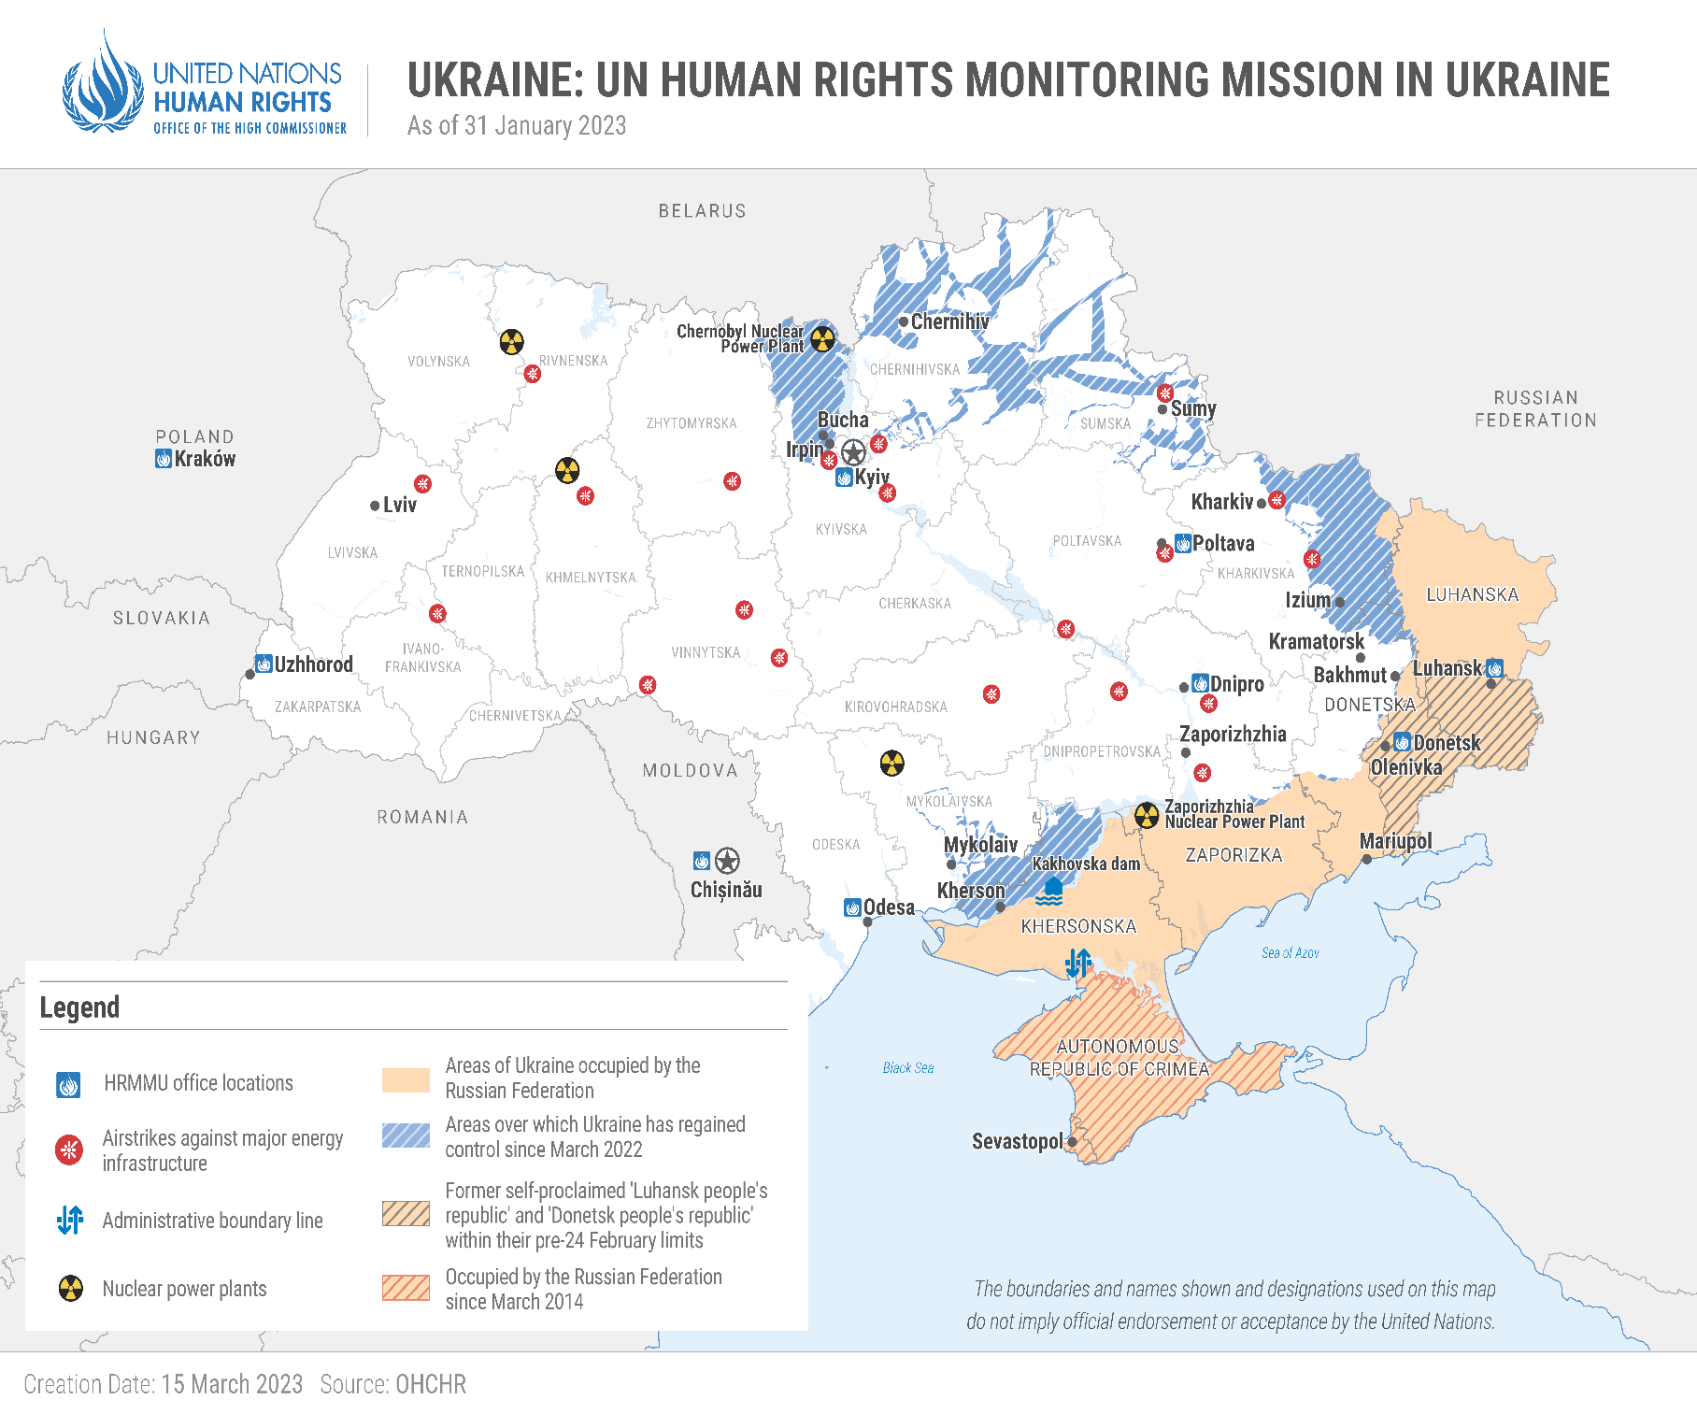

I Executive Summary
1. This thirty-fifth report by the Office of the High Commissioner for Human Rights (OHCHR) on the human rights situation in Ukraine covers the period from 1 August 2022 to 31 January 2023. It is based on the work of the United Nations Human Rights Monitoring Mission in Ukraine (HRMMU).
2. The human rights situation across the country remains dire amid the ongoing armed attack by the Russian Federation against Ukraine. The international armed conflict has led to a wide range of human rights violations affecting both civilians and combatants. OHCHR has verified numerous allegations of arbitrary deprivation of life, arbitrary detention and enforced disappearance, torture and ill-treatment, and conflict-related sexual violence (CRSV).
3. During the reporting period, OHCHR recorded a total of 5,987 civilian casualties, with 1,605 persons killed and 4,382 persons injured. However, actual casualty numbers are likely considerably higher, since these figures only include the cases that OHCHR has been able to verify. A large number of civilian casualties resulted from attacks where explosive weapons with wide area effects were used. The war has taken a heavy toll on civilians, with acts of hostilities killing groups of individuals and in some cases multiple members of the same families at once.
4. Since October 2022, Russian strikes targeting critical energy infrastructure have killed at least 116 civilians and injured at least 379. They have resulted in serious shortages of electricity, affecting the population’s capacity to face the winter. Moreover, the hostilities have severely impacted civilian infrastructure and housing. OHCHR recorded damage or destruction to 107 medical facilities and 179 educational facilities during the reporting period. The damage to and destruction of civilian infrastructure have also infringed on the enjoyment of other human rights, including the rights to security, health, work, education, housing, social support and services for persons with disabilities, and freedom of religion or belief.
5. During the reporting period, OHCHR documented the killings of 21 civilians by Russian armed forces, both through summary executions and attacks on individual civilians. It also documented 214 cases (185 men, 24 women and 5 boys) of enforced disappearances and arbitrary detentions of civilians in territory of Ukraine that was or remains under the occupation of the Russian Federation. Russian armed forces arrested victims in their homes, workplaces, in the street, or at checkpoints during so-called ‘filtration’ processes. OHCHR documented 10 cases (7 men, 3 women) of enforced disappearances and arbitrary detentions of media workers and human rights defenders in territory occupied by the Russian Federation.
6. OHCHR is gravely concerned about the arbitrary detention, enforced disappearance and torture or other ill-treatment of children. During the reporting period, OHCHR documented the enforced disappearances of five boys between 14 and 17 years old by Russian armed forces. The children were all subjected to torture or other ill-treatment, and, in one case, the victim was deported to Belarus.
7. From February 2022 to 31 January 2023, OHCHR documented 133 cases of CRSV (85 men, 45 women, 3 girls), the majority of which took place in territory occupied by the Russian Federation. 109 cases are attributable to Russian armed forces or Russian law enforcement and penitentiary staff. Sexual violence frequently occurred in a context of deprivation of liberty, as well as in residential areas of villages. It also took place during so-called ‘filtration’ processes by Russian armed forces. During the reporting period, OHCHR documented three cases of rape against women in small communities where Russian armed forces were stationed.
8. OHCHR documented transfers of civilians to areas in occupied territory or to the Russian Federation, some of which may amount to forced transfers or deportations. These transfers include children and adults who lived in institutionalised settings and unaccompanied children from parts of Donetsk, Kharkiv, Kherson, Kyiv, Odesa and Zaporizhzhia regions while they were occupied by the Russian Federation or temporarily controlled by Russian armed forces.
9. OHCHR documented that freedom of movement restrictions imposed by the occupying authorities have jeopardised access to social security and health care. Residents of Kharkiv, Kherson and Zaporizhzhia regions were left with little or no cash to provide for their means of subsistence. In areas of Kherson which were occupied by the Russian Federation until November, checkpoints established by Russian armed forces prevented civilians from leaving their villages from March to the end of the occupation, thereby severely undermining their access to medical assistance.
10. In the Autonomous Republic of Crimea and the city of Sevastopol, Ukraine (Crimea), occupied by the Russian Federation, the occupying authorities continued to prosecute individuals on the grounds of “public actions directed at discrediting” and “obstructing” the Russian armed forces. By 31 January 2023, OHCHR had documented 210 prosecutions since the introduction of these punishable offenses in 2022. There was a progressive increase in convictions throughout 2022.
11. In territory of Ukraine under control of the Government of Ukraine, OHCHR documented 91 cases of enforced disappearances and arbitrary detentions (79 men, 12 women) committed by Ukrainian armed forces and law enforcement agencies. Most detainees were arrested for suspicion of collaborating with, or other forms of aiding, Russian armed forces. OHCHR interviewed 8 individuals (3 men and 5 women) prosecuted for the crime of “collaboration activity”, several of whom reported being beaten during their arrest or following their transfer to places of detention, held incommunicado in unofficial places of detention, denied access to legal aid and subjected to torture and ill-treatment during interrogations. OHCHR also documented the arbitrary detention of 88 Russian civilian sailors who legally entered Ukraine before 24 February 2022, but were not thereafter allowed to disembark from their ships in Izmail, Odesa region. One sailor died from a chronic condition due to the lack of adequate medical care.
12. In a welcome development, on 1 December, the Parliament of Ukraine adopted a law in order to align national criminal legislation with the Convention against Torture and Other Cruel, Inhuman or Degrading Treatment or Punishment. The law notably brings the domestic definition of “torture” in line with the Convention.
13. Since 24 February 2022, OHCHR has documented 24 cases of CRSV in territory controlled by the Government of Ukraine. All cases occurred between March and July 2022. They mostly affected men and consisted predominantly of threats of sexual violence during the initial stages of detention by Ukrainian law enforcement officers, and of forced public stripping of alleged lawbreakers by civilians or members of territorial defence forces.
14. OHCHR notes the efforts of the Government of Ukraine to integrate a victim-centred approach into CRSV investigations and to provide assistance to survivors. It also welcomes the Government’s ratification of the Council of Europe Convention on Preventing and Combating Violence Against Women and Domestic Violence (Istanbul Convention), which entered into force on 1 November.
15. OHCHR also welcomes the Government’s decision to maintain and continue to pay pensions in all areas of Ukraine, including to those who were registered as IDPs before 24 February 2022. OHCHR notes, however, that social assistance for those in need remains frequently inadequate. OHCHR continues to document inadequate housing in conflict-affected areas, where many people’s homes have been damaged or destroyed.
16. OHCHR documented searches conducted by the SBU as “security measures” in several monasteries, offices, education facilities and other property of the Ukrainian Orthodox Church (UOC). OHCHR is concerned that official actions targeting the UOC could be discriminatory. OHCHR also recalls the necessity of ensuring that all those facing criminal charges enjoy the full spectrum of non-derogable fair trial rights.
17. OHCHR continues to monitor the prosecution of war crimes in Ukraine. While welcoming the substantial efforts of the Government of Ukraine to prosecute war crimes and uphold the right of victims to truth and effective remedies, OHCHR has concerns regarding the overall fairness of certain proceedings. In particular, 12 perpetrators were convicted and sentenced in absentia, which in some circumstances may be contrary to the right to be present during one’s trial.
II. Methodology
18. The report is based on information gathered during 99 field visits, 32 visits to places of detention, and 1,090 interviews with victims and witnesses of human rights violations, as well as with relatives of victims and their lawyers, Government representatives, members of civil society and other interlocutors. It also draws from information obtained from court proceedings, official records, open sources and other relevant material. Findings are based on verified information collected from primary and secondary sources that are assessed as credible and reliable. They are included in the report where the “reasonable grounds to believe” standard of proof is met, namely where, based on a body of verified information, an ordinarily prudent observer would have reasonable grounds to believe that the facts took place as described. Legal conclusions are drawn when there are reasonable grounds to conclude that the facts meet all the elements of a violation. While OHCHR cannot provide an exhaustive account of all human rights violations committed throughout Ukraine, it obtains and verifies information through a variety of means in line with its established methodology and bases its conclusions on verified cases.
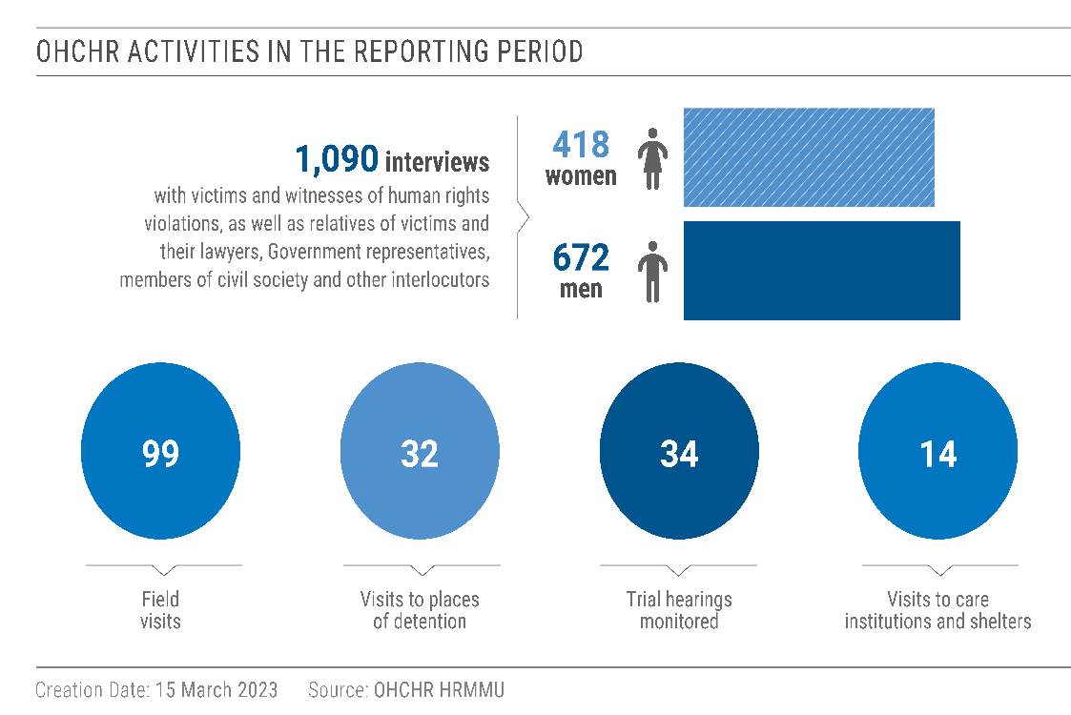
19. OHCHR applies the same standard of proof when documenting conflict-related civilian casualties. In some instances, it may take time before conclusions can be drawn, meaning that the numbers of civilian casualties are revised as more information becomes available. OHCHR applies the “reasonable grounds to believe” standard in attributing a civilian casualty to a particular party. It should be noted that the verification process is based on a factual determination, and that not all civilian casualties are necessarily deaths or injuries in violation of international humanitarian law (IHL).
20. While some violations covered in this report may have taken place prior to the reporting period, all information in this report was verified and documented during the reporting period
21. Information in this report is used with full respect for informed consent of sources as to its use, as well as OHCHR’s own assessment of any material risk of harm that such use may cause. This may entail removing identifying details to better ensure the confidentiality or protection of sources.
22. OHCHR shared the draft report with the concerned States for factual comments, as per usual practice.
III. Impact of Hostilities on the Civilian Population
A. Civilian Casualties
Civilian casualties during the reporting period
23. From 1 August 2022 to 31 January 2023, OHCHR recorded 5,987 civilian casualties in the country. They included:
- 1,605 persons killed (631 men, 388 women, 43 boys and 25 girls, as well as 516 adults and 2 children whose sex is not yet known).
- 4,382 persons injured (1,140 men, 780 women, 115 boys and 82 girls, as well as 2,191 adults and 74 children whose sex is not yet known).
24- This is a 60 per cent decrease compared with the preceding six months, during which 15,032 casualties were recorded, with 6,340 persons killed and 8,692 injured.
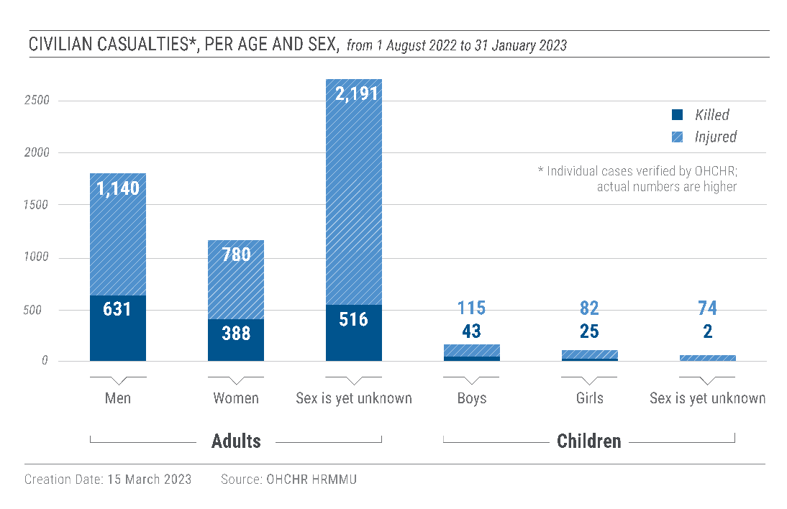
25. During the reporting period, civilian casualties were documented as follows:
- 4,796 [1,220 civilians killed (401 men, 270 women, 31 boys and 15 girls, as well as 501 adults and 2 children whose sex is not yet known) and 3,576 injured (735 men, 449 women, 91 boys and 63 girls, as well as 2,171 adults and 67 children whose sex is not yet known)] were recorded in 334 settlements in areas under Government control when the casualties occurred, constituting 80.1% of civilian casualties recorded in the reporting period.
- 1,191 [385 civilians killed (230 men, 118 women, 12 boys and 10 girls, as well as 15 adults whose sex is not yet known) and 806 injured (405 men, 331 women, 24 boys and 19 girls, as well as 20 adults and 7 children whose sex is not yet known)] were recorded in 93 settlements in areas under territory occupied by the Russian Federation when casualties occurred, constituting 19.9% of civilian casualties recorded in the reporting period.
26. OHCHR notes that the actual figures are likely considerably higher. Many reports of civilian casualties are still pending corroboration by OHCHR, notably those from Mariupol (Donetsk region), and Lysychansk, Popasna and Sievierodonetsk (Luhansk region).
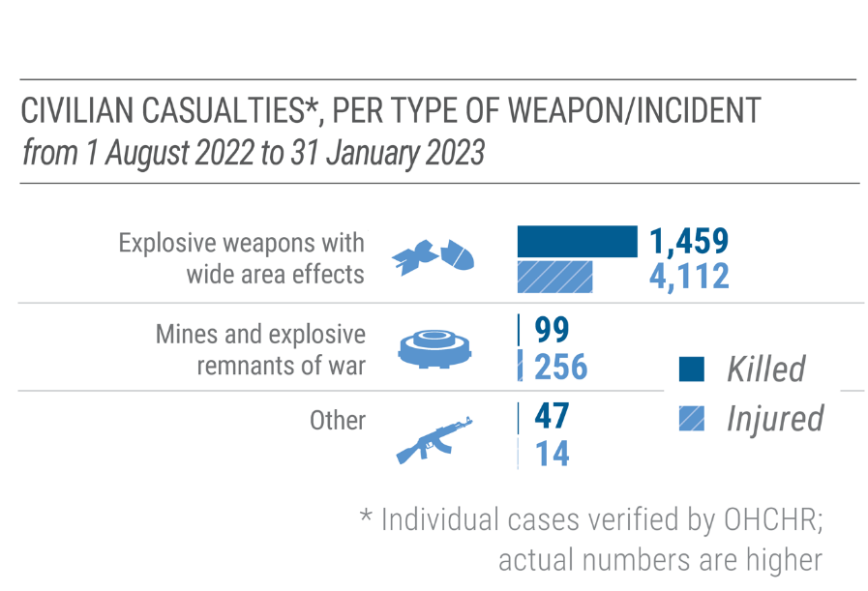
27. The vast majority of civilian casualties (1,459 persons killed and 4,112 injured, or 93 per cent) were caused by the use of explosive weapons with wide area effects, including shelling from heavy artillery, multiple launch rocket system (MLRS), missiles and air strikes, in populated areas. 99 civilians were killed and 256 injured as a result of explosive remnants of war (ERW) and mine-related incidents (6 per cent). Another 47 civilians were killed and 14 injured (1 per cent) by fire from small arms and light weapons (SALW), including as a result of crossfire and sniper fire.
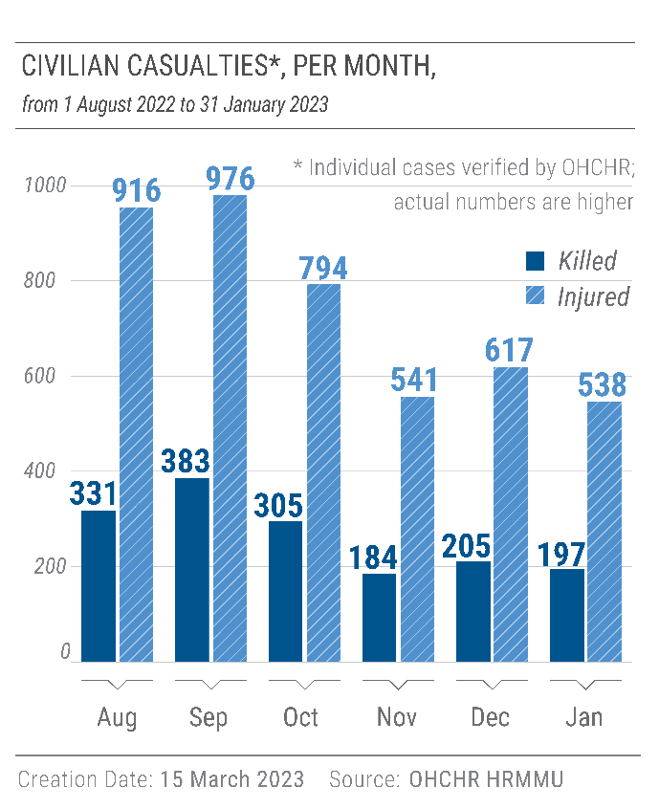
28. In several cases, the use of explosive weapons with wide area effects caused multiple civilian casualties. For example, on 22 September, mortar shells hit the district of Voroshulovskyi in the Russian-occupied city of Donetsk, killing three women, two men and one boy. On 30 September, a missile killed 32 people (15 women, 11 men, 1 boy, 1 girl, and 4 adults whose sex is not yet known) and injured 90 (28 men, 11 women, 1 girl, and 50 adults whose sex is not yet known) who were queuing in Government-controlled parts of Zaporizhzhia region to cross to Russian-occupied territory. On 20 October, a MLRS rocket hit the village of Chervonyi Prapor /Stare, in Russian-occupied areas of Luhansk region, killing 7 men, including 6 emergency workers. On 14 January, a missile hit a residential building in Dnipro, killing 45 persons (15 women, 10 men, 4 girls, 3 boys, and 13 adults whose sex is not yet known) and injuring 80 (15 women, 9 men, 5 girls, 4 boys, as well as 39 adults and 8 children whose sex is not yet known).

Explosive weapons with wide area effects claimed lives of multiple family members
29. The war has taken a heavy toll on civilians, with the hostilities in some cases killing multiple family members at once. From 1 August 2022 to 31 January 2023, OHCHR recorded 17 such incidents involving explosive weapons with wide area effects, where at least one family member was killed and at least one more injured. For example, on 24 August, a missile attack killed a couple in Chaplyne, Dnipropetrovsk region, and left their 17-year-old daughter injured and orphaned. On 25 August, mortar shelling in Horlivka, in Russian-occupied parts of Donetsk region, killed a woman and injured her two children, a boy and a girl. On 29 September, a missile hit a residential building in Dnipro, killing an 8-year-old boy, his 9-year-old sister, and their mother and grandmother. On 6 October, a missile that hit a residential building in Zaporizhzhia killed a young woman, her 10-year-old brother, and their parents. In Krivi Rih, Dnipropetrovsk region, a missile attack on 16 December killed a toddler and his parents, leaving his older brother, who was with his grandmother at the time of the attack, an orphan. On 5 January, shelling in Beryslav, in the Government-controlled part of Kherson region, killed a 12-year-old boy and his parents. On 14 January, no less than six families lost at least two of their members in the missile attack that killed 45 persons in Dnipro.
30. The hostilities have also impacted journalists and media workers, with seven (five men and two women) injured during the reporting period. This brings to 22 the total number of injured journalists documented by OHCHR since the beginning of the armed attack. Five of these casualties resulted from indiscriminate shelling, while the full circumstances of the other two incidents are still being verified. all victims were on assignment when they were injured. Shelling killed one media worker in areas of Kherson region that were occupied by the Russian Federation at the time of the incident on 20 October 2022. This brings to 18 (14 men and 4 women) the total number of lethal incidents documented by OHCHR since 24 February 2022.
Mine-related incidents and explosive remnants of war
31. During the reporting period, mines and ERW continued to kill and injure civilians and to seriously limit their freedom of movement, economic opportunities and access to basic services, including education and healthcare. OHCHR recorded 355 civilian casualties caused by mines and ERW, with 99 persons killed (82 men, 11 women, 4 boys, and 2 girls) and 256 injured (175 men, 32 women, 18 boys, as well as 22 adults and 9 children whose sex is not yet known). Men and boys represent 86 per cent of these casualties, which comprise 6 per cent of all civilian casualties recorded by OHCHR during that period. For example, on 15 August 2022, PFM-1 mines killed a woman and injured a man in the city of Donetsk occupied by the Russian Federation. On 8 November, two men working for a road maintenance company were killed and two others heavily injured near Government-controlled Chkalovske (Kharkiv region) as a result of an anti-tank mine explosion on the road they were repairing. The number of civilian victims of mines and ERW is expected to rise considerably in 2023 as the level of contamination of Ukraine, which was already among the highest in the world from 2014 to 2021, dramatically increased in 2022 and on current trajectory will likely continue to increase in 2023.
32. OHCHR stresses that the use of anti-personnel mines does not comply with the IHL principle of distinction, as they are inherently indiscriminate, nor with the prohibition to employ weapons and methods of warfare of a nature to cause superfluous injury or unnecessary suffering. Ukraine has ratified the 1997 Convention on the Prohibition of the Use, Stockpiling, Production and Transfer of Anti-Personnel Mines and on their Destruction (Ottawa Convention). Moreover, both Ukraine and the Russian Federation are bound by the Protocol on Explosive Remnants of War, which inter alia requires parties to an armed conflict, after the cessation of active hostilities and as soon as feasible, to mark and clear, remove or destroy explosive remnants of war in affected territories under their control. They are also required to take all feasible precautions to protect civilians from the risks and effects of explosive remnants of war, including marking, fencing, monitoring, warnings and risk education to the civilian population.
Civilian casualties during the entire conflict period
33. From 14 April 2014 to 31 January 2023, OHCHR recorded a total of 11,052 conflict-related civilian deaths (5,357 men, 3,147 women, 358 boys, 250 girls, and 1,909 adults and 31 children whose sex is not yet known). Taking into account the 298 people on board Malaysian Airlines flight MH17, which Russian-affiliated armed groups shot down on 17 July 2014, the total civilian death toll has reached at least 11,350.
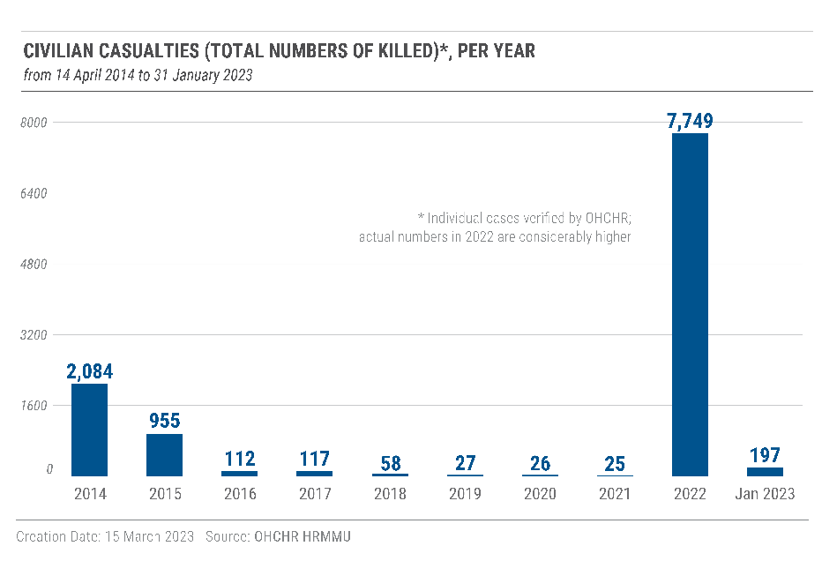
B. Destruction of and damage to civilian objects
34. During the reporting period, OHCHR verified widespread destruction of and damage to civilian objects across the country, in particular medical and educational facilities, as well as critical energy infrastructure. Most incidents resulted from explosive weapons with wide area effects, such as heavy artillery, MLRS and cruise missiles. While OHCHR has not been able to assess compliance with IHL for each individual incident, the patterns, scale and frequency of damage and destruction strongly indicate that recurring violations of IHL have taken place.
Medical and educational facilities
35. OHCHR has serious concerns about the scale and frequency of destruction of medical facilities. Some incidents may also amount to a violation of the rules of IHL which afford them a special protection status. During the reporting period, OHCHR documented that military attacks destroyed 20 healthcare facilities and damaged 87 more. Actual figures are likely higher. Of them, 57 were attributed to Russian armed forces, 45 to Ukrainian armed forces, and 5 are not yet attributed because they occurred in areas of Donetsk and Kharkiv regions that were contested at the time of the attack. These attacks have put both patients and medical staff at risk, and resulted in 30 civilian casualties among staff, patients and their companions, with 8 civilians killed (3 women, 2 men, 1 boy and 2 adults whose sex is not yet known) and 22 injured (9 women, 9 men and 4 adults whose sex is not yet known).
36. For example, on 3 October, a missile hit a hospital in Government-controlled Kupiansk, Kharkiv region, killing one doctor (man) and injuring two nurses (women). On 23 November, a missile hit a maternity ward in Government-controlled Vilniansk, Zaporizhzhia region, killing a new-born boy and injuring his mother and two doctors. On 28 January, a MLRS strike damaged a hospital in the city of Novoaidar, in the occupied part of Luhansk region. The destruction of medical facilities has also restricted access to healthcare and jeopardised the right to health. IHL prescribes that hospitals shall be protected at all times during armed conflict and not be objects of attack.
37. During the reporting period, OHCHR documented the destruction of 61 educational facilities and damage to 118 of them. Actual figures are likely higher. 96 of the attacks are attributed to Russian armed forces, 66 to Ukrainian armed forces, and 17 attacks are not yet attributed (in areas of Donetsk, Kharkiv, Kherson regions that were contested at the time of the attack). The hostilities and their impact on educational facilities have severely disrupted the education of millions of students.
38. In total, from 24 February 2022 to 31 January 2023, OHCHR documented the destruction of 38 medical facilities and 156 educational facilities, and the damage of 287 medical facilities and 475 educational facilities. 598 cases are attributed to the Russian armed forces and 279 cases to Ukrainian armed forces. 79 cases occurred in contested areas and are not yet attributed. The actual number of destroyed or damaged medical and educational facilities on both sides of the front line is likely considerably higher. In addition to the destruction of health facilities, many health professionals have fled conflict-affected areas, making it harder to access a doctor or receive specialised services. Many pharmacies have also closed or are not supplied with sufficient medication.
C. Strikes on critical energy infrastructure
39. On 10 October, Russian armed forces initiated a series of strikes by cruise missiles, ground-to-air missiles (used against ground targets) and loitering munitions targeting critical infrastructure, and in particular energy objects across Ukraine. As of 31 January 2023, they had launched 14 of these attacks. OHCHR received credible reports that the attacks damaged or destroyed at least 76 objects of energy infrastructure in 19 regions of Ukraine and Kyiv, mostly cogeneration plants and electricity substations. They also killed at least 116 civilians, injured at least 379, and damaged at least 5 apartment buildings, 70 private houses, 4 cultural facilities, 5 plants and 20 other civilian objects.
40. The strikes have caused power, heating, and water supply outages and disrupted mobile and internet connectivity and railway traffic across the country. They have put millions of civilians at risk during the colder months and disrupted education for millions of children in Ukraine. They have also created new flows of displacement. While temperatures were freezing, the Government of Ukraine had to introduce regular power cuts in all regions to enable repair works and mitigate the shortage of electricity. Given the adverse impact that the large-scale destruction of critical energy infrastructure has had on the enjoyment of the rights to life, health, education and an adequate standard of living for broad sectors of the civilian population in affected areas, OHCHR is gravely concerned that these strikes do not appear to conform with the rules on the conduct of hostilities, in particular the principle of proportionality.
IV. Human Rights in territory of Ukraine occupied by the Russian Federation
A. Application of Russian law in occupied territory
41. From 23 to 27 September, Russian occupation authorities in the occupied territory of Donetsk, Luhansk, Kherson and Zaporizhzhia regions purported to hold ‘referenda’ in these regions on becoming part of the Russian Federation. On 30 September, the President of the Russian Federation signed so-called “Treaties on the Accession of the Donetsk People’s Republic, the Lugansk People’s Republic, the Zaporozhye Region and the Kherson Region to the Russian Federation”, purportedly annexing and consequentially applying Russian legislation in these occupied territories, in displacement of the existing legal system. On 13 October 2022, the United Nations General Assembly, in its resolution ES11/4 on “Territorial integrity of Ukraine: defending the principles of the Charter of the United Nations”, condemned the organization of the so-called ‘referenda’ and the attempted illegal annexation of the Donetsk, Kherson, Luhansk and Zaporizhzhia regions, and declared that the unlawful actions of the Russian Federation have no validity under international law and do not form the basis for any alteration of the status of these regions of Ukraine.
42. The occupation of territory as a result of international armed conflict is a temporary de facto situation which neither affects the legal status of occupied territory, nor deprives the occupied power of sovereignty. Annexation of occupied territory in wartime is unlawful and does not deprive protected persons of protection under the Geneva Convention IV. IHL provides that the legislation of the occupied country shall remain applicable in the occupied territory unless the occupying power is “absolutely prevented” from doing so, or unless they constitute a threat to the security of the occupying power or an obstacle to the application of the Geneva Convention IV. The occupying power may legislate only if it is essential to protect its security and that of its occupying forces, to implement its obligations under international humanitarian and international human rights law, to maintain the orderly government of the territory.
43. On 19 October, the President of the Russian Federation signed Decree No. 756 imposing martial law in Donetsk, Kherson, Luhansk and Zaporizhzhia regions, parts of which are occupied by the Russian Federation. The decree provides for a wide range of measures that may be implemented “if required”, including curfews, property seizures, internment, and restrictions on freedom of movement, freedom of association, and activities of political parties and other public associations. These measures restrict a number of human rights guaranteed by IHRL. OHCHR recalls that the States have the obligation to respect and ensure IHRL in all circumstances where they exercise jurisdiction, including in places under their effective control, and must ensure that any restrictions of human rights remain compatible with the requirements of applicable international human rights treaties.
B. Right to life, liberty and security of persons
“I live 300 meters from my office. Over around four weeks in spring, on my way to work each day, I passed the bodies of 17 civilians killed by shelling. There was no one to take care of the bodies. It was like this everywhere in the town.”
– A head of ambulance service in Izium

Killings
44. During the reporting period, in addition to the cases covered by a thematic report issued on 7 December 2022, OHCHR documented the killings of 21 civilians (17 men, 4 women) by Russian armed forces, both through summary executions and attacks on individual civilians: 14 in Kyiv, 5 in Kharkiv, and 2 in Zaporizhzhia regions.
45. In May 2022, members of the Chechen ‘Kadyrovtsy’ unit executed a 70-year-old forensic expert from the morgue of Izium, Kharkiv region. The perpetrators killed the victim with multiple gunshots after he refused to give up his vehicle, which was specifically adapted to cater for his disability.
46. Also in Izium, Russian armed forces killed a 36-year-old woman who was last seen entering a Russian military base in the Honcharivka area of town on 2 June 2022. The same day, Russian troops delivered the victim’s body to a local morgue. She had a single gunshot wound to her chest.
47. In Balakliia, Kharkiv region, OHCHR documented the killing of a 27-year-old nurse who was last seen departing from work on 18 March 2022. Two weeks later, on 1 April, his body was found in the nearby village of Husarivka, bearing marks suggesting torture, including missing fingers. A local unit from former self-proclaimed ‘Luhansk people’s republic’ stationed in the area informed the relatives of the victim that members of a Russian military unit operating a checkpoint in the nearby village of Bairak had abducted him.
Conflict-related detentions
48. During the reporting period, OHCHR documented 214 cases (185 men, 24 women and 5 boys) of enforced disappearances and arbitrary detentions of civilians that occurred in territory of Ukraine while under the occupation of the Russian Federation. These cases took place both before and during the reporting period in Kyiv, Chernihiv, Sumy, Kharkiv, Donetsk, Luhansk, Kherson, Mykolaiv and Zaporizhzhia regions. Russian armed forces and law enforcement agencies arrested individuals in their homes, workplaces, in the street, or at checkpoints during so-called ‘filtration’. They deprived the liberty of civilians with strong pro-Ukrainian views or in possession of Ukrainian state symbols, including priests; participants in public rallies against the occupying authorities; public officials; former members of the Ukrainian armed forces and law enforcement bodies; and those suspected of providing assistance and information to the Ukrainian armed forces.
49. Since 24 February 2022, OHCHR has documented a total of 621 cases (544 men, 71 women and 6 boys) of enforced disappearances and arbitrary detentions of civilians. 296 of the victims (243 men, 47 women and six boys) were released after various periods of detention usually lasting for several days or weeks. However, 297 victims remain disappeared or arbitrarily detained, usually in formal places of detention in occupied territory of Ukraine and in the Russian Federation. 28 of the victims (26 men and 2 women) were found dead with signs of violence on their bodies.
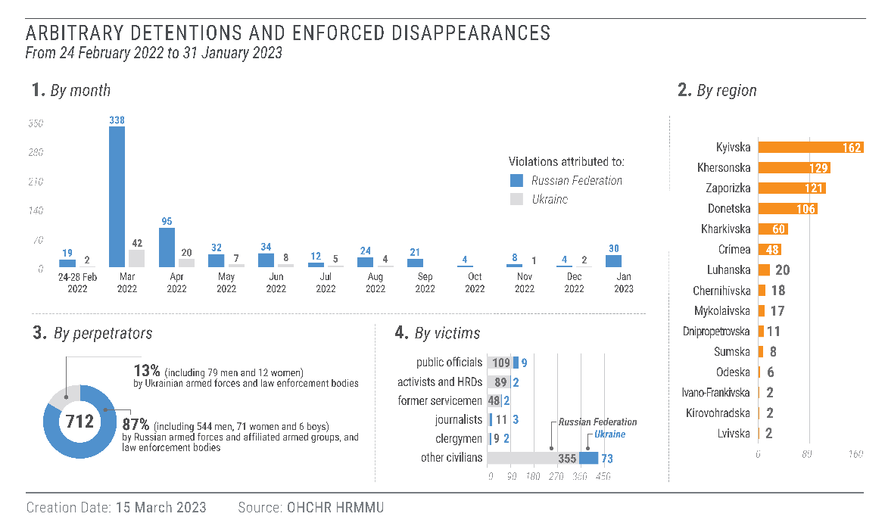
50. During the reporting period, OHCHR interviewed 89 individuals upon their release from captivity and received additional information from relatives about their treatment in detention. 91 per cent of the individuals (93 per cent of men, 79 per cent of women and 100 per cent of boys) reported acts amounting to torture and ill-treatment while deprived of liberty. Members of the Russian armed forces and the Security Service of Russia (FSB) reportedly tortured or otherwise ill-treated victims to force them to confess to providing assistance to Ukrainian armed forces, to compel them to cooperate with the occupying authorities or to intimidate those with pro-Ukrainian views. Victims stated that prison guards punched them; beat them with batons and rifle butts; slashed them with knives; threatened to shoot their hands and legs, mutilate or execute them; deprived them of sleep; exposed them to freezing temperatures, sometimes after pouring water on them; electrocuted them; and subjected them to mock executions or sexual violence, including threats of rape and deliberate infliction of force or electrocution on sexual organs.
Children subjected to arbitrary detention and enforced disappearance
51.OHCHR is gravely concerned that children have been subjected to arbitrary detention, enforced disappearance, torture and ill-treatment. During the reporting period, OHCHR documented the enforced disappearances of five boys between 14 and 17 years old by Russian armed forces. The boys were all subjected to ill-treatment or torture, and one boy was deported to Belarus.
52. In September 2022, a 14-year-old boy and his adult uncle were abducted by Russian armed forces in Kherson region for the uncle’s alleged involvement in filming military positions and transferring information to Ukrainian armed forces. They were handcuffed, blindfolded and then placed in a hole dug in the ground on the property of a gas station, where they were beaten. Two hours later, they were transferred to an unofficial place of detention in the city of Kherson. The boy was separated from his uncle and detained with adult male detainees in a shower room for several days. The 12 detainees were provided with inadequate food and potable water, being forced to share five liters of water and stale biscuits. He was interrogated twice, during which time he heard other victims being ill-treated. He was then transferred to an archive room. He and his uncle were released ten days later. Throughout their detention, their family members were unable to ascertain their fate and whereabouts.

53. During the reporting period, OHCHR documented an increased risk of enforced disappearance at the Administrative Boundary Line (ABL) between Crimea and Kherson region, especially for male travellers. OHCHR documented that three men and one woman were subjected to enforced disappearance at the ABL after Russian armed forces searched their mobile devices for any statements or symbols that might be perceived as anti-Russian or pro-Ukrainian. OHCHR documented a similar pattern of enforced disappearance of residents in Kherson, while it was occupied by the Russian Federation, followed by their transfer to and detention in Crimea.
54. In one case, a young Crimean Tatar went missing in July after he left his home in Kherson region to reunite with his mother in Crimea. When he did not arrive as planned, the man’s relatives tried to find him and learned that he had either been stopped when attempting to cross the ABL or apprehended in Kherson region and forcibly transferred to Crimea. The family and a privately hired lawyer made numerous attempts to locate the individual, but received no substantial response from the occupation authorities. The man remained disappeared until October when his arrest was registered and criminal charges were brought against him. His relatives learned that, prior to being charged, he had been detained in a pre-trial detention centre in Simferopol, without any formal status or clear legal grounds.
55. During the Russian occupation of areas of Kherson and Kharkiv regions, over which Ukrainian armed forces regained control during the reporting period, OHCHR documented 177 cases of enforced disappearances and arbitrary detentions (159 men, 17 women and 1 boy). OHCHR also documented a pattern of arbitrary detention in unofficial locations and identified 35 places used to detain civilians in those areas. These included buildings of law enforcement bodies (often equipped with temporary detention cells) and industrial or civilian buildings where Russian armed forces and affiliated armed groups were stationed. For example, OHCHR documented the case of two women and one man who were arbitrarily detained by Russian armed forces in the police station of the town of Balakliia, Kharkiv region. Russian armed forces and law enforcement bodies apparently apprehended the victims because of their pro-Ukrainian views. The victims reported that they and other detainees were tortured and ill-treated. Russian soldiers and FSB officers interrogated the man three times, during which they severely beat him and electrocuted him with a TA-57 (field military telephone also widely known as Tapik) to force him to confess to sharing information with Ukrainian armed forces. The two women were not subjected to physical violence but experienced high levels of mental distress because they heard and saw other detainees being tortured, including a woman sharing their cell who had signs of torture and told them what had happened to her. All three victims were released in mid-August and taken to the front line and forced to move to territory controlled by Ukraine. In Kherson region, OHCHR documented the enforced disappearance of a local public official who was arrested by six FSB officers in mid-August and detained in the building of a local court in the town of Bilozerka. During his four days of detention, FSB officers beat and electrocuted him every day for up to two hours at a time, accusing him of being “Nazi” because he refused to cooperate with the occupying authorities. On the fifth day, the victim negotiated his release by making under duress a promise to cooperate and managed to escape.
Conflict-related sexual violence
56. From 24 February 2022 to 31 January 2023, OHCHR documented 133 cases of CRSV (85 men, 45 women, 3 girls), 109 of them perpetrated by Russian armed forces, law enforcement authorities or penitentiary staff, either in Russian-occupied territory of Ukraine or in the Russian Federation itself. Most of the documented cases occurred either in a context of deprivation of liberty or in villages and communities that were controlled by Russian armed forces.
57. In the majority of the cases that took place in a context of deprivation of liberty, sexual violence was used as a form of torture or ill-treatment. It consisted of rape, electrocution, burning, tying up and beating of genitals, forced nudity, forcing someone to watch or conduct sexual violence against another person, unjustified cavity or strip searches, homophobic insults and threats of sexual violence towards victims or their loved ones. Sexual violence was directed mostly against men POWs, but also against detained civilian men. Sexual violence against women in a context of detention mainly consisted of unjustified strip searches or threats of sexual violence.
58. OHCHR documented a case where a man POW was tortured during an interrogation in a so-called ‘prosecutor’s office’ in Donetsk in July 2022. The interrogator told guards to take the POW to the toilet, where the guards taped his mouth with duct tape, beat him and tasered him in the genitals. In a separate case from July 2022, penitentiary guards from Russian-affiliated armed groups tortured a POW in the penal colony near Olenivka, including by stripping him and burning his genitalia with a lighter. Both of these cases were documented during the reporting period through interviews with POWs who were exchanged in September 2022.
59. In another case, a woman was subjected to repeated rape while held by the FSB. In the beginning of April 2022, FSB officers repeatedly visited her to ask about the whereabouts of her son, a SBU officer. They offered her to work for them, but she refused and told others that the city would soon be liberated by Ukrainian armed forces. In July, eight armed men who introduced themselves as FSB officers entered her house and proceeded to beat and strangle her. They blindfolded her and her husband and drove them to their base of operations. They brought her into a shed and her husband to a nearby garage. A man who introduced himself as the commander told her: “Tell me how you love Ukraine now. We’ll beat Ukraine out of you”. He then left, and six men in balaclavas and sports clothes took her to a room which had hammers, tongs, electrical wires, whips and other tools laid out on a table. They undressed her while strangling and beating her, touched her breasts and buttocks, raped her by inserting their fingers into her vagina and pressed themselves against her body. Later that day, seven men, including a commander, yelled at her that they would see how much a Ukrainian she was and threatened to tie her to a pole, rape her again, film the rape and send the video to her son. They undressed her again, beat and kicked her. The commander raped her again. Over the next days, they continued torturing her, including by electrocution. The commander raped her on multiple occasions by forcing her to perform oral sex until she agreed to cooperate. She said she tried to commit suicide while detained.
60. During the reporting period, OHCHR documented three cases of rape against women in small communities of Kyiv and Kherson regions where Russian armed forces were stationed. In one case that occurred in Kyiv region in March, three Russian soldiers entered the house of the victim and her husband. One of them took her to a nearby house to “talk”. While reloading his gun, he accused her of assisting the Ukrainian armed forces. He pointed his gun to her head, ordered her to undress and threatened to shoot her knee if she did something wrong. He raped her while holding a gun next to her knee. She reported seeing other used condoms in the house. Local residents in Kyiv region told OHCHR that they tried to “hide girls and young women” from armed men, who were in some instances drunk, by dressing them in old, baggy clothes and by not allowing them to go out.
61. The contact of civilians, especially women and girls, with armed men more generally continued to pose high risks of sexual violence. For instance, a woman reported that two members of the Russian armed forces suggested in crude terms to engage in oral sex with them while they were driving her to a checkpoint.
Treatment of prisoners of war
62. During the reporting period, OHCHR interviewed 142 Ukrainian POWs (122 men, 20 women) after their release and repatriation or return. The Russian Federation did not grant OHCHR access to places of internment despite repeated requests. OHCHR documented serious violations of IHL and gross violations IHRL at all stages of captivity, including 14 summary executions, 6 deaths of wounded POWs due to lack of medical attention, torture and ill-treatment of 86 per cent of interviewed POWs, and inhuman conditions of evacuation and internment. Detailed information on the treatment of POWs in the hands of the Russian Federation and Ukraine is reflected in a separate report published in March 2023.
Movements or relocations of civilians
63. OHCHR documented cases of transfers of civilians, including children and adults in social care institutions, adults in pre-trial and penitentiary institutions, and unaccompanied children, from the occupied parts of Donetsk, Kharkiv, Kherson, Kyiv, Odesa and Zaporizhzhia regions into the Russian Federation. Some documented cases may amount to forced transfers and deportations, in breach of Geneva Convention IV. It remains difficult to assess the actual scale of forced transfers and deportations due, in part, to the lack of access to Russian-occupied territory of Ukraine and to the Russian Federation.
64. During the reporting period, OHCHR documented 16 cases where civilians (involving 90 men, 28 boys, 18 girls and 2 women) were transferred without their consent, or the consent of their parents, guardians or other legal representatives, from the occupied parts of Donetsk, Kharkiv, Kherson, Kyiv and Odesa regions to the Russian Federation. Three of those cases involved dozens of civilians. In four other cases, dozens of civilians, including children, being detained by Russian armed forces were transferred to Belarus. Some of these civilian detainees were further transferred to the Russian Federation. In five further cases, civilians were transferred from occupied territory to Government-controlled territory as a form of punitive “expulsion”.
65. Persons transferred and their family members experienced human rights violations during or after the transfers, including violations to the rights to respect of family life, to know the fate and whereabouts of missing relatives, to liberty and security, and to be free from cruel, degrading and inhumane treatment; the rights of children to preserve their identity, including nationality, name and family relations, not to be separated from their parents against their will, and to family reunification; the right of detained persons to have contact with the outside world, family visits and correspondence; and the right of detainees’ family members to be notified of the transfer and place of custody.
66. OHCHR documented that approximately 1,600 civilian prisoners who had been serving sentences in different penal colonies in the Kherson region before February 2022 were transferred to the Russian Federation in early November and sent to penal colonies in Krasnodar, Rostov and Volgograd regions. OHCHR was able to establish the identity and general whereabouts of 75 of them. A family member of one such detainee told OHCHR that the man was first transferred from where he was serving his sentence to the Northern Penal Colony No 90 in Kherson, where detainees were forced to work repairing equipment for Russian military needs. In early November, he and other prisoners were deported to the Russian Federation. Families were not informed about the deportation of their loved ones. The authorities did not provide information about their fate and whereabouts, which may also amount to enforced disappearance. Relatives were not able to send them letters or money directly. OHCHR has information about 27 transferred prisoners who were released upon the end of their sentence and immediately placed in detention centres for foreign nationals, based on decisions of the Russian authorities ruling their stay in the Russian Federation undesirable and their deportation to Ukraine.
67. OHCHR also documented cases where unaccompanied Ukrainian children were moved to the Russian Federation in possible violation of article 49 of Geneva Convention IV and article 78 of Additional Protocol I. On 27 May 2022, a group of 31 children (16 boys and 15 girls) from Donetsk region were deported from the occupied city of Donetsk to the Russian Federation. The children were in institutionalised care, lost or separated from their parents or guardians during the hostilities. Such a girl, who had been undergoing medical treatment in Mariupol, was transferred to Donetsk with a group of other children in March. From Donetsk, she was taken to a facility near Moscow, and by autumn she had been placed in foster care in the Moscow region. Her family in Government-controlled Ukraine did not know about her fate and whereabouts, and although they heard in the media that she was in the Russian Federation, they did not have any contact with her as of 31 December 2022. Three children from the same group were taken to the Russian Federation after their father failed to pass ‘filtration’ and was detained and subjected to enforced disappearance by Russian armed forces and affiliated groups. Four other children from this group were taken to the Russian Federation after their foster mother went missing during the hostilities in Mariupol. One boy was transferred from the Mariupol area, where he lived with relatives, to Donetsk and then to the Russian Federation, despite his family ties in Ukraine. He was placed in a foster family in the Moscow region and issued a Russian passport. The Russian Presidential Commissioner for the Rights of the Child reported that she personally took into foster care one of the boys from the group, and that he had received Russian citizenship in September. Pursuant to article 50 of Geneva Convention IV, the Russian Federation is prohibited from making changes to the personal status of displaced children, including their nationality.
68. According to a statement from the Russian Federation Presidential Commissioner on Child Rights, 27 of these 31 children “voluntarily” remained in the Russian Federation, where two of them turned 18. Three children were returned to their father and one child allegedly went back to live with neighbours in territory of Donetsk region occupied by the Russian Federation. According to the Russian Federation Presidential Commissioner on Child Rights, as of 31 December 2022, 380 children from Donetsk and Luhansk regions were in foster families in the Russian Federation. In late October 2022, the Russian authorities asserted that, after 24 February, up to 2,500 children from Ukraine were residing in temporary accommodation centres in the Russian Federation and that some of them have remained there, while others were resettled to social institutions or placed in foster care with Russian families.
69. OHCHR has also documented that children from Russian-occupied parts of Kharkiv region were sent to summer camps in the Russian Federation with the consent of their parents, but were not returned home at the end of the vacation period. The Russian authorities requested their parents to travel to the Russian Federation in person to get their children back. In a summer camp in Krasnodarskyi Krai, in the Russian Federation, about 200 children remained after the summer and were enrolled in a local school. OHCHR interviewed the mother of one child who faced financial and administrative hurdles associated with having to travel. She was able to get her child back three months later with the help of volunteers who provided funds for her trip to the Russian Federation and back. States must take measures to avoid unnecessary separation of children from their families that is not in the best interest of the child.
70. It remains unclear how many unaccompanied children from Ukraine have been placed in summer camps, temporary accommodation centres or institutionalised care in the Russian Federation, or how many children were transferred there with their parents. Nevertheless, OHCHR has observed that there is no functioning mechanism for the reunification of children with their relatives in Ukraine. IHL prohibits forced transfers of civilians within an occupied territory, and deportation outside such territory. It provides for a specific exception where an occupying power may undertake the temporary evacuation of the civilian population from a given area for the security of the population or imperative military reasons, or specifically of children where there are compelling reasons of health or medical treatment. Whether such an exception is met needs to be determined in each particular case.
Forced conscription
71. On 21 September 2022, the President of the Russian Federation ordered the start of a conscription campaign into the armed forces that also extended to men residing in Crimea. Although the exact number of men from Crimea who were conscripted remains unclear, OHCHR noted numerous reports of Crimean residents being conscripted to participate in Russian military operations against Ukraine. Under IHL, an occupying power may not compel protected persons to serve in its armed or auxiliary forces. No pressure or propaganda which aims at securing voluntary enlistment is permitted. Furthermore, compelling a protected person to serve in the forces of a hostile power may amount to a war crime.
72. In addition to conscription, the Russian Federation conducted two regular military drafts in 2022. According to official announcements from the Russian occupation authorities in Crimea, 2,500 men from Crimea were conscripted in the autumn 2022 military draft to undergo compulsory military service. Criminal prosecution for draft evasion continued to be used to enforce conscription. Men were typically convicted for failing to appear at their local military draft commission upon receiving an official summons. In one case, the central district court in Simferopol sentenced a second-year university student with no source of income to pay a fine of 50,000 roubles. In another, the court convicted and fined a university student 35,000 roubles. As of 31 December 2022, a total of 84 men had been sanctioned for draft evasion during the occupation of Crimea. OHCHR notes that, under Russian domestic law, conviction for draft evasion does not absolve a person from the obligation to complete military service.
C. Economic and social rights
Right to social security and health
73. The imposition by occupying authorities of various restrictions on the freedom of movement of residents of occupied territory has jeopardised their access to social security and health care and undermined their means of subsistence and to enjoy their right to life with dignity. OHCHR has documented that residents of occupied territory of Kharkiv, Kherson and Zaporizhzhia regions, with scant access to their bank accounts and savings, were often left with little or no cash to provide for their means of subsistence, as Ukrainian banks are not operational there. In Zalyzhnichne, Kharkiv region, one man told OHCHR that his grandmother, who could not access her pension from January until September when Ukraine regained control over the area, had no cash and survived only on the vegetables grown in her garden.
74. In areas of Kherson that were occupied by the Russian Federation until November, checkpoints established by Russian armed forces prevented people from leaving their villages from March until the end of the occupation, which severely restricted access to medical assistance. OHCHR received several reports that older persons had died because they could not access essential medication. In Balakliia, Kharkiv region, during the period of occupation, all checkpoints were closed and no medical supplies could enter the city. Moreover, OHCHR documented that civilians receiving medical treatment for cancer and other diseases in Kharkiv city were not allowed to leave Balakliia, except on rare occasions. In one village in Kherson region, local residents, including older persons with diabetes, were not allowed to travel to another settlement to obtain their medication. In Izium, the central hospital was significantly damaged, partially occupied by Russian armed forces and turned into a military hospital.
75. The ‘treaties’ of accession of occupied regions of Ukraine adopted by the Russian Federation in September provided that, as a matter of Russian law, all Ukrainian citizens and stateless persons permanently residing in these regions would be recognised as citizens of the Russian Federation, with the exception of those who failed to take an oath or formally rejected Russian citizenship within one month of the entry into force of the ‘treaties’. OHCHR notes with concern that residents of occupied territory who wish to maintain their Ukrainian citizenship may be excluded from pension, social security and health insurance schemes administered by the Russian occupation authorities.
D. Civic space and fundamental freedoms
“We have enough material to arrest you any time again.”
- An officer of a special police unit to a male Crimean Tatar human rights defender

“Earlier we would say that Crimea is a grey zone. It has now gone totally black.”
– A man human rights defender in Crimea
Freedoms of opinion, expression, assembly and association
76. During the reporting period, OHCHR documented 10 cases (7 men, 3 women) of enforced disappearances and arbitrary detentions of media workers and human rights defenders in territory occupied by the Russian Federation. In the vast majority of these cases, the violations occurred before the reporting period but were documented with a delay, either after the victims were released and then moved to Government-controlled territory, or after the Government of Ukraine regained control over areas in Kherson and Kharkiv regions. OHCHR is concerned that shrinking civic space hinders individuals from freely reporting human rights violations or abuses that they may have experienced or witnessed.
77. Civilians who expressed pro-Ukrainian views and advocated in public spaces or via social media, and civilians who were affiliated with Ukrainian political parties, were systematically threatened, arbitrarily arrested and detained, tortured and ill-treated. Frequently, they were afterwards forcibly taken to humanitarian crossing points and ordered by Russian armed forces to go to territory under the control of the Government of Ukraine.
Freedoms of opinion, expression, assembly and association in Crimea
78. In Crimea, Russian authorities continued to prosecute individuals on the grounds of “public actions directed at discrediting” and “obstructing” the Russian armed forces. By 31 January 2023, OHCHR had documented 210 prosecutions (against 138 men and 72 women) since the introduction of these punishable offenses in 2022. No fewer than 206 prosecutions (against 137 men and 69 women) resulted in convictions. There was a progressive increase in the number of convictions throughout 2022. Convictions verified by OHCHR resulted in fines ranging from 30,000 to 75,000 roubles and imprisonment from 5 to 15 days. Crimean residents were convicted, inter alia, for various expressions made in private conversations such as mentions of Russian “attack” or “aggression”, criticism of ‘Z’ and ‘V’ symbols used by the Russian armed forces, and references to the occupation of Crimea. Public expressions that became the basis for prosecution varied from social media posts, comments or “no war” hashtags, to statements uttered in a public place involving calls for ending the war, criticism of the Russian military or Russian President, or references to war crimes, occupation, suffering of civilians or “a terrorist state”. Some individuals were convicted for non-verbal expressions such as watching video clips of “Bayraktar” on a personal mobile phone, wearing a blue and yellow armband, displaying an anti-war tattoo and asking a disc jockey in a café to play a video clip depicting the Ukrainian army.
79. In one case, six individuals were charged with publicly displaying the symbol of an “extremist organization” and discrediting Russian armed forces two days after a disc jockey played a Ukrainian patriotic song during a wedding at a restaurant in Bakhchysarai on 10 September. On 13 September, a local court in Bakhchysarai convicted the disc jockey, the mothers of the bride and the groom, a guest, and the owner of the restaurant and his wife. Four of them were sentenced to detention for periods ranging from 5 to 15 days, and the remaining two were ordered to pay administrative fines. The court considered an extract of the song calling “to liberate brothers, Ukrainians from Moscow’s chains” to amount to “discrediting the Russian Federation Armed Forces”.
80. Restrictions on the exercise of the right to freedom of expression particularly affected teachers in Crimea. They were pressured to actively endorse the Russian armed attack on Ukraine, to cultivate a positive attitude among schoolchildren towards the military operations against Ukraine, and to generally refrain from criticizing the Russian authorities. Teaching staff who refused to follow these guidelines faced retaliation and sanctions. In one documented case, the school administration refused to prolong a contract with a female Crimean Tatar teacher following complaints by students’ parents. The teacher had discussed with her students alleged violations against civilians by the Russian armed forces in Ukraine. The teacher was also convicted for “discrediting the Russian Federation Armed Forces”. On 10 August 2022, the Supreme Court of Crimea upheld the decision of a lower court confirming that she had expressed “personal opinion with the objective of forming the opinion of others”. She was found guilty and fined 30,000 Russian roubles. The court made no reference to the victim’s right to freedom of expression or appropriate restriction of her rights on the basis of any legitimate public interest. The woman was forced to seek employment in a different region.

81. On 1 December, a law adopted by the Russian Federation came into force, which precludes ‘foreign agents’ (i.e. those considered to be under the influence of foreign states, individuals or international organizations) from working in the public service or educational institutions and from organising public assemblies. The law purports to automatically apply in all territory that the Russian Federation occupies in Ukraine. OHCHR is concerned that the application of this new law by the occupying power, in violation of its obligation to respect the laws of Ukraine in the administration of occupied territory, could also seriously undermine freedoms of association and expression, the right to privacy and the right to participate in public affairs.
Freedom of religion or belief
82. OHCHR documented three cases of enforced disappearance, arbitrary detention, torture or other ill-treatment, and unlawful deportations perpetrated by Russian armed forces against clergy and members of Ukrainian Greek Catholic and Christian Evangelical communities in Zaporizhzhia, Kherson and Kharkiv regions. Moreover, the Russian occupation authorities raided, ransacked and closed three places of worship belonging to the Baptist community in Melitopol, reportedly on the grounds of the community’s purported links with foreign intelligence services. The premises of the “Melitopol Christian Church” were further converted into a youth centre.
83. OHCHR documented the case of a Baptist pastor from Kharkiv region who was abducted in May by three masked men in uniforms of the Russian armed forces, then taken to a police station and subjected to severe beatings. While being tortured, he was told that “there can be only the Russian Orthodox Church in the area” and that “there is no place for a Baptist church”. No information on his fate and whereabouts was provided to his relatives, nor was his detention acknowledged by the occupation authorities before he was released without conditions.
Administration of justice and accountability
“I went from being a witness to a suspect and then a defendant in a moment. At some point he [the investigator] asked me: ‘Who shot at civilian buildings in Mariupol?’ - I replied: ‘Russians did’. He then said: ‘Oh, you are going in the wrong direction’. Immediately after, two men in masks stormed into the room and dragged me to a toilet to beat me.”
- A Ukrainian prisoner of war on his interrogation in Donetsk ‘prosecutor's’ office

84. OHCHR interviewed 11 POWs (10 men and 1 woman) that have been indicted, tried or sentenced in Donetsk for mere participation in hostilities. OHCHR also documented torture and ill-treatment of POWs before or during their interrogations by so-called ‘prosecutors’ of Russian-affiliated armed groups, either to compel them to confess, to testify against other individuals or to sign records of interrogations with statements that POWs had not provided. Five of POWs subjected to such interrogations told OHCHR they were not provided with legal counsel during the pre-trial investigation.
85. Three POWs interviewed by OHCHR were tried in camera by a so-called ‘court’ lacking essential guarantees of independence and impartiality. For instance, POWs tried in Donetsk complained that the ‘judges’ were visibly biased against them, selecting only parts of their statements and testimony that would support verdicts of guilt. Moreover, four POWs complained that their lawyers had not provided them with legal assistance and had only advised them to plead guilty. One POW sentenced to death penalty also reported that his supposedly free legal aid lawyer had contacted his relatives and requested the equivalent of US$ 5,000 to file an appeal against the death sentence. Another POW, who was from a third country and did not speak Russian well, was provided with the text of his indictment in Russian, although he had requested its translation into English.
86. OHCHR notes that depriving a protected person of the rights to a fair trial is a grave breach of Geneva Convention III and Additional Protocol I.
87. On 13 December 2022, the Parliament of the Russian Federation approved, in its first reading, a draft federal law which, inter alia, provides for amnesties for the criminal offences committed in territory of Donetsk, Luhansk, Zaporizhzhia and Kherson regions of Ukraine, where such offences were committed for the sake of “protecting the interests of the Russian Federation”. OHCHR is concerned that, if adopted, this law could effectively grant amnesty for an overly broad range of crimes, encompassing conduct constituting gross violations of IHRL or serious violations of IHL, as well as those amounting to international crimes. It may also impede the rights of victims to an effective remedy, including reparation, and to know the truth about violations of IHRL and IHL. OHCHR recalls that the Russian Federation has an obligation to investigate and prosecute war crimes, crimes against humanity and other gross human rights violations.
V. Human Rights in territory controlled by the government of Ukraine
A. Right to liberty and security of persons
“People had their bones broken. This is what happens there”
– A conflict-related man detainee on the treatment by the SBU in Odesa
Conflict-related detentions
88. Since 24 February 2022, OHCHR has documented 91 cases of enforced disappearances and arbitrary detentions (79 men, 12 women) committed by Ukrainian armed forces and law enforcement agencies in Government-controlled territory that occurred during and before the reporting period (70 per cent in February-April, 22 per cent in May-July, 8 percent during the reporting period). Most detainees were arrested under suspicion of having collaborated with or aided Russian armed forces. Several others were apprehended under suspicion of having participated in armed groups in 2014-2015.
89. In some cases, the SBU apprehended victims in their homes or on the street and held them in police departments, SBU buildings or makeshift places of detention (such as private houses or basements) for up to three days without access to a lawyer. In some cases, they did not register the arrest. OHCHR notes that, under Ukrainian law, law enforcement officers can legally arrest and detain persons without judicial review for up to three days, but these persons are entitled to a lawyer from the moment of their apprehension. Moreover, while authorities must allow arrested or detained persons to inform a family member of the fact and place of detention, this is rarely respected in practice. The use of incommunicado detention deprives individuals of due process guarantees they are entitled to, and exposes them to greater risks of being tortured or ill-treated. In this regard, OHCHR notes that in 43 per cent of documented cases of enforced disappearances and arbitrary detentions, members of Ukrainian armed forces and law enforcement agencies tortured or ill-treated the detainees by punching them, beating them with batons, electrocuting them or threatening to maim or execute them, or to beat their loved ones or subject them to sexual violence. The torture or ill-treatment was carried out in order to extract information or compel detainees to confess or incriminate themselves, often on camera.
90. In one case, the police apprehended a woman in Donetsk region and handed her over to the SBU in early March for allegedly passing information to Russian armed forces, which she denied. She was held at a police station for two days without access to the outside world. During interrogations, SBU officers hit her in her ribs, placed a bag over her head and electrocuted her several times, requesting her to confess in writing. She eventually confessed responsibility under duress, after the SBU officers brought her friend to a room and tortured him with electricity in front of her.
91. OHCHR is particularly concerned about the ill-treatment of a 17-year-old boy who was detained by members of territorial defence forces and handed over to the SBU in Donetsk region in April. Under threat of death and violence to his family, the boy was forced to confess on video-camera that he had transmitted the positions of Ukrainian armed forces to Russian intelligence. The boy was not informed about his right to legal aid or offered a lawyer. He was held in solitary confinement at a temporary detention facility for three days, during which he was fed only once, had no access to potable water and slept on a bare plank bed. After his transfer to a pre-trial detention facility, two guards threatened to beat him up for allegedly being a ‘separatist’. He was accused of state treason punishable by 15 years or life imprisonment, and the proceedings in his case have been held in camera.
92. The arbitrary deprivation of liberty of 88 civilian Russian sailors for approximately eight months resulted in the death of one of them. They had legally entered Ukraine before 24 February 2022 but were not allowed to disembark from their vessels in Izmail, Odesa region, after the beginning of the armed attack. On 23 August, one male sailor died because he did not receive sufficient medical care for a chronic condition. On 7 and 8 September, OHCHR attempted to visit the sailors but was denied access by the Ukrainian authorities. On 17 October, the sailors were released during a prisoner exchange between Ukraine and the Russian Federation.
Amendments to the legal framework on the prevention of torture
93. In a welcome development, on 1 December, the Parliament adopted a law amending the Criminal Code and in order to align national legislation with the Convention against Torture and Other Cruel, Inhuman or Degrading Treatment or Punishment (draft law no. 5336). The law notably brings the domestic definition of “torture” in line with the Convention by including acts committed at the instigation of, or with the consent or acquiescence of, a public official or other person acting in an official capacity. The prison term for torture committed by a State agent ranges between 7 and 12 years, whereas the maximum duration was previously set at only five years. In addition, the law establishes that no statute of limitation applies to the crime of torture committed by a State agent.
Gender-based violence, including sexual violence
94. From 24 February 2022 to 31 January 2023, OHCHR documented 24 cases of CRSV (18 men and 6 women) in Government-controlled territory of Ukraine. All cases occurred from March to July 2022. They mostly affected men and consisted predominantly of threats of sexual violence by Ukrainian law enforcement agencies during the initial stages of detention. Many cases also consisted of forced public stripping of alleged lawbreakers, perpetrated mostly by civilians or members of territorial defence forces.
95. In 13 cases, Ukrainian law enforcement officials beat the genitals of detainees, threatened them with sexual violence and forced them to strip. In one case, SBU officers beat, stripped and threatened to rape and cut the genitals of a man to force him to confess to cooperation with the FSB. He was told that the rape would be recorded and the video sent to his children.
96. OHCHR acknowledges the efforts of the Government of Ukraine to integrate a victim-centred approach into CRSV investigations and to provide assistance to survivors. On 16 December 2022, the Government updated a National Action Plan for the implementation of United Nations Security Council Resolution 1325 on Women, Peace and Security which will cover the period up to 2025. It aims to ensure the provision of effective and timely assistance to victims of gender-based violence, CRSV and human trafficking.
97. By the end of January 2023, the Office of the Prosecutor General reported that it had initiated investigations into 155 cases of CRSV committed by Russian armed forces (65 cases in Kherson region, 52 cases in Kyiv region, 17 cases in Donetsk region, 9 cases in Kharkiv region, 6 cases in Zaporizhzhia region, 4 cases in Chernihiv region, 1 case in Mykolaiv region, 1 case in Luhansk region) against 106 women, 38 men and 11 girls since February 2022.
98. OHCHR welcomes the ratification of the Istanbul Convention by Ukraine, which entered into force on 1 November, and aims to protect, prevent, and combat violence against women and domestic violence.
99. Due in particular to active hostilities, displacement, and occupation of parts of the Ukrainian territory, the number of complaints for domestic violence to the police decreased in 2022 in comparison with 2021. This decrease, combined with the lack of specialists, prompted the Government of Ukraine, with the support of international partners, to take measures to improve the availability of support services for victims and survivors of gender-based violence. For instance, in August, a mobile application for women victims of gender-based violence was launched. The panic button sends an automatic call for help to the police without the victim having to call them.
Treatment of prisoners of war
"They [soldiers from Ukrainian armed forces] didn't let me sleep, tied me to something, kicked me the whole night, beat my head with some hard object, and said: “You take up arms again, we will kill your family.”
– A Russian prisoner of war who was tortured during the first night of his captivity

100. During the reporting period, the Ukrainian Government continued to grant OHCHR full and unimpeded access to the official places of internment of POWs. OHCHR interviewed 88 Russian POWs (87 men, 1 woman) in eight places of internment and after their release. In 46 per cent of documented cases, OHCHR documented patterns of torture or other ill-treatment perpetrated by Ukrainian armed forces, military police or the SBU, usually at the beginning of captivity or during initial interrogations or evacuations. Detailed information on the treatment of POWs in the hands of Ukraine is reflected in a separate report published in March 2023.
Killings of Civilians
101. OHCHR continued to corroborate reports of dozens of killings of civilians perceived as so-called ‘traitors’ against Ukraine for their alleged collaboration with the Russian Federation in territory occupied by it or controlled by Russian armed forces since 24 February 2022. While the perpetrators remain unknown, OHCHR has concerns that some of these killings may have been committed by agents of the Government of Ukraine or with its acquiescence. Given that in most of the reported cases the victims do not appear to have been legitimate military targets, there is need for thorough and impartial investigations into such cases.
B. Economic and social rights
Right to social security and health
102. In 2017, the Government of Ukraine adopted the “Affordable Medicines Programme”, an outpatient reimbursement scheme to improve access to prescription medicines. During the reporting period, access to this programme in conflict-affected areas became limited by unreliable mobile and internet network connections and frequent power cuts caused by Russian strikes on energy infrastructure. Without functioning communication networks, primary healthcare service providers cannot transmit digital prescriptions to patients and pharmacies cannot verify the patients’ eligibility.
103. OHCHR welcomes the Government’s decision to maintain and continue to pay pensions in all areas of Ukraine, including to those who were registered as IDPs before 24 February 2022. However, OHCHR notes that social assistance for those in need remains frequently inadequate. Social assistance is based on a statutory minimum assistance level set down in the State Budget Law, which covered only half of the real costs of living as estimated by the Ministry of Social Policy in January 2022. Despite an inflation rate of over 25 per cent, social assistance levels will remain the same for 2023, as the Budget Law adopted on 3 November did not increase the statutory minimum. Moreover, social assistance provided to persons with disabilities is based on the statutory subsistence level for people who have lost their ability to work and are thus eligible for financial compensation by the State. However, the amount of social assistance set for this category of beneficiaries is lower than other categories, even if persons with disabilities often face greater living costs, notably in securing suitable transportation and accessible housing.
104. OHCHR is concerned that conditions attached to loans from international donors may further restrict Ukraine’s ability to ensure the right to social security. On 21 December, the Ukrainian Government agreed with the International Monetary Fund to cap social payments as a condition for receiving increased funding. Although no details are available about what this will mean in practice, OHCHR is concerned that such a condition may make the lives of those in a vulnerable situation even more precarious. OHCHR notes that the World Bank has warned of a significant rise in poverty levels in Ukraine.
Right to an adequate standard of living including housing
105. OHCHR continues to document inadequate housing in conflict-affected areas where many people’s homes have been damaged or destroyed. The Government passed a resolution outlining the procedures for undertaking urgent repair work to homes in areas where there are no more hostilities. OHCHR notes, however, the absence of any provisions prioritising people in vulnerable situations such as older persons, who constitute the majority of civilians remaining in these areas.
106. In areas of central and western Ukraine perceived as being relatively safe, rents have substantially increased with the influx of IDPs. The increase has forced many IDPs, including some who receive housing assistance from the Government, to remain for long periods of time in ill-equipped collective centres. For example, in January 2023, OHCHR interviewed a woman with a disability who had been staying in a collective centre since April 2022, as she could not afford to rent private accommodation. In some cases, IDPs have decided to return home in areas affected by hostilities. For instance, in October and November 2022, three women and one man from Izium, Kramatorsk and Sloviansk returned to areas under hostilities as they could not afford to rent suitable housing in safer locations.
107. Although the Government has adopted affordable mortgage programmes, OHCHR notes that these programmes are unlikely to support the most vulnerable and those dependent on social assistance due to interest rates of seven per cent for IDPs and deposit requirements. The Government has not yet adopted measures to ensure access to affordable housing for the most vulnerable.
108. Moreover, the series of Russian missile strikes targeting critical energy infrastructure since October have severely impacted those with mobility problems, including older persons and persons with disabilities, who fear using elevators in case of a power cut. They are less able to leave their apartments, and therefore prevented from accessing medication, food and the heating points set up by the Government to provide heating, electricity and water to those without power.
C. Civic space and fundamental freedoms
Freedoms of opinion, expression, assembly
109. On 13 December, the Parliament of Ukraine adopted the Law “On Media”, which aims to update the legal framework governing media and ensure its compliance with international standards. OHCHR is concerned that the law disproportionally restricts the use of minority languages in media by increasing the State language quota requirements for broadcasters. The new law requires licensed television broadcasters to increase the proportion of broadcasting in Ukrainian from 75 to 90 per cent at national and regional levels, and from 60 to 80 per cent at local level. The law provides for the preferential treatment of official languages of the European Union as compared to other minority languages, without stated justification. It contains several provisions restricting freedom of expression, including a ban on the publication of material that promotes the actions of the “aggressor-state”, and the prohibition for “citizens and entities of the aggressor-state” to broadcast in Ukraine. In OHCHR’s view, these provisions do not meet the standards for permissible restrictions on freedom of expression under IHRL.
Freedom of religion or belief
110. During the reporting period, three draft laws in these areas were registered in Parliament. Draft law no. 8221 bans the Russian Orthodox Church, as well as the operations of religious organizations that are organizationally or canonically linked to it, and prohibits them from renting state or private property in Ukraine. The draft law also foresees banning the use of the term “Orthodox” in names of religious organizations not related to the Orthodox Church of Ukraine. OHCHR notes that due to vague legal terminology and the absence of sufficient justification, the limitations of the freedom to manifest one’s religion contained in the draft law cannot be regarded as “prescribed by law” and “necessary” within the meaning of article 18(3) of the International Covenant on Civil and Political Rights (ICCPR).
111. Draft law no. 8262 simplifies the procedure for the transition of religious communities from one religious organization to another by lifting certain formal requirements. It also includes provisions prohibiting religious organizations affiliated with decision-making centres in the Russian Federation from renting state and municipal property.
112. Draft law no. 8371 establishes a procedure for the dissolution of religious organizations with links to the Russian Federation. It refers to them as “religious organizations affiliated with influence centres, the management of which is located outside Ukraine in the country which carries out armed aggression against Ukraine”.
113. The SBU conducted searches (some of which it referred to as “security measures”) in several monasteries, offices, education facilities and other property of the Ukrainian Orthodox Church (UOC) in Kyiv, Rivne, Zhytomyr, Ivano-Frankivsk, Chernivtsi, Dnipropetrovsk, Khmelnytskyi, Cherkasy, Volyn, Kherson, Ternopil, Poltava and Zakarpattia regions. In some cases, SBU officers questioned several clergymen with the use of a polygraph. The SBU confirmed that at least three notices of suspicion were issued to UOC clergy – two under article 161 of the Criminal Code (violating the equality of citizens based on race, nationality, religious belief, disability or other grounds) and one with multiple charges including trespass against the territorial integrity and inviolability of Ukraine, and denial of the armed aggression of the Russian Federation against Ukraine. At least two suspects are under round-the-clock house arrest. OHCHR is concerned that the State’s activities targeting the UOC could be discriminatory. OHCHR also recalls the need to ensure that all those facing criminal charges enjoy the full spectrum of applicable fair trial rights.
Law on Minorities
114. OHCHR notes the adoption of the Law “On National Minorities (Communities) of Ukraine” on 13 December. While welcoming the additional guarantees provided to national minorities, OHCHR is concerned that the law does not eliminate various provisions of Ukrainian legislation that provide for differential treatment between European Union languages, languages of indigenous peoples and other minority languages in several fields, including secondary level education, advertising, print media, film distribution and screening, television and radio broadcasting, book publishing and distribution, scientific publications, and computer software. Moreover, in those areas where persons belonging to minorities reside in substantial numbers, the law does not explicitly provide for the use of minority languages in communications with public authorities, or for geographical names or toponyms in those languages. OHCHR is also concerned by the provision restricting certain rights of national minorities “belonging to the aggressor state” for the duration of the martial law and for six months after its revocation, which may constitute violations of several rights of the ICCPR.
D. Administration of justice and accountability
115. OHCHR continues to monitor the prosecution of war crimes in Ukraine. During the reporting period, Ukrainian courts found 20 members of the Russian armed forces guilty of violating the rules and customs of war, specifically for torturing civilians, indiscriminate shelling of civilian objects and pillage of civilian property. OHCHR welcomes the efforts of the Government of Ukraine to prosecute war crimes and uphold the rights of victims to truth and effective remedies, but has concerns about the overall fairness of certain proceedings. In particular, 12 perpetrators were sentenced in absentia, which in some circumstances may violate the right to be present during one’s trial. In these cases, the courts and prosecutors summoned the defendants by merely publishing a notice in Ukrainian media or on the court websites. Such measures may constitute insufficient proof that the defendants were notified of trial dates and waived their right to be present.
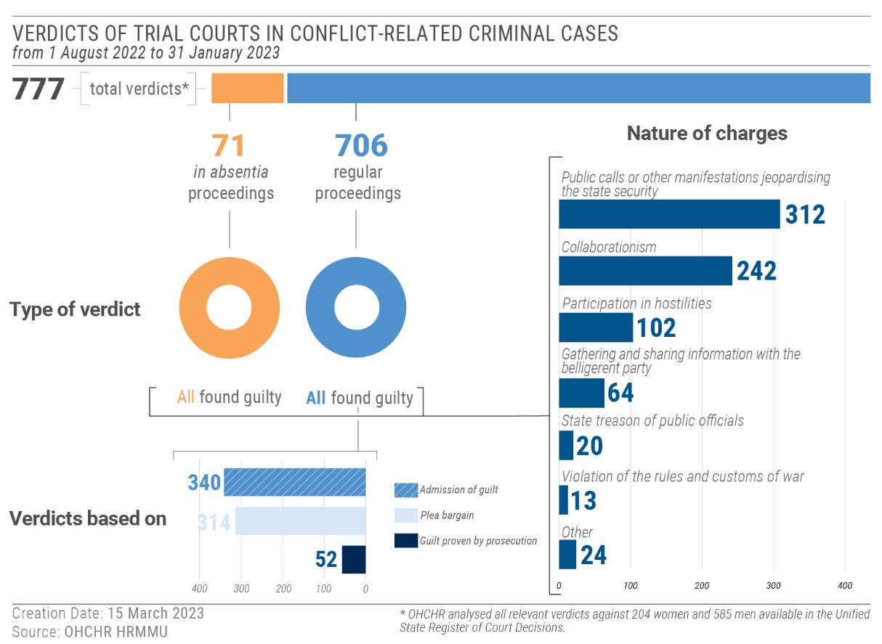
116. During the reporting period, Ukrainian courts delivered guilty verdicts against 69 men from Russian-affiliated armed groups, captured as POWs after 24 February 2022. They were charged with inter alia trespass against territorial integrity, state treason, membership in a terrorist organization, membership in unlawful armed formation and unlawful possession of firearms. Prison sentences ranged from 11 and 15 years. In interviews with OHCHR, ten POWs reported that courts had not examined the criminal charges against them and stated that they only pleaded guilty in order to be sentenced promptly and be included in an exchange of POWs. OHCHR recalls that sentencing members of Russian-affiliated armed groups for conduct constituting mere participation in the hostilities violates their combatant privilege. Moreover, OHCHR notes with concern that in cases for state treason, where intent is a mandatory element of the crime, Ukrainian courts did not consider the impact of forced recruitment of numerous members of Russian-affiliated armed groups.
117. OHCHR also continued to follow criminal proceedings against civilians prosecuted for conflict-related crimes. During the reporting period, Ukrainian courts rendered 271 verdicts in such cases against 271 persons (179 men and 94 women). OHCHR remains concerned that defendants are often denied the possibility of release on bail, which may put them under undue duress, as previously reported. Of concern, on 26 August 2022, an investigative judge of the Krasnohvardiiskyi district court in Dnipro did not allow OHCHR to observe a bail hearing in a conflict-related criminal case, referring to the protection of the parties’ health during the COVID-19 quarantine. Based on an analysis of 909 court judgments in conflict-related criminal cases, OHCHR found that courts remanded defendants in custody pending criminal proceedings in all but 30 cases. In this regard, OHCHR notes with concern that the Head of the SBU stated in a media interview that its agency had met with chairpersons of the Supreme Court and appeal courts, with the aim of ensuring that conflict-related detainees are not released from pre-trial detention pending the finalisation of proceedings.
118. OHCHR welcomes the stated commitment of the General Prosecutor’s Office of Ukraine to investigate all allegations of mistreatment of POWs, but regrets the lack of significant developments in these investigations and that no cases have yet been brought before courts. Of concern, since 24 February 2022, OHCHR has recorded from interviews and open sources seven incidents involving the summary executions of around 25 POWs and persons hors de combat, allegedly perpetrated by Ukrainian armed forces. In relation to five of these incidents involving 22 victims, Ukraine has initiated pre-trial investigations. OHCHR notes that these investigations have not yet resulted in charges being brought against any of the alleged perpetrators.
Law on collaboration activities
119. According to the Office of the Prosecutor General of Ukraine, as of 31 January 2023, 4,291 criminal proceedings had been launched under article 111-1 of the Criminal Code of Ukraine for collaborating with the Russian Federation. OHCHR is concerned that the law on collaboration activities does not comply with IHRL and IHL. In particular, the law encompasses individuals who carry out uncoerced work for the occupying authorities, which may include educational and medical workers, among others providing key services. This provision is not in line with the principles underlying the law of occupation under IHL, compliance with which presumes a certain level of cooperation between the occupation and local authorities. In addition, articles 50 and 56 of Geneva Convention IV explicitly require the cooperation of national and local authorities with the occupying power to ensure the functioning of medical establishments and educational and care facilities for children.
120. Moreover, the use of vague and subjective terminology in article 111-1 does not sufficiently comply with international human rights standards on restrictions of the rights to liberty, security of persons and freedom of expression, or with the principle of legality. OHCHR is also concerned at the apparent lack of proportionality between offences and applicable penalty.
121. In addition, the broad language of the law, which de facto criminalises all employment and business activities in the occupied territory, may impact the enjoyment of the rights to work and to an adequate standard of living for residents in Russian-occupied territory. OHCHR is concerned that the law may have a far-reaching impact not only on the rights of individuals living in occupied territory, but also on social cohesion and, ultimately, on future reintegration efforts.
122. Civilians prosecuted for the alleged crime of collaboration activity
During the reporting period, OHCHR interviewed eight individuals (three men and five women) prosecuted for the alleged crime of collaboration activity, including five persons who were charged with collaboration activity for continuing to work in a local public administration or under the occupation authorities while their villages and towns were occupied. In one case, an elderly woman who volunteered, without affiliation, to distribute food, was charged with collaboration activity and now faces 15 years in prison. Moreover, several individuals suspected of collaborating with the Russian Federation complained of arbitrary arrests, incommunicado detention in unofficial places, torture or ill-treatment during interrogations to extract confessions, denial of access to legal aid or other violations of the right to a fair trial.
VI. Technical cooperation and capacity building
123. During the reporting period, OHCHR published its 34th periodic report on the human rights situation in Ukraine; a thematic report on Killings of civilians in Kyiv, Chernihiv, and Sumy regions; and a three-month update on the human rights situation in Ukraine. OHCHR also released weekly updates on civilian casualties in Ukraine. OHCHR public reports are an important tool for advocacy by diverse actors with the Government to better respect, protect and fulfill human rights, on the basis of reliable and verified information about human rights and humanitarian law violations committed in Ukraine, enabling action to be taken for the protection of victims and for the accountability of perpetrators.
124. OHCHR engaged in sustained advocacy efforts with the Ukrainian Government on the protection of POWs. In November, it issued two statements presenting HRMMU’s findings on the treatment of POWs. OHCHR also undertook advocacy efforts with and provided technical advice to the Ukrainian Parliament, recommending amendments to several laws to bring them in line with international standards and best practices. OHCHR shared with the Prosecutor General’s Office data on civilian casualties among children from 2014 to 2021, to support the improvement of national capacity to record civilian casualties.
125. During his country visit to Ukraine in December 2022, the High Commissioner for Human Rights, Volker Türk, met with Government officials and called for strict compliance with international human rights and humanitarian law, encouraged accountability for all victims of the conflict, and advocated for strengthening the rule of law, civic space and democratic society in Ukraine. He also met with civil society organizations and families of victims and POWs.
126. OHCHR supported the United Nations Country Team in Ukraine (UNCT), including through developing joint UNCT submissions to the UN Committee on the Rights of Persons with Disabilities and to the UN Committee on the Elimination of Discrimination against Women. OHCHR also coordinated joint comments, with UNDP and UNHCR, to Ukraine’s amended national human rights strategy. In addition, OHCHR prepared regular updates on the six grave violations against children in times of war, and coordinated the UNCT contribution to the Secretary-General on conflict-related sexual violence.
127. HRMMU issued 3 statements and 43 social media posts, and appeared in over 665 media articles during the reporting period.
VII. Conclusions and recommendations
128. A year after the Russian Federation launched a full-scale armed attack against Ukraine, the hostilities continue to exert a severe toll on children, women and men across the country. OHCHR reiterates all calls upon the Russian Federation to immediately cease its armed attack, and for all parties to the conflict to fully respect their obligations under IHRL and IHL and to actively pursue a just and durable peace, in line with the UN Charter and international law, through intensified diplomacy and dialogue. It also calls on all Member States to support such a resolution of the international armed conflict.
129. While OHCHR has not been able to assess compliance with IHL for each individual incident, the patterns, frequency, scale and severity of civilian casualties and of destruction of and damage to civilian objects – including hospitals and schools – strongly indicate that recurring violations of IHL have taken place.
130. OHCHR is gravely concerned, in particular, by cases of killings, enforced disappearances, conflict-related sexual violence, forced transfers and deportation, forced conscription, torture and other ill-treatment of POWs, as well as significant restrictions to civil and political rights, and the broad impact of the armed conflict on the enjoyment of economic, social, and cultural rights across society. OHCHR reminds all parties to the conflict that the information in its reports aims to enable duty-bearers to take actions for the protection of victims, hold perpetrators to account, provide remedies and prevent further violations. OHCHR recalls that accountability should be pursued at all levels, with prioritisation of a victim-centered approach and support for survivors. National programmes of reparation and assistance to victims should also be considered, without awaiting the formal outcomes of legal proceedings.
131. OHCHR urges the implementation of the following recommendations, many of which have already been raised in previous reports:
132. To all parties to the conflict:
(a) Respect and ensure respect for international human rights law and IHL, at all times and in all circumstances;
(b) Ensure full compliance with IHL principles of distinction, proportionality and precaution, including by refraining from using explosive weapons in populated areas and from using or installing heavy weapons or other military objectives in or near populated areas;
(c) Ensure timely and effective investigations into all allegations of violations of IHL and human rights, including allegations of torture, ill-treatment, arbitrary detention and sexual violence; ensure that alleged perpetrators, including persons in positions of command, are duly prosecuted; and uphold the rights of victims and their families to truth, justice and reparations;
(d) Respect IHRL and IHL in relation to the treatment of POWs and persons hors de combat, and investigate and prosecute all cases of serious violations of IHL in relation to their treatment, regardless of the affiliation of the perpetrators;
(e) Cease prosecuting POWs entitled to combatant status under IHL for conduct which is in substance mere participation in the hostilities;
(f) Facilitate provision of information on a regular basis to relatives of POWs regarding them, in particular about their place of internment and health status, and ensure that POWs are able to correspond with the outside world, in line with the obligations of a detaining power under Geneva Convention III and the requirements of IHRL;
(g) Provide unimpeded, confidential access to OHCHR and other independent international monitors to all places of detention, including places of internment for POWs, wherever located;
(h) Uphold fair trial guarantees for all individuals prosecuted in relation to the international armed conflict, including POWs;
(i) Establish a functioning mechanism of tracing family links and family reunification for children transferred to the occupied territory of Ukraine and to the Russian Federation;
133. To the Russian Federation:
(j) Immediately cease the armed attack that commenced on 24 February 2022 in the territory of Ukraine and fully comply with the binding order on provisional measures issued by the International Court of Justice on 16 March 2022;
(k) Ensure that any evacuation, including of children, is conducted in full respect of IHRL and IHL;
(l) Immediately cease the practice of arbitrary detention and enforced disappearance, and investigate cases committed by Russian armed forces, law enforcement agencies, with a view of prosecuting and punishing those responsible, and ensure effective remedies to victims;
(m) Immediately release all civilians subjected to enforced disappearance and arbitrary detention by Russian armed forces and law enforcement agencies;
(n) Ensure that any grant of amnesty is with strict respect to international law and does not encompass gross violations of IHRL, serious violations of IHL or other international crimes;
(o) Take all necessary precautionary measures to prevent sexual violence and implement a zero tolerance policy within its armed forces, including through issuing clear orders prohibiting sexual violence against civilians, prisoners of war, and members of its own forces, and by holding perpetrators to account;
(p) Ensure that lawyers and human rights defenders in Crimea can perform their professional functions without intimidation, hindrance, harassment or improper interference;
(q) Respect and ensure that the rights to freedom of opinion and expression, peaceful assembly, association, thought, conscience and religion can be exercised without discrimination by all individuals and groups in territory under its occupation, and take measures to create an environment conducive to the free exchange of information and ideas;
(r) Refrain from wholesale restrictions on social media websites or on websites of media outlets and civil society organizations;
(s) Ensure individuals in Crimea can express opinions that are critical of the Government or of the armed attack by the Russian Federation against Ukraine, without retaliation, imprisonment or other content-based sanction;
(t) End the conscription of Ukrainian nationals residing in Crimea into its armed forces and any pressure or propaganda aimed at securing voluntary enlistment;
(u) Provide representatives and staff of international human rights and humanitarian organisations, including those of the United Nations, with full, unhindered, timely, and safe access to persons who have been transferred from conflict-affected areas of Ukraine to the Russian Federation or to areas of Ukraine controlled by Russian armed forces;
(v) Strengthen cooperation and prompt exchange of information with OHCHR by establishing and guaranteeing dedicated communication channels;
(w) Adhere to the prohibition of changing the personal status of children displaced from Ukraine, including nationality, and of adoption during or immediately after emergency, in line with international standards;
(x) Ensure that no adoptions of children separated from their parents take place during and immediately after the international armed conflict;
134. To the Parliament and the Cabinet of Ministers of Ukraine:
(y) Bring the recently adopted laws “On Media” and “On National Minorities (Communities) of Ukraine” fully in line with international standards;
(z) Ensure that draft laws no. 8221, 8262 and 8371 fully comply with the requirements of articles 18 (“freedom to manifest one’s religion or belief) and 22 (“freedom of association”) of the ICCPR;
135. To State and local authorities in Ukraine:
(aa) Take effective measures to ensure that all victims of sexual violence and torture can access adequate medical and psychological services, including sexual and reproductive health services, such as post exposure prophylaxis (PEP) and emergency contraception, in a safe, confidential, gender-sensitive and rapid manner;
(bb) Take effective measures to ensure that displaced older persons and persons with disabilities can access timely quality healthcare and rehabilitation services;
(cc) Continue efforts for the deinstitutionalization of persons with disabilities, including those who were evacuated from places of active hostilities to safer regions;
(dd) Ensure the provision of adequate social assistance to all in need by further simplifying administrative requirements and processes and by broadening the definition of people considered as displaced or in precarious situations, and take adequate steps to ensure everyone’s access to adequate and affordable housing;
(ee) Ensure that victims and survivors have fair, effective and prompt access to justice; consider national programmes of reparation providing necessary medical, psychosocial, financial and other forms of assistance to victims;
136. To the Office of the Prosecutor-General and State Bureau of Investigation and other law enforcement agencies:
(ff) Issue internal instructions for the effective investigation of sexual violence, ill-treatment and torture based on international standards and practice (e.g. Istanbul Protocol and the International Protocol on the Documentation and Investigation of Sexual Violence in Conflict), conduct investigations into such allegations with due regard to the rights, needs and wishes of survivors, and in a gender and age sensitive manner;
(gg) Investigate and prosecute all cases of enforced disappearance to hold all perpetrators accountable, regardless of their affiliation, and provide victims effective remedy;
137. To the Judiciary of Ukraine:
(hh) Respect, protect and ensure full enjoyment of the rights to due process and fair trial for all individuals charged with crimes in relation to the armed attack by the Russian Federation, including war crimes; in particular, ensure respect for the presumption of innocence, the right to effective legal assistance, and the right to a trial before an independent and impartial court;
(ii) Respect and apply international human rights standards when considering pre-trial measures for individuals accused of conflict-related crimes, in particular, by not limiting pre-trial restrictive measures to detention alone;
138. To the international community:
(jj) Urge the parties to respect IHRL and IHL in Ukraine, and work collectively to ensure remedy, redress and reparation for violations and to prevent further violations;
(kk) Support efforts to ensure accountability, at the national and international levels, for all violations of IHRL and IHL committed in Ukraine, and work to ensure, as appropriate, effective coordination and coherence between accountability actors at national, regional and international levels;
(ll) Support national institutions, local civil society networks and other relevant actors by providing resources and strengthening their capacities to work with survivors, in particular those of sexual violence, torture or other ill-treatment and enforced disappearance, and to provide non-discriminatory comprehensive assistance, particularly in smaller towns and rural areas;
(mm) Support implementation of the updated National Action Plan on “Women, Peace and Security”;
(nn) Support human rights defenders, including networks of women human rights defenders, who work for the protection of human rights in Ukraine;
(oo) Assist Ukraine in enhancing its capacity for safe, efficient, and effective demining operations and support programs to educate civilians to the risks posed by mines and ERWs, particularly in areas over which Ukraine has regained control.

HRMMU was deployed on 14 March 2014 to monitor and report on the human rights situation throughout Ukraine, with particular attention to the Autonomous Republic of Crimea, eastern and southern regions of Ukraine, and to propose recommendations to the Government and other actors to address human rights concerns. For more information, see A/HRC/27/75, paras. 7-8.
OHCHR refers to Russian armed forces as comprising all actors fighting on behalf of the Russian Federation, including the Armed Forces and National Guard Forces of the Russian Federation, as well as affiliated armed groups of the former self-proclaimed ‘republics’ and Wagner Group military and security contractors. In the same way, OHCHR refers to Russian prisoners of war (POWs) in relation to all individuals from the above-mentioned forces that fell into the hands of the belligerent party, regardless of their nationality.
See General Assembly resolutions 68/262, 71/205, 72/190, 73/194, 73/263, 74/17, 74/168, 75/29, 75/192, 76/179 and 77/229.
OHCHR refers to Ukrainian armed forces as comprising all actors fighting on behalf of Ukraine, namely the Armed Forces of Ukraine (including units of the Territorial Defense), National Guard of Ukraine and State Border Guard Service of Ukraine, both under the authority of the Ministry of Interior, some units of the Security Service of Ukraine (SBU), National Police and other law-enforcement agencies directly engaged in hostilities, as well as members of organized resistance movements. OHCHR refers to Ukrainian POWs in relation to all individuals from the above-mentioned forces that fell in the hands of the belligerent party, regardless of their nationality.
With 672 men and 418 women interviewed.
See OHCHR, Report on the human rights situation in Ukraine, 16 February to 15 May 2019, available at www.ohchr.org/Documents/Countries/UA/ReportUkraine16Feb-15May2019_EN.pdf, para. 20.
These incidents involve civilians who were killed or injured by mines (antipersonnel or anti-vehicle), other explosive devices such as booby traps, or unexploded ordnance which inadvertently detonated when touched.
PFM-1 mines, also known as butterfly mines, are Russian or Soviet made high explosive anti-personnel land mines. OHCHR is following up on all reported cases of the use of PFM-1 mines in Ukraine, both in Government-controlled territory and in territory occupied by the Russian Federation. In 2022, the number of such reports significantly increased, reaching their peak in August. The use of PFM-1 mines, especially when they are planted in populated areas, may amount to an indiscriminate attack on civilians and therefore an IHL violation.
See Additional Protocol I, arts. 48, 51(2) and (4). Parties to a conflict must always distinguish between civilians and combatants. Direct attacks on civilians, indiscriminate attacks and the use of indiscriminate weapons are prohibited. In addition, customary IHL obliges the parties to a conflict to take particular care to minimize the indiscriminate effects of anti-personnel mines, see ICRC CIHL Database, Rules 81-83.
See Additional Protocol I, art. 35(2). OHCHR notes that the Ottawa Convention bans the use of anti-personnel mines. The Russian Federation has not ratified the Ottawa Convention but is bound by the Protocol on Prohibitions or Restrictions on the Use of Mines, Booby-Traps and Other Devices (Protocol II, as amended on 3 May 1996) annexed to the Convention on Prohibitions or Restrictions on the Use of Certain Conventional Weapons which may be deemed to be Excessively Injurious or to have Indiscriminate Effects (Convention on Certain Conventional Weapons). It prohibits the use of anti-personnel mines which are not detectable, restricts anti-personal mines which do not have self-destruct or self-deactivation features, obliges belligerents to remove them after the end of active hostilities and take all feasible precautions to protect civilians from their effects.
See Protocol on Explosive Remnants of War to the Convention on Prohibitions or Restrictions on the Use of Certain Conventional Weapons which may be deemed to be Excessively Injurious or to have Indiscriminate Effects (Protocol V), 2003.
Article 19 of the Geneva Convention I for the Amelioration of the Condition of the Wounded and Sick in Armed Forces in the Field; article 18 of the Geneva Convention IV relative to the Protection of Civilian Persons in Time of War; article 12 of the Protocol Additional to the Geneva Conventions of 12 August 1949, and relating to the Protection of Victims of International Armed Conflicts; rule 28 of customary IHL. According to article 13(1) of Additional Protocol I, hospitals lose the protection afforded by IHL if they are used to “commit, outside their humanitarian function, acts harmful to the enemy”. However, in such cases, the protection may cease “only after a warning has been given setting, whenever appropriate, a reasonable time-limit, and after such warning has remained unheeded”. Even when hospitals have lost their special protection, the general rules of IHL apply, including the principle of proportionality.
The Ministry of Healthcare reported that 540 medical facilities had been destroyed or damaged since 24 February 2022 (Ukrinform, The healthcare system is confidently holding the medical front, 12 February 2023, www.ukrinform.ua/rubric-society/3668211-viktor-lasko-ministr-ohoroni-zdorova-ukraini.html, last consulted on 10 March 2023). The Ministry of Education and Science reported that 441 educational facilities had been destroyed and 3,121 damaged since 24 February 2022 (Official Telegram channel, Sergiy Shkarlet, 21 February 2023, https://t.me/SerhiyShkarlet/2178, last consulted on 10 March 2023).
Even if some of the targeted power plants may have been military objectives, or had a dual function in that they served both civilian and military purposes, Russian armed forces must nevertheless fully abide by the principle of proportionality, which prohibits attacks against military objectives which are “expected to cause incidental loss of civilian life, injury to civilians, damage to civilian objects, or a combination thereof, which would be excessive in relation to the concrete and direct military advantage anticipated” (article 51(5)(b) of Protocol Additional to the Geneva Conventions of 12 August 1949, and relating to the protection of victims of international armed conflicts (Protocol I), of 8 June 1977).
The Russian Parliament ratified the “Treaties on the Accession” on 3 October 2022. Nevertheless, they took effect from the date of their signature, i.e. on 30 September 2022, according to the reservations made by the “Parties” to each “Treaty”.
Article 8 of each “Treaty”.
Article 43 of the Hague Regulations Concerning the Laws and Customs of War on Land, annexed to the Hague Convention IV.
Article 64 of Geneva Convention IV relative to the Protection of Civilian Persons in Time of War of 12 August 1949.
See OHCHR, Killings of civilians: summary executions and attacks on individual civilians in Kyiv, Chernihiv, and Sumy regions in the context of the Russian Federation’s armed attack against Ukraine, December 2022, available at https://www.ohchr.org/en/documents/country-reports/killings-civilians-summary-executions-and-attacks-individual-civilians
In such cases detainees were held incommunicado, including in makeshift places of detention, and their relatives had no information about their fate and whereabouts during some or the entire period of detention. Although the Russian Federation has not ratified the International Convention for the Protection of All Persons from Enforced Disappearance, the prohibition on enforced disappearances constitutes customary IHL and is therefore binding on all states. See Rule 98, ICRC Database on Customary IHL. Furthermore, the Human Rights Committee has noted that enforced disappearances result in a violation of the right to life and other rights under the International Covenant on Civil and Political Rights (ICCPR): General Comment no. 36, para. 58.
IHRL and IHL both prohibit the arbitrary deprivation of liberty, see ICCPR art. 9 (1); ICRC Customary IHL Study, Rule 9; Human Rights Committee, General Comment no. 35, paras. 12 and 64. The aspects of justified deprivation of liberty are reflected in the article 9 of the ICCPR, ratified by the Russian Federation. On elements that indicate the arbitrariness of arrest and detention, see Human Rights Committee, General Comment No. 35, paras. 10-23.
In some cases, victims were too traumatised to share information directly with OHCHR or remained in the territory of Ukraine occupied by the Russian Federation.
Before the arrest, FSB and Russian servicemen visited the victim several times to persuade him to cooperate with the occupying authorities.
The precarious security situation in parts of Ukraine, stigma and trauma associated with sexual violence, lack of victims’ access to services (including sexual and reproductive health services) and breakdown in referral pathways are all factors contributing to the continued underreporting of such cases.
79 cases were documented during the reporting period.
Cases were documented in Kyiv, Kharkiv, Kherson, Chernihiv and Zaporizhzhia regions.
On one occasion only, on 19 August 2022, OHCHR was allowed to meet with a group of Ukrainian POWs interned in a pre-trial detention facility (SIZO) in Luhansk. However, OHCHR was not allowed to speak with them confidentially.
OHCHR, Report on the Treatment of Prisoners of War and Persons Hors De Combat in the Context of the Armed Attack by the Russian Federation against Ukraine – 24 February 2022 to 23 February 2023, March 2023. Available at https://www.ohchr.org/en/documents/country-reports/report-treatment-prisoners-war-and-persons-hors-de-combat-context-armed
The only part of Odesa region that was controlled by Russian armed forces was the Zmiinyi Island, from February to June 2022.
The man was able to call his relatives while he was still in Ukraine.
See OHCHR, Update on the human rights situation in Ukraine 1 August – 31 October 2022, December 2022, available at www.ohchr.org/sites/default/files/documents/countries/ua/2022-12-02/HRMMU_Update_2022-12-02_EN.pdf
MK.ru, Ombudsman Lvova-Belova took into custody a boy from Mariupol, 13 July 2022, www.mk.ru/social/2022/07/13/ombudsmenlvovabelova-vzyala-pod-opeku-malchika-iz-mariupolya.html (last consulted on 23 November 2022).
See OHCHR, Update on the human rights situation in Ukraine, 1 August – 31 October 2022, p. 3.
Website of the Commissioner on Child Rights, The HRC sent a rebuttal to international organizations about the forced removal of Ukrainian children, 19 October 2022, http://deti.gov.ru/articles/news/spch-napravil-v-mezhdunarodnye-organizacii-oproverzhenie-fejkov-o-prinuditel-nom-vyvoze-ukrainskih-detej (last consulted on 10 March 2023).
Russian Agency for Legal and Judicial Information (RAPSI), Every child should have a family: Lvova-Belova about the year 2022, 30 December 2022, available at https://rapsinews.ru/human_rights_protection_publication/20221230/308602742.html (last consulted on 10 March 2023).
Website of the Commissioner on Child Rights, Maria Lvova-Belova and Karim Atassi, Head of the UNHCR Office in the Russian Federation, discussed the situation of orphans of Donbas in Russia, 24 October 2022, http://deti.gov.ru/articles/news/mariya-l-vova-belova-i-glava-predstavitel-stva-uvkb-oon-v-rf-karim-atassi-obsudili-polozhenie-detej-sirot-donbassa-v-rossii (last consulted on 10 March 2023).
OHCHR verified such instances from Kharkiv region that occurred during the previous reporting periods. Some children have not reunited with their parents as of December 2022.
Kuban 24, In Gelendzhik, children from Kharkiv region began to learn the school curriculum, 22 September 2022, https://kuban24.tv/item/v-gelendzhike-deti-iz-harkovskoj-oblasti-nachali-obuchenie-po-shkolnoj-programme (last consulted on 10 March 2023).
See United Nations Convention on the Rights of the Child, arts. 8-9.
In late October 2022, Russian authorities stated that after 24 February, during different time periods, between 1500 and 2500 children from Ukraine were residing in temporary accommodation centres; some stayed there, while others were resettled to social institutions or given to Russian foster families. According to the Ukrainian authorities, as of mid-November 2022, 11,225 children were deported to the Russian Federation or forcibly transferred to Russian-occupied territory of Ukraine. Of them, 7,644 were reported as transferred from Donetsk region, and 116 were orphaned or deprived of parental care. No data is available regarding how many of them were unaccompanied. (Source: OHCHR correspondence with Office of the Ukraine Parliamentary Commissioner for Human Rights, 17 November 2022, and with National Information Bureau of Ukraine, 19 November 2022.)
Geneva Convention IV, art. 51. Legislative restrictions and penalties for media reporting and the expression of opinions (see section IV.D) mean that access to independent information about the armed attack against Ukraine remains severely limited for any prospective service members. Furthermore, as noted in A/77/220, para. 44, State-controlled reporting and the introduction of special lessons in schools on the “operations” of the Russian military in Ukraine could be viewed as measures aimed at securing voluntary enlistment for engagement in hostilities against Ukraine.
Geneva Convention IV, art. 147.
See Human Rights Committee, General Comment no. 36, para 26.
Article 5 of the “Treaties on the Accession of the Donetsk People’s Republic, the Lugansk People’s Republic, the Zaporozhye Region and the Kherson Region to the Russian Federation”.
These acts are punishable under article 207.3 of the Russian Federation Criminal Code and the article 20.3.3 of the Code of Administrative Offenses. These laws significantly restrict the right to freedom of expression, including the freedom to seek, receive and impart information and ideas of all kinds in accordance with ICCPR, art. 19(2). Additionally, the application of such legislation in Crimea violates the Russian Federation’s obligation, as the occupying Power, to respect the penal laws of the occupied territory according to Geneva Convention IV, art. 64.
Bayraktar is a Ukrainian patriotic propaganda song that became popular after its release on 1 March 2022. It refers to the Baykar Bayraktar TB2 combat drone and its deployment against Russian troops.
Law “On control of activities of individuals under foreign influence”, Federal Law No. 255-FZ.
Those included “Novoe Pokolenie” (New Generation) or “Melitopol Christian Church”, “Slovo Zhyttia” (Word of Life) and “Blahodat” (Grace) temples.
Under customary IHL, individuals entitled to POW status have combatant immunity and cannot be prosecuted for having participated in hostilities, or for lawful acts of war committed in the course of the international armed conflict, even if such acts would otherwise constitute an offence under domestic law. POWs charged with crimes or subject to disciplinary sanctions are entitled to due process and fair trial guarantees. No sentence or punishment may be passed on them unless it is delivered by an impartial and regularly constituted court. See Geneva Convention IV, arts. 99-108. See also ICCPR, art. 14; Geneva Convention III, arts. 102-108; Additional Protocol I, art. 75(4).
Article 105 of Geneva Convention III provides that “documents which are generally communicated to the accused by virtue of the laws in force in the armed forces of the Detaining Power, shall be communicated to the accused prisoner of war in a language which he understands, and in good time before the opening of the trial”.
Geneva Convention III, art. 130; Additional Protocol I, art. 85(4)(e).
See article 2 of the draft federal law No.246425-8 “On the application of provisions of the Russian Federation Criminal Code and Criminal Code of Procedure in the territories of the Donetsk People’s Republic, Lugansk People’s Republic, Zaporozhye and Kherson regions”. The suggested amnesty also extends to acts committed for the sake of “protecting the interests of the Donetsk People’s Republic, Lugansk People’s Republic, protected interests of the citizens or organizations of the Russian Federation, Donetsk People’s Republic, Lugansk People’s Republic, the population and organizations of Zaporozhye and Kherson regions”.
Convention for the Protection of All Persons from Enforced Disappearance, arts. 1-2. Ukraine ratified the Convention in 2015.
In March 2022, Ukraine notified the United Nations Secretary-General of its derogation from certain human rights obligations for the duration of the martial law, including article 9 of the ICCPR, which prohibits the arbitrary or unlawful deprivation of liberty. The Human Rights Committee has maintained that the fundamental guarantee against arbitrary detention is non-derogable, including the protection against deprivation of liberty that is unreasonable or unnecessary under the circumstances. Moreover, the lawfulness of the derogation must be assessed in each particular case on the basis of whether “strictly required by the exigencies of the situation”. ICCPR, art. 4(1); General Comment no. 35, paras. 4, 65-66.
Articles 211 and amendments to article 615 of the Criminal Procedure Code made on 27 July 2022.
Ukraine did not justify why it was in the national interest to prohibit the sailors from leaving the territory of Ukraine, and did not follow the appropriate procedures for such a prohibition: see Geneva Convention IV, art. 35. Ukraine did not intern the sailors in line with requirements of articles 41-43 of the Convention or detain them in a manner otherwise reasonable or necessary in accordance with IHRL.
As noted above in section IV.B, OHCHR documented 13 cases of CRSV in total throughout this period.
All cases occurred from March to July 2022, but were documented during the reporting period.
Suspilne media, The GPO presented a strategy for victims of sexual violence during the war, 14 October 2022, available at: https://suspilne.media/294906-v-ogpu-prezentuvali-strategiu-dla-postrazdalih-vid-seksualnogo-nasilstva-pid-cas-vijni (last consulted on 13 March 2023).
Survivor Relief Centers, available at: https://1547.ukc.gov.ua/dovidkova-informatsiya/tsentry-dopomogy-vryatovanym
National Action Plan for the Implementation of United Nations Security Council Resolution 1325 on “Women, Peace and Security” for the period until 2025, as amended in accordance with the Order of the Cabinet of Ministers No. 1150 of 12/16/2022, available at: https://zakon.rada.gov.ua/laws/show/1544-2020-%D1%80#Text
Ukrinform, Panel discussion: 16 Days Against Violence, video, 25 November 2022, watch from 30:25, www.ukrinform.ua/rubric-presshall/3621161-16-dniv-proti-nasilstva.html (last consulted on 10 March 2023).
Rozirvy kolo, 4 August 2022, Facebook post, https://z-upload.facebook.com/rozirvykolo/posts/5047601618685067 (last consulted on 10 March 2023).
SIZOs in Dnipro, Kharkiv, Kyiv, Poltava, Zaporizhzhia, Odesa, Kryvyi Rih and the POW camp in Lviv region.
OHCHR, Report on the Treatment of Prisoners of War and Persons Hors De Combat in the Context of the Armed Attack by the Russian Federation against Ukraine – 24 February 2022 to 23 February 2023, March 2023. Available at https://www.ohchr.org/en/documents/country-reports/report-treatment-prisoners-war-and-persons-hors-de-combat-context-armed
Cabinet of Ministers Resolution No. 457, 16 April 2022. Available at: https://zakon.rada.gov.ua/laws/show/457-2022-%D0%BF#Texthttps://zakon.rada.gov.ua/laws/show/457-2022-%D0%BF#Text.
OHCHR, Update on the human rights situation in Ukraine, December 2022, available at www.ohchr.org/sites/default/files/documents/countries/ua/2022-12-02/HRMMU_Update_2022-12-02_EN.pdf
World Bank Ukraine, Rapid Damage and Needs Assessment, August 2022, p. 94, https://openknowledge.worldbank.org/handle/10986/37988 (last consulted on 30 November 2022).
See the Letter of Intent and Updated Memorandum of Economic and Financial Policies between IMF and Ukraine.
World Bank, Ukraine Rapid Damage and Needs Assessment, August 2022.
Cabinet of Ministers Resolution No. 473, “The procedure for performing urgent work to eliminate the consequences of armed aggression of the Russian Federation related to damage to buildings and structures”, 19 April 2022. Available at www.minregion.gov.ua/napryamki-diyalnosti/building/normatyvno-pravove-regulyuvannya-pytan-obstezhennya-ta-vykonannya-pershochergovyh-robit-z-vidnovlennya-poshkodzhenyh-obyektiv/.
According to Government estimates, the average monthly rent for a 1-room apartment increased by 32.7 per cent from UAH 4,294 to UAH 5,699 in 2022. In Lviv, the average rental price increased by 2.1 times to UAH 10,977, while Dnipro region saw an increase of 65 per cent. See sctp_22ue.xlsx (live.com)
Decree № 56
The Draft law registered on 30 March 2022 allowing for the establishment of marginal rental prices has not yet been adopted.
Cabinet of Ministers Resolution No. 1401, “Issues of organization and functioning of points of invincibility”, 17 December 2022. Available at: https://zakon.rada.gov.ua/laws/show/1401-2022-%D0%BF#Text.
The law will enter into force on 31 March 2023 with the exception of certain provisions which will enter into force on other dates as prescribed by the Law.
An exception is prescribed for “citizens of the aggressor state” who have residence permits in Ukraine.
Restrictions on freedom of expression imposed by the law are so overly broad that they fail to meet the tests of necessity and proportionality for such restrictions, as established by article 19 (3) of the ICCPR and interpreted by the Human Rights Committee. The categories outlined in the law relating to the publication of material that promotes the actions of aggressor or occupying State, and of material featuring persons included in the list of persons who are posing a threat to the national media space, exceed in their scope specific threats to national security. In addition, the law forbids individuals or entities from broadcasting in Ukraine simply because they are citizens, residents, or are linked to an aggressor or occupying State, which appears discriminatory in nature and likewise fails to meet the standards for permissible restrictions under article 19 (3).
On 1 March 2022, Ukraine notified the United Nations Secretary-General of the derogation from certain of its human rights obligations, in accordance with article 4 of the ICCPR. Ukraine notified the United Nations Secretary General of its waiver of obligations under arts. 3, 8(3), 9, 12, 13, 17, 19, 20, 21, 22, 24, 25, 26 and 27 of the ICCPR. Article 4(2) of the ICCPR specifically provides that no derogation may be made from article 18, which contains inter alia provisions on freedom of religion.
For instance, by allowing a transition by vote of the majority present instead of the majority of the community.
The SBU stated that warrants were issued authorizing searches in Dnipro, Rivne, Ternopil and some facilities in Kyiv.
The Ukrainian Orthodox Church, often informally referred to as “Moscow Patriarchate”, is one of largest Orthodox Christian religious organizations currently active in Ukraine. In February 2022, leaders of the UOC criticized the actions of Russian Federation and declared the cutting of organizational ties with the Russian Orthodox Church. These decisions of the UOC were later formalized through changing its charter.
Procedural requirements for investigative activities (including searches) are reflected in the Ukrainian Criminal Procedure Code. While the activities of the SBU were similar to searches, these actions were officially referred to as ‘security measures’. The SBU did not specify why it did not apply the regular search procedure.
For instance, article 10(2) of the Law allows individuals belonging to national minorities to hold public events (meetings, conferences, rallies, exhibitions, training courses, seminars, training sessions, discussions, fora and others) in the languages of these national minorities.
Such differential treatment is provided by the Law “On ensuring the functioning of the Ukrainian language as the state language” and the Law “On general secondary education”.
This may contravene Article 11.3 of the Framework Convention for the Protection of National Minorities and Article 10.2 of the European Charter for Regional or Minority Languages.
These include the right to freedom of peaceful assembly, the right to receive state funding for events associated with the implementation of the rights and freedoms of national minorities, the right of representatives of national minority NGOs to participate in advisory bodies of state administrations and local councils, and other rights mentioned in paragraph 3 of the “Transitional Provisions” of the law.
The United Nations Human Rights Committee in Maleki v. Italy concluded that a State bore a burden of proof to demonstrate that the accused had been “summoned in a timely manner” and “informed of the proceedings against him”. The Committee reasoned that it is the obligation of a domestic court to verify that the accused had actual knowledge about a case before commencing a trial in absentia. Merely taking steps to inform an accused and assuming, in light of those steps, that the accused has acquired actual knowledge of the proceedings against him is insufficient.
While IHL does not explicitly prohibit the prosecution for state treason of combatants who defected, OHCHR is concerned that the prosecution for state treason of persons serving in Russian-affiliated armed groups is inconsistent with the principle of combatant immunity
See article 370 of the Criminal Procedure Code of Ukraine, No.4651-VI of 12 April 2012.
Crimes against national security (articles 109 - 114-2, chapter I of the Special Part of the Criminal Code), certain crimes against public security (articles 258 - 258-5, 260 chapter IX of the Special Part of the Criminal Code), crimes against peace, security of humanity and international order (articles 436 – 438, chapter XX of the Criminal Code).
OHCHR, Human Rights in the Administration of Justice in Conflict-Related Criminal Cases in Ukraine, April 2014 – April 2020. See ICCPR, art. 9; Human Rights Committee, General Comment no. 35.
OHCHR notes that neither the judge nor the parties wore any protective gear like masks at the beginning of the hearing, before OHCHR was ordered to leave the courtroom. On 13 September, OHCHR wrote to the court requesting that the judge share the records (including video and audio records) of the hearings, but has not received any reply.
See interview on Youtube, A bouquet of cotton from the Head of the SSU. Natalia Moseichuk - Vasyl Maliuk, 21 December 2022, last consulted on 10 March 2022 at www.youtube.com/watch?v=TmvSXKejas0&t=1084s&ab_channel=%D0%9D%D0%B0%D1%82%D0%B0%D0%BB%D1%96%D1%8F%D0%9C%D0%BE%D1%81%D0%B5%D0%B9%D1%87%D1%83%D0%BA.
This article, which establishes criminal liability for collaborating with an “aggressor State”, was introduced by law no. 2108-IX, which was adopted by the Parliament of Ukraine on 3 March 2022. The law punishes a wide range of conducts, including denying the existence of an aggression against Ukraine, working for and transferring property to occupying authorities, holding positions in courts or law enforcement authorities of the occupying power. The penalties include banning offenders from specific activities or posts, confiscation of private property, and up to life in prison.
In accordance with these principles, the occupying power does not acquire sovereignty over the occupied territory and is required to maintain a life in the occupied territory as normal as possible.
According to IHRL, these rights can be restricted only subject to strict conditions (see articles 9(1) and 19(3) of the ICCPR and article 1 of Protocol to the Convention for the Protection of Human Rights and Fundamental Freedoms). One of these conditions is that such restrictions must be provided by law, which must be formulated with sufficient precision to enable an individual to regulate his or her conduct accordingly (See Human Rights Committee, General Comment No. 35, para. 22; Human Rights Committee, General Comment No. 34, para. 25; European Court of Human Rights, Beyeler v. Italy [Grand Chamber], para. 109).
Article 15 of the ICCPR requires that “all elements of crime are in explicit and precise terms encapsulated in the legal definitions of the crimes” (A/HRC/10/3/Add.2, para. 53).
The law criminalizes “commercial activities in co-operation with the aggressor state or the occupation authorities”. The scope of such “co-operation” is not defined.
Enshrined in articles 6 and 11 of the International Covenant on Economic, Social and Cultural Rights.
Indeed, such individuals knowing that they may receive harsh punishments for collaboration activities, may, de facto, be forced to stop working in occupied territory. This, in turn, may result in the loss of their income and, thus, limit their and their families’ access to adequate food, clothing, housing, heating and other living conditions.
OHCHR notes that, following the enactment of the law, a number of draft laws containing amendments to it were registered in parliament. However, these draft laws also raise concerns about their compliance with international standards.
OHCHR was informed that to determine individuals who collaborated with the Russian Federation in the areas recently retaken by Ukraine, SBU officers often interrogated individuals who remained in their villages during the Russian occupation. Such measures were carried out in the course of the so-called ‘filtration’ procedures.

