A/HRC/51/CRP.1
29 September 2022

English only
Human Rights Council
Fifty-first session
12 September–7 October 2022
Agenda item 10
Technical assistance and capacity-building
Situation of human rights in Ukraine: 1 February to 31 July 2022
Office of the United Nations High Commissioner for Human Rights
Conference room paper

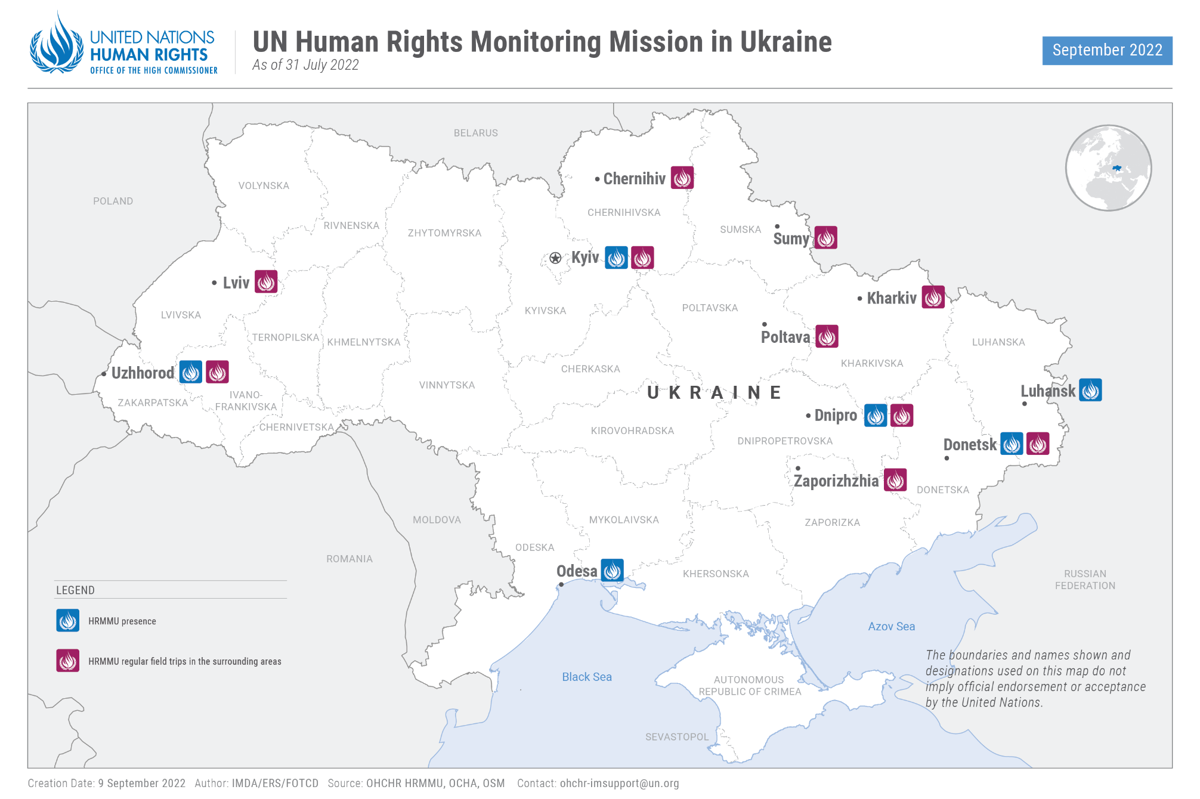
I. Executive Summary
1. This thirty-fourth report by the Office of the High Commissioner for Human Rights (OHCHR) on the human rights situation in Ukraine covers the period from 1 February 2022 to 31 July 2022. It is based on the work of the United Nations Human Rights Monitoring Mission in Ukraine.
2. The ongoing armed attack by the Russian Federation against Ukraine and associated hostilities have resulted in a dire human rights situation across the country. The armed conflict has led to a wide range of human rights violations affecting both civilians and combatants. OHCHR has verified numerous allegations of arbitrary deprivation of life, arbitrary detention and enforced disappearance, torture and ill-treatment, and conflict-related sexual violence (CRSV).
3. During the reporting period, OHCHR recorded a total of 12,649 civilian casualties, with 5,385 persons killed and 7,264 persons injured. However, actual casualty numbers are likely considerably higher, since these figures only include the cases that OHCHR has been able to verify. A large number of civilian casualties resulted from attacks where explosive weapons with wide area effects were used.
4. The hostilities have severely impacted civilian infrastructure and housing. OHCHR recorded damage or destruction to 252 medical facilities, 384 educational facilities and 90 places of worship. The hostilities have also infringed on the enjoyment of other human rights, including the rights to health, work, education, housing and freedom of religion or belief.
5. OHCHR continued to document and verify allegations of unlawful killings of hundreds of civilians by Russian armed forces while they controlled settlements in the Kyiv, Chernihiv, Sumy and Kharkiv regions in February and March 2022. Most victims were men, but there were also women and children. As the recovery, exhumation and identification of mortal remains is ongoing, the scale of civilian casualties is yet to be fully assessed. OHCHR also documented at least six killings of civilians perceived as so-called ‘traitors’ for their alleged collaboration with the Russian Federation in areas occupied by it or controlled by Russian armed forces or affiliated armed groups.
6. OHCHR is also concerned about the arbitrary detention and enforced disappearance of representatives of local authorities, journalists, civil society activists and other civilians by Russian armed forces and affiliated armed groups. OHCHR documented 407 cases of enforced disappearance (359 men, 47 women, 1 boy) attributable to Russian armed forces and affiliated armed groups. Among the victims, 17 men and 1 woman were eventually found dead. OHCHR also documented 47 cases of arbitrary arrest and detention, as well as 31 cases that may amount to enforced disappearance (28 men and 3 woman) attributable to the Ukrainian law enforcement bodies. The victims were persons suspected of providing support to Russian armed forces and affiliated armed groups.
7. OHCHR is particularly concerned about torture and ill-treatment of civilian detainees by Russian security forces and affiliated armed groups, which was documented in most areas under Russian control. Out of 38 civilians released from detention (34 men, 4 women) and interviewed by OHCHR, 33 reported experiencing torture and ill-treatment while in detention. OHCHR also documented complaints about torture and ill-treatment in 34 cases of arbitrary detention and enforced disappearance perpetrated by law enforcement bodies of Ukraine.
8. OHCHR documented cases of CRSV against women, girls, and men, although it remains difficult to verify cases and assess the breadth of sexual violence. Sexual violence remains underreported, notably due to stigma and limited access to services as a result of the prevailing security situation. OHCHR verified 43 cases of CRSV, mostly attributable to Russian armed forces. They occurred in different regions of Ukraine, including Kyiv and Chernihiv regions. CRSV against women and girls mostly occurred in residential areas controlled by Russian armed forces, close to military positions, while CRSV against men was typically part of torture and ill-treatment by Russian armed forces inflicted in detention.
9. OHCHR documented violations of international human rights law and international humanitarian law (IHL) by the belligerent parties in relation to the treatment of prisoners of war and persons hors de combat. Attributable to one or both parties these include extrajudicial executions, torture and ill-treatment, sexual violence, prosecution of prisoners of war for participation in the hostilities, violation of fair trial guarantees, denial of medical assistance, exposure to public curiosity, violations in relation to the conditions of internment, lack of food and water, poor sanitation, and pillage of personal belongings. Some of these violations may amount to war crimes. OHCHR documented patterns of ill-treatment of prisoners of war held by Russian armed forces and affiliated armed groups during all periods of internment. In particular, this was documented in penal colonies and pre-trial detention facilities in the Russian Federation and in territory of Ukraine controlled by Russian armed forces or affiliated armed groups, where prisoners of war were held in violation of the rule that they shall not be interned in close confinement. OHCHR also found that most prisoners of war in the power of the Government of Ukraine continued to be interned in special wards of penitentiary facilities, in violation of the rule that prisoners of war shall not be interned in close confinement. As of 31 July, OHCHR had no confidential access to prisoners of war interned by the Russian Federation and affiliated armed groups. This lack of access diminishes the effective protection of detainees.
10. OHCHR found recurring human rights and IHL violations in trials before Ukrainian courts against members of Russian-affiliated armed groups and servicemen of Russian armed forces. OHCHR cautions that prosecuting for state treason individuals serving in Russian-affiliated armed groups and entitled to prisoner of war status is inconsistent with the principle of combatant immunity. Moreover, OHCHR also found that ‘courts’ in self-proclaimed ‘republics’ continued to sentence civilians for conflict-related crimes in proceedings that do not meet international fair trial standards.
11. The intensive and wide-scale hostilities have caused mass displacement of the civilian population, with grave implications for the enjoyment of human rights, including economic and social rights. At the end of July, over 6.7 million persons have been displaced within Ukraine, and an additional 6.3 million have become refugees outside Ukraine. OHCHR welcomes efforts by the Government of Ukraine to organize safe evacuation of the civilian population from conflict-affected areas and to provide the displaced with basic accommodation, and access to healthcare and financial assistance. However, OHCHR is concerned that some men may refrain from registering as internally displaced persons (IDPs) for fear of being conscripted, thereby losing access to a source of assistance. OHCHR also notes that people without smartphones or digital access, or any type of documentation, may be unable to register as IDPs.
12. Hostilities have also had a particularly severe impact on the rights of people and groups in situations of vulnerability, including persons with disabilities and older persons, the majority of whom are women. OHCHR documented numerous cases of deaths of older persons due to the dire humanitarian situation in areas affected by hostilities.
13. OHCHR is concerned about infringements on the rights to freedom of religion, opinion, expression, and peaceful assembly. Between 24 February and 31 July, 17 journalists and media workers, including bloggers, were killed. Moreover, freedom of expression, including access to media, has been restricted in areas occupied by the Russian Federation or controlled by Russian armed forces or affiliated armed groups. OHCHR is concerned that the shrinking civic space and highly restrictive environment in these areas hinder people from reporting human rights violations that they have experienced or witnessed. The Parliament of Ukraine also adopted a law which introduced a ban on Russian publications (as of 31 July, the President of Ukraine had not yet signed it). Although freedom of expression and information can be restricted in time of public emergency, OHCHR cautions that the ban is disproportionate, especially since it extends beyond the duration of martial law which was introduced in Ukraine on 24 February.
14. In the Autonomous Republic of Crimea and the city of Sevastopol, Ukraine (“Crimea”), occupied by the Russian Federation, the application of legislation penalizing a wide spectrum of real or perceived criticism of the Russian Federation and its armed forces has unduly restricted the right to freedom of opinion and expression and severely limited the space for dissenting and critical opinions on matters of public interest. OHCHR has documented the prosecution of 89 individuals in Crimea for “public actions directed at discrediting the armed forces of the Russian Federation” since the legislation was introduced in March 2022. OHCHR also received information in relation to teachers being pressured to actively endorse the armed attack by the Russian Federation against Ukraine and refrain from criticizing the occupation authorities. During the reporting period, the legitimate activities of human rights defenders were also obstructed by arrests, prosecution, and the blocking of access to websites of human rights NGOs.
II. Methodology
15. The report is based on information gathered during 78 field visits, 20 visits to places of detention, monitoring of 14 trial hearings, 14 visits to care institutions and shelters, and 1,024 interviews with victims and witnesses of human rights violations, as well as relatives of victims and their lawyers, Government representatives, members of civil society and other interlocutors. It also draws from information obtained from court documents, official records, open sources and other relevant material. Findings are based on verified information collected from primary and secondary sources that are assessed as credible and reliable. They are included in the report where the “reasonable grounds to believe” standard of proof is met, namely where, based on a body of verified information, an ordinarily prudent observer would have reasonable grounds to believe that the facts took place as described and where legal conclusions are drawn, that these facts meet all the elements of a violation. While OHCHR cannot provide an exhaustive account of all human rights violations committed throughout Ukraine, it obtains and verifies information through a variety of means in line with its established methodology, and bases its conclusions on verified cases.
16. OHCHR applies the same standard of proof when documenting conflict-related civilian casualties. In some instances, documenting conflict-related civilian casualties may take time before conclusions can be drawn, meaning that the numbers of civilian casualties are revised as more information becomes available. OHCHR applies the “reasonable grounds to believe” standard in attributing a civilian casualty to a particular party. It bases its conclusions in particular on the geographic location of the civilian casualty, the direction of fire, and the context surrounding the incident. It should be noted that the documentation of civilian casualties is based on a factual determination, and that not all civilian casualties are necessarily deaths or injuries in violation of IHL.
17. Information in OHCHR reports is used in full respect of informed consent of all sources as to its use, as well as OHCHR’s assessment of any risk of harm that such use may cause. This may entail removing identifying details to ensure the confidentiality or protection of sources.
18. OHCHR shared the draft report with the concerned States for factual comments.

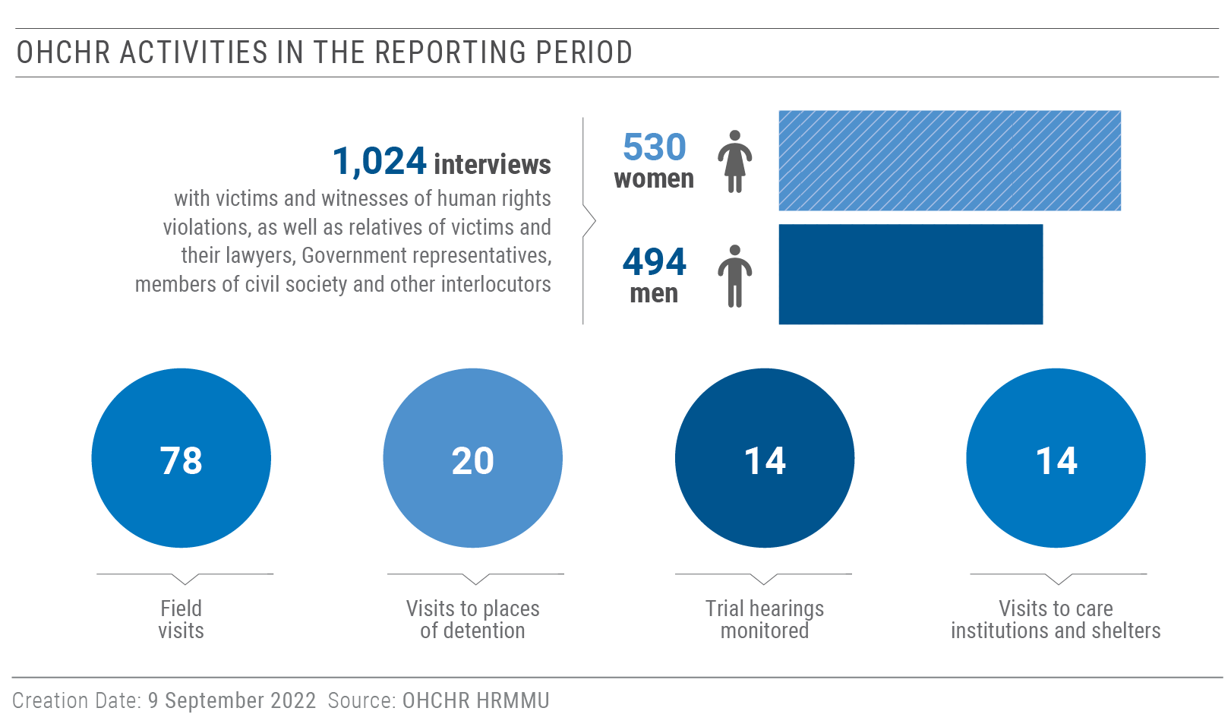
III. Impact of hostilities on the civilian population
19. On 24 February 2022, the Russian Federation initiated a wide-scale armed attack against Ukraine with its ground, air and naval forces. Russian ground forces penetrated the territory of Ukraine in ten regions (Kyiv, Chernihiv, Zhytomyr, Kharkiv, Sumy, Donetsk, Luhansk, Zaporizhzhia, Kherson and Mykolaiv) with support from Russian-affiliated armed groups, while Russian air and naval forces launched cruise missile attacks across Ukraine. Most of the hostilities occurred in or near densely populated areas, including big cities such as Chernihiv, Kharkiv, Donetsk, Horlivka, Makiivka, Mariupol, Kherson and Mykolaiv. The use of explosive weapons with wide area effects, including shelling from heavy artillery, multiple launch rocket systems (MLRS), missiles and air strikes in the vicinity of densely populated settlements, often in an indiscriminate manner, resulted in civilian casualties at a massive scale and damage and destruction of civilian objects at an unprecedented level, far in excess of previous periods of hostilities since 2014. The hostilities have furthermore resulted in the contamination of broad swaths of territory of Ukraine by tens of thousands of mines and explosive remnants of war (ERW).
A. Civilian Casualties
“They lived happily ever after and died in one day. From a direct hit of a shell on their house.”
- The relative of a couple killed by shelling in Mariupol.
20. From 1 February to 31 July 2022, OHCHR recorded 12,649 civilian casualties in the country. They included:
a. 5,385 civilians killed (2,111 men, 1,435 women, 173 boys and 147 girls, as well as 1,481 adults and 38 children whose sex is not yet known).
b. 7,264 civilians injured (1,454 men, 1,056 women, 221 boys and 157 girls, as well as 4,183 adults and 193 children whose sex is not yet known).
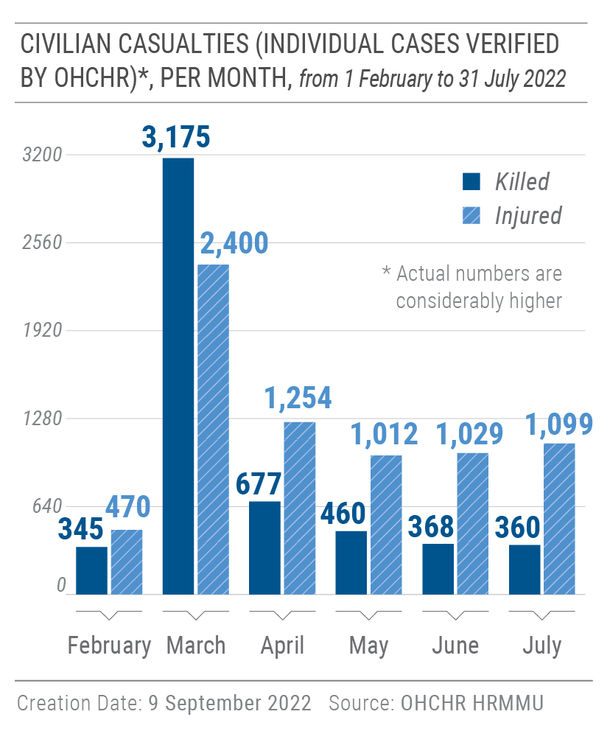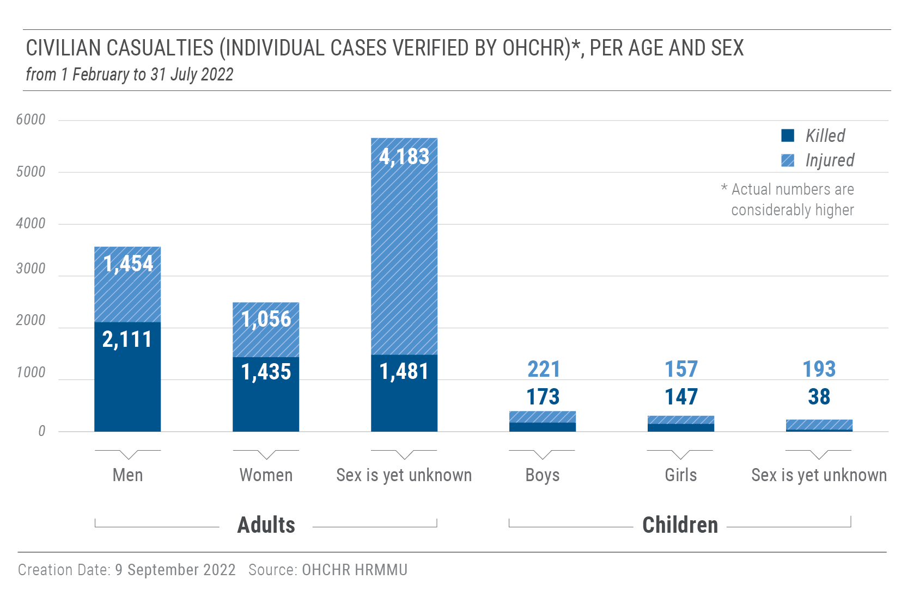
21. These casualties were documented as follows:
a. 11,398 (5,131 civilians killed and 6,267 injured) were recorded in 518 settlements in areas under Government control when the casualties occurred, constituting 90.1% of civilian casualties recorded in the reporting period.
b. 1,251 (254 civilians killed and 997 injured) were recorded in 52 settlements in parts of Luhansk and Donetsk regions controlled by Russian armed forces and affiliated armed groups, constituting 9.9% of civilian casualties in the reporting period.
22. OHCHR notes that the actual figures are likely considerably higher. Many reports of civilian casualties are still pending corroboration by OHCHR. This concerns, for example, casualties reported in Mariupol (Donetsk region), Izium (Kharkiv region), and Lysychansk, Popasna, and Sievierodonetsk (Luhansk region).
23. Most (92.1 %) of the civilian casualties (4,664 killed and 6,984 injured) were caused by the use of explosive weapons with wide area effects, including shelling from heavy artillery, MLRS, missiles and air strikes, in populated areas. This includes situations where military equipment was stored in and deployed from populated areas. Eighty-four civilians were killed and 118 injured as a result of ERW and mine-related incidents (1.6%). Another 637 civilians were killed and 162 injured (6.3%) by fire from small arms and light weapons (SALW), including as a result of crossfire, sniper fire, escalation of force incidents and wilful killings, as well as from beatings, stabbings and accidents involving either military vehicles or civilian vehicles driven by military.
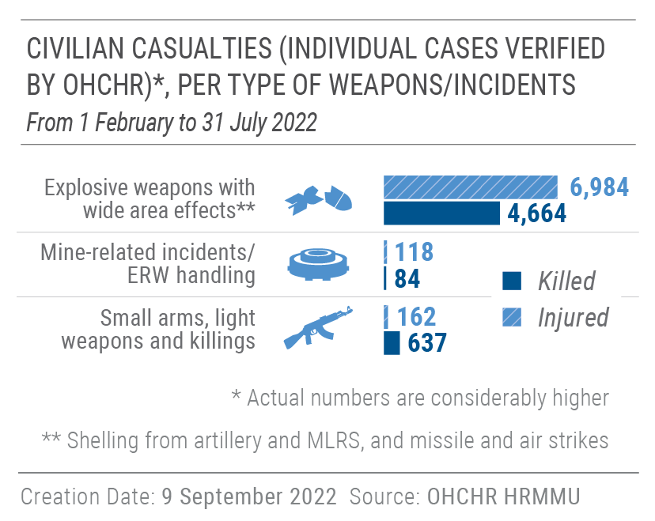
24. A large number of civilian casualties resulted from attacks involving explosive weapons with wide area effects. For example, on 14 March, a ‘Tochka-U’ missile hit the centre of Donetsk (controlled by Russian armed forces and affiliated armed groups), killing 15 civilians and injuring 36, including 1 boy. On 8 April, another ‘Tochka-U’ missile with cluster munitions hit a railway station in Kramatorsk (Government-controlled part of Donetsk region), killing 60 civilians, including 7 children, and injuring another 111, of whom 17 were children. On 30 May, MLRS and mortar shelling hit residential areas of Donetsk, including educational facilities, killing six civilians, including one girl, and injuring ten, including two girls. On 21 June, a MLRS strike carrying cluster munitions killed one girl and one man, and injured five civilians in Makiivka, a city in Donetsk region controlled by Russian armed forces and affiliated armed groups. On 27 June, a missile strike hit a shopping mall in Kremenchuk (Poltava region) in Government-controlled territory, killing 21 civilians and injuring 61, including 1 child. On 1 July, a missile hit an apartment building and recreation center in Serhiivka (Odesa region) in Government-controlled territory, killing 21 civilians, including 1 boy, and injuring 39, including 3 boys and 3 girls.
B. Destruction and damage to civilian objects
25. During the reporting period, OHCHR verified the widespread destruction of and damage to civilian objects across the country, in particular medical and educational facilities, and to housing in Kyiv, Chernihiv, Kharkiv, Sumy, Donetsk, Luhansk, Mykolaiv, Kherson, Zaporizhzhia and Donetsk. The majority was caused by explosive weapons used in populated areas. While OHCHR has not been able to assess compliance with IHL for each individual incident, the scale of damage and destruction strongly indicates that violations of IHL have occurred.
26. OHCHR verified damage or destruction to 252 medical facilities caused by the hostilities. They included 152 hospitals (including 17 children’s hospitals and 12 perinatal centres and maternity hospitals), 12 psycho-neurological facilities, and 88 other medical facilities. Out of those, 209 were damaged, 24 were destroyed, and 19 were looted. OHCHR believes the actual number of affected medical facilities to be likely considerably higher.
27. OHCHR verified that hostilities damaged or destroyed 384 educational facilities (252 schools, 70 kindergartens, 41 specialized schools, 20 universities and 1 scientific centre). Out of this number, 79 were destroyed, and 305 were damaged. Some attacks on educational facilities were likely due to the belligerent parties’ use of schools for military purposes. OHCHR believes the actual number of affected education facilities is likely considerably higher.
28. During the reporting period, OHCHR documented that 39 places of worship were destroyed and 51 damaged as a result of the hostilities. In Kharkiv, for example, two synagogues were damaged, as well as a Karaim Kenassa, the only Karaite place of worship in Government-controlled territory.
29. The wide-scale hostilities and the extensive use of explosive weapons with wide area effects in populated areas, both by Russian armed forces and affiliated armed groups, as well as by Ukrainian armed forces, caused mass damage to and destruction of civilian housing in several regions, notably Kyiv, Chernihiv, Kharkiv, Sumy, Donetsk, Luhansk, Mykolaiv, Kherson and Zaporizhzhia. According to the Deputy Head of the Ukrainian Parliamentary Committee for the Organization of State Power, some 15 million square meters of housing were damaged or destroyed in Government-controlled territory as of 7 July. According to Russian-affiliated armed groups, at least 8,130 civilian houses were damaged or destroyed by hostilities in territory of Donetsk and Luhansk region under their control.
1. Power generating stations
30. OHCHR remains highly concerned about the enormous risks that the conduct of hostilities near or in nuclear power plants poses for the civilian population, including the potential short- and long-term impacts on life, health, the environment and the economy. On 24 February, Russian armed forces took control over the Chornobyl nuclear power plant and retained control until 31 March. During that period, the International Atomic Energy Agency (IAEA) and the Ukrainian nuclear regulator lost communication with the Chornobyl site. Direct communication was only restored on 19 April.
31. On 4 March, Russian armed forces conducted a military offensive in the area of the Zaporizhzhia nuclear power plant in Enerhodar city, the largest of the four functioning nuclear stations in Ukraine. On 17 July, Russian forces reportedly arbitrarily detained the head of the environmental protection department of the nuclear power plant. As of 31 July, his whereabouts remained unknown. In late July, the Ukrainian nuclear regulator alleged that Russian armed forces had positioned at least 14 units of military equipment and ammunition in the facility housing one of the nuclear reactors and had begun digging trenches, thus creating a significant risk for the overall integrity and security of the plant. Russian armed forces still controlled the site as of 31 July.
32. In July, from their positions near the nuclear plant, Russian forces reportedly carried out several attacks against Ukrainian forces based in Nikopol, a Government-controlled city just across the Dnipro River from Enerhodar. In late July, Ukrainian armed forces reportedly targeted the positions of Russian armed forces in Enerhodar.
33. OHCHR recalls the statement of the United Nations Secretary-General, urging the Russian Federation and Ukraine to immediately demilitarize the Zaporizhzhia nuclear plant, given the enormous risks of radiation leaks.
IV. Right to life, liberty and security of persons
- Killings of civilians
“They [Russian armed forces] were simply shooting at us one by one.”
- A civilian woman from Bucha who stayed in the town while it was under control of the Russian armed forces.

34. In addition to civilian casualties caused by hostilities, OHCHR also documented civilian deaths caused by wilful killings and summary executions by SALW, stabbing or torture.
1. Killings of civilians by Russian armed forces in February and March
35. OHCHR continued to corroborate allegations of killings of hundreds of civilians by Russian armed forces while they controlled settlements in Kyiv, Chernihiv, Sumy and Kharkiv regions in February and March 2022. Following several field visits to settlements in Kyiv and Chernihiv regions, OHCHR corroborated serious violations of IHL committed by Russian armed forces.
36. As of 31 July, local authorities reported that over 1,346 civilian bodies had been recovered in Kyiv region. They included civilians killed as a direct result of hostilities, civilians killed unlawfully, including by summary execution, and civilians who died because of stresses on their health resulting from the hostilities or lack of access to medical aid.
37. OHCHR has documented that civilians were killed in a number of ways. Some were shot while fleeing in their vehicles. Others were shot in the street while crossing the road on foot or gathering basic foodstuffs, sometimes by snipers. While most victims were men, many women and children were also killed, often while on the move in search of either food supplies or opportunities to evacuate. The wilful killing of civilians is prohibited at all times. Such actions would constitute war crimes as grave breaches of the Geneva Conventions.
38. OHCHR corroborated the case of three civilian men who were tortured and then killed in Stoianka, Kyiv region, a village controlled by Russian armed forces in March 2022. On 29 March, a witness saw two of the men walking with Russian servicemen towards their house. On 1 April, the bodies of the two men, and that of a third man from the village, were found in the basement of the house, which had been used by Russian soldiers while they controlled Stoianka. Relatives who identified the victims at the morgue observed that all three bodies displayed signs of torture, including bound hands and legs, multiple knife wounds and severed fingers. This was confirmed by photographs provided to OHCHR. A forensic expert determined that gunshot wounds to the chest were the cause of death for all three victims.
39. In another case, on 18 March, two sources interviewed by OHCHR witnessed Russian servicemen force three civilian men at gunpoint to a construction site at the Yablunska-Yaremchuka crossroad in Bucha, and then summarily execute them. OHCHR also received video footage showing the moment before the killings took place, as the Russian servicemen took the men away. According to one witness, the men’s hands were tied behind their backs when a senior Russian serviceman shot them dead, one at a time. One of the victims was seen praying and pleading not to be killed before being shot. The Russian serviceman then shot another victim in his knees, causing him to fall to the ground, before killing him with another shot. Their bodies remained at the site until sometime in April, because local residents were afraid to move them until after Russian forces had withdrawn from the area on 31 March.
2. Extrajudicial executions of people perceived as so-called ‘traitors’
40. OHCHR documented six killings of civilians perceived as so-called ‘traitors’ against Ukraine for their alleged collaboration with the Russian Federation in territory occupied by it or controlled by Russian armed forces or affiliated armed groups since 24 February. While those who committed the killings remain unknown, OHCHR has concerns that some of these killings may have been perpetrated by agents of the Government of Ukraine or with their acquiescence. Most of the victims were former or active officials of local authorities, officers of law enforcement bodies or civilians who were believed to have voluntarily cooperated and worked with the occupation authorities. As these victims were civilians, they cannot be considered legitimate military targets. As such, these killings may amount to extrajudicial executions and war crimes, and should be investigated and prosecuted accordingly.
B. Conflict-related detention
1. Conflict-related detention by Russian armed forces and affiliated armed groups
41. OHCHR recorded a significant increase in the number of conflict-related detentions since the start of the Russian armed attack on Ukraine. Enforced disappearances and arbitrary detention of civilians have become widespread in territory controlled by Russian armed forces or affiliated armed groups, with 407 cases documented by OHCHR (359 men, 47 women, 1 boy). The majority of victims were active or former public officials of local authorities, human rights defenders, civil society activists, journalists and media workers. OHCHR also documented the enforced disappearance of clergy, retired service personnel of the Ukrainian armed forces, active staff of emergency services and municipal facilities, as well as civilians not holding any public office.
42. OHCHR documented 18 victims (17 men and 1 woman) who were found dead after their disappearance, some of them with signs of a violent death, and others who died in detention due to lack of medical care. At least 232 victims remain arbitrarily deprived of their liberty, most in unknown locations with unknown conditions of detention. 160 victims were released from detention, escaped or were left behind when Russian armed forces retreated, and a further 15 victims were released during so-called ‘exchanges of prisoners of war’. OHCHR notes that the detention of civilians for the purposes of carrying out an exchange may amount to hostage-taking, which would be considered a war crime in this context.
43. OHCHR also notes with concern the death in detention of a civilian British man on 10 July in Donetsk, reportedly due to inadequate medicine for diabetes. The victim was detained in Zaporizhzhia region by Russian-affiliated armed groups while evacuating civilians and was later reportedly prosecuted for being a mercenary. OHCHR stresses that a wilful omission to provide necessary medical care, which seriously endangers the physical health or integrity of persons who are in the power of the adverse Party and deprived of their liberty in connection with the armed conflict, amounts to a war crime.
44. OHCHR documented the enforced disappearance of 36 civilians who were detained by Russian armed forces and affiliated armed groups near Mariupol in March and April, while they were trying to bring humanitarian assistance to the city. Following their arrests, Russian armed forces and affiliated armed groups refused to acknowledge to relatives that they were detaining the victims, or repeatedly concealed the victims’ fate. OHCHR confirmed that two of the detainees were released after a week, and 33 were released after more than two months in detention. No ‘criminal cases’ were opened against them by ‘authorities’ of self-proclaimed ‘Donetsk people’s republic’. Victims reported being taken to different places of detention, including garages, basements of police stations, and other unofficial places of detention, where they were confined in overcrowded rooms or cells and provided with the bare minimum of water and food. Perpetrators beat, electrocuted and otherwise ill-treated the detainees. In some places of detention, civilians were kept together with prisoners of war, many of whom had visible signs of torture and injuries, but appeared to receive no or inadequate medical treatment.
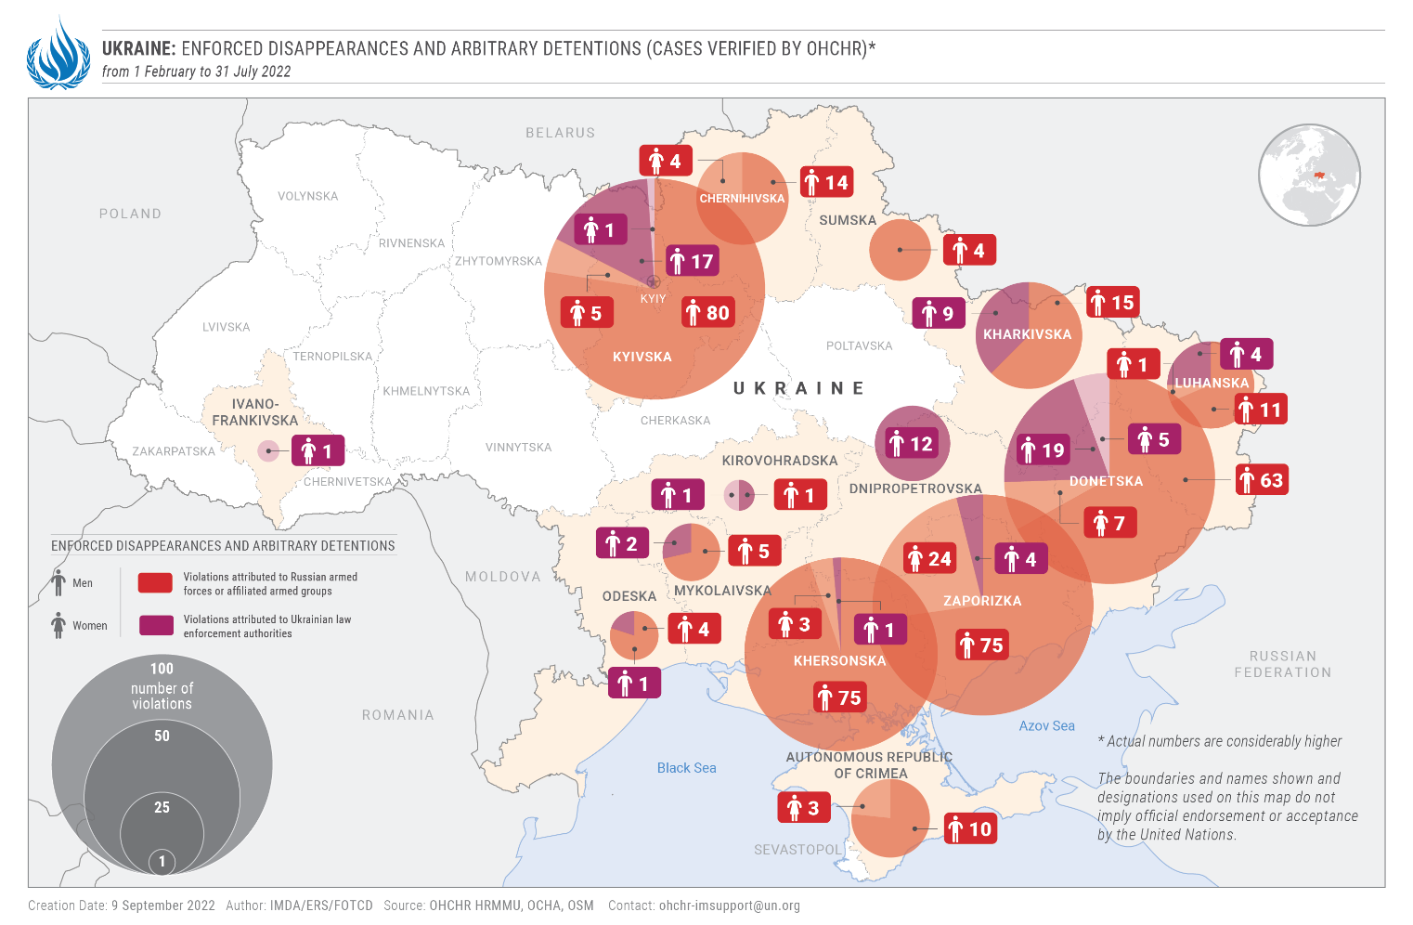
2. Conflict-related detention by the Government of Ukraine
45. OHCHR continued to document cases of enforced disappearance and arbitrary detention by Ukrainian law enforcement agencies and armed forces in Government-controlled territory. OHCHR documented 47 cases of arbitrary arrest and detention, as well as 31 cases (28 men and 3 women) that may amount to enforced disappearance. Twenty-nine of the victims were subsequently either released or their relatives received confirmation of their official detention.
46. OHCHR documented the case of a man who was subjected to enforced disappearance by the Security Service of Ukraine (SBU). He was first detained, tortured and ill-treated by Russian armed forces in Zaporizhzhia region. After his release, the victim went to the city of Zaporizhzhia in early May to file a complaint. As he approached the SBU building, he was attacked and beaten by two unknown men with masks, who then dragged him into a building, undressed and searched him, and accused him of cooperating with Russian armed forces. The two men brought the victim, blindfolded, to an apartment, detained him there for the next day and night, and beat him again. The victim managed to escape but was arrested the following day by police and the SBU, transferred to an unidentified house and held there until 24 May without any contact with the outside world. During this time, his relatives were not informed about his fate. He was then transferred to an SBU building, notified of suspicion of collaborationism (article 111-1 of the Criminal Code) and remanded in custody by a judge.
47. OHCHR notes that, following the enactment of martial law, the Parliament of Ukraine amended the Criminal Procedure Code to enable law enforcement officers to arrest and detain persons without judicial review. These amendments were superseded by a law passed by the Parliament on 27 July. On 14 April 2022, the Parliament amended another provision of the Criminal Procedure Code with a provision establishing that, during martial law, the only measure of restraint applicable to conflict-related crimes is detention. OHCHR notes that although Ukraine has availed itself of the right to derogate from the right to liberty and security of person under article 9 of the International Covenant on Civil and Political Rights (ICCPR), some elements of this right are non-derogable, in particular the guarantee against arbitrary detention when it is “unreasonable or unnecessary under the circumstances.”
3. Places of conflict-related detention
48. During the reporting period, OHCHR located 76 places of detention where civilians were being detained for conflict-related reasons. Among these facilities, 44 were controlled by Russian armed forces or affiliated armed groups, 12 by the Russian Federation (8 in the Russian Federation and 4 in Crimea) and 20 were controlled by Ukrainian authorities. 26 of the places of detention controlled by Russian armed forces or affiliated armed groups were unofficial and therefore failed to meet minimum international standards of detention. Ukrainian authorities also used 7 unofficial places of detention, including private apartments, sanatoriums and basements of abandoned buildings. Most individuals who were detained in unofficial facilities reported to OHCHR ill-treatment and inhumane conditions of detention, including confinement in overcrowded premises and lack of food, water, sanitation, access to healthcare, and communication with relatives. In 12 of these unofficial places of detention, victims also faced torture and sexual violence, or witnessed the torture of other detainees.
C. Torture and ill-treatment
49. OHCHR documented widespread practices of torture or ill-treatment of civilian detainees by Russian armed forces and law enforcement bodies, as well as Russian-affiliated armed groups. Of 38 released civilians (34 men, 4 women) interviewed by OHCHR, 33 individuals reported having various forms of torture or ill-treatment inflicted on them while in detention, in order to force them to confess to having cooperated with the Ukrainian armed forces, to force them to cooperate with Russian armed forces or affiliated armed groups, or simply to intimidate them. Methods of torture or ill-treatment included punching, kicking, hitting with batons and rifle butts, strangling, electrocution, shooting with rubber bullets, cutting with knives, threats of sexual violence, holding positions for long periods, exposure to cold temperatures, locking in the “hot box”, water or food deprivation, mock executions, prolonged use of handcuffs, hooding, and threats of bringing detainees to the front line and abandoning them there. In some cases, the torture lasted for several hours and caused severe injuries. Women who were interviewed did not report any specific forms of torture or ill-treatment, but also mentioned poor conditions of detention, including overcrowded cells and lack of adequate food or water.
50. In cases of arbitrary detention and enforced disappearance reportedly perpetrated by law enforcement bodies of Ukraine, OHCHR recorded 34 complaints of torture or ill-treatment, including beatings, threats of executions, threats with loaded guns of being shot in the limbs, and threats of bringing detainees to the front line and abandoning them there.
51. OHCHR is particularly concerned about the case of two men who were tortured to death in Kherson by Russian armed forces. Both men were reportedly members of the territorial defence forces, but had laid down arms and did not directly participate in hostilities after Russian armed forces entered the city. On 27 March, they were detained by Russian armed forces in the local police department, where they were accused of assisting Ukrainian armed forces, severely beaten, and left without medical assistance. In mid-April, one of the victims was brought to Sevastopol and died of his injuries soon after. The body of the other man was found in the Dnipro River in late May. Torture and arbitrary deprivation of life are absolutely prohibited, and in the situation of an armed conflict, both violations may constitute war crimes.
52. OHCHR documented the case of a civilian man who was arrested and tortured in late June by Russian servicemen at a crossing point near Chonhar village, Kherson region. He was driving from Mariupol to Crimea when he was detained at the crossing point. He was interrogated and his phone was seized and searched. When the servicemen found a photo of him and his child in Ukrainian national costumes, they accused him of having a negative attitude towards the Russian Federation, and beat him to compel him to confess to cooperating with Ukrainian armed forces. They also threatened to rape him and tried to undress him. Later, the victim heard other men being beaten and threatened with sexual violence in an adjacent room. On the following day, the victim was released without explanation and denied entry to Crimea. The victim sustained severe injuries that may result in a life-long disability.
53. OHCHR also documented the torture and ill-treatment of a group of four civilians, including two priests who had volunteered to retrieve the bodies of Ukrainian soldiers believed to have been killed on Zmiinyi island on 25 February. Once on the island, the men were arrested by Russian armed forces together with the 17 crewmembers of the rescue ship. Russian forces took the group to Sevastopol (Crimea), and then to Shibekine and Staryi Oskol in Belgorod Region (Russian Federation). In Shibekine, the men were held for six days in unheated military tents, where they were denied medical care and some suffered frostbite. In Staryi Oskol, Russian penitentiary staff repeatedly beat the detainees and frequently subjected them to body searches, including cavity searches, and electric shocks to their genitals. The Russian staff recorded these acts of torture and ill-treatment on video, and threatened to upload the videos online or to send them to the victims’ relatives, creating additional psychological distress. The victims were released from detention during an ‘exchange of prisoners of war’ in May 2022.
D. Conflict-related sexual violence
“I said ‘You could have been my grandson’ and he replied ‘Keep quiet, otherwise I will kill you.”
- A victim of rape.

54. While OHCHR cannot yet draw conclusions regarding the scale of CRSV perpetrated since February, it has documented numerous cases perpetrated against women, girls and men. The precarious security situation in parts of Ukraine, stigma and trauma associated with sexual violence, and lack of victims’ access to services are all factors contributing to underreporting of such cases. OHCHR documented 9 cases of rape (against 8 women and 1 girl), 15 cases of sexual violence used as a method of torture or ill-treatment against men, and 11 cases of forced public stripping against both men and women considered to be ‘lawbreakers’. OHCHR also recorded 8 cases of other forms of sexual violence (against 5 women, 1 man, 2 girls), such as forced nudity, unwanted sexual touching, sexual abuse and threats of sexual violence. Many of the documented cases were associated with other human rights violations, such as wilful killings, incommunicado and arbitrary detention, torture and looting. Thirty cases were committed by Russian armed forces or law enforcement, 2 cases were committed by Ukrainian armed forces or law enforcement and 11 cases were committed by civilians or members of territorial defence units. All forms of sexual violence are human rights violations under international law, and some cases documented by OHCHR may also amount to war crimes.
55. In one documented case, three Russian soldiers approached a house in Kyiv region in March, and asked a 59-year-old woman where her husband was. When she replied that he had died, one soldier ordered her to undress, threatening that if she did not comply, her situation would get worse. He forced her naked outside, poking his rifle at her, and then resting it between her legs and buttocks. He ordered her to turn around, while the two other soldiers watched and laughed. He then pushed her into the house, knocked her down on the sofa with the rifle and raped her twice. During the entire ordeal, he did not let go of his gun.
56. In another documented case, also in March in Kyiv region, two Russian soldiers came to the house of a couple and their four-year-old daughter. At gunpoint, they took the woman to another room, ordered her to her knees and gang-raped her. Her husband was brought from another room and forced to watch. They then beat him with a pot and forced him to perform a sexual act on her while they watched. The woman heard her daughter crying in another room, but could not see what happened to her. Later, the daughter told her mother that a man “gave her his wee-wee”, which suggests she was also subjected to an act of sexual violence. When Russian soldiers left, they said that they would “go to others”. OHCHR received two more allegations of sexual violence from the same location and timeframe, but has not yet been able to corroborate them.
57. The majority of cases of CRSV documented by OHCHR against women and girls occurred while Russian armed forces were stationed in residential areas, close to their military positions. In these cases, women were subjected to rape, including gang rape, by members of Russian armed forces. The majority of CRSV cases against men occurred in the context of detention by Russian armed forces. Beatings in the genital area, electrocution to genitals, forced nudity, unjustified cavity and body searches, and threats of rape against detainees and their loved ones were used as a method of torture and ill-treatment to intimidate, punish or extract confession. OHCHR also received some allegations of sexual violence and harassment of women at checkpoints during so-called ‘filtration’ processes organized by Russian armed forces.
58. OHCHR has grounds to believe that many combatants of the Russian armed forces and affiliated armed groups did not receive information or instructions on the lawful conduct of hostilities, including the prohibition of sexual violence, as is required by IHL.
59. The armed attack by the Russian Federation against Ukraine has reduced access to services for victims of sexual violence. A lack of comprehensive and long-term services for victims of sexual violence, including healthcare, rehabilitation, and psychosocial support, will impede the healing process, contribute to delays in reporting, and may hinder accountability efforts in the future.
60. According to the Prosecutor General’s Office of Ukraine, 43 criminal cases involving sexual violence were opened against members of the Russian armed forces between 24 February and 31 July. Five Russian servicemen were notified of suspicion.
E. Treatment of prisoners of war and other persons hors de combat
61. OHCHR documented violations of IHL and international human rights law in relation to the treatment of prisoners of war and persons hors de combat. These included extrajudicial executions, torture and ill-treatment, violations of fair trial guarantees, prosecution of prisoners of war for participation in the hostilities, denial of medical assistance, exposure to public curiosity, violations in relation to the conditions of internment, lack of food and water, and pillage of personal belongings by one or both of the belligerent parties.
62. Since 24 February, OHCHR has conducted confidential interviews with 142 prisoners of war (all men) in seven facilities run by the Government of Ukraine, with full and unimpeded access. As of 31 July, despite requests, OHCHR had no access to prisoners of war interned by the Russian Federation and affiliated armed groups. This lack of access deprives detainees of additional protections. OHCHR interviewed 35 servicepersons (32 men and 3 women) of the Ukrainian armed forces after their release from internment between April and July 2022. OHCHR also interviewed 17 civilians (16 men, 1 woman) who were detained with prisoners of war captured by Russian armed forces and affiliated armed groups, and who witnessed violations in relation to the treatment of prisoners of war.
1. Prisoners of war in the power of the Russian Federation
63. OHCHR documented patterns of mistreatment of prisoners of war detained by the Russian armed forces and affiliated armed groups during all periods of their internment. OHCHR verified that, out of 35 interviewed, 27 servicemen of the Ukrainian armed forces were subjected to torture by Russian armed forces and law enforcement bodies, as well as affiliated armed groups. Victims described being punched, kicked, beaten with police batons and wooden hammers, electrocuted, threatened with execution or sexual violence, and shot in the legs. Perpetrators tortured victims for the purpose of extracting military information, securing confessions of war crimes, forcing them to testify against other prisoners of war, or as a form of punishment for participating in the hostilities.
64. Of particular concern, OHCHR received credible information regarding the deaths of two Ukrainian servicemen as a result of torture. The first victim was reportedly beaten and electrocuted to death by members of Russian armed forces on 9 May at the Melitopol airfield. Two witnesses told OHCHR that the victim was brought to the classroom of a pilot school showing signs of torture, and died soon after. The second victim reportedly sustained lethal blows when guards beat prisoners of war upon their arrival to the Volnovakha penal colony near Olenivka, Donetsk region, on 17 April. The denial by the Russian Federation of confidential access of independent observers to places of internment is a major impediment to verifying such reports, ensuring accountability and preventing future such violations.
65. OHCHR has serious concerns about so-called ‘admission procedures’ in the Volnovakha penal colony near Olenivka, Donetsk region, and in pre-trial detention facilities in Briansk, Kursk, Staryi Oskol, Rostov-on-Don and Taganrog of the Russian Federation. These ‘admission procedures’ reportedly subject prisoners of war to beatings, positional torture, electrocution, placement in a “hotbox”, exposure to cold temperatures, threats of physical and sexual violence, threats by a dog and humiliating treatment upon their arrival to places of internment. Most of the prisoners of war interned in the Russian Federation who were interviewed by OHCHR reported being forced to learn and recite the Russian national anthem or other patriotic songs on a daily basis, under threats of physical violence. OHCHR received complaints from eight Ukrainian servicemen about a lack of medical assistance; however, ten servicemen indicated that they had received necessary medical care after their transfer to a hospital. Of concern, nine interviewees reported to OHCHR that wounded fellow servicemen had died within days of their capture, due to the lack of medical care in improvised places of internment. All interviewees also complained about the insufficient amount and quality of food and water distributed to interned Ukrainian prisoners of war.
66. OHCHR is aware of a video, widely disseminated via social media on 28 July, which depicts a man who appears to be a member of the Russian armed forces kicking the head of a man wearing a uniform of the Ukrainian armed forces, cutting off his testicles with a utility knife and shooting him dead. The circumstances of this video are pending further corroboration by OHCHR.
67. OHCHR documented 52 cases of pillage of personal belongings of Ukrainian servicemen captured by Russian armed forces and affiliated armed groups, including of mobile phones, jewellery, watches, jackets and boots. In five cases, money was stolen from bank accounts with bank cards seized from interned Ukrainian servicemen.
68. OHCHR is not aware of the establishment of camps for prisoners of war, as required by IHL, in the Russian Federation or in territory occupied by the Russian Federation. OHCHR received information that Ukrainian prisoners of war were interned in penal colonies, pre-trial detention facilities (SIZOs), police stations and improvised places of internment, such as barns or buildings used as forward operating bases by Russian armed forces and affiliated armed groups. OHCHR notes that this would violate the rule that prisoners of war shall not be interned in close confinement.
69. OHCHR is concerned about the situation of prisoners of war who are held incommunicado. Most prisoners of war whose cases were followed by OHCHR, and who were interned in the Russian Federation or in territory controlled by Russian armed forces or affiliated armed groups, were unable to contact their relatives. In only 2 out of 35 cases were prisoners of war able to do so, albeit briefly by telephone, and without providing information about their place of internment.
2. Incident at Volnovakha penal colony near Olenivka
70. During the night of 28-29 July, several dozen Ukrainian prisoners of war were reportedly killed and over one hundred injured when Volnovakha penal colony No. 120 (Donetsk region) was allegedly struck by shelling. The United Nations Secretary-General has established a fact-finding mission, which will endeavour to ascertain the facts of this incident and report to the Secretary-General upon completion of its work.
3. Prisoners of war in the power of Ukraine
71. The majority of prisoners of war in the power of Ukraine have been detained in special wards of penitentiary facilities, including SIZOs and penal colonies, but also military garrisons and guardhouses. OHCHR documented 50 cases of torture and ill-treatment of prisoners of war during their capture or while in transit camps of internment. These include cases where prisoners of war were beaten, shot, stabbed in the legs, electrocuted, forced to remain in one position for prolonged periods, and threatened with physical violence by members of the Ukrainian armed forces after they had surrendered and thus acquired the status of hors de combat. One prisoner of war was subjected to suffocation by members of Ukrainian law enforcement bodies during his interrogation, reportedly by the Kharkiv SBU.
72. OHCHR also documented cases of beatings and forced nudity during the transportation of prisoners of wars to or from transit camps. Although in most cases, prisoners of war faced beatings during or immediately after capture, OHCHR documented six cases when prisoners of war were subjected to beatings upon their arrival in a penal colony.
73. OHCHR also received information that several prisoners of war in facilities run by the Ukrainian authorities were not able to inform their relatives about their whereabouts and status for weeks after their internment.
74. On 22 June, OHCHR visited a camp for prisoners of war established in Lviv region in mid-April. OHCHR was able to observe all the facilities, speak with the administration and have confidential interviews with prisoners of war about the conditions of internment and services available. OHCHR observed that the camp appeared to comply with the main requirements of the Geneva Convention relative to the treatment of prisoners of war. However, most prisoners of war in the power of Ukraine continue to be interned in special wards of penitentiary facilities, in violation of the rule that prisoners of war shall not be interned in close confinement.
F. Forced recruitment
75. During the reporting period, OHCHR documented 65 cases of forced recruitment by Russian-affiliated armed groups. According to information received, men between 19 and 55 years old, mainly students and employees of the public sector, were requested by their employers, military ‘commissariats’ or university administrations to report to designated assembly points for enlistment. Refusal to be conscripted led to ‘criminal prosecution’.
76. Enlistment in Russian-affiliated armed groups is also punishable under Ukrainian legislation. On this basis, men who were forcibly recruited into such groups and then captured by Ukrainian armed forces are being prosecuted by Ukrainian law enforcement, in particular, for State treason, trespassing against national security or joining unlawful armed formations. Many such prisoners of war interviewed by OHCHR expressed fear of being forcibly recruited for a second time should they be transferred to self-proclaimed ‘republics’, following the procedure of simultaneous release. OHCHR notes that forcing civilians to serve in Russian-affiliated armed groups may amount to compelling them to serve in the armed forces of a hostile power, which constitutes a war crime. OHCHR is also concerned that Ukrainian authorities are prosecuting individuals who have been the victims of forced recruitment. In this context, it is important to note that under international law, individuals entitled to prisoner-of-war status have combatant immunity and cannot be prosecuted for having participated in hostilities, or for lawful acts of war committed in the course of the armed conflict, even if such acts would otherwise constitute an offence under domestic law.
G. Evacuation of persons from areas affected by hostilities
77. Intense hostilities and the takeover of various areas of Ukraine by Russian armed forces and affiliated armed groups have resulted in massive forced displacement of civilians, including to territory controlled by Russian armed forces and affiliated armed groups. Those fleeing danger often felt compelled to evacuate in whichever direction was possible, irrespective of their own preferences. OHCHR has not been granted access to the Russian Federation in order to verify allegations of displaced Ukrainians being deported to Russia.
78. OHCHR continued to receive allegations of human rights violations committed during the so-called ‘filtration’ of civilians by Russian armed forces or affiliated armed groups. Individuals subjected to ‘filtration’ include those leaving areas of ongoing or recent hostilities, and those residing in or moving through territory controlled by Russian armed forces or affiliated armed groups, including children as young as 14. During ‘filtration’ processes, Russian armed forces or affiliated armed groups often subjected persons to body searches, sometimes involving forced nudity and detailed interrogations about an individual’s personal background, family ties, political views and allegiances. They examined personal belongings, including mobile devices, and gathered personal identity data, pictures and fingerprints. Persons awaiting ‘filtration’ often spent nights in vehicles or unequipped premises, sometimes without adequate access to food, water and sanitation.
79. OHCHR received numerous allegations that men and women who were perceived as having ties with Ukrainian armed forces or state institutions, or as having pro-Ukrainian or anti-Russian views, were subjected to arbitrary detention, torture, ill-treatment, and enforced disappearance. The ‘filtration’ process reportedly continued as individuals crossed the border into the Russian Federation, where they were repeatedly interrogated and searched. OHCHR received allegations that those individuals perceived as having ties with Ukrainian armed forces were detained at the Russian border and in the Russian Federation. Miscellaneous unrelated provisions of the Code of Administrative Offences of the Russian Federation were reportedly used as pretexts for their detention.
80. OHCHR has been seeking access to individuals detained after failing to pass ‘filtration’, and to those who reportedly passed ‘filtration’ but were nevertheless detained and sent to a ‘centre for evacuees’ in Bezimenne, in territory of Donetsk controlled by Russian armed forces and affiliated armed groups. As of 31 July, OHCHR had not been granted access to these individuals. OHCHR is concerned that they may be subjected to torture and ill-treatment.
V. Leave no one behind – Economic and Social Rights
A. Internally Displaced Persons
81. By the end of July, over 6.7 million persons had been displaced within Ukraine. The Government of Ukraine has contributed to evacuation efforts. In March, the Government launched a programme to provide basic accommodation, healthcare and financial assistance to those forced to flee areas affected by the hostilities. However, this programme only provides support to IDPs who have registered in person with a centre for the provision of administrative services, or online through the state-run Diia portal. While the Government of Ukraine has simplified the procedures of registration for those who do not have papers, some categories of IDPs could still have no access to the benefits of the program. These include persons without smartphones or digital access, such as older persons, and persons without any form of documentation such as Roma and young persons from the self-proclaimed 'republics' without identification documents issued by Ukrainian authorities.
82. Moreover, as of 1 May, this assistance was available only to IDPs who fled areas of active fighting or territory occupied by the Russian Federation, and to people whose houses had been destroyed or rendered uninhabitable. OHCHR stresses that, with winter approaching, the definition of ‘uninhabitable’ should be interpreted as broadly as possible. Moreover, individuals who remained in areas of active hostilities, or whose house was not destroyed, are ineligible for financial support. However, many of them lost their income and suffered additional stress on their health due to hostilities. They also constitute a vulnerable group.
83. OHCHR received reports of people, including many older women and families, who returned to unsafe areas in eastern and southern Ukraine because they were unable to afford to live in more peaceful areas, where rental prices have increased due to an influx of IDPs. As a result, they are once again at risk of shelling and gunfire, and experience the absence of basic services. Some returned to damaged homes that offer little or no protection from hostilities or harsh weather.
84. The socio-economic situation of the Roma community also deteriorated during the reporting period, as many of its members faced specific vulnerabilities and hardship due to lack of access to economic and social opportunities, adequate housing and quality medical assistance.
85. According to UNHCR, as of 31 July, approximately 6.3 million refugees from Ukraine were recorded across Europe and over 1.8 million were recorded in the Russian Federation. OHCHR has concerns that the deterioration of the economic situation, destruction of social ties and mass population displacement have heightened risks of sexual violence and trafficking, especially for women and girls. OHCHR notes that this phenomenon of mass displacement will raise human rights issues in the future, notably in terms of repatriation and related issues.
B. Persons with disabilities
86. Women, men and children with disabilities, residing in both communities and long-term care facilities, have been at particular risk since the start of the armed attack by the Russian Federation. They have lacked access to bomb shelters, evacuation trains, necessary medication and adequate housing suited to their needs.
87. OHCHR interviewed an older woman with a disability who is an IDP from Luhansk region and the sole caregiver for her adult son, who has a psychosocial disability. She is particularly vulnerable to economic hardship, as she lacks access to adequate livelihood opportunities and must purchase necessary medications with her small pension and her son’s disability pension. Since they are unable to afford separate housing, they must reside in an IDP collective centre that is not equipped to shelter people with disabilities.
88. OHCHR was informed that access to healthcare was especially limited in areas of active hostilities or controlled by Russian armed forces, during the entire reporting period. This significantly affected persons with disabilities and people with chronic diseases. A 54-year-old woman with epilepsy died in March 2022 in Kyiv region, as the hospital where she usually received medical care was unable to provide services due to active hostilities, and no humanitarian corridors for evacuation were open at that time. There were many similar cases reported across Ukraine.
89. OHCHR is concerned about shelling and bombing impacting long-term care facilities in Kharkiv, Luhansk, Mykolaiv, and Sumy regions, allegedly by Russian armed forces, which placed residents at great risk. At least three people were injured during the shelling of Atynskyi long-term care facility for persons with intellectual and psychosocial disabilities in Sumy region.
C. Older persons
90. Many older persons, including women, stayed in conflict-affected areas because they were unable or unwilling to leave their homes, and were subsequently exposed to injury, lack of access to basic services, degrading living conditions or death. OHCHR documented the deaths of at least 12 older persons due to the dire humanitarian situation in areas affected by hostilities. This included one man whose oxygen device stopped functioning because of a power cut, in Bucha, when it was under control of Russian armed forces in March. In Irpin, a woman reportedly died of COVID-19 alone in her apartment in early March, as other residents had evacuated the building, while all further movement was restricted or prohibited by the Russian armed forces.
91. OHCHR received several reports that many bomb shelters lack adequate accommodation for older persons, especially those with limited mobility or chronic health conditions. Moreover, older persons living in long-term care facilities in areas affected by hostilities faced enormous risks to their life and health. On 11 March, Russian armed forces struck a long-term care facility for older persons and persons with disabilities in Stara Krasnianka (Luhansk region), where Ukrainian armed forces had regrouped. At least 56 bed-ridden residents died in the resulting fire. Eleven surviving residents and the staff were taken by Russian armed forces to the Svatove long-term care facility, currently under their control. In a long-term care facility in Borodianka, Kyiv region, 13 older persons died between 24 February and 13 March, following an evacuation of the area, due to the absence of urgent medical care and basic services such as heating, water and electricity. In Bucha, five older persons died due to a lack of access to basic services in a private nursing home between 24 February and 9 March, after which the remaining residents were evacuated to safety.
92. In areas affected by hostilities, older women without families have been particularly vulnerable to economic hardship due to the low pensions many of them receive, as a result of discrimination in the labour market or caregiving responsibilities in the past. They often lack financial resources to repair their homes and maintain an adequate standard of living. OHCHR interviewed several dozen older women in Kyiv and Chernihiv regions who, having repaired damaged windows in preparation for winter, are now left without funds to cover necessary medication, food and heating supplies.
VI. Administration of Justice and Accountability
- Administration of justice
93. In order to ensure accountability for violations of international human rights law and IHL, it is critical that the relevant authorities investigate allegations, and collect and preserve evidence (including forensic evidence). Those responsible, regardless of their affiliation, must be held to account and victims and their relatives must enjoy their rights to justice, truth, and reparations.
94. OHCHR welcomes efforts of the Government of Ukraine to investigate and prosecute serious violations of IHL and gross violations of international human rights law perpetrated in the context of the armed attack by the Russian Federation, and to bring perpetrators to account. It also notes Government efforts to address violations perpetrated by its own agents and awaits concrete progress in this regard. The Government of Ukraine has also extended its cooperation to various independent international governmental and non-governmental organisations, whose work can complement accountability efforts, including the International Criminal Court. OHCHR recalls that the law on cooperation with the International Criminal Court, adopted on 3 May by the Parliament of Ukraine, included an explanatory note that restricts its scope to the investigation and prosecution of only those individuals who are fighting for Russian armed forces or affiliated armed groups. Therefore, the cooperation of the International Criminal Court with Ukrainian judicial authorities in cases of alleged crimes committed by individuals fighting on the side of Ukraine remains outside the scope of the law and unregulated. This may have a serious impact on the right to effective remedy for all victims of international crimes, regardless of the perpetrator.
95. The Russian Federation also has an obligation to investigate, prosecute, and punish members of armed forces and affiliated armed groups found to have committed violations of IHL and international human rights law, including summary executions, sexual violence, torture and other cruel, inhuman or degrading treatment against civilians and prisoners of war. OHCHR is not aware of any measures taken at the national level in the Russian Federation to hold its combatants or those in command to account for such violations. OHCHR is concerned that any efforts to date have been focused only on the prosecution of Ukrainian prisoners of war and civilians in proceedings that lack transparency, independence and impartiality. OHCHR notes that access to such proceedings has been denied to international observers.
96. Since 24 February, national courts of Ukraine have rendered guilty verdicts against six members of Russian armed forces and affiliated armed groups for violations of the rules and customs of war. One Russian serviceman was convicted of killing a civilian, and two servicemen were found guilty of indiscriminate shelling resulting in damage to civilian objects. In addition, three members of Russian-affiliated armed groups were prosecuted and sentenced for pillage of private property.
97. OHCHR documented fair trial violations in judicial proceedings in Ukraine against servicemen of Russian armed forces and affiliated armed groups prosecuted for war crimes and crimes against national security, and against civilians prosecuted for crimes against national and public security. OHCHR also documented fair trial violations in cases before the ‘court’ of self-proclaimed ‘Donetsk people’s republic’, in which death sentences were handed down against three non-nationals who were members of the Ukrainian armed forces, and who were detained in Donetsk. OHCHR also documented fair trial violations in proceedings against civilians in ‘courts’ of self-proclaimed ‘Donetsk people’s republic’ and ‘Luhansk people’s republic’.
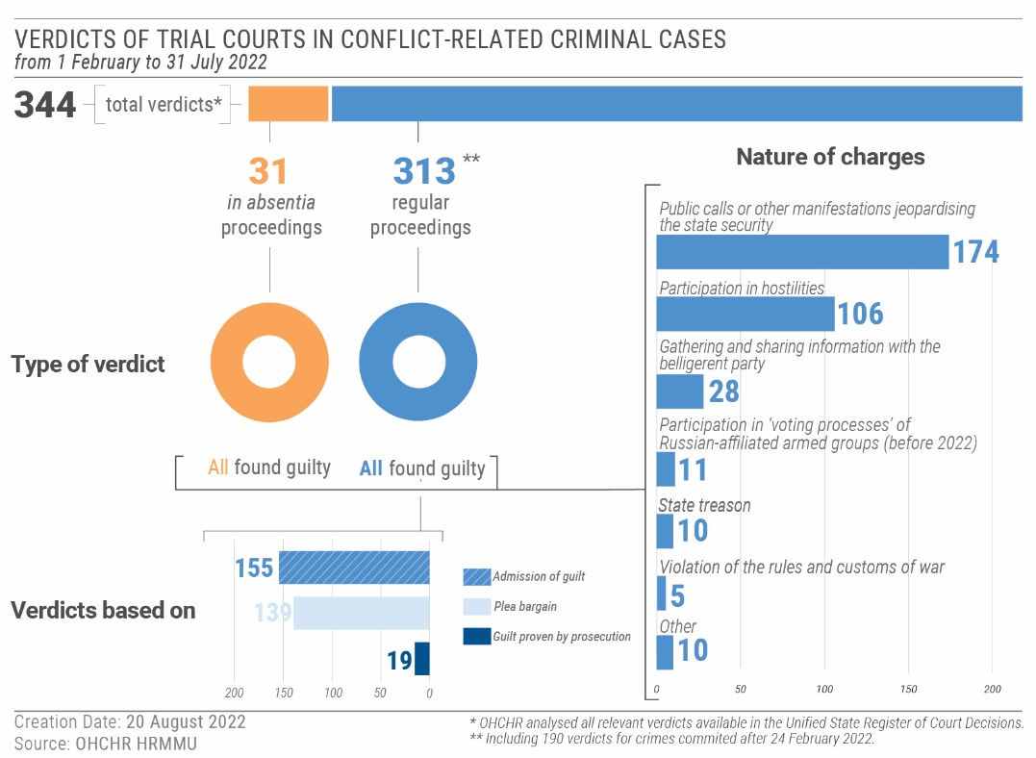
- Administration of justice by the Government of Ukraine
98. OHCHR monitored 14 proceedings and analysed 344 verdicts during the reporting period, and is concerned about recurring human rights and IHL violations in trials against members of Russian armed forces and affiliated armed groups.
99. OHCHR documented violations of the right not to be compelled to testify against oneself or confess one’s guilt, and the right to prepare a defence. In such cases, prosecutors and investigators offered defendants the possibility to be released during an ‘exchange of prisoners of war’ in return for their confession in court, or alternatively, to serve long prison terms. OHCHR is concerned that this practice applies undue psychological pressure on defendants to accept an arbitrary offer and confess, regardless of their innocence or guilt. OHCHR notes that, prior to July, there was no legal basis to offer a defendant to be exchanged, and even after the procedure was formally established, there was no guarantee that a particular defendant would be included in any exchange. Further, those defendants who had indeed committed a grave crime were afforded an opportunity to evade standing trial and any punishment in return for a confession, depriving victims of justice and the ability to seek compensation. Additionally, in 19 documented cases, defendants did not have the possibility to converse with their appointed legal aid lawyer prior to the trial.
100. OHCHR also documented violations of the presumption of innocence and equality of arms in one case brought against servicemen of the Russian armed forces. In that case, the SBU published a defendant’s confession online prior to the trial. That defendant stood trial for killing a civilian, while his fellow servicemen, who may have given orders to kill the civilian, were released during an “exchange of prisoners of war”. This may breach the obligation of Ukraine to investigate and prosecute war crimes, where appropriate. In addition, the defence lawyer was denied his request to question the released servicemen, which may have jeopardised the equality of arms. Lastly, the release and exchange of the servicemen may also jeopardize the realization of rights of victims to truth and reparations.
101. OHCHR notes that defendants from Russian-affiliated armed groups captured after 24 February were sentenced to prison terms of between 11 and 15 years for trespass against territorial integrity, state treason, membership in a terrorist organisation, membership in unlawful armed formation and unlawful possession of firearms. IHL does not explicitly prohibit the prosecution for state treason of combatants who defected. However, sentencing members of Russian-affiliated armed groups for mere participation in the hostilities under the above-listed crimes violates their combatant privilege.
102. Violation of the principle of non bis in idem is also a matter of particular concern in criminal cases against prisoners of war. OHCHR documented four cases where members of Russian-affiliated armed groups were convicted and sentenced twice for the same continuing conduct: once for membership in an armed group prior to 24 February 2022, and again 1-2 months later for membership in the same armed group after the start of the armed attack by the Russian Federation.
103. OHCHR is concerned that the prosecution for state treason of persons serving in Russian-affiliated armed groups is inconsistent with the principle of combatant immunity, and also jeopardises eventual accountability proceedings of those individuals responsible for forced recruitment. Furthermore, Ukrainian legislation requires ‘intent’ as a prerequisite for state treason. The prosecution of individuals subjected to forced recruitment, without due consideration of the levels of duress they were under, overlooks the roles played by perpetrators of forced recruitment. Moreover, this raises questions of unequal treatment, as people forced to serve in armed groups were sentenced to the same terms as those who voluntarily entered them.
104. On 28 July, Parliament adopted a legal procedure on the ‘exchanges’ of prisoners of war, including those who are suspected, accused or convicted of committing crimes. Amendments provide that even prisoners of war accused of committing crimes, including international crimes such as war crimes and crimes against humanity, can be released from detention and exchanged, while the criminal proceedings against them continue in absentia. OHCHR recalls that States must investigate international crimes alleged to have been committed on their territory, and, if appropriate, prosecute suspects. Moreover, victims of gross human rights violations and serious violations of IHL have the right to truth, justice and reparations. Although persons who have been suspected, accused or sentenced for committing war crimes would not be formally granted amnesty if ‘exchanged’ by Ukrainian authorities, they may be effectively absolved from serving any sentence which, in turn, may violate victims’ rights and constitute de facto amnesty.
105. OHCHR also continued to follow criminal proceedings against civilians prosecuted for conflict-related crimes. During the reporting period, Ukrainian courts rendered 260 verdicts in such cases, against 261 persons (194 men and 67 women). OHCHR documented 27 cases of arbitrary detention, enforced disappearance, torture, ill-treatment of defendants and suspects in order to compel them to testify, procedural violations for house searches or arrests, and lack of access to legal counsel during the initial period of detention and interrogation.
2. Right to a fair trial in self-proclaimed ‘republics’
106. OHCHR remains gravely concerned about the death penalty imposed on 9 June and 9 July by the so-called ‘supreme court’ of self-proclaimed ‘Donetsk people’s republic’ on five men who had served with the Ukrainian armed forces. OHCHR noted significant violations of fair trial guarantees in the first case, brought against two men from the United Kingdom and one from Morocco, including violations of the presumption of innocence, the right not to be compelled to testify against oneself or to confess guilt, and right to a public hearing, raising serious doubts about the independence and impartiality of the so-called ‘courts’, the equality of arms and right to review before an independent higher tribunal. The failure to comply with fair trial guarantees in cases where defendants face the death penalty renders any sentence arbitrary in nature, and any execution carried out, a violation of the right to life. OHCHR is further concerned that charges of acting as mercenaries may have been specifically used against the three men in order to deprive them of prisoner of war status, thereby stripping them of protection against prosecution for mere participation in hostilities.
107. OHCHR has concerns about the announcement in late May by so-called ‘authorities’ of self-proclaimed ‘Donetsk people’s republic’ that they would hold a ‘trial’ against the prisoners of war who surrendered in the Azovstal plant facility on 20 May, after the almost three-month long siege of Mariupol. OHCHR warns that such ‘trials’ would not meet fair trial requirements and may result in death sentences, as already documented in other cases.
108. OHCHR also notes with concern that 25 Ukrainian servicemen released from internment, some of whom had been interned in a penal colony in Olenivka and brought for interrogations to Donetsk, complained that they had been beaten and threatened with violence by unknown armed men present during interrogations to extort confessions of war crimes and testimonies against other prisoners of war.
109. OHCHR remains concerned that ‘courts’ of self-proclaimed ‘republics’ continued to sentence civilians for conflict-related crimes in proceedings that do not meet international fair trial standards, and may thus amount to war crimes. During the reporting period, OHCHR documented sentences passed against five men and one woman. Furthermore, 36 civilians subjected to arbitrary detention and enforced disappearance complained to OHCHR about beatings, electrocution and other forms of torture and sexual violence by Russian-affiliated armed groups or associated ‘security services’ to force them to testify or confess.
VII. Civic space and fundamental freedoms
“You should be grateful that we're not charging you with an offence and fining you.”
- The administration of a kindergarten in Russian-occupied territory when firing a teacher for an anti-war social media post.
A. Freedoms of opinion, expression, peaceful assembly and association
1. Freedom of opinion, expression and information
110. During the reporting period, 17 journalists and media workers were killed (13 men and 4 women) and 15 injured (14 men and 1 woman) as a result of hostilities. The majority of these incidents happened in February and March when hostilities were highly intensive, especially in Kyiv region. OHCHR is alarmed that four journalists were injured by gunfire while wearing protective gear in cars clearly marked as “Press” or “TV”.
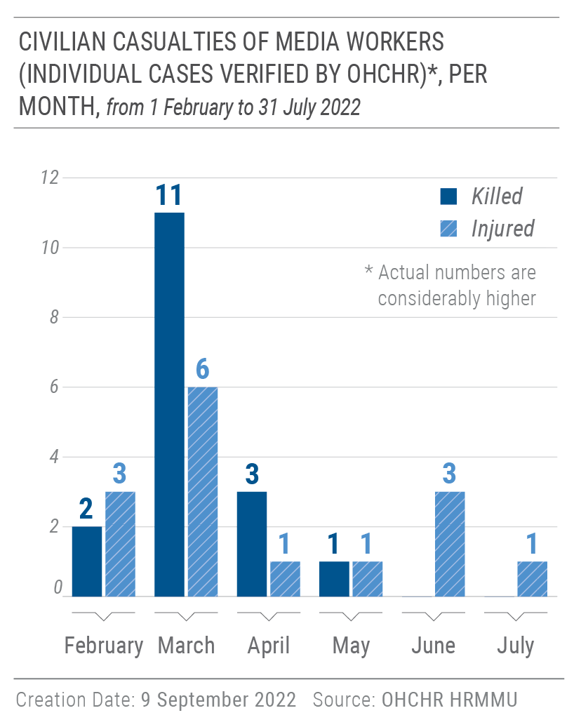
111. OHCHR recorded 14 cases of arbitrary arrest and enforced disappearance of 7 journalists, 4 human rights defenders, 1 cultural worker and 2 civilians related to their exercise of freedom of expression and opinion. Thirteen victims were arbitrarily arrested or subjected to enforced disappearance by Russian armed forces or affiliated armed groups in territory under their control. One journalist was subjected to enforced disappearance by law enforcement agencies of Ukraine. Such violations not only infringe upon victims’ rights, but also have a chilling effect on free expression and may lead to self-censorship and shrink the space for civic action.
112. OHCHR is concerned about restricted access to Ukrainian media in territory currently under control of Russian armed forces or affiliated armed groups, who seized and disconnected Ukrainian television channels and radio stations, replacing them with channels from the Russian Federation or self-proclaimed ‘republics’. Similarly, in territory of Donetsk, Luhansk and Kherson regions that they control, Russian armed forces or affiliated armed groups raided local print media, and either forced staff to promote narratives of “successful liberation by Russian armed forces” in their publications, or seized equipment and premises to enable them to print themselves. Moreover, people in those areas are deprived of access to Ukrainian mobile connection and Internet, and are excluded from widely used social media platforms and messaging applications, such as Facebook, Instagram and Viber, which is likely to hinder their ability to maintain ties with their relatives and loved ones in Government-controlled territory.
113. Restrictions on the right to freedom of expression imposed by the Russian Federation in territory it occupied, and in particular on the right to receive and impart information and ideas of all kinds regardless of frontiers, may not meet the strict requirements for permissible restrictions laid down in the International Covenant on Civil and Political Rights.
114. Following the commencement of the armed attack against Ukraine, Russian Federation authorities introduced legislation in occupied Crimea to penalize a wide spectrum of criticism of the Russian authorities and its armed forces. The application of these laws in Crimea unduly restricted the right to freedom of opinion and expression and severely limited the space for dissenting views on matters of public interest.
115. Since the introduction of liability in Crimea for “public actions directed at discrediting armed forces of the Russian Federation” on 4 March, OHCHR documented the prosecution of 89 individuals (55 men and 34 women), 84 of whom were convicted (54 men and 30 women). In at least 29 of these cases, individuals were sanctioned for social media posts in which they had criticized the armed attack by the Russian Federation against Ukraine, blamed Russian political leaders or armed forces for alleged war crimes or called for an end to hostilities with slogans akin to “Stop the War”. In no less than 21 cases, Crimean residents faced charges for oral public statements involving any general criticism of the armed attack. At least 13 cases involved either persons who picketed alone or who placed anti-war slogans on their private vehicles.
116. In a particularly concerning case, a prominent criminal defence lawyer and human rights defender, Edem Semedlyaev, was convicted of “discrediting the Russian Federation armed forces” for being tagged in a Facebook post created by another user. The post referred to Russian military losses in Ukraine, civilian casualties, and allegations of rape and looting by Russian soldiers, and called for the end of “the criminal regime of Putin”. Mr. Semedlyaev did not share the post on his page or endorse it in any way. On the contrary, he deleted the tag from his page. On 25 May, however, the court found Mr. Semedlyaev guilty, reasoning that the tagged post appeared on his profile page for “more than one day” and that “the owner of the Internet page bears responsibility for publishing illegal information”. The court considered as an aggravating factor that Mr. Semedlyaev had engaged in “public calls to actions threatening to cause harm to life and/or health of citizens, property, and mass violations of public order or public safety” and fined him 75,000 RUB (ca. 1,220 USD), an amount at the higher end of the scale for such convictions. In another case, on 16 May, a man from Yevpatoriia was fined 30,000 RUB (ca. 490 USD) under the same charges for his social media posts critical of the so-called “special military operation”.
117. OHCHR received information about teachers in Crimea being pressured to actively endorse the Russian armed attack on Ukraine, to cultivate a positive attitude among schoolchildren towards the military operations against Ukraine, and to generally refrain from criticizing the Russian authorities. Pedagogical staff who refused to follow these guidelines faced retaliation and sanctions. OHCHR reiterates that the right to freedom of expression protects everyone from being coerced to hold or not hold any particular political opinion.
118. In one documented case, a kindergarten teacher was dismissed from her position for her post on VKontakte, a social media platform in Russia, which stated “War is always horrible. It’s losses. It’s destruction.” and criticised people who supported the Russian authorities. The woman’s colleagues reported her post to the regional education department, which ordered the kindergarten administration to dismiss her from her position for “amoral behaviour”, which was added to her permanent employment record. She has remained unemployed since March 2022 and doubts she can secure any alternative employment in the educational sector. OHCHR is also aware of convictions of two other women teachers for “discrediting Russian armed forces” in Crimea, one of whom allegedly said in a classroom that there were no Nazis in Ukraine and that Russian soldiers committed sexual violence against children. The dismissal of any person from their employment purely on the basis of their political opinions contravenes international human rights law. According to the Committee on Economic, Social and Cultural Rights, academic freedom includes the liberty of individuals to fulfil their functions without discrimination or fear of repression by the State and to enjoy all the internationally recognized human rights.
119. Following a decision by Roskomnadzor, the social media networks Facebook and Instagram were banned in the Russian Federation, on 4 and 11 March 2022 respectively, which also affected users in Russian-occupied Crimea. Separately, on 21 March, a district court in Moscow banned all products of Meta Platforms Inc., the parent company of Facebook, “on the territory of the Russian Federation” on the basis of “conducting extremist activities”. These bans significantly limit the freedom to seek, receive and impart information and ideas in Crimea. It also restricts the space for political discussions, journalistic activities and civic activism in Crimea and subject to prosecution those who continue to use these platforms. The Human Rights Committee considers general bans on the operation of websites contrary to international human rights law and recommends that any permissible restrictions be content-specific.
2. Freedom of peaceful assembly and association
120. During March and April, numerous peaceful protests were held in areas controlled by Russian armed forces in Kyiv region and occupied by the Russian Federation in Kherson and Zaporizhzhia regions. OHCHR documented at least ten cases where Russian armed forces dispersed peaceful assemblies by resorting to unnecessary and disproportionate force, such as using teargas, flash grenades and firearms (discharged above participants’ heads). The vast majority of these incidents occurred in Kherson region, while others were reported in the cities of Enerhodar, Melitopol, Tokmak and Berdiansk in Zaporizhzhia region and in Slavutych in Kyiv region. On one such occasion on 26 March, several thousand peaceful protesters gathered in the centre of Slavutych with Ukrainian flags to express their support for Ukraine and demand that Russian armed forces leave the city. The Russian armed forces used flash grenades, tear gas and firearms to disperse the protesters, seriously injuring one male protester.
121. On 3 May, the Parliament of Ukraine introduced a special procedure and additional grounds for the dissolution of political parties in Ukraine. The new law permits, following expedited court proceedings and upon application of the Ministry of Justice, the ban and confiscation of all private property and funds belonging to political parties that engage in the justification, legitimization or denial of the “Russian armed aggression against Ukraine”, the glorification or justification of individuals participating in it, as well as in the propaganda of the “Russian Nazi totalitarian regime”. OHCHR is concerned that the law is vague and uncertain in scope, and that the fast-track procedure in particular lacks adequate safeguards against arbitrariness, including with regard to the right to a public hearing and the principle of equality of arms.
122. Following its entry into force on 18 May, no less than 16 political parties have been banned, including Opozytsiina Platforma – Za Zhyttia, the party which came second at the latest parliamentary election. Fifteen of these bans were ordered in the absence of the respondents.
123. In areas occupied by the Russian Federation or controlled by Russian armed forces and affiliated armed groups, Ukrainian political parties are unable to operate as this carries numerous risks, for individuals who conduct political activities, notably criminal liability on charges of crimes like espionage, terrorism and extremism. In several areas of Government-controlled territory, all political activities are currently on hold due to the proximity of hostilities and associated security concerns.
3. Freedom of religion or belief
124. During the reporting period, local authorities in at least seven territorial communities in Kyiv, Sumy and Lviv regions temporarily suspended the activities of the Ukrainian Orthodox Church (often unofficially referred to as the Ukrainian Orthodox Church of Moscow Patriarchate) for the duration of martial law. Local authorities, for instance the City Council of the Brovary District in Kyiv region, also prohibited meetings, rallies, marches, as well as other mass events of the Ukrainian Orthodox Church for the duration of martial law, without providing a clear justification for the prohibition.
125. This suspension raises concerns as to its compliance with international human rights standards. Authorities did not explain the basis on which such measures were introduced, or how they were deemed necessary and proportional to protect public safety, order, health, morals or the fundamental rights and freedoms of others, as required by article 18(3) of the International Covenant on Civil and Political Rights. Furthermore, as activities of other regional communities and organizations have not been suspended, this unfavourable treatment of the Ukrainian Orthodox Church may amount to a discriminatory measure on the ground of religion or affiliation with a particular religious group.
126. In territory occupied by the Russian Federation or controlled by Russian armed forces or affiliated armed groups, the overall environment for religious minorities remains highly restrictive. OHCHR is concerned that shrinking civic space hinders individuals from reporting human rights violations that they may have experienced or witnessed.
4. Human rights defenders in Crimea
127. During the reporting period, the information, regulatory and security environment in which human rights defenders operated in Crimea significantly deteriorated. Legitimate activities of human rights defenders were obstructed by arrests and prosecutions, as well as the blocking of access to websites of human rights NGOs.
128. On 26 and 27 May, two men human rights defenders, Ayder Azamatov and Nazim Sheikhmambetov, and one woman human rights defender, Emine Avamileva, all of whom work as defence lawyers in high-profile cases in Crimea, were arrested. They were prosecuted for “participation in a mass simultaneous gathering of citizens with a violation of sanitary norms” in relation to short media interviews they gave during a gathering of Crimean Tatars on 25 October 2021. The men were convicted and sentenced to 8 days in prison, while Ms. Avamileva was sentenced to 5 days. The defendants explained to the court that the purpose of the media interviews was to inform the public about cases of wide interest involving the prosecution of Crimean Tatars. The court’s reasoning was limited to findings that the minimum physical distance between the defendants and participants of the gathering had not been maintained and that facemasks were not used. The court did not consider whether the limitations on freedom of expression were necessary to achieve the alleged aim being pursued. Furthermore, the imposition of custodial sentences in these cases cannot be considered proportionate to the alleged offences.
129. These convictions represent a flagrant example of interference by the occupation authorities with both the work of human rights defenders and the media, and send a clear warning to others who wish to speak up about human rights violations.
130. Leading human rights NGOs which focus on Crimea – Crimean Human Rights Group (CHRG), Human Rights Centre ‘Zmina’ and Crimea SOS – informed OHCHR that the Russian authorities had blocked their websites without any prior notice. Additionally, on 6 May, the Russian General Prosecutor recognized the activities of CHRG as “undesirable” and determined that they “pose a threat to the constitutional order and security” of the Russian Federation. Furthermore, on 8 April, the Russian authorities ordered the closure of the offices of Amnesty International and Human Rights Watch in the Russian Federation. These two leading international human rights organizations also conducted human rights monitoring and reporting on Crimea.
131. Law enforcement authorities in Crimea continued to issue human rights defenders, affiliates of Crimean Tatar community institutions, and other active citizens with written ‘warnings’ not to engage in ill-defined ‘extremist’ or other ‘illegal’ activities. A Crimean Tatar human rights defender affiliated with the Mejlis informed OHCHR that he receives, on average, five warnings annually, usually ahead of key Crimean Tatar and Ukrainian commemorative dates. The human rights defender considers these warnings an attempt to stifle grassroots initiatives to organize assemblies or other public events.
B. Discrimination, hate speech, racially-motivated violence and manifestations of intolerance
1. Lesbian, gay, bisexual, transgender, and intersex (LGBTI) community
132. During the reporting period, OHCHR documented five attacks against eight LGBTI people in Government-controlled territory. In one case, on 27 February, unknown armed men wearing camouflage forcefully entered the office of a well-known LGBTI organization in Kyiv. They claimed that light signals were coming from the office, which could have meant that saboteurs were in the building. Four male members of the organization who were present at that time were taken to a local police department. When the police learnt about their sexual orientation and that they were all originally from Luhansk, they verbally abused them using homophobic slurs, made them kneel facing the wall and repeatedly kicked them. The four men were released in the morning without any explanation for their detention. On the following day, the same group of armed men again forcefully entered the office of the LGBTI organization. They searched the office, used homophobic speech towards members of the organization, beat them, and then left. The National Police initiated a criminal investigation against the armed men who entered the office under “brigandism”. Reportedly, the investigation is ongoing and some suspects have been identified.
133. In territory occupied by the Russian Federation or controlled by Russian armed forces or affiliated armed groups, the overall environment for the LGBTI community remains dangerous and highly restrictive. OHCHR is concerned that this restrictive environment deters LGBTI persons from reporting human rights violations.
2. Ban on publications
134. On 19 June, the Ukrainian Parliament adopted a law that introduces a ban on the import and distribution in Ukraine of publications from the Russian Federation, the Republic of Belarus, and the temporarily occupied territory of Ukraine. The law, which has not yet been signed by the President of Ukraine, revokes previously issued permits for the import and distribution of such items and stipulates that permits are necessary to import publications issued in Russian language from other countries. The publication, import, and distribution in Ukraine of book editions containing works by Russian authors is also prohibited. However, this ban will not apply to books published in Ukraine before 1 January 2023.
135. On 1 March, Ukraine derogated from the right to freedom of opinion and expression guaranteed in article 19 of ICCPR for the duration of martial law. OHCHR notes, however, that the law will continue to apply after the end of martial law in contradiction to the ICCPR, which requires derogation measures to be exceptional and temporary in nature. Furthermore, pursuant to Article 4(1) of the ICCPR, the State may introduce derogations from its human rights obligations only to the extent strictly required by the exigencies of the situation. OHCHR notes that the law does not provide a clear justification for the general ban, which applies broadly, to all publications, regardless of their content.
C. Dismissal and appointment procedures of the Ombudsperson
136. On 31 May 2022, the Parliament of Ukraine dismissed Ms. Liudmyla Denisova from the post of Ukrainian Parliament Commissioner on Human Rights (“Ombudsperson”), pursuant to the procedure envisaged in Law No. 2259 – IX “On Amendments to Certain Laws of Ukraine on the Functioning of Public Service and Local Authorities during Martial Law”.
137. OHCHR regards the dismissal procedure established by this law as not in line with international standards and best practices. The law gives Parliament complete discretion to dismiss the Ombudsperson without specifying that such dismissal can only be based on serious grounds of misconduct or incompetence. Furthermore, the law allows the Parliament to dismiss the Ombudsperson by simple majority. OHCHR notes that the resolution on the dismissal of Ombudsperson Denisova was adopted by Parliament through an unnecessarily speedy procedure and did not contain any explanation of the reasons for her dismissal.
138. OHCHR also notes that the appointment of the new Ombudsperson and the procedure envisaged in Law No. 776/97-ВР “On the Ukrainian Parliament Commissioner for Human Rights” were likewise not in line with international standards and best practices. In particular, the vacancy of the post of Ombudsperson was not broadly advertised; there were no consultations with civil society organizations during the screening, selection and appointment process, and the Ombudsperson was not elected through an appropriate qualified parliamentary majority, which would have ensured that the appointed candidate received wide support from both majority and opposition parties. OHCHR nevertheless welcomes the commitment of the new Ombudsperson to elaborate amendments to this law, and stands ready to provide technical expertise to ensure its full conformity with international standards and best practices.
VIII. Technical cooperation and capacity building
139. During the reporting period, OHCHR adapted its work to respond to a vastly changed human rights situation compared with the the period covered by the last OHCHR periodic report on Ukraine. In this context, OHCHR published an Update on the human rights situation in March, and a thematic report on the human rights situation in the context of the armed attack by the Russian Federation against Ukraine in June, with targeted recommendations.
140. Since 27 February, OHCHR has released daily, then weekly updates on civilian casualties in Ukraine. OHCHR also delivered a training on civilian casualty recording to 50 national experts contracted by the World Health Organization to collect data on the impact of hostilities on medical establishments.
141. OHCHR continued to support national stakeholders engaged in the protection of persons with disabilities, and to assist persons with intellectual and psychosocial disabilities with restoration of their legal capacity. On 4 February, thanks to the assistance of the Ombudsperson’s Office and OHCHR, a local court in the Sumy region restored the legal capacity of a man with a psychosocial disability living in a long-term care facility. On 18 April, OHCHR published a briefing note on the human rights situation of persons with intellectual and psychosocial disabilities in Ukraine.
142. OHCHR led advocacy efforts with the Ukrainian Government on the protection of prisoners of war. In June, representatives of the Ministry of Defense informed OHCHR that headquarters for coordination had been created to oversee the exchange and internment conditions of prisoners of war. OHCHR also led advocacy efforts with the Ukrainian Parliament, recommending amendments to several laws to bring them in line with international standards and best practices.
143. OHCHR supported the United Nations Country Team in Ukraine (UNCT), including through developing joint UNCT submissions to the Committee on the Rights of the Child and for consideration at the 23rd session of the Committee on Enforced Disappearances. It additionally submitted to the Ministry of Justice of Ukraine joint UNCT comments on the “Analytical report on the state of implementation of the national strategy in the field of human rights in 2021”. OHCHR also facilitated coordination with the UNCT to prepare a matrix of trainings on documenting IHL and international human rights violations.
144. OHCHR prepared regular updates on the six grave violations against children in times of war, which were submitted by the Resident Coordinator and Humanitarian Coordinator in Ukraine to the Office of the Special Representative of the Secretary-General for Children and Armed Conflict.
145. HRMMU issued 5 statements and 102 social media posts, and appeared in over 850 media articles during the reporting period.
IX. Conclusions and recommendations
146. The armed attack by the Russian Federation against Ukraine has had a devastating impact on the enjoyment of human rights across the country. During the reporting period, OHCHR documented IHL and international human rights law violations that highlight the heavy toll of the conflict on civilians. OHCHR reiterates its calls upon the Russian Federation to immediately cease its armed attack, and for all parties to respect their obligations under international law and engage in diplomacy and dialogue.
147. The extensive use of explosive weapons with wide area effects in or near populated areas must immediately halt. The high number of civilian casualties and the extent of destruction and damage to civilian objects strongly suggests the failure of the parties, in particular the Russian Federation, to comply with the rules of IHL governing the conduct of hostilities, including the principles of distinction, proportionality and precaution, and the prohibition of indiscriminate attacks.
148. There have also been widespread violations of the rights to life, liberty and security. OHCHR is particularly concerned about the torture and ill-treatment of protected persons and is closely monitoring processes of administration of justice. There have also been numerous violations of economic, social and cultural rights, including the rights to adequate housing and social security.
149. The escalation of hostilities has had a particularly harsh impact on groups in vulnerable situations, including older persons and persons with disabilities, throughout Ukraine.
150. Based on its findings from the reporting period, OHCHR urges the implementation of the following recommendations, many of which are contained in OHCHR’s previous report:
151. To all parties to the conflict:
(a) Respect and ensure respect for international human rights law and IHL, at all times and in all circumstances;
(b) Ensure full compliance with IHL principles of distinction, proportionality and precaution, including by refraining from using explosive weapons in populated areas and from using or installing heavy weapons or other military objectives in or near populated areas;
(c) Ensure timely and effective investigations into all allegations of violations of IHL and human rights, including allegations of torture, ill-treatment, arbitrary detention and sexual violence; ensure that alleged perpetrators, including persons in positions of command, are duly prosecuted; and uphold the rights of victims and their families to truth, justice and reparations;
(d) Respect IHL and international human rights law in relation to treatment of prisoners of war and persons hors de combat, and investigate and prosecute all cases of serious violations of IHL in relation to their treatment, regardless of the affiliation of the perpetrators;
(e) Cease prosecuting prisoners of war entitled to combatant status under IHL for conduct which is in substance mere participation in the hostilities;
(f) Facilitate provision of information on a regular basis to relatives of prisoners of war regarding their loved ones, in particular about their place of internment and health status, and ensure that prisoners of war are able to correspond with the outside world, in line with the obligations of a detaining power under Geneva Convention III and the requirements of international human rights law;
(g) Provide unimpeded confidential access to OHCHR and other independent international monitors to all places of detention, including places of internment for prisoners of war, wherever located;
(h) Cease practices of exposing prisoners of war to public curiosity through recording and publishing videos of them;
(i) Uphold fair trial guarantees for all individuals prosecuted in relation to the armed conflict, including prisoners of war;
(j) Take immediate steps to demilitarize the area in and around the nuclear power plant in Zaporizhzhia and follow the recommendations of the International Atomic Energy Agency;
(k) Cooperate with the Fact-Finding Mission regarding the Incident at Olenivka and provide it with full and unimpeded access to the site;
152. To the Russian Federation:
(l) Immediately cease the armed attack that commenced on 24 February 2022 in the territory of Ukraine and fully comply with the binding order on provisional measures issued by the International Court of Justice on 16 March 2022;
(m) Ensure rapid and unimpeded passage of humanitarian relief for civilians in need and protection to affected civilians;
(n) Ensure that any procedures applied to evacuees are conducted with respect to their rights, dignity and privacy and in accordance with international human rights law and IHL norms;
(o) Immediately halt retroactive practices of arrest, prosecution or conviction of civilians, including former members of Ukrainian armed forces, for acts lawfully committed or for opinions or ideas expressed before its occupation of territory in Ukraine;
(p) Immediately cease the practice of arbitrary detention and enforced disappearance, and investigate cases committed by Russian armed forces, law enforcement agencies, and affiliated armed groups, with a view of prosecuting and punishing those responsible, and ensure effective remedies to victims;
(q) Immediately release all civilians subjected to enforced disappearance and arbitrary detention by Russian armed forces, law enforcement agencies, and affiliated armed groups;
(r) Guarantee life and security of prisoners of war, in particular, those who were sentenced to death in proceedings that violated essential international fair trial guarantees;
(s) Take all necessary precautionary measures to prevent sexual violence and implement a zero tolerance policy within its armed forces, including through issuing clear orders prohibiting sexual violence against civilians, prisoners of war, and members of its own forces;
(t) Ensure that lawyers and human rights defenders in Crimea can perform all of their professional functions without intimidation, hindrance, harassment or improper interference;
(u) Respect and ensure that the rights to freedom of opinion and expression, peaceful assembly, association, thought, conscience and religion can be exercised without discrimination by all individuals and groups in territory under its occupation, and take measures to create an environment conducive to the free exchange of information and ideas;
(v) Refrain from wholesale restrictions on social media websites, as well as websites of media outlets and civil society organizations;
(w) Ensure individuals in Crimea can express opinions that are critical of the government and the armed attack by the Russian Federation against Ukraine, without any retaliation such as imprisonment or other sanctions;
(x) Ensure local education departments and school administrations in Crimea refrain from putting any pressure on or retaliating against teachers for expressing political opinions, including critical views about the armed attack by the Russian Federation against Ukraine;
(y) Provide representatives and staff of international human rights and humanitarian organisations, including those of the United Nations, with full, unhindered, timely, and safe access to persons who have been transferred from conflict-affected areas of Ukraine to the Russian Federation or to areas of Ukraine controlled by Russian armed forces and affiliated armed groups;
(z) Strengthen cooperation and exchange of information with OHCHR by guaranteeing communication channels;
153. To the Parliament and the Cabinet of Ministers of Ukraine:
(aa) Amend Law of Ukraine No. 776/97-ВР of 23.12.1997 “On the Ukrainian Parliament Commissioner for Human Rights” to align it with international standards and best practices;
(bb) Extend the scope of application of the law on cooperation with the International Criminal Court to all alleged crimes committed, regardless of perpetrator or affiliation to parties to the conflict;
154. To State and local authorities in Ukraine:
(cc) Take effective measures to ensure that all victims of sexual violence can access adequate medical and psychological services, including sexual and reproductive health services such as Post Exposure Preventive (PEP) Treatment Starter Kits, in a safe, confidential, child-sensitive and rapid manner;
(dd) Take effective measures to ensure that displaced older persons and persons with disabilities can access timely quality healthcare and rehabilitation services;
(ee) Continue efforts for the deinstitutionalization of persons with disabilities, including those who were evacuated from places of active hostilities to safer regions;
(ff) Ensure the provision of adequate social assistance to all in need by further simplifying administrative requirements and processes and by broadening the definition of people considered as displaced or in precarious situations, and take adequate steps to ensure everyone’s access to adequate and affordable housing, including by establishing rent controls;
155. To the Office of the Prosecutor-General and State Bureau of Investigation and other law enforcement agencies:
(gg) Issue internal instructions for the effective investigation of allegations of conflict-related sexual violence, ill-treatment and torture based on international standards and practice (e.g. Istanbul Protocol and the International Protocol on the Documentation and Investigation of Sexual Violence in Conflict), conduct investigations into such allegations with due regard to the rights and needs of survivors and ensure that alleged perpetrators are duly prosecuted;
(hh) Investigate and prosecute all cases of enforced disappearance to hold all perpetrators accountable, regardless of their affiliation, and provide victims effective remedy;
(ii) Cease prosecuting prisoners of war, including members of Russian affiliated armed groups entitled to combatant status under IHL, for conduct which is in substance mere participation in the hostilities;
(jj) Proactively and efficiently investigate all violent crimes, including hate crimes, against LGBTI people, and ensure that all perpetrators are brought to account through a fair trial without undue delays;
156. To the Judiciary of Ukraine:
(kk) Respect, protect and ensure full enjoyment of the rights to due process and fair trial for all individuals charged with crimes in relation to the armed attack by the Russian Federation, including war crimes; in particular, ensure respect for the presumption of innocence, the right to effective legal assistance, and the right to a trial before an independent and impartial court;
(ll) Respect and apply international human rights standards when considering pre-trial measures for individuals accused of conflict-related crimes, in particular, by not limiting pre-trial restrictive measures to detention alone;
157. To Russian affiliated armed groups:
(mm) Release individuals detained for exercising their human rights;
(nn) Ensure that any procedures applied to evacuees are conducted in the respect of their rights, dignity and privacy and in accordance with international human rights law and IHL;
(oo) Cease forced recruitment of Ukrainian nationals.
158. To the international community:
(pp) Urge the parties to respect international human rights law and IHL in Ukraine, and work collectively to ensure remedy, redress and reparation for violations and to prevent further violations;
(qq) Support national institutions, local civil society networks and other relevant actors by providing resources and strengthening their capacities to work with survivors of sexual violence, torture and ill-treatment and to provide non-discriminatory comprehensive services, particularly in smaller towns and rural areas;
(rr) Support efforts to ensure accountability, at the national and international levels, for all violations of international human rights law and IHL committed in Ukraine, and work to ensure, as appropriate, effective coordination and coherence between accountability actors at national, regional and international levels;
(ss) Support human rights defenders who work for the protection of human rights in Ukraine, including in Crimea;
(tt) Support calls of the International Atomic Energy Agency for responsible parties to implement its recommendations regarding safety and integrity of nuclear power generating stations in Ukraine.

HRMMU was deployed on 14 March 2014 to monitor and report on the human rights situation throughout Ukraine, with particular attention to the Autonomous Republic of Crimea, eastern and southern regions of Ukraine, and to propose recommendations to the Government and other actors to address human rights concerns. For more information, see UN Human Rights Council, Report of the United Nations High Commissioner for Human Rights on the situation of human rights in Ukraine, 19 September 2014, A/HRC/27/75, paras. 7-8, available at www.ohchr.org/EN/HRBodies/HRC/RegularSessions/Session27/Documents/A-HRC-27-75_en.pdf.
This is OHCHR’s first periodic report on the human rights situation in Ukraine since the Russian Federation’s armed attack on Ukraine started on 24 February 2022. The information in this report builds on OHCHR’s previous thematic report presented at the 50th session of the UN Human Rights Council in July 2022. As that report covered the period 24 February 2022-15 May 2022, there is an element of overlap between both reports.
See General Assembly resolutions 68/262, 71/205, 72/190, 73/194, 73/263, 74/17, 74/168, 75/29, 75/192 and 76/179.
With 530 women and 494 men interviewed.
See OHCHR, Report on the human rights situation in Ukraine, 16 February to 15 May 2019, para. 20, available at www.ohchr.org/Documents/Countries/UA/ReportUkraine16Feb-15May2019_EN.pdf.
Civilian casualties in parts of other regions of Ukraine which were controlled by Russian armed forces (Kharkiv, Kherson and Zaporizhzhia) are not included in this report, as they are still pending verification.
These incidents concern cases in which civilians were killed or injured by mines (antipersonnel or anti-vehicle), by other explosive devices such as booby traps, or by unexploded ordnance which inadvertently detonated when civilians touched them.
These incidents concern cases in which military opened fire on civilians who they perceived as a threat.
OHCHR, The situation of human rights in Ukraine in the context of the armed attack by the Russian Federation, June 2022, para 32, available at https://www.ohchr.org/en/documents/country-reports/situation-human-rights-ukraine-context-armed-attack-russian-federation.
Through a combination of methods including site visits, interviews, analysis of open sources and satellite imagery, and remote monitoring.
These occurred in Chernihiv, Donetsk, Kharkiv, Kyiv, Luhansk, Mykolaiv, Sumy, Zaporizhzhia and Zhytomyr regions, and were mostly caused by the use of explosive weapons, such as heavy artillery, MLRS, missiles and airstrikes.
The Ministry of Healthcare of Ukraine stated on 24 July that 123 medical facilities were destroyed beyond repair and 746 damaged.
On 2 June, the Ministry of Education and Science of Ukraine reported 182 education facilities destroyed and 1756 damaged in the country since 24 February.
Some buildings located in areas affected by intense hostilities such as in Luhansk and Donetsk regions were repeatedly damaged, including buildings in the Sviatohirsk Lavra, a major Orthodox Christian monastery in Donetsk region. The only two synagogues in Mariupol were completely destroyed. See OHCHR, The situation of human rights in Ukraine in the context of the armed attack by the Russian Federation, June 2022, para 56.
IHL provides special protection for nuclear electrical generating stations. Article 56(1) of Additional Protocol I provides that nuclear electrical generating stations “shall not be made the object of attack, even where these objects are military objectives, if such attack may cause the release of dangerous forces and consequent severe losses among the civilian population. Other military objectives located at or in the vicinity of these works or installations shall not be made the object of attack if such attack may cause the release of dangerous forces from the works or installations and consequent severe losses among the civilian population.” In addition, military objectives should not be located at or in the vicinity of such works and installations; and such works and installations should never be used to shield military operations (Rule 42 of customary IHL). OHCHR also recalls that launching an attack against works or installations containing dangerous forces in the knowledge that such attack will cause excessive loss of life, injury to civilians or damage to civilian objects constitutes a grave breach of Additional Protocol I and shall be regarded as a war crime. See article 85(3)(c) and article 85(5) of Additional Protocol I.
OHCHR, The situation of human rights in Ukraine in the context of the armed attack by the Russian Federation, June 2022, para. 58.
OHCHR, Ibid., June 2022, para. 59.
Ukrinform.ua, Invaders kidnapped the head of ZNPP environmental protection service, 18 July 2022, available at https://www.ukrinform.ua/rubric-regions/3531607-zagarbniki-vikrali-nacalnika-sluzbi-ohoroni-navkolisnogo-seredovisa-zaes.html
United Nations, Secretary-General's statement on Zaporizhzhia Power Plant, 11 August 2022, available at https://www.un.org/sg/en/content/sg/statement/2022-08-11/secretary-generals-statement-zaporizhzhia-power-plant.
Statement of the head of the Kyiv regional department of the National Police, published on 19 July 2022 on the official Facebook page of the National Police, available at https://www.facebook.com/pol.kyivregion/videos/1073281156625085.
See OHCHR, The situation of human rights in Ukraine in the context of the armed attack by the Russian Federation, June 2022, para 80.
Geneva Convention IV, arts. 32 and 147; Additional Protocol I, art. 75(2)(a)(i) and ii). Willful killings and torture are also prohibited by customary IHL (see rule 89 and 90). Additional Protocol I, art. 85 (5) defines grave breaches of IHL as war crimes.
For example, on 19 April, an advisor to the Minister of Internal Affairs stated on a talk show that “there is [a service] established and working in occupied territories. When you hear that someone in occupied territories ‘suddenly died’ – this is the work of our services”.
See Geneva Convention III, art. 4 (a); Additional Protocol I, arts. 43 and 50.
Geneva Convention IV, art. 34. See also Rome Statute of the International Criminal Court, art. 8(2)(a)(viii).
Article 11 of Additional Protocol I.
Article 2, Convention for the Protection of All Persons from Enforced Disappearance. The Convention was ratified by Ukraine in 2015. Although it has not been ratified by the Russian Federation, the prohibition on enforced disappearances constitutes customary international law and, therefore, is binding for all states. See Rule 98, ICRC Database on Customary International Humanitarian Law.
Law No 2201-IX of 14 April 2022. The amendments enabled law enforcement officers to arrest a person in flagrante without court review, for up to nine days. They also enabled the heads of the prosecutor’s office, in cases where an investigative judge is not able to perform his/her duties, to extend the pre-trial detention for persons suspected of committing conflict-related crimes, war crimes, or other serious crimes without court review (Article 615 of the Criminal Procedure Code of Ukraine, amended by the Law No 2201-IX of 14 April 2022).
The relevant amendments were in force until 25 August, when Law No. 2462-IX of 27 July 2022 entered in force. It restricted the period of detention without a court order to three days instead of nine, and deprived the prosecutors of the right to choose a measure of restraint.
Paragraph 6 of article 176 was introduced to the Criminal Procedure Code on 14 April 2022 by law No. 2198-IX. Prior to the amendments, the court or an investigative judge could choose from a set of less intrusive measures of restraint.
On 1 March, Ukraine notified the United Nations Secretary-General of the derogation from certain of its human rights obligations, in accordance with article 4 of the ICCPR and article 15 of the Convention for the Protection of Human Rights and Fundamental Freedoms (ECHR), for the duration of the martial law introduced on 24 February pursuant to Decree No. 64/2022 “On the Introduction of Martial Law in Ukraine”. The martial law was introduced in the entire territory of Ukraine for a term of 30 days, and was subsequently extended until 21 November.
See Human Rights Committee, General Comment No. 35, para. 66. In assessing whether or not a detention is reasonable or necessary, a court should consider whether less restrictive measures would be sufficient to achieve the purpose.
The “hot box” is a method of torture where a detainee is placed in solitary confinement in a box in arid regions, in which they would experience extreme heat, dehydration, or death.
Although the exact affiliation of the perpetrators is unknown to the victim, he believes that they belonged either to border guards, to the FSB or to Russian armed forces.
Rape, gang rape, forced nudity, beating and electrocution to genitals, unwanted sexual touching, being forced to watch an act of sexual violence against another person, being forced to commit a sexual act against another person, unjustified body and cavity searches, threats of sexual violence.
Forced nudity, threats of sexual violence.
Forced public stripping.
Sexual violence perpetrated by private individuals constitutes a human rights violation when State authorities fail to prevent it, or investigate and prosecute those responsible.
64 members of the Russian armed forces, 78 members of Russian-affiliated armed groups.
This included verbal abuse and being forced to sing or apologize before portraits of Soviet leaders.
Pillage is prohibited under IHL. See Hague Regulations, art. 47; ICRC, Customary International Humanitarian Law, Vol. 1, Rule 52. IHL requires that all effects and articles of personal use, except arms, military equipment and military documents, shall remain in the possession of prisoners of war, with exceptions only for security reasons.
Articles 21 and 22 of the Geneva Convention III relative to the treatment of prisoners of war provide that prisoners of war may not be held in close confinement except where necessary to safeguard their health and then only during the continuation of the circumstances which make such confinement necessary. Except in particular cases which are justified by the interest of the prisoners themselves, they shall not be interned in penitentiary facilities.
Article 70 of Geneva Convention III provides that immediately upon capture or not more than one week after arrival at a camp, even if it is a transit camp, prisoners of war shall be enabled to write directly to their families a capture card informing their relatives of their capture, address and state of health.
Transit camps should be used as places of brief internment during the transportation of prisoners of war to permanent camps.
Additional information about cases of extrajudicial executions of prisoners of war may be found in OHCHR The situation of human rights in Ukraine in the context of the armed attack by the Russian Federation, para. 105.
Geneva Convention III, arts. 21-22.
Article 406 of the ‘criminal code’ of self-proclaimed ‘Luhansk people’s republic’ and article 388 of the ‘criminal code’ of self-proclaimed ‘Donetsk people’s republic’.
Article 260 of the Criminal Code of Ukraine punishes membership in an unlawful armed formation by the term of imprisonment ranging from 2 to 15 years of imprisonment, and art. 111.2 (State treason) punishes actions against sovereignty or national defence of Ukraine during martial law with a term in prison ranging from 15 years to lifetime with confiscation of property.
Geneva Convention IV, arts. 51 (1), 147.
Additional Protocol I to the Geneva Conventions, art. 85 (5).
See further OHCHR The situation of human rights in Ukraine in the context of the armed attack by the Russian Federation, para. 73-75.
International Organization for Migration, Ukraine Internal Displacement Report, 23 July 2022, available at https://dtm.iom.int/reports/ukraine-%E2%80%94-internal-displacement-report-%E2%80%94-general-population-survey-round-7-17-23-july-2022.
The programs were announced by the Prime Minister of Ukraine on 21 March 2022 and envisage monetary, housing and employment support for IDPs. See OHCHR, Situation of human rights in Ukraine, June 2022, para. 61.
Resolution No.755 of 1 July 2022 “On amending resolutions of the Cabinet of Ministers of Ukraine of 1 October 2014 No. 509 and of 20 March 2022 No.332”.
OHCHR, The situation of human rights in Ukraine in the context of the armed attack by the Russian Federation, June 2022, para. 64.
UNHCR, Ukraine situation flash update #24, 5 August, available at https://data.unhcr.org/en/documents/details/94640.
OHCHR, The situation of human rights in Ukraine in the context of the armed attack by the Russian Federation, June 2022, para. 66-67.
Ibid., para. 70.
Ibid., para. 35-36.
OHCHR interviews, Kyiv and Chernihiv regions, June-July 2022.
The obligation to respect, ensure respect for and implement international human rights law and international humanitarian law includes, inter alia, the duty to investigate violations effectively, promptly, thoroughly and impartially and, where appropriate, take action against those allegedly responsible in accordance with domestic and international law, as well as to provide adequate access to justice and remedies to victims. A/RES/60/147, article 3. For example, the Government of Ukraine launched investigations into incidents of inhumane treatment of prisoners of war, as well as cases of arbitrary detentions and enforced disappearances referred by OHCHR.
OHCHR, The situation of human rights in Ukraine in the context of the armed attack by the Russian Federation, June 2022, paras. 132-133.
The right not to be compelled to testify against oneself or to confess guilt must be understood in terms of the absence of any undue psychological pressure from the investigating authorities with a view to obtaining a confession. See CCPR/C/GC/32, para. 41.
Previously, such ‘exchanges’ have sometimes failed to materialize for long periods up to several years. See OHCHR, Human Rights in the Administration of Justice in Conflict-Related Criminal Cases in Ukraine from April 2014 - April 2020, para. 61.
OHCHR observed concerns in relation to the right to prepare a defence. OHCHR also observed that at least 13 trials were conducted in what appeared to be ‘expedited’ proceedings. In those cases, defendants participated in trials via videoconference, preparatory hearings and hearings on the merits were held in one day, and verdicts based mostly on admissions of the guilt made during trial were rendered on the same or the next working day. These proceedings raise concerns about the overall fairness of the trial, particularly in light of the fact that confessions were provided under duress.
Defendants should normally not be shackled or kept in cages during trials or otherwise presented to the court in a manner indicating that they may be dangerous criminals. See CCPR/C/GC/32, para. 30.
Ibid, para. 32.
In relation to this OHCHR has repeatedly emphasized that the application of a counter-terrorism framework in situations of armed conflict may present legal challenges. OHCHR Human Rights in the Administration of Justice in Conflict-Related Criminal Cases in Ukraine April 2014 – April 2020, para. 92
See Geneva Convention III relative to the Treatment of Prisoners of War, article 86: No prisoner of war may be punished more than once for the same act, or on the same charge. Referring both to the same ‘act’ and ‘charge’ Article 86 prohibits a subsequent punishment if it is based on the same act committed by the same offender, regardless of how that act is legally classified in any subsequent charge. See also Additional Protocol I, art. 75(4)(h).
By the first verdict defendants were sentenced for the trespass against territorial integrity and membership in unlawful armed formations. By the second verdict brought a month or two later, defendants were found guilty of state treason and membership in a terrorist organization. In total, OHCHR observed an overall lack of unified classification of crimes imputed to the members of Russian-affiliated armed groups.
See articles 40 and 111 of the Criminal Code of Ukraine.
For the purposes of imposing a punishment, Ukrainian criminal law defines the commission of an offence under influence of threats, coercion or other dependence as a mitigating circumstance.
Law of Ukraine “On amending Criminal Code, Criminal Procedure Code and other legislative acts concerning legal procedure of exchanges of prisoners of war” No. 2472-IX of 28 July 2022.
IHL Customary law, Rule 158.
Article 4 of the Basic Principles and Guidelines on the Right to a Remedy and Reparation for Victims of Gross Violations of International Human Rights Law and Serious Violations of International Humanitarian Law provides that “In cases of gross violations of international human rights law and serious violations of international humanitarian law constituting crimes under international law, States have the duty to investigate and, if there is sufficient evidence, the duty to submit to prosecution the person allegedly responsible for the violations and, if found guilty, the duty to punish her or him”.
OHCHR Human Rights in the Administration of Justice in Conflict-Related Criminal Cases in Ukraine April 2014 – April 2020, Sections VI (B) and VI (G)
OHCHR, The situation of human rights in Ukraine in the context of the armed attack by the Russian Federation, June 2022, para. 114.
Ibid., para. 115.
In territory under control of Russian armed forces or affiliated armed groups, relatives usually cannot request information about the whereabouts of the missing person due to fear of persecution. Moreover, enforced disappearances are usually conducted by military personnel and not so-called ‘authorities’ of self-proclaimed ‘republics’, which hinders people to approach them.
Due to sanctions against the Russian Federation, a number of popular messengers and social media are unavailable to holders of Russian sim cards without a VPN service. Meanwhile, connecting through regular cell network from Russian to Ukrainian numbers carries additional roaming expenses, which often represent an excessive burden for people in already vulnerable situation.
The Human Rights Committee clarified that restrictions to the right to freedom of expression are permitted only if they are necessary and proportionate to grounds listed in ICCPR article 19(3), namely: they must be provided by law; they may only be imposed for respect of the rights or reputations of others and for the protection of national security or of public order, or of public health or morals (CCPR/C/GC/34, paras. 21-49).
OHCHR, The situation of human rights in Ukraine in the context of the armed attack by the Russian Federation, June 2022, para. 117.
While the impugned measures are prescribed by law, OHCHR is concerned that they may not meet the requirements of necessity and proportionality in accordance with article 19 of the ICCPR.
Article 20.3.3 of the Russian Federation Code of Administrative Offences.
One person was acquitted, while four cases were still pending.
The Human Rights Committee has stated that “Any form of effort to coerce the holding or not holding of any opinion is prohibited. See General Comment No. 34, para. 10.
See CCPR/C/48/D/309/1988, para. 6.4
Committee on Economic, Social and Cultural Rights, General comment No. 13: The Right to Education, para. 40.
A Russian State agency with certain law enforcement functions in media and information sectors.
The court reasoned, inter alia, that the social networks enable “publications containing false information of public significance about the course of the special military operation and conduct of the Russian military”.
General comment No. 34, para. 43.
Ukraine derogated from a number of rights, including from the right to freedom of association and peaceful assembly with others enshrined in articles 21 and 22 of the ICCPR.
The new law requires the court to consider such cases within one month starting from the opening of the proceedings.
The new procedure allows the court not to inform a political party about the case brought against it by the Ministry of Justice and not to send summons (pursuant to the law the defendant is deemed to be duly notified upon three days after the publication of relevant information on the official websites of the Ministry of Justice and of the Ukrainian Parliament and in such cases the court may hear the case in the defendant’s absence), or after the publication of hard copies of the case-file. The right of the defendants to participate in the court hearings may also be hindered because the law attributes exclusive jurisdiction over such cases to the appeal administrative court in Lviv, although the appeal administrative court in Kyiv (which would normally have jurisdiction over such cases) is still operational.
This church is often referred to as the Ukrainian Orthodox Church – Moscow Patriarchate to differentiate it from the Orthodox Church of Ukraine.
Activities of Ukrainian Orthodox Church were suspended in Brovary, Kaharlyk and Pereiaslav in Kyiv region, in Konotop in Sumy region, in Horodok, Drohobych and city of Lviv in Lviv region. See for instance decision No. 716-26-08 of 6 May 2022 City Council of the Brovary District in Kyiv region.
Ukraine derogated from ICCPR article 21, which enshrines the right to freedom of assembly. According to the Human Rights Committee, any measure derogating from the ICCPR must be limited to the extent strictly required by the exigencies of the situation. This requires that States must provide careful justification for any specific measure taken pursuant to the derogation (CCPR/C/21/Rev.1/Add.11, paras. 4-5)
According to article 4(2) of the ICCPR, no derogation can be made to article 18, which safeguards the right to freedom of thought, conscience and religion. Nevertheless, article 18(3) of the ICCPR provides that freedom to manifest one’s religion or beliefs may be subject only to such limitations as are prescribed by law and are necessary to protect public safety, order, health, or morals or the fundamental rights and freedoms of others. Furthermore, the Human Rights Committee has specified that restrictions “must be directly related and proportionate to the specific need on which they are predicated” (CCPR/C/21/Rev.1/Add.4, para. 8).
ICCPR, arts. 4 and 26.
Article 187(4) of the Criminal Code of Ukraine. “Brigandism” combined with the illegal seizure of goods or values, defined as significant pursuant to legislation in force, or committed by an organized group, or accompanied with infliction of grievous bodily injury.
Law No. 2309-IX “On establishing restrictions on the import and distribution of publishing products from the aggressor state, the Republic of Belarus, the temporary occupied territory of Ukraine”.
On 20 June, the bill was sent forward for the President’s signature but had not been signed into law as of 31 July.
The definition of “Russian authors” include authors who are or were in any period after 1991 citizens of the Russian Federation, with the exception of former citizens of the Russian Federation who are (or at the time of death were) citizens of Ukraine and do not have (at the time of death did not have) citizenship of the Russian Federation.
CCPR/C/21/Rev.1/Add.11, para. 2.
The Human Rights Committee, in its General Comment No. 29, stated that States must provide careful justification for any specific measure taken pursuant to the derogation (paras. 4-5).
See: General Observation no. 2.1 of the Sub-Committee on Accreditation of the Global Alliance of National Human Rights Institutions, adopted by the Global Alliance of National Human Rights Institutions Bureau on 21 February 2018; Section II (5) of the Recommendation CM/Rec(2021)1 of the Council of Europe’s Committee of Ministers to member States on the development and strengthening of effective, pluralist and independent national human rights institutions (adopted by the Committee of Ministers on 31 March 2021 at the 1400th meeting of the Ministers' Deputies); Principle 11 of the Principles on the Protection and Promotion of the Ombudsman Institution of the European Commission For Democracy Through Law (Venice Commission); and Paragraphs 7.3 and 7.5 of the Recommendation no. 1615 of 2003 of the Parliamentary Assembly of the Council of Europe.
Resolution No. 2294-IX of 31 May 2022.
Section B.1 of the Principles relating to the Status of National Human Rights Institutions, adopted by the United Nations General Assembly Resolution 48/134 of 20 December 1993; General Observation 1.7 and 1.8 of the Sub-Committee on Accreditation of the Global Alliance of National Human Rights Institutions ; Principles 6, 7, 8 of the Principles on the Protection and Promotion of the Ombudsman Institution of the Venice Commission; Section II (4) of the Recommendation CM/Rec(2021)1 of the Council of Europe’s Committee of Ministers; Paragraph 7.3 of the Recommendation no. 1615 of 2003 of the Parliamentary Assembly of the Council of Europe. See also the recommendations of the Sub-Committee on Accreditation of the Global Alliance of National Human Rights Institutions in its last review of the accreditation status of the Ombudsperson (Global Alliance of National Human Rights Institutions, Report and Recommendations of the session of the Sub-Committee on Accreditation, Geneva, 14-18 October 2019, pp. 21-22).
The Ombudsperson may then submit its proposed amendments to a body with legislative initiative, such as the Parliament or Cabinet of Ministers.
OHCHR, The situation of human rights in Ukraine in the context of the armed attack by the Russian Federation, June 2022.
Available at https://ukraine.un.org/en/resources/publications.
OHCHR, Human rights situation of persons with intellectual and psychosocial disabilities in Ukraine, available at https://ukraine.un.org/en/177892-human-rights-situation-persons-intellectual-and-psychosocial-disabilities-ukraine.
On 11 July 2022, Ukraine was added as a situation of concern with immediate effect. See A/76/871-S/2022/493, para. 313.

