United Nations logo **United Nations Human Rights Council**

**Easy to read**

**Climate change and the problems it is causing for people who might already be treated unfairly**

Climate change is about the earth getting warmer and the problems that it is causing for people and the planet we live on.

# A picture containing logo Description automatically generatedAbout us

We are from the United Nations.

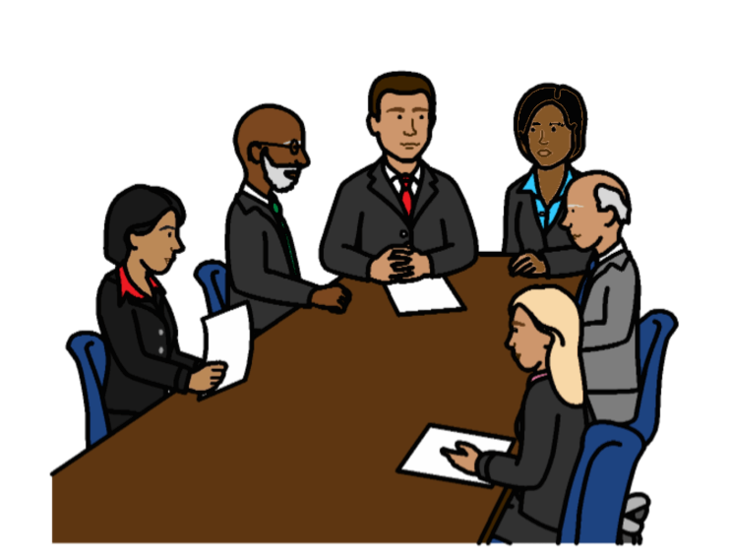

The United Nations is a group of countries that work to make the world better and safer.

Our job is to make sure that

everyone in the world is treated fairly and gets their human rights.

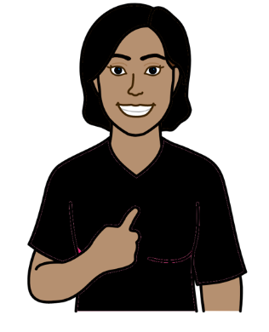

Everyone has human rights.

For example, everyone has the right to food, water and a healthy world to live in.

That is what should happen in everyone’s lives.

# Icon Description automatically generatedAbout this report

This report is about climate change problems and why they are worse for some groups of people in the world.

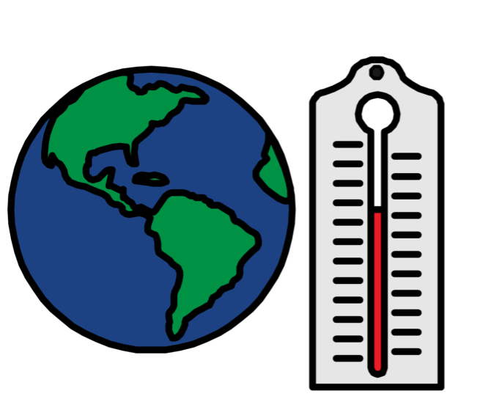

Climate change is about changes to the earth we live on.

The earth is getting warmer.

That is causing big problems for people and the planet we live on.

For example, climate change can cause big weather problems like floods, too much heat and bad storms.

It can also cause problems for animals and plants.

This report is about:

* Climate change problems for some groups of people in the world
* Some good work that countries and organizations told us they are doing on climate change
* What countries should do next

**Why climate change is worse for some groups of people**

Climate change is causing problems for everyone.

For example, there have been

big floods, too much heat and bad storms in many parts of the world.

But climate change has been

even worse for some groups of people.

That includes:

* People who are poor or people who live in poorer countries
* People with disabilities
* Children and older people
* A picture containing clipart

  Description automatically generatedWomen and girls
* People who live in places where there are big climate change problems, like small islands or very dry places
* People who had to leave their homes because of climate change or other problems
* Other groups of people who are often left out or treated unfairly

Many of these people already find it hard to get the things they need.

For example:

* A picture containing icon

  Description automatically generatedFood and clean water
* Health care and medicine
* Safe housing
* Education

But climate change has made things worse for them.

For example:

More people are having to leave their homes because of floods, not enough rain or other climate change problems.

That can put them in danger and make it hard to get the things they need.

Many people in poorer countries are in danger because of where they live.

That includes people on small islands where the sea could get too high and come on to the land.

And people who live in unsafe housing.

Many people who are poor need to grow food on their land.

That is so they can earn money and have enough to eat.

Some people have lived on their land for a very long time.

It is very important to them and their community.

But climate change is making it harder for many people to use their land.

For example, too much heat or rain can make it hard to grow food.

Many people know a lot about their land and the local area.

They can really help to stop climate change problems.

But people who make decisions often do not listen to them or use their ideas.

Climate change can also make life worse for other groups of people. Like people with disabilities.

For example, people with disabilities might find it hard to leave quickly if there is a flood or other problem.

And they might find it harder to get the support they need.

Climate change might be worse for some people for more than one reason.

For example, if someone is poor and has a disability.

Climate change problems are usually worse for people in poorer countries.

And many poorer countries do not have enough money or support to deal with climate change problems.

But that is unfair because most climate change problems are caused by richer countries.

Many countries have promised to give poorer countries more money and support to help with climate change.

But they are not giving enough.

Many poorer countries had to borrow money to fix climate change problems.

But they often have to pay the money back. That makes them even poorer.

There is not enough information about climate change problems for all groups of people.

That includes people who are often left out or treated unfairly.

**Some good work that people have been doing**

Many people in the world have worked hard to help stop climate change.

That includes people who have the most climate change problems.

For example:

* Many people have joined together to speak up about climate change and their rights.

* Many people have started projects to do with climate change.

For example, projects to share ideas about climate change.

And projects to share seeds that are easier to grow as the weather changes.

* Some people have taken companies and governments to court about climate change problems.

For example, problems where too many trees are cut down. That can make climate change worse.

Many countries are also doing good work on climate change.

For example:

Mexico is making sure that people who need the most support know about climate change problems that might happen.

Mauritius and Iraq are working to keep people safe from climate change problems.

Guatemala, Slovakia and Greece are supporting more groups of people to take part in making decisions about climate change.

Argentina and Latvia are making sure that plans about climate change include groups of people who are often left out.

**What countries should do now**

Many countries in the world have made promises about:

* 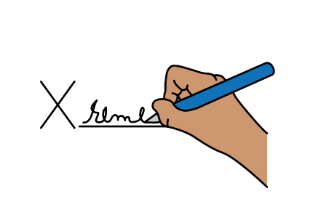Making sure that everyone gets their human rights.

For example, their right to food, water and a healthy world to live in.

* Doing more to stop climate change.

Some countries are causing more climate change problems than others.

They should do more straight away to stop climate change and make sure that people get their rights.

For example:

Countries should use less things that damage the earth by 2030. Like coal, gas and oil.

Countries should give more money and support to poorer countries to help them deal with climate change problems.

Poorer countries should not have to pay that money back.

Everyone should get information they can understand about climate change and what is being done about it.

That includes information about

big climate change problems

and how to get ready for them.

Countries should work to stop different groups of people being left out and treated unfairly.

Countries should work with people who need the most support to make plans and decisions about climate change.

The plans should work well for people who have the most climate change problems.

Countries should support all groups of people to have a real say about climate change.

It should be safe for everyone to speak up.

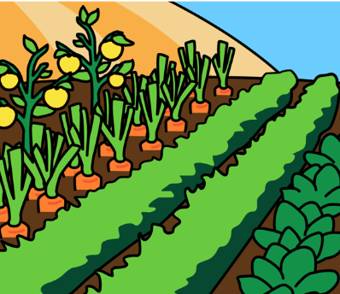Countries should work with people to find better ways to deal with climate change.

For example, finding new ways to grow food that is safe from climate change.

Countries should make sure that

people can stay on their land and do things that are important to them.

Countries should ask people first if they are happy with climate change plans in their community.

People should get support if climate change stops them from getting their rights.

For example, they should get advice and support from the courts.

Countries should get better information about climate change and the problems it is causing for people and their rights.

All of these things will help people who need the most support to get their rights.

**Pictures by The Picture Communication Symbols ©1981–2016 by Mayer-Johnson LLC a Tobii Dynavox company. All Rights Reserved Worldwide. Thousands of resources available for free at** [**www.boardmakeronline.com**](http://www.boardmakeronline.com/)